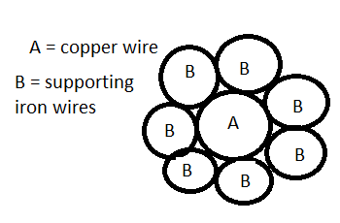

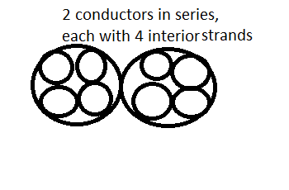

Where 2 is the number of conductors in series, 4l is the length of each conductor, 4 is the number of strands in each conductor and r is the radius of one of the strands