**Direction**: direction of F that acts on a North pole placed at that point, from north to south

Figure 1: uniform centre, loop outside

**Asked for direction of B**: if it is into th epage then write it as perpendicular to and into the page, for full marks

Strength uniform in central portion of field, weakens at edges

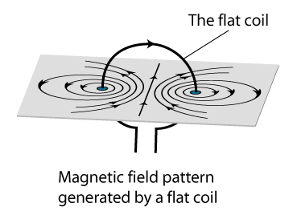Right hand grip rule: thumb points in direction of conventional current, direction fingers are turning gives field direction

**Shape and Direction of field produced by current in straight wire:** closed circles around the vertical wire

Increase strength: >I, >N, add soft iron rod in coil with axis perpendicular to coil plane

Force due to interaction of two magnetic fields (field due to 1. Magnet and 2. Current in wire)

**Magnetic flux density =** force per unit carrying length

**How variable d.c supply can change emf:** Magnitude: increase rate of change/ change current faster, Direction: reverse polarity of supply/ increase current

**Force on current carrying conductor in magnetic field measured on balance:** F on wire causes by I flowing in B field, Upward force on wire, Equal and opposite downward F on magnet, more I is needed for same readings with smaller wire, safety- don’t let I get too high as it causes heating

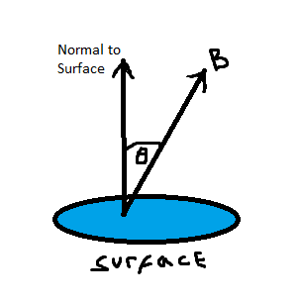**Principle of electric motor** Left side of loop experiences upward force while right side, downward. Resultant moment turns coil.

where = magnetic flux linkage in webers (Wb),

**Weber:** (Magnetic) ﬂux linking a 1 turn coil producing 1 V per second

**Tesla:** One tesla is the magnetic ﬂux density which will cause a conductor 1 meter long carrying a current of one amp at right angles to the ﬁeld to experience a force of one newton.

= BAN when e.m.f = 0, when e.m.f is max,

is cosine function, e.m.f is sine function, Note: one is max when the other is zero

|F| = BILsin(α), where α is the angle between the magnetic field and current direction

Max F when I and B fields perpendicular, Min F (zero) when I and B field in same direction (when wire is parallel to field lines) or act 180° to each other

**For one coil, ie N=1:**

For **EM Induction** there must be relative motion between the magnet and conductor

**Faraday’s Law of EM Induction:** induced emf is equal to rate of change of flux linkage/ proportional to rate of change of flux, demonstrated by changing the speed of movement of magnet/coil

**Lenz’s Law:** direction of induced current opposes change in magnetic flux producing it, demonstrated by changing the direction of the magnet which changes the direction of the meter deflection

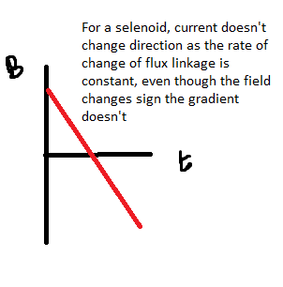

**Why emf goes from + to – when magnet dropped through coil:** induced N pole at top of coil as magnet approaches causes a + emf at point of entry, polarity reverses as magnet leaves (attraction), so the direction of current and thus emf reverses to -, there will be a larger negative emf peak as the magnet is moving faster so rate of change increases

ie minus the gradient of the magnetic flux linkage against time graph. When Coil is perpendicular to ﬁeld, Magnetic ﬂux through coil is maximum so rate of change of ﬂux = 0 (Thus emf induced is zero), also note than if the emf wave has a period of 2s that it only takes 1s to go from max to min, important for questions involving ΔB and Δt

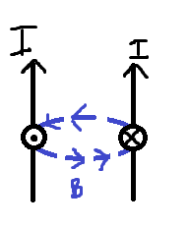**Two parallel wires carrying current in same direction:** force between them is attractive due to the circular magnetic field

Transformer:** a.c input to primary coil produces changing which produces changing in secondary coil (as they are linked by a (laminated, continuous loop, soft etc) soft iron core which maximizes ) a.c output (emf) induced in secondary coil,  **=**

Assuming no E loss, but, it is lost due to:

|  |  |
| --- | --- |
| **Problem** | **Solution** |
| Resistive wire heat (windings of both coils) | Oil as coolant/ use lower R wire |
| Not all magnetic flux passes through secondary coil (flux leakage/loss) | Wind both coils on one limb of core/on top of each other/ continuous loop structure core |
| Reversing magnetization direction results in large eddy currents which increase the heat of iron core (which heats wires and increases their resistance) | Laminate core |
| Hysteresis (lag between induction and force) | Soft iron |

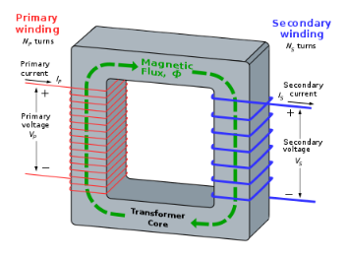**Transmission:** Step up, transmit, step down: , decreasing R with large wires isn’t feasible so we step up voltage (which in turn reduces current).

Figure : Alternatively use voltmeter in parallel to capacitor or resistor

|  |  |
| --- | --- |
| **Step Up** | **Step Down** |
|  |  |
|  |  |
|  |  |

**Capacitance/Farad**: charge stored per volt, , Parallel: , Series: , E =

**Charging/Discharging experiment**: Switch closed: charges*. Switch open: discharges through resistor (which slows rate of discharge). *Electrons ﬂow from capacitor plate to positive terminal of battery and ﬂow to other plate from negative side of battery. Until there is no voltage difference

**Measuring variation of voltage with time**: Start timer when charging starts, record voltage at (regular) intervals until voltage reaches the supply voltage (i.e. stops rising)

The **time constant** is the product of the capacitance and resistance. It is the time taken for the voltage across the capacitor to fall to ()

**Determining time constant**: Charge the capacitor by closing switch. Open switch and allow capacitor to discharge, recording voltage and time.

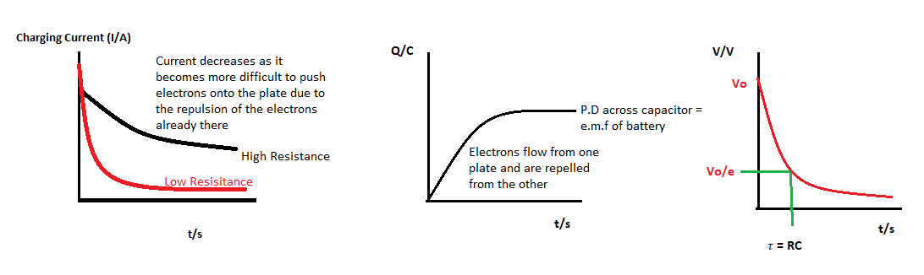Plot voltage vs time and read time when voltage falls to () or do the following plot where = -1/grad

, ,

V above can be replaced with Q or I and the same equations and rules apply.

For experiment involving last graph, you can find t = 2 as well (t to fall to ) and avg

**Flash gun**: shutter on camera pressed causes rapid discharge of the capacitor through a gas filled flash tube producing an intense flash

**Defibrillator**: when hearts rhythm is disturbed a defibrillator can provide a controlled shock to stop ventricular fibrillation. It transfers a precise amount of energy in a short time using a capacitor which stores electric charge in the electric field between metal plates separated by an insulator. The circuit has minimal resistance for fast charging, but it can’t be too small as this would damage the power supply. The voltage of a mains operated defibrillator should be stepped up and changed to d.c before charging the capacitor

A capacitor marked “47uF, 12V” indicates in normal use the ration of Q to P.D across capacitor is and that is it is designed to work <= 12V, above this the insulator (dielectric) between the plates will break down and charge will leak from one side of the capacitor to the other.

For questions like: How would you use a number of these capacitors to get a total capacitance of x and a maximum voltage of y. Use the fact that voltage splits in series to work out the number of capacitors in series then work out how many parallel branches will be required to get the target total capacitance required.