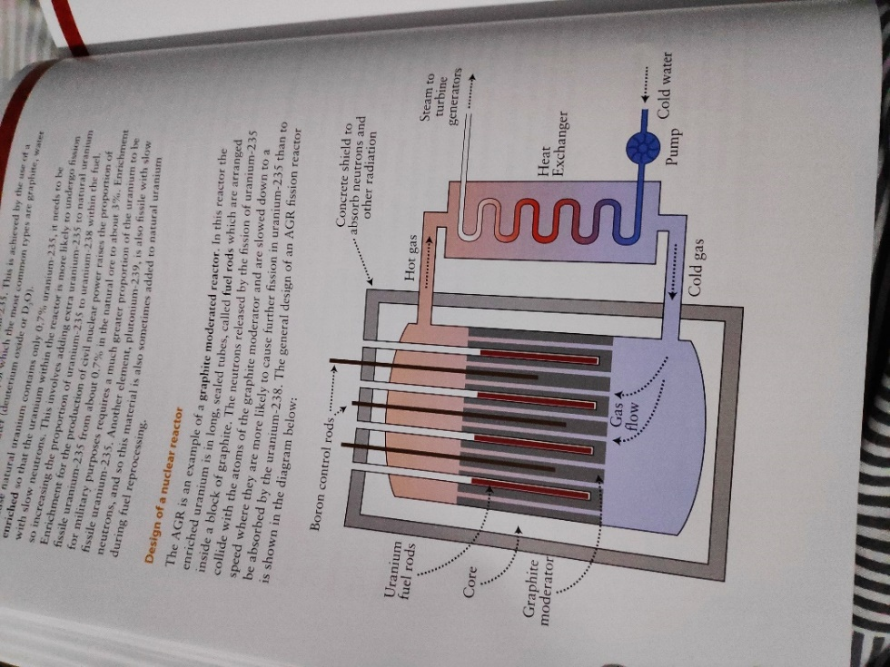U fuel is enriched with U-235 as it only contains 0.7%

Why fusion difficult: maintain high temp for sufficient time

**AGR** is a **graphite moderated reactor**. Neutrons released by fission of U-235 collide with atoms of graphite moderator, are slowed to increase chance of further fission on U-245 than absorption by U-238.

**Chain Reaction:**  neutrons released from fission of nucleus that don’t escape or get absorbed by a neighbouring nucleus go on to cause further fission reactions with a neighbouring nucleus, releasing more neutrons. Rate neutron production > rate neutron loss to sustain reaction. **Controlled**-power station, **Uncontrolled**-bomb.

**Critical Size:** min size of reactor capable of sustaining chain reaction. Must have at least enough fissile material to reach critical mass. If core size too small, too many neutrons escape, and chain reaction stops.

**Moderator:** material such as graphite/(heavy) water which reduces speed of fast neutrons. U-235 undergoes fission w/ slow/thermal neutrons (U-238 fissile with very fast neutrons)

**Control Rods**: change fission rate by capturing excessive neutrons and thus decreasing no. available neutrons. Eg. Boron coated steel rod capable of absorbing neutrons without undergoing fission. Max absorption when fully fitted. U in rod < critical size to prevent uncontrolled fission.

**Coolant:** captures/transfers heat released by fission and passes through heat exchanger which produces steam which drives turbine, generating electricity

**Shielding:** Think concrete shield prevents penetrating gamma waves and neutrons from escaping by absorbing them.

**Fusion Temp:** >15million °C to give H nuclei enough Ek to overcome electrical repulsion between protons. Repulsion causes Ek to decrease and Ep to increase so they must be projected together at very high speed.

**Plasma:** Ions and electrons (ionized gas/matter)/ gas of ions

**Why use plasma confinement:** provide correct conditions for fusion (temp, > time, > particle density)

**Gravitational Confinement**: Gravitational F confine plasma in stars, not suitable for terrestrial fusion as a mass > earth required.

**Inertial Confinement**: intense ion/laser beam directed towards solid fuel pellet to heat it to fusion temp and extract E before plasma escapes.

**Magnetic Confinement:** toroidal coils generate magnetic field which exerts F on charged particles. Particles perpendicular to magnetic field move in circular path. Particles at an angle to the field travel in a spiral. $F = Bqv_{perp}, Bq= \frac{mv_{perp}}{r}$

**Deuterium-Tritium (D-T) reaction**: ${}_{1}^{2}D+ {}_{1}^{3}T → {}_{2}^{4}{He} + {}_{0}^{1}n$, large supply of D from sea water and T from Li, >E release than similar reactions, limited waste: no long-term storage required, single stage reaction, relatively low temp required, plasma easier to control, greater possibility of collisions

ITER Plasma Heating: **1**. induced current by EM induction allows electrons and ions to gain E however as temp and R increase the heating effect is reduced. **2.** D ions accelerated to high v by electric field. gain electron to become neutral, enter plasma and collide with particles, transferring their E to them and heating. **3.** High E microwaves transfer E directly to plasma particles. Specific freq. matches ion/electron type’s natural/resonant freq.

**Be blanket surrounding vacuum vessel:** shields from andslows high E neutrons (absorbs, preventing them from escaping). Their Ek is transferred to heat energy which is collected by water coolant and used for electricity production.

**Adv**: low $CO_{2}$& $SO_{2}$ emission (no contribution to global warming/acid rain/meet climate change targets), employment opportunities, little radioactive waste for fusion, easy to stop fusion reaction, prevent energy crisis due to overdependence on fossil fuels such as oil

**Disadv**: high E input before useful output obtained, expensive plants (superconducting magnets etc), non-renewable nuclear fuels, mining/refining/recycling fuel rods produces $CO_{2}$, radioactive materials into environment if accident, waste harmful to health for thousands of years, difficulty storing waste, risk of nuclear accident, power stations targeted for attacks/theft, nuclear power technology used for weapons, construction/decommission cost