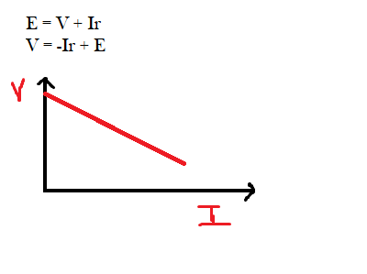Percentage change in voltage = $\frac{V_{0} - V_{F}}{V_{0}}$

Plotting linear graphs: $T = kM^{n} → ln(T) = nln(M) + ln(k)$

$$θ_{t}=θ_{R}+Ae^{-kt}→ln\left(θ_{t}-θ_{R}\right)=ln\left(Ae^{-kt}\right)=ln\left(A\right)+ln\left(e^{-kt}\right)=ln\left(A\right)+-ktln\left(e\right)$$

$$ln\left(θ_{t}-θ_{R}\right)=-kt+ln\left(A\right)$$

$$y = mx + c$$

|  |  |  |
| --- | --- | --- |
| **Voltage** | **Timebase** | **CRO Display** |
| None | Off |  |
| On |  |
| +DC | Off |  |
| On |  |
| AC | Off |  |
| On |  |

If a straight line graph through the origin is expected but the line of best fit of the plotted points doesn't go through the origin, this is an indication of a systematic uncertainty

If there is a large scatter of points around the line of best fit, this is an indication of a large uncertainty, possibly due to random errors

State the longest and shortest length a string measured 0.12m could be to 3 decimal places

Longest = 0.124m, shortest = 0.115m

When finding the average period of a pendulum we assume that the period doesn't change with each amplitude of the swing/oscillation and therefore the total time for several oscillations can be divided by the number of swings to find the period

When multiple readings are taken then the uncertainty is half the range in the results therefore the answer is given as the average plus or minus half the range

To plot error bars - plot the mean value with lengths of half the range of the data points on either side



Parallax error - occurs when scale not viewed at right angles or placed too far from the object

For lengths greater than one metre it is better to use a tape measure with 1mm divisions which can measure

Liquids in glass containers curve up at the edges and down at the middle therefore the reading should be taken from the bottom of the meniscus

To improve meniscus visibility a card with a dark stripe may be placed behind the measuring cylinder

In liquids and materials where the curvature occurs in the opposite way where the edges of the liquid curve down and the centre rises then the reading should be taken from the top of the meniscus

Protractor uncertainty - angle measurement uncertainty is half the division ie half a degree but there is also the uncertainty in aligning the protractor with the normal which is another half degree uncertainty therefore the total uncertainty when measuring an angle with a protractor is +/- 1 degree

Thermometer usually has divisons of 1°C so a temperature reading has an uncertainty of ±0.5°C and a temperature change of of ±1°C

Uncertainty in single reading is typically of ± ( $\frac{1}{2}$ smallest division)

Volume of stone found by change in water volume when stone added, to find volume of floating object like cork attach it to a stone

In electrical experiments read values for current as voltage is increased to the desired value and decreased to the desired value and find the average of the two currents

Line of best fit gives best intercept and the range of intercept values can be found between the points where the lines of minimum and maximum slope cross the y axis. The percentage uncertainty in the intercept is the intercept from the best fit plus or minus half the range.

Precise and accurate - measurements close to the true value and readings are similar ie random/systematic uncertainties are small

Precise and inaccurate - measurements show small difference but average far from the true value

Imprecise and accurate - measurements show large variation but the average is close to the true value

Imprecise and inaccurate - measurements show large variation and the average is far from the true value

Object on ramp may not travel in a straight line giving more uncertainty in the distance travelled and in the experimental results

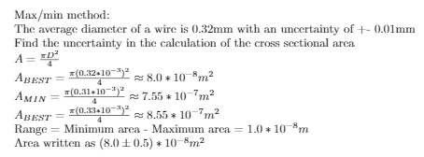

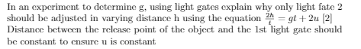

There could be uncertainty in a measurement if the quantity being measured isn't constant

Uncertainty is the interval/range in which the true value can be considered to lie

Error is the difference between the measurement and the true value

precision is the degree of uncertainty in a measurement

accuracy is how close a measurement is to the true value

a precise measurement contains more information

there is no limit to how far away from the average a measurement can be

size of random uncertainty reduced by taking more readings

Systematic uncertainty shifts all measurements away from true value by the same amount, significantly affecting accuracy - Occurs when instrument goes out of alignment or not calibrated properly

Taking more readings will not affect systematic uncertainty as it is present in every measurement

subtract zero error from every measurement

adding or subtracting measurements : add uncertainties

multiplying or dividing measurements : add percentage uncertainty

functions of measurements (log sin etc) : same percentage uncertainty

sometimes error bars are not shown as they would be too small to be of any significance

projecting beyond the limit of measured data is called extrapolation

Important to ensure everything other than the independent variable being changed and the dependent variable being observed are kept constan

Sensors, data loggers and computer interfaces can be used to take reading

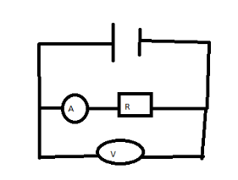 Given that the ammeter used has negligible resistance and the resistance of the voltmeter is of the same order of magnitude as the resistor

Explain why the resistance determined from this arrangement should give an inaccurate value:

The current recorded on the ammeter is high as it includes the current that goes into the voltmeter