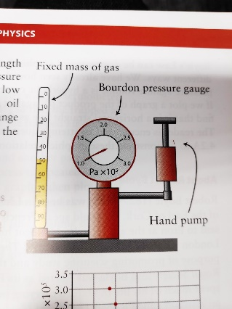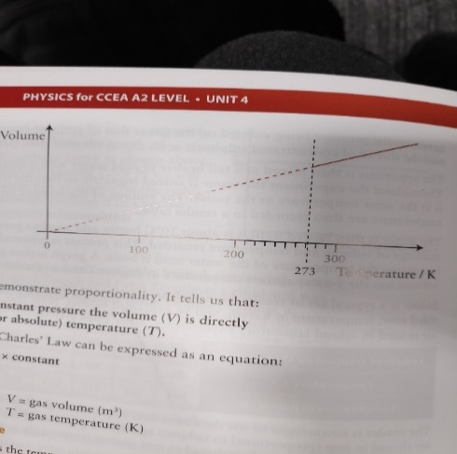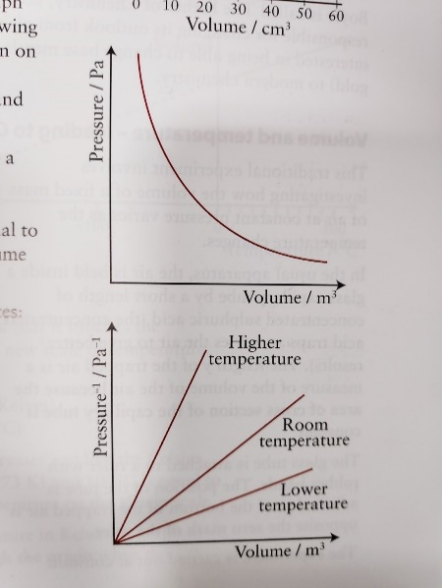**Boyle’s Law:** For a fixed mass of gas at const. temp, V is inversely proportional to P, pV = const

PV

V

If column of air has constant CSA, length proportional to volume

Oil should have low vapor pressure to keep gas mass const.

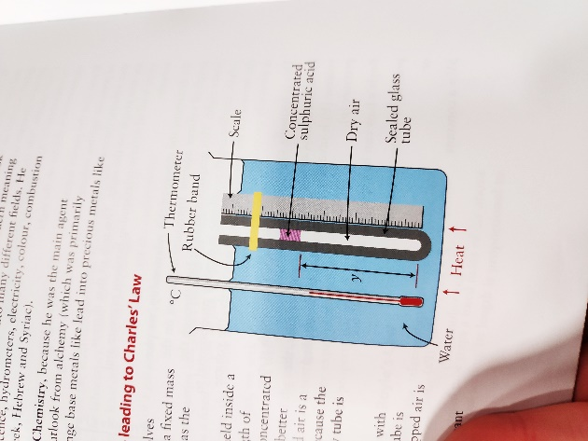Wait for air to return to room temp after using pump

**Charles’ Law**: For a fixed mass of gas at const. P, V is directly proportional to Kelvin (absolute) T, V/ T = const. L against T (in K) is straight line through origin

Acid dries air, length of trapped air is V as diameter const, P on gas from atmosphere and acid

Stir so T-Air = T-Water, Heated 10°C and readings taken (V & T)

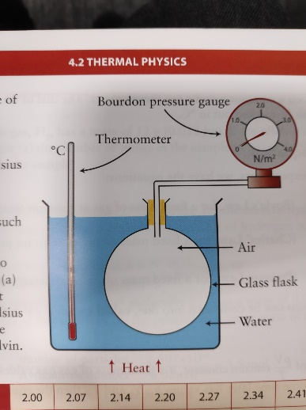Absolute Zero: -273°C/ 0K: theoretcal temp at which molecules stationary as substance has 0 thermal energy

**Guy Lussac/ Pressure Law:** For fixed mass gas at const. V, P is directly proportional to K/ absolute temp, P/T = const.

Apparatus may also be ised as thermometer with dial on pressure gauge set to °C (constant volume gas thermometer)

**Ideal Gas Equ**. PV/T = const. PV = nRT = NkT (in Kelvin)

**Mole** is amount of substance containing same no. particles as atoms in 0.012kh of C-12

No moles 1kg U-235 = 1000/235 = 4.2

$N_{A = \frac{N}{n} = }$ no. particles per mol.Molecular mass (m) = $\frac{molar mass}{N_{A}}$

Kinetic Theory – no intermolecular F, molecule’s V negligible, const. v between perfectly elastic collsiions (Ek and ρ conserved) of negligible duration

**Pressure** = $\frac{Total F exerted by all colliding molecules}{A of wall}$: collisions cause Δρv (implying F and reactive F from Newton’s Laws)

**Boyle’s** **Law**: <V = <d between collsions, Δρ same but >freq therfore >P

**Charles’ Law**: >T = >Ek therefore >Δρ per collsion, to maintain pressure const. freq decreases, >V =>d=<freq

**Pressure Law**: >T = >Ek, >Δρ &freq. therefore >P

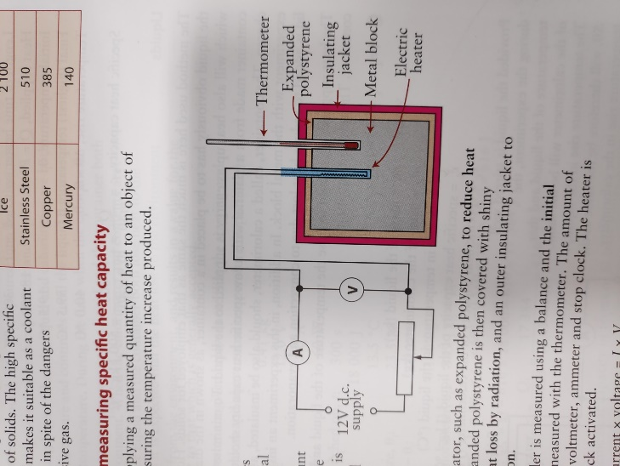**Avogadro’s Law**: equal V of all gases under same conditions contain same no molecules. $k_{= \frac{R}{N_{A}} }$

$PV = \frac{1}{3}ρNm<c^{2}>$, $root mean square speed=\sqrt{<c^{2}>}$, P = $\frac{1}{3}ρ<c^{2}>$, $ρ = Nm/V$ = M/V, $\frac{F}{ΔP} = A, \frac{1}{2}m<c^{2}>=\frac{3}{2}kT$

Real gas Ek+Ep, Ideal gas: only Ek,

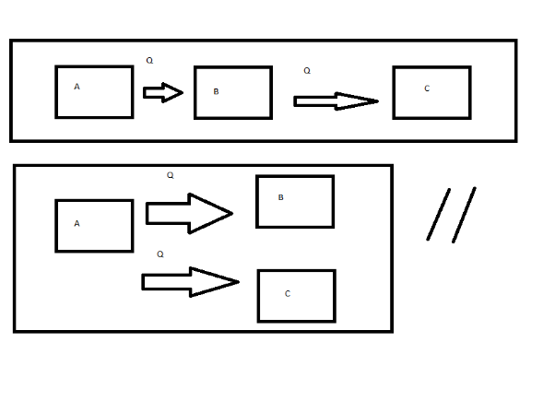SHC exp: Oil around thermometer to improve thermal contact, insulator reduces heat loss by conduction, foil reduces loss by radiation & jacket by convection, mass measured w/ balance, record intial temp, switch on heater (heat 15 $°$ C), record V&I, t w/ stopclock, final temp takern as highest temp reached by block after heater switched off $c = \frac{Pt}{mΔθ}$

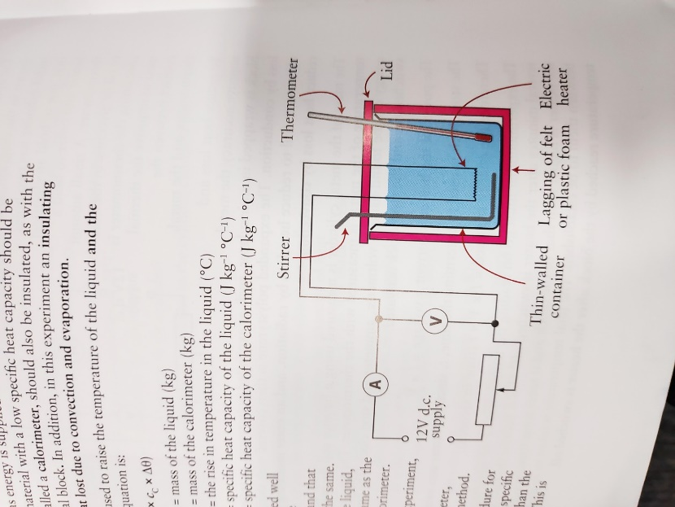Insulating lid reduces heat loss by evaporation & convection

Q = Q(liquid) + Q(calorimeter), heat loss to environment, reduce error: cool liquid to 5°C, start exp when liquiad & calorimeter both (room temp - 5), heat to (room temp + 5 so heat loss cancels heat gain (from environment)

SHC: quantity heat E required to raise 1kg of a sample by 1K/1°C

If block lagged, all heat supplied heats block (no loss)

Scales not used for final mass as mass lost to evaporation

Gas behaves more ideal at >T & <P, as Ep becomes less significant