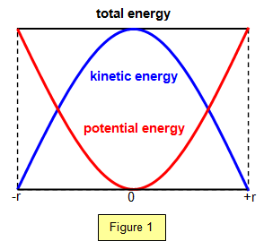s=r $θ$, $ω=\frac{2π}{T}$, v=r $ω$, $a=\frac{v^{2}}{r}=vω= rω^{2}$

|  |  |  |  |
| --- | --- | --- | --- |
|  | Displacement | Velocity | Acceleration |
| Variation w/ t | $$Acosωt$$ | $$-ωAsinωt$$ | - $ω^{2}Acosωt$ |
| Max | Amplitude=A | At fixed point (equilibrium) x=0, v= $ωA$ | Extremity of x, $a= ω^{2}A$ |
| Min | At fixed point (equilibrium), 0 | Extremity of x, 0 | At fixed point, 0 |
| Variation w/ x |  | $$ω\sqrt{\left(A^{2}-x^{2}\right)}$$ | $$ω^{2}x$$ |

$E_{k}=\frac{1}{2}mω^{2}A^{2}\sin^{2}ωt$, $T = 2π\sqrt{\frac{L}{g} }= 2π\sqrt{\frac{m}{k}}$, Tension = ke, F=kx, E=k $A^{2}$

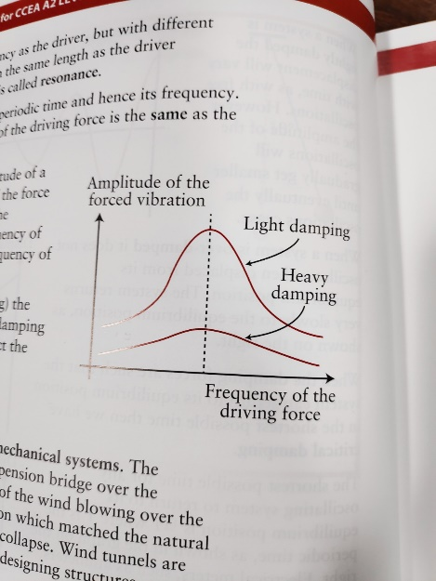Free vibration/undamped – no E transfer to/from system, Forced vibration (ex Barton’s Pendulums) – forced to oscillate at freq. of eternal oscillator which is giving it E, Condition for resonance: driving freq. = natural freq. Example of resonating system: singer and class, how to damp this system: fill with water, Oscillate in water to increase damping

Shifted left

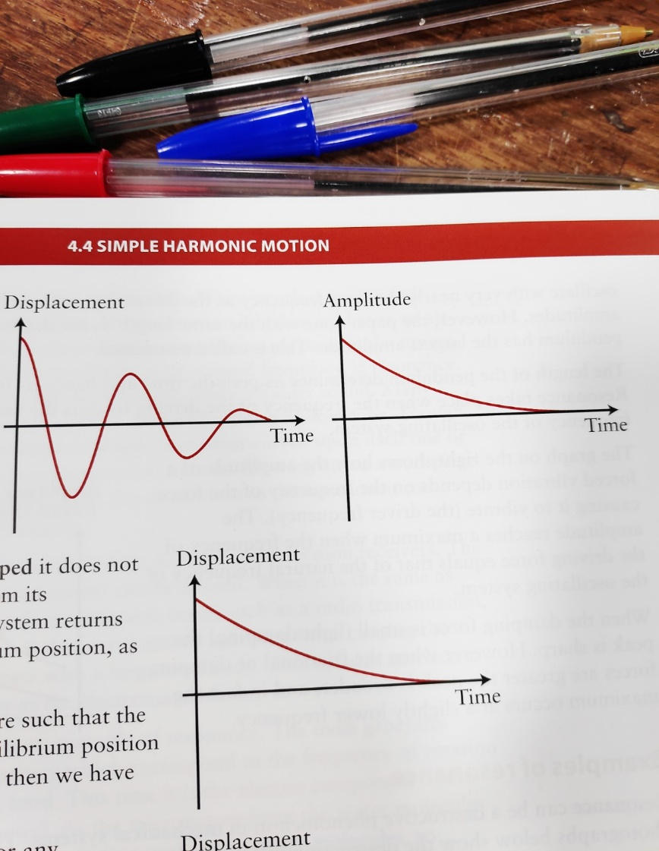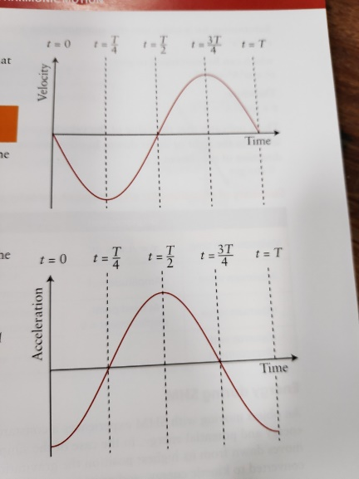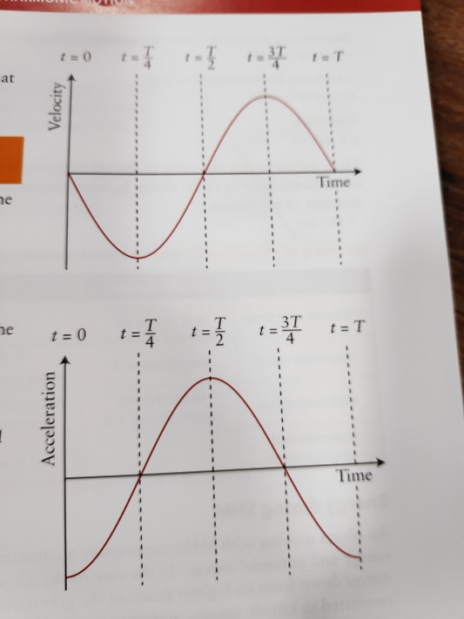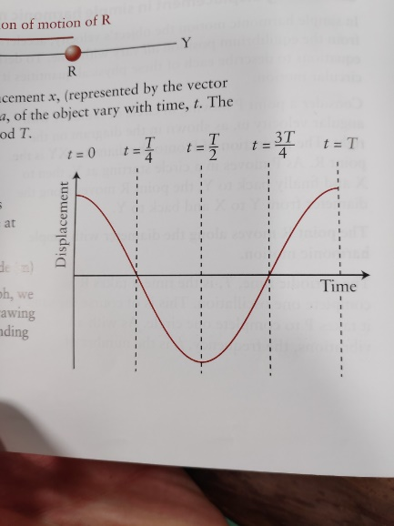Lightly Damped: Over Damped: Critically Damped

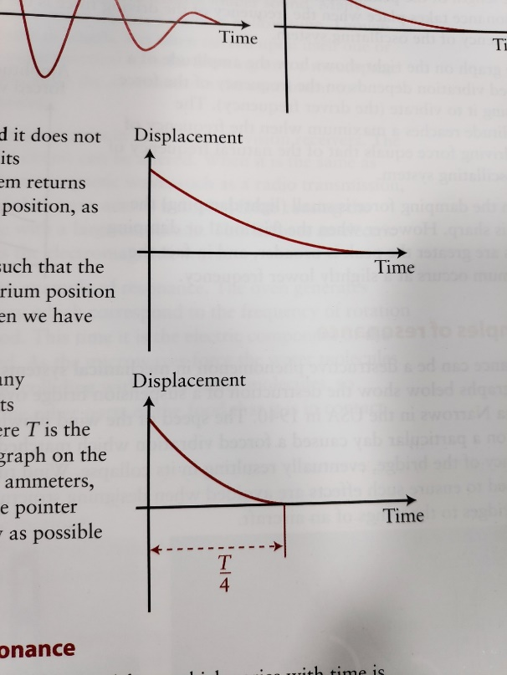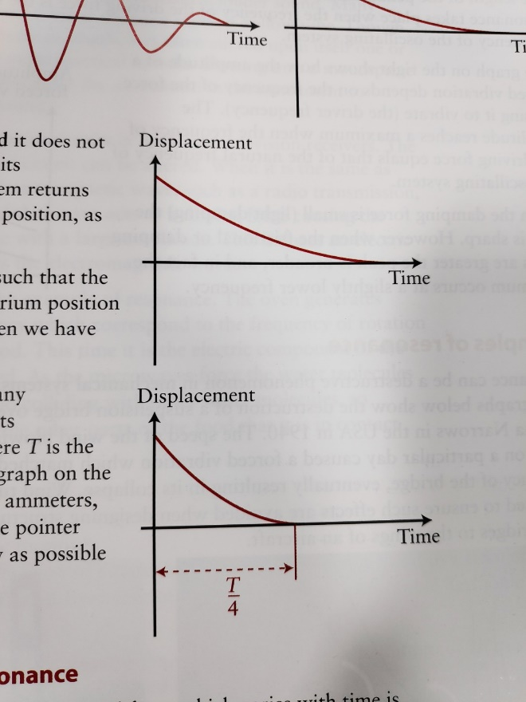

Cyclist on bend has $ω$ as they sweep an angle over time, Fr between tyres&road permit the UCM, SHM: a directly proportional to d from fixed point & direted towards fixed point. Cause of damping for moving obj is fr, effect is E loss and <A, how travel in circle at const speed but have a? direction & thus v changing, a is rate of change of v, when obj first reaches equilibrium: $x(t) = Acosωt, A can't be 0 ∴ cosωt = 0, ωt =\cos^{-1}{(0) = \frac{π}{2}, ∴ t= \frac{π}{2ω}}$

|  |  |  |
| --- | --- | --- |
|  | SHM | UCM |
| T | T for one oscillation | T for one revolution/orbit |
| F | Acts toward equilibrium | Acts toward centre of circle |
| Varies depending on position of object | Const. |

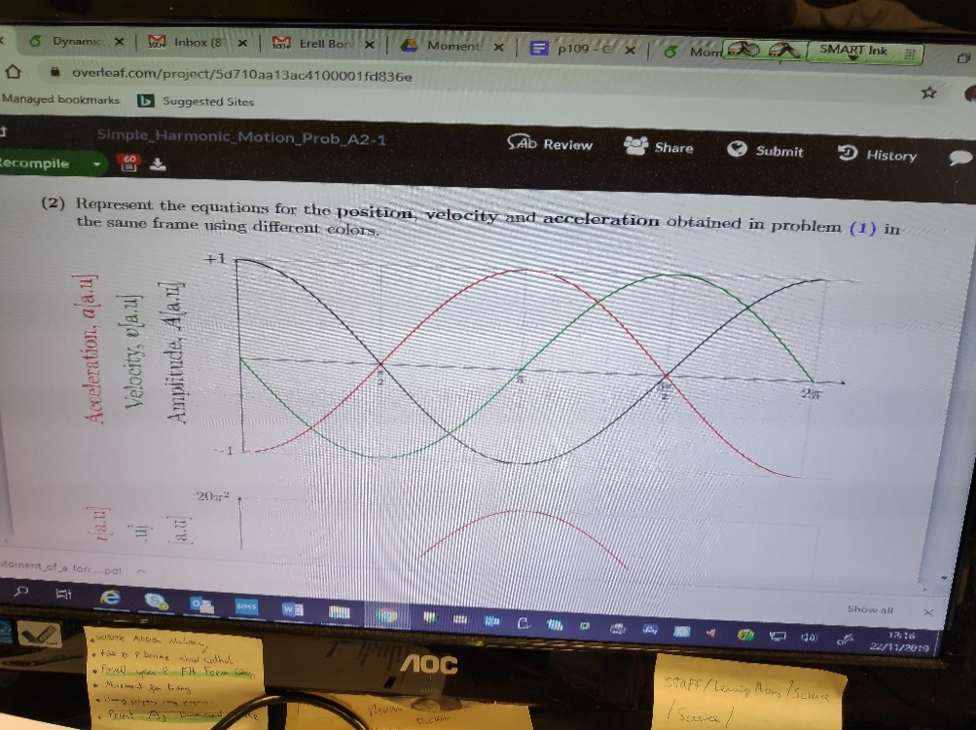Both overdamped and critically damped systems lose E and return to equilibrium position without oscillating, Critically damped does so in the quickest possible time, Total E of system is not conserved as E leaves the system to move air particles/ due to air resistance

Why chain w/ hammer can’t be horz: W_hammer acts downwards and must be balanced by vertical tension component