CMP73010 Assignment 1 document (2017)

In order to create a pull request for a Github repository:

1. In the *Code* tab for the master repo you wish to pull, select *New pull request*

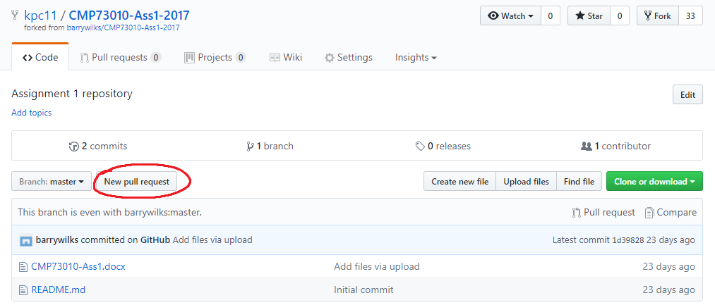

1. Select to either compare between two separate branches, or two different forks, then select the two branches/forks you wish to compare. You should then be given the option to write a title and description for the pull request before creating it.

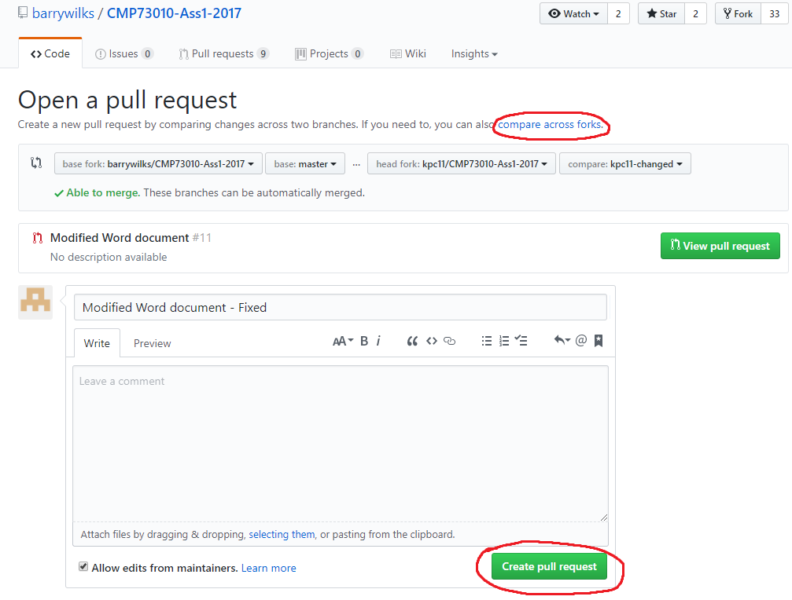

1. You will be taken to the *Pull requests* page.

