CMP73010 Assignment 1 document (2017)

To create a pull on GitHub;

**Step 1:** Search for the relevant repository

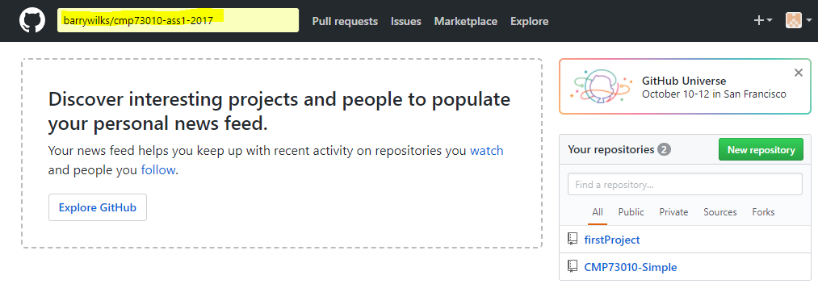

**Step 2:** Select repository

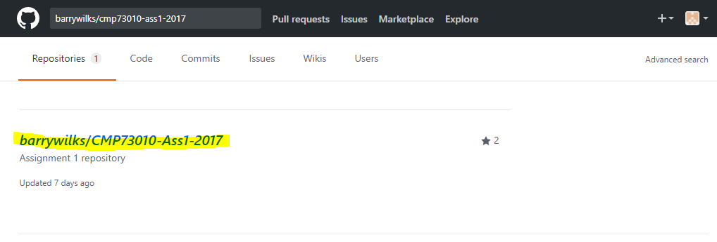

**Step 3:** Fork the repository

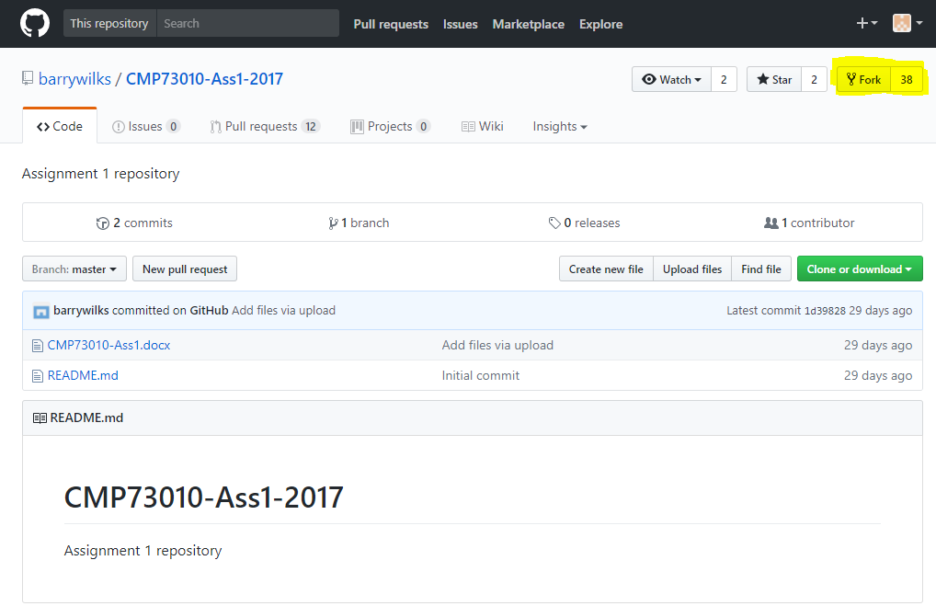

**Step 4:** Click on the file you wish to edit

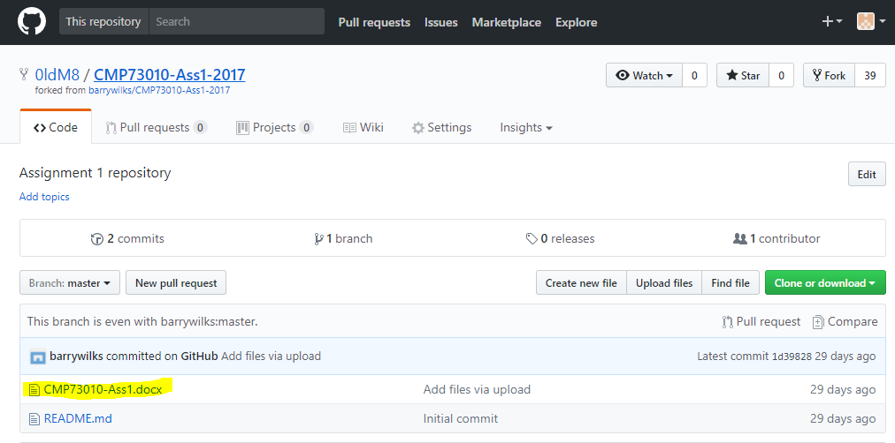

**Step 5:** Download the file *View Raw* and edit accordingly

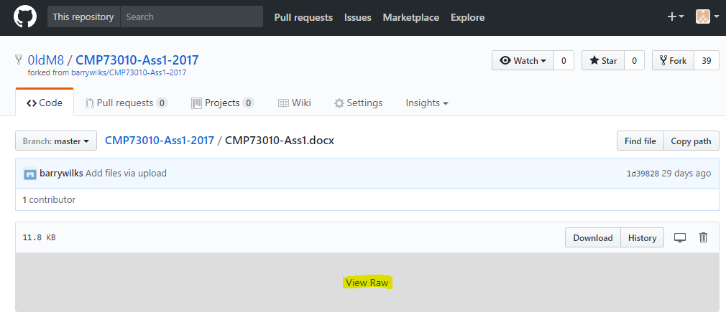

**Step 6:** Return to the forked repository main screen

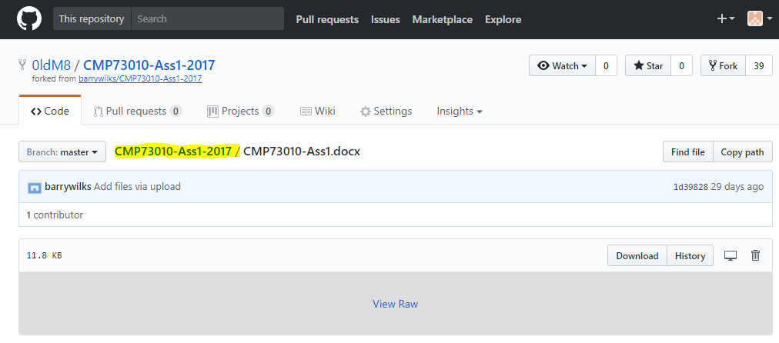

**Step 7:** Upload the edited file to the repository

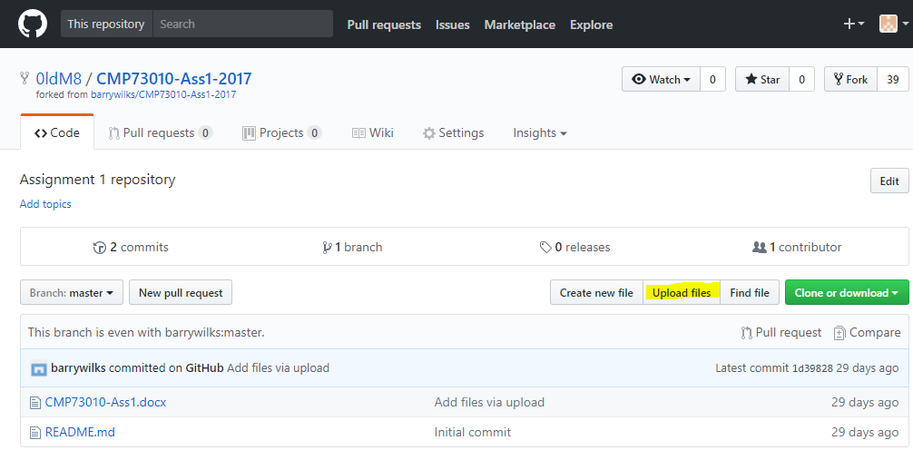

**Step 8:** Select or the file and commit changes

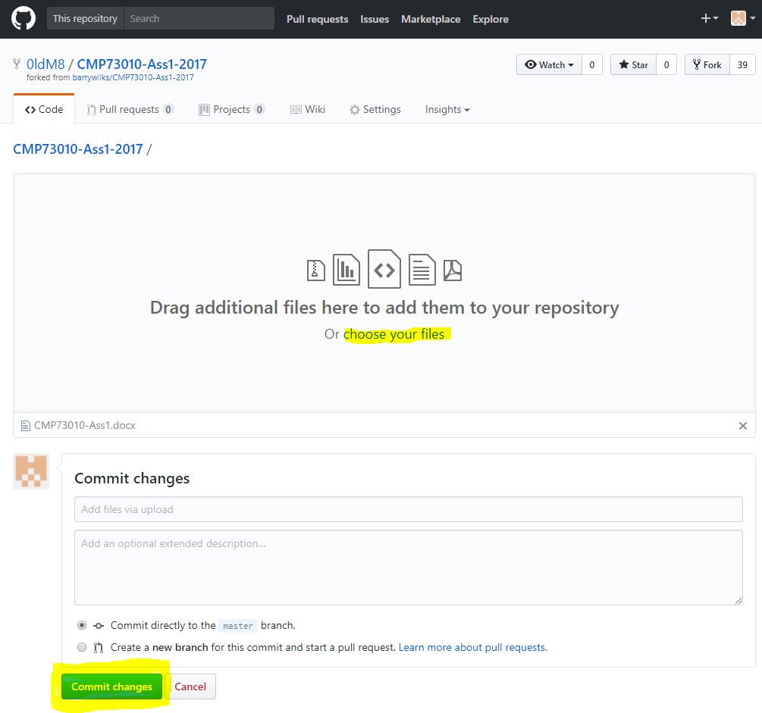

**Step 9:** Click *New Pull Request*

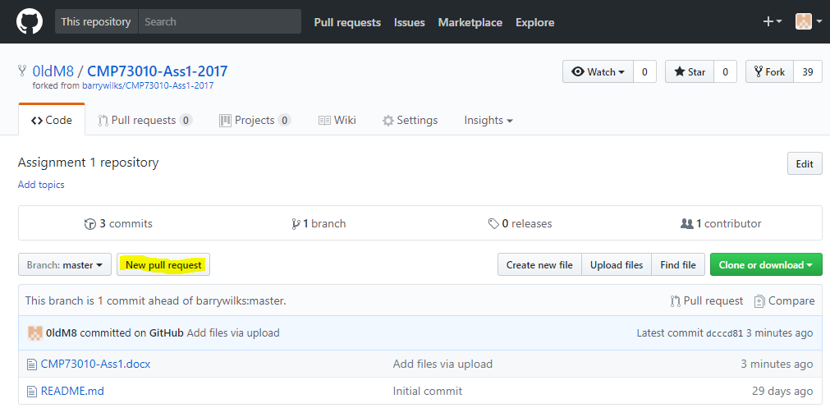

**Step 10:** Click *Create Pull Request*

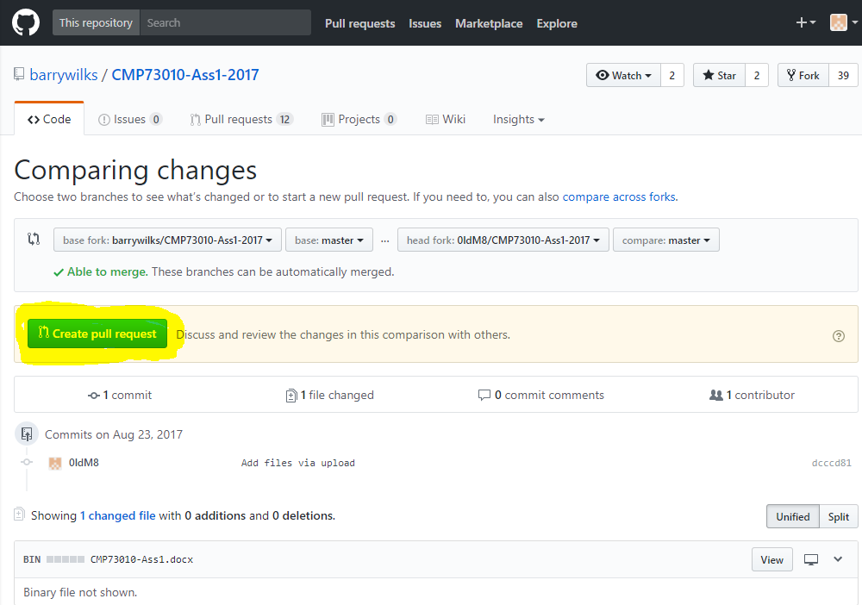

**Step 11:** Fill in the descriptive areas and *Create Pull Request*

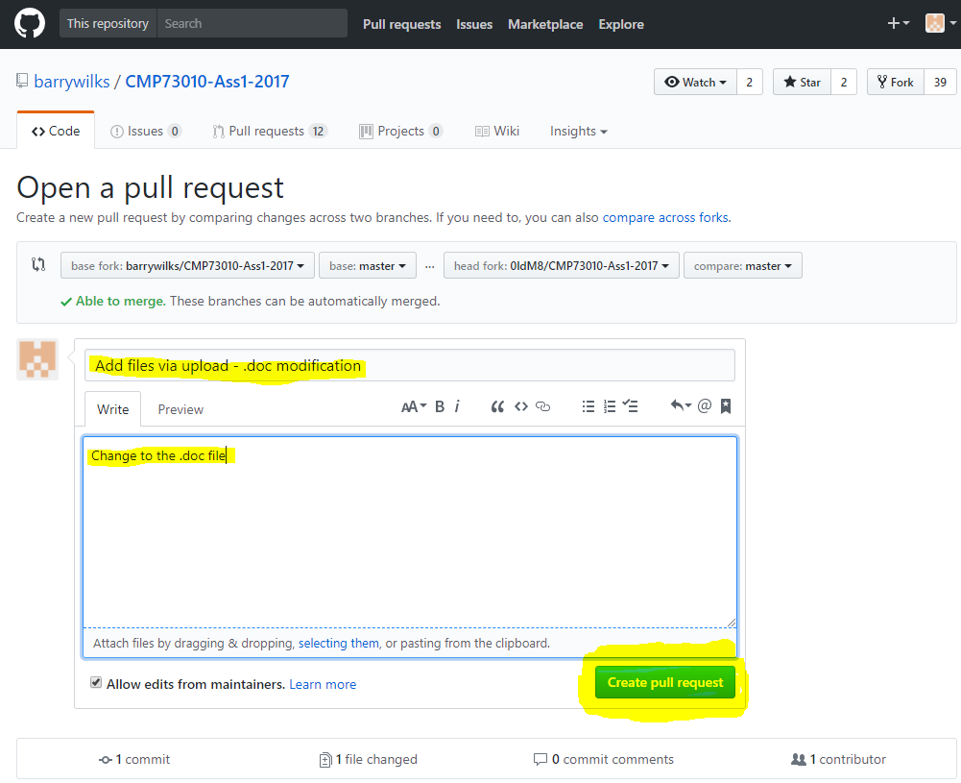

- SUCCESS –

