**Assignment 1**

This assignment is due on 19th April, 2021 at 11:00 pm. In addition to the report it includes a component that must be completed on-line. Suggestions for the report structure are given in each section of the requirement. The report itself should be submitted through the Turnitin link in your MySCU site. The maximum word count for the report is 1500 words (excluding headings, references, tables, and appendices). This assignment is worth 20% of your overall mark.

Please note that the assignment is due some weeks after the required materials are covered in the lectures and workshops. Please do not leave the assignment to the last minute as you can start work on much of the assignment well before the due date. If you do require an extension for submission you must request this before the due date. Unless an extension is agreed, a late penalty will be applied. Each day late on submission will apply a 5% mark deduction penalty. Please note that a timestamp of 11:01 on the due date is considered one day late.

This assignment positions you as a software development consultant in a large well-known consulting firm and covers testing, configuration management and software tendering assignments for different clients in your portfolio.

Important: You must submit your own solution with reasoning; however, we are perfectly happy for you to chat and discuss with your classmates but ultimately your submission must be your work. The last bit is particularly important. Do not copy and paste your classmates work and do not let your work be copied. This can have serious ramifications for academic misconduct. What we are looking for is your unique thought process behind your designs and solutions, as well as the actual solutions. Reports which do not give satisfactory reasons for their designs and solutions will be penalised.

**Part 1 – Testing (10 marks)**

The Acceptance Test (5 marks)

A university requires a system for student submissions of assignments. The system must accept submissions in a variety of formats, track student submission time and dates, provide for a word-count calculation and sends the submitter a receipt of submission when a file (or files) have been submitted. The system also provides a possibility of saving submissions temporarily as draft. The system requirements include:

1. Check for the correctfile formats
2. Track student submission time and dates
3. Calculate word-count that may notify the sender if it does not meet word limits
4. Send a receipt of submission
5. Allow draft submission of the assignment

Outline an acceptance test for the above system as described. In the study guide, this is steps 1, 2 and 3 of the acceptance test criteria. Most of step 1 is in the above system description but you can refine and expand if you wish.

Remember that acceptance tests can be designed *without access to the actual product*. Detailed testing of the product is for the next part of this assignment (detailed black-box testing). You can *enhance* the requirements above if you wish or clarify them based on your own knowledge. If you do adjust the requirements your plan will be assessed against your *new* specification. You should be able to describe your acceptance test in 300-500 words (1-2 pages).

The detailed black-box test plan (5 marks)

As part of a client presentation to explain the benefit of black-box testing to both a technical and nontechnical audience, you are asked to design a detailed black-box test for a popular software product.

The product to develop the detailed black-box test plan is the Microsoft 365 Excel Print dialog, as shown below. This version of Excel is available to all students so you can see its operation if you need to.

The various drop-down lists will vary between users of the software. When you specify tests, you can assume that the setup for the test can be achieved. For example, you may say “add five printers and select the last one” and assume that this can be achieved.

Produce a detailed black-box test plan for this dialog box. You do not have to produce a detailed black- box test for any dialog box or new screen that any of the controls launch. However, you may have to refer to the selectable options for testing each of the widgets on this dialog as you test the interaction between widgets.

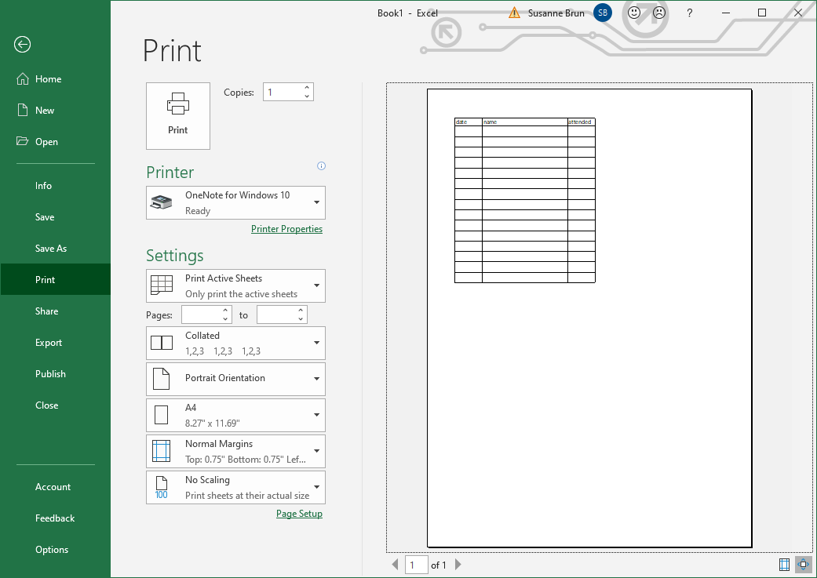

Note that you can, if you wish, apply your test plan to the product, e.g. you can test individual input fields and interaction between fields. This is a commercial product, so you would expect the product to pass the test (if you do find a bug then we will notify the software developers). For this assignment we are looking at the test plan, not the actual test results.

For the detailed test plan, you will be assessed based on how your test plan applies to this part of the total product. The total Excel 365 product is an extensive system so do not attempt to do a detailed test on more than this dialog box. Remember that testing is a creative process, especially when trying to break the software. You should come up with test ideas that other people will not think of (including your marker). In addition, it will not be possible to exhaustively test the software. Marks will mainly be awarded on the completeness of your strategy for testing for each widget. Creative testing ideas will be sufficiently rewarded but there are basic testing strategies that you must describe.

**Part 2 - Configuration management (5 marks)**

Code/file version management (2 marks)

Version management systems are a daily reality for the software development professional. On GitHub is a public project named: SCUteach/ISYS3001_S1_2021

You are required to sign up to GitHub and then:

1. Fork this project into your public space (1 mark)
2. Modify the Word document called *ISYS3001.docx* (it contains instructions) and request a pull of the project (1 mark)

Note: at various times the project manager will pull changes into the mainline. This will be reflected in your GitHub view of the project.

Important: In your assignment submission for the rest of the assignment you must state your GitHub account name! (So that the marker can confirm your project activity). Remember that your name will be public so please do not disclose any personal information. Do not place your student-ID in the GitHub document or elsewhere in the project. As this only requires your GitHub account name it will not be counted among the word count.

Build Management (3 marks)

A client of yours has confidential plans to develop an open-source web browser and has asked you to provide   
 advice on build management by looking at a competitor (Mozilla ‘Firefox’).

Give your advice as follows:

1. A brief description of the nightly build system of Mozilla Firefox for managing changes to software and systems (1 mark)

2. How Mozilla arrives at a release of Firefox that is distributed to the public (1 mark)

3. Advantages and Disadvantages of this system for the client (1 mark).

Note that the nightly builds *evolve* over time so carefully reference the facts that you have gathered and indicate the dates to which your descriptions refer.

You should be able to answer this section in about 400 words.

**Part 3 - Request for Proposal (RFP) (5 marks)**

Provide a detailed RFP for the following system.

Aussie Business Buzz (ABB) is a business that sells a variety of technology products (e.g. PCs, laptops, phones, routers), provides device repairs and mobile device accessories. They want an integrated system to support their 6 branch shops as the opportunity arises. They envisage the system will evolve over time and plan to expand to many more locations.

Their initial requirements are:

1. A *customer relations database* with information about products and services purchased, devices left with them for repair (customer details, customer purchase history, problem report, work details, etc.)
2. A *marketing system* that allows for digital marketing using e-mail, social media, and any other modern marketing techniques. This will use details in the customer relations database but allow other prospective customers details to be entered in the existing Aussie Business Buzz website (not part of this RFP).
3. A *stock management system* that includes products for sale, parts for use in repairs, automatic ordering from wholesalers. The system must be able to be used for individual locations to find products and parts at other ABB locations when necessary.
4. Reports for management, who may be at any location, of the status of all the above so they can order stock, recruit staff, and make other management decisions*.*

Your RFP should use one or more guidelines that you will reference. You may be tempted to go overboard here so try to restrict your RFP to a reasonable size (up to 1000 words maximum), less if possible. Remember that the less restrictions the better in an RFP so that the responders can come up with new ideas that you have not imagined so far. This also means your RFP will not contain much technical information about the requested system but will contain information about your existing systems (the web site, unless you add to the specification).

Your RFP should allow for a bespoke software development; but it should also clearly be able to consider existing applications, solutions built from components, SaaS solution, other solutions, and any combination of these.

As you will learn, your RFP must contain:

1. The system description
2. Explanation of how you would evaluate proposals received
3. Explanation of how you would answer questions
4. Any other facts that would ensure proposals are useful to you and worth a supplier’s effort to respond to the RFP

Note there are many things missing from the above specification that you may wish to add to your RFP. A lot of your RFP will be details that you will need to make up, e.g. who to contact and how. You can use your own information or make up names and other data along the ABB theme.

**Mark deductions (after):**

|  |  |
| --- | --- |
| Demerit areas | Marks |
| Not writing Report Title, Student Name, Student Number, etc. on the first page | 1% |
| Not writing the Executive Summary (Abstract) | 1% |
| Not using a table of content and/or page numbers | 1% |
| Not writing the Introduction and Conclusion sections | 1% |
| Incorrect referencing and/or reference list not on a separate page | 1% |
| Exceeding the maximum word-limit (+/- 10%) | 2% |
| Late submission penalty | 5% per day |

**Further Notes:**

* **Word-limit:** The maximum word-limit will be strictly applied. The marker can deduct marks for writing over this word-limit. So, make sure your report is completed within the given word-limit. There is no maximum word-limit applicable for Title, Executive Summary, Reference List, and appendices.
* **Start early and submit on-time:** Avoid any pitfalls that may arise due to late start. Thus, start your assignment as soon as possible to submit on-time. For late submissions, the standard assessment submission policy will be applied (see the unit profile).
* **Appendix:** You may add appendices to document any additional material you wish to include such as tables, diagrams, figures, or other supplementary material. Appendices do not contribute to the word count of the document.
* **Reference:** You should add a reference section and include any references, including publications (literature, books, etc.), which you want to refer to, to support your report.
* **Late Submission:** This assignment will be due on Monday, 19th April, at 11:00pm. A penalty of 5% of the available mark will be deducted from the actual mark for each day of late submission up to five days.
* **Consultation:** You will have the opportunity to show your assignment draft to your tutors/unit assessor for feedback. Several assignment consultation slots will be organised; follow the announcements from the unit assessor.
* **Contact:** Please contact the unit assessor/lecturer/tutors if you have any issues or confusions.