SoilGuard: data flow
Where each dataset comes from, where it is calculated, and how the results reach the screen
App: barsa1ly.github.io/soilguard · Code: github.com/barsa1ly/soilguard (commit 0a3d5fe) · November 11, 2026

1. In one paragraph
SoilGuard is a static web page. When you pick a point in one of the chosen states, your browser asks each agency's web service for the data at that point, all at the same time. Every calculation then runs in your browser, in the JavaScript files under js/. There is no SoilGuard server: GitHub Pages only delivers the files. The soil survey gives the erodibility (I) and the climatic factor (C), which combine into the bare-soil erosion potential E = I × C / 100. Hourly wind, calibrated to the nearest airport and weighted by how dry each month is, decides which months are risky. The practice planner turns both into a plan. The Drought and Soil maps themes (sections 9–12) show drought now and since 2000, the soil's chemistry by depth, runoff and soil loss in the small watershed around the point, and soil moisture by depth.

2. How to read the diagrams
- Columns, left to right: where the data comes from, what the browser calculates, what is combined, and what you see.
- Colours: brown = soil and land data, blue = weather and wind data, purple = built into the app, green = calculated in your browser, orange = combined, dark grey = results on screen, red = refused.
- Borders: a solid border means the app reads the data directly from the agency that produces it; a dashed border means a re-hosted copy (Open-Meteo, Iowa Environmental Mesonet).
- Arrows: solid arrows carry data; dashed arrows are fallbacks, taken only when the source above fails, with the condition written beside them.

3. What happens when you pick a point
- Location check. The state button chooses among the open states (Texas for now; js/config.js lists them); only their files load (outline, airports, statewide layers, county C), and everything outside them is covered. The point is tested against the chosen states' outlines (U.S. Census 1:5,000,000, simplified together so neighbours share their borders). A place found by search, GPS or coordinates in another state adds that state; a map click outside them is refused. A map click or pin drag is also checked against building footprints (USA Structures), roads (Census TIGER) and water bodies (USGS NHD). If it fails, the app says why and downloads nothing.
- Soil. Soil Data Access finds the SSURGO map unit under the point, then runs 8 queries at once. The soil engine derives texture, WEG, I and water properties, and the risk card can show E as soon as the soil arrives.
- Elevation and land cover, at the same time. Five USGS 3DEP elevations give slope and aspect (15 s limit, then Copernicus via Open-Meteo). Land cover comes from NLCD (8 s limit) or the Sentinel-2 10 m map.
- Gridded wind and moisture, at the same time. Hourly wind for the chosen period comes straight from NASA (MERRA-2 through NASA POWER, usually 1–3 s). If NASA errors or has not answered within 20 s, the app switches to ECMWF through Open-Meteo. Daily rain and ET₀ come from gridMET, else NASA POWER, else Open-Meteo. The Wind tab first shows the model, uncalibrated.
- Airport calibration, in the background. The app takes up to 6 nearby airports from the state's file (the airports within about 150 km of the state), downloads hourly records from NOAA one year per request, keeps the first station with at least 60 % of hours, downloads the same model at that station's cell, trains the monthly quantile mapping and redraws every result as calibrated.
- Practices. When you choose a land use (the default comes from land cover) and answer 2–5 questions, the planner builds the plan from the risk, soil group, region and windy months: in Texas from its own rules, in every other state from the state's practice profile, loaded the first time its tab opens.
- Changes. Editing the soil layer, the threshold or the units recalculates in the browser with no new downloads. Changing the period, the model or the calibration station downloads again.
- Downloads. Every chart can be saved as PNG, TIFF or JPEG at a chosen size and DPI, or as CSV. The data sheet has tabs for weather files, soil files or both: it reads daily weather for the chosen dates (gridMET, PRISM, NASA POWER or your file), takes the survey soil or yours, and writes files for DSSAT, SWAT+, EPIC, APEX, APSIM, AquaCrop and CENTURY into one zip (section 8, Figure 5). Its Preview button draws all of that as charts and tables first, with nothing saved.

4. The whole picture
Figure 1. Data sources (left), calculations in the browser (middle) and results on screen (right) for one point.

5. Wind and climate: three sources to monthly risk
Three lanes run at the same time. Each lane is a priority list: the app uses the first source that answers. Lane B only exists to calibrate lane A; if no airport qualifies, the model is used uncalibrated.
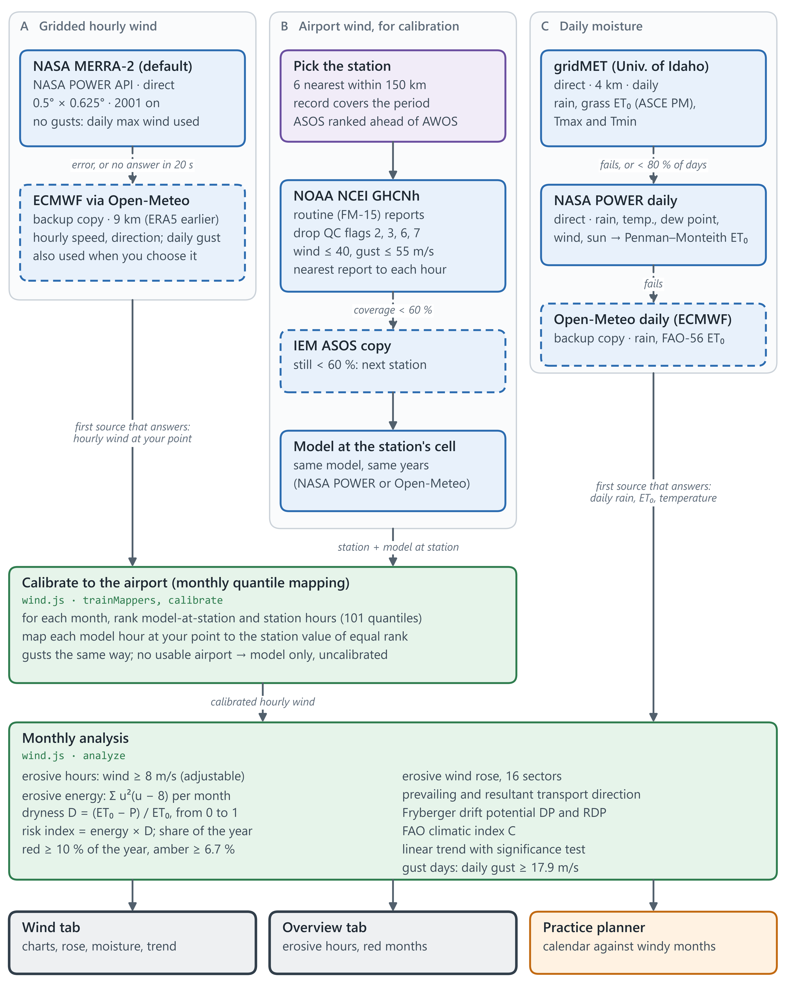
Figure 2. Wind and moisture pipeline with every fallback.

6. Soil survey to erosion risk
The main column is the path to the risk class. The right column holds the profile, your edits (sand to CaCO₃ on Wind erosion › Soil, pH on Soil maps › Soil) and the result boxes. Your edits replace the surveyed surface layer, so every value below them is recalculated.
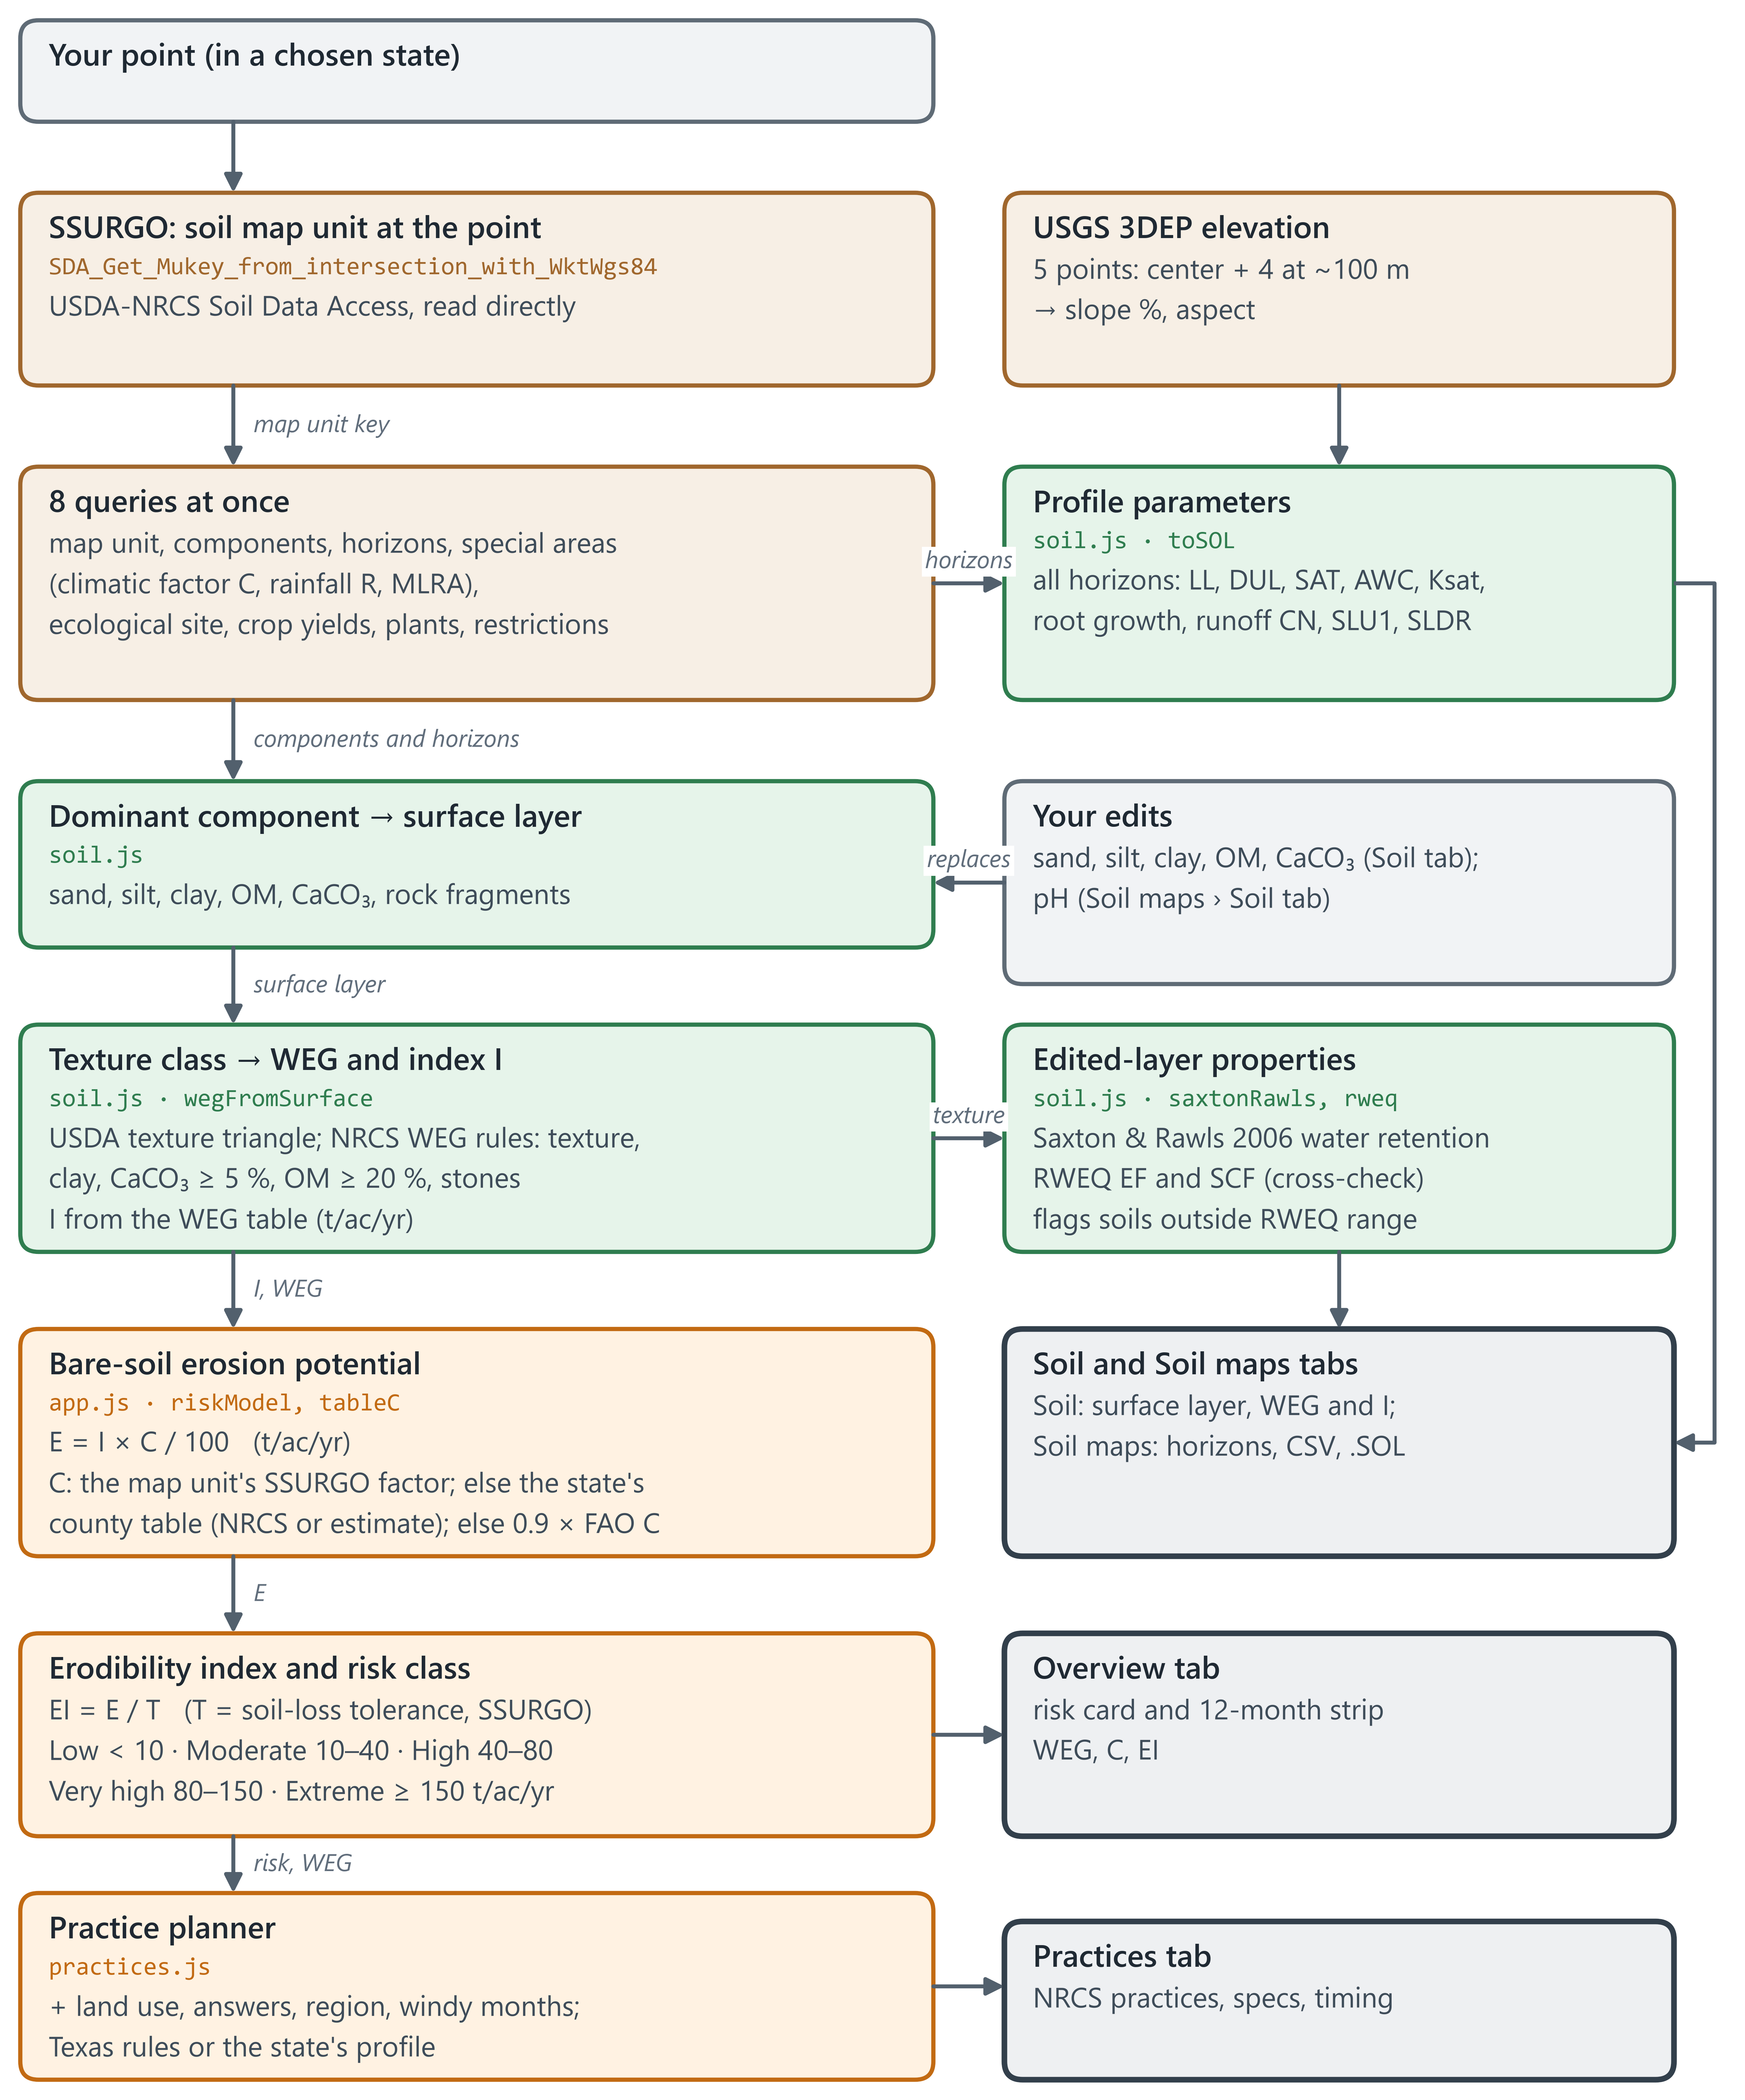
Figure 3. Soil and erosion-risk pipeline.

7. Field or area analysis
The area tool (polygon button on the map) works on a whole field or ranch instead of one point. Four sources are read at once for the boundary; sample points then give the share of the open land in each Wind Erodibility Group and risk class.
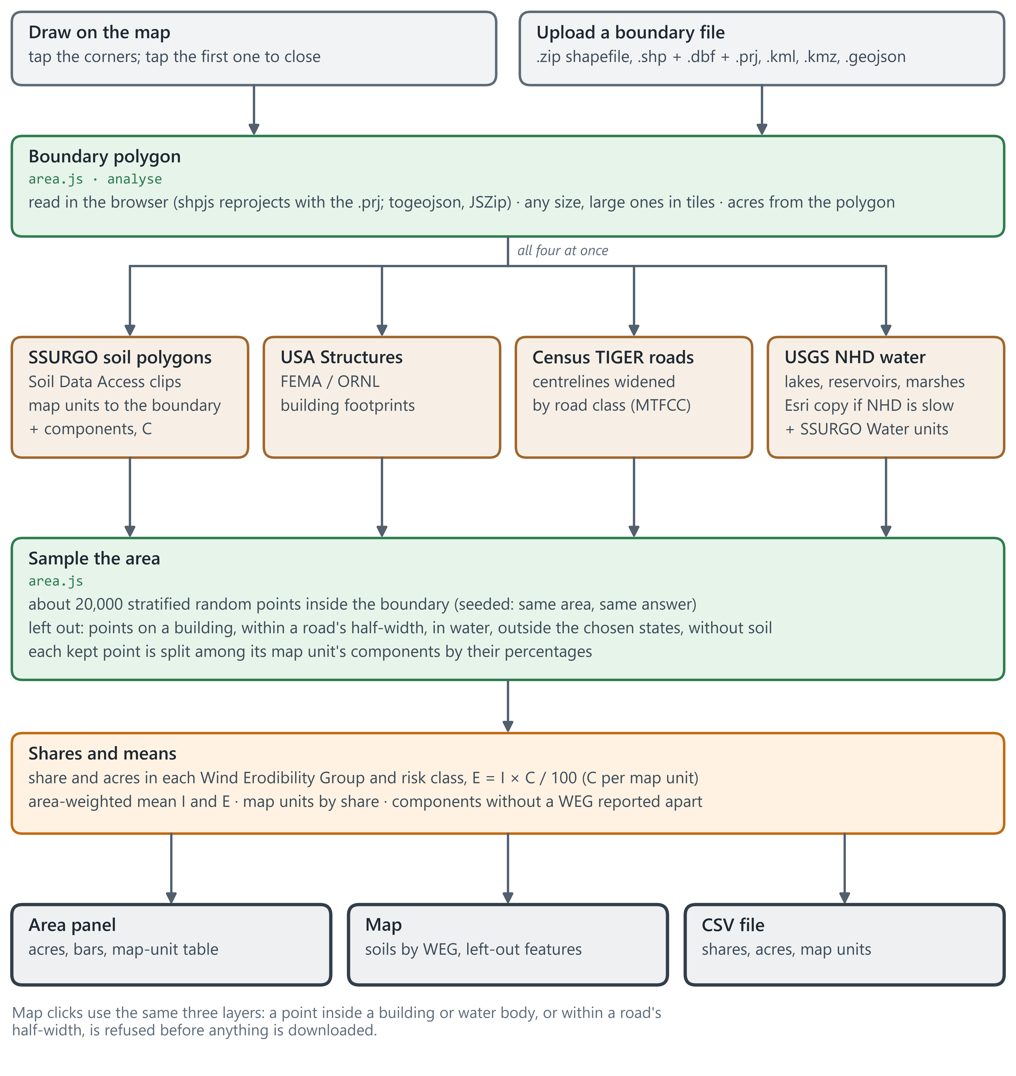
Figure 4. Field or area analysis, and the map-click check.

8. Model files, with your own weather and soil
The data sheet (DOWNLOAD tab) writes files for crop and watershed models. Its weather comes from one source you choose, or from your own daily file; its soil is the survey's profile or yours. Your files are read in the browser and never sent anywhere. The area tool's grid uses the same sources and writes the same model files once for each soil and each weather cell, with an index (models/runs.csv) that joins every cell to its files.
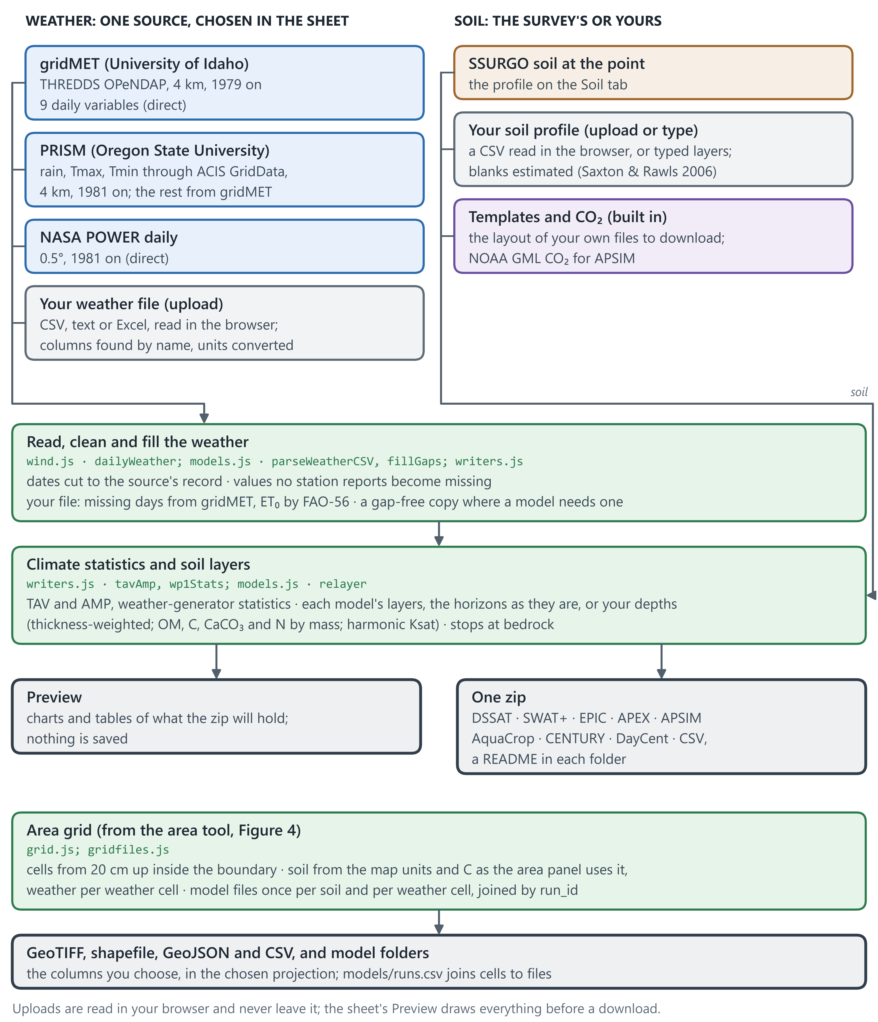
Figure 5. Model files from the data sheet, with your own files, and the area grid.

9. Drought and Soil maps themes
The Drought and Soil maps themes put an agency's layer on the map and give the panel their own tabs. The Drought Monitor's weekly classes at the point come from Esri's Living Atlas copy, with NDMC's own maps for any week it lacks; the data sheet and the area grid can add them to a download. The Soil maps read the soil survey (as USFS 30 m images and through Soil Data Access), UC Davis SoilWeb grids built per state, USGS total elements and SoilGrids total nitrogen; sections 10–12 show them in detail.
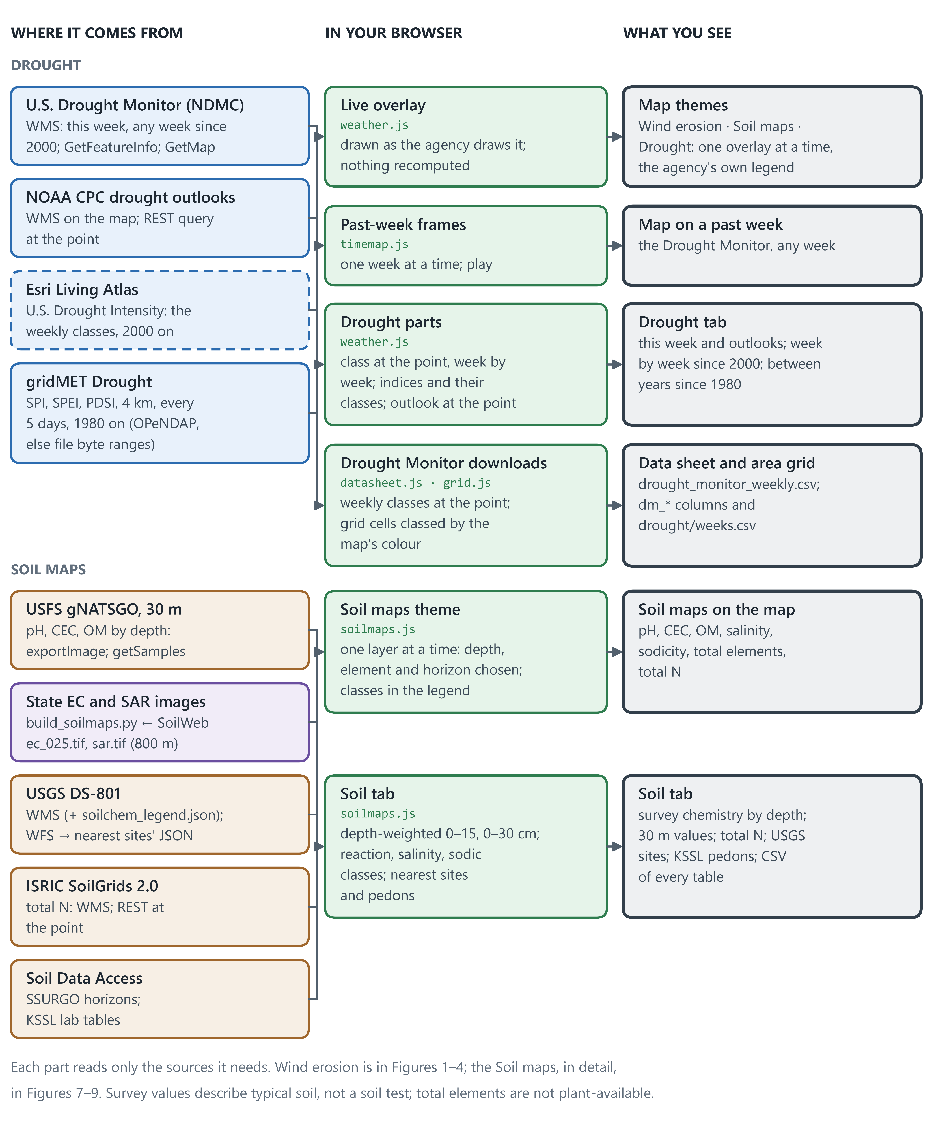
Figure 6. Drought and Soil maps: live layers, tabs and downloads.

10. Soil maps theme and its tabs
The Soil maps theme shows one soil chemistry layer at a time: pH, CEC and organic matter from the USDA Forest Service's 30 m maps of the soil survey, salinity and sodicity pre-built from UC Davis SoilWeb, total elements from the USGS, and total N from ISRIC SoilGrids; its layers are buttons in three groups (soil chemistry, basins, soil moisture). It comes right after Wind erosion and has four tabs. Overview gives a headline coloured by the survey's pH group and tiles for the soil, its watershed and its moisture; it asks for nothing itself, but draws the Soil and Basin tabs once, out of sight, and reads from them, and each tile's Details link opens its tab at its card. The Soil tab gives the dominant soil's horizons and site parameters from the survey read for the wind erosion (Figure 3), the survey's chemistry by depth with its classes, the 30 m values, SoilGrids N, and the nearest USGS sites and NRCS lab pedons, with a CSV of each table or all of them; a site or pedon shows on the map when its name is clicked. The Basin and Soil moisture tabs follow (Figures 8 and 9). USGS and SoilGrids values are total, not plant-available; no map covers the US for soil-test nutrients; boron and phosphorus survey data is limited.
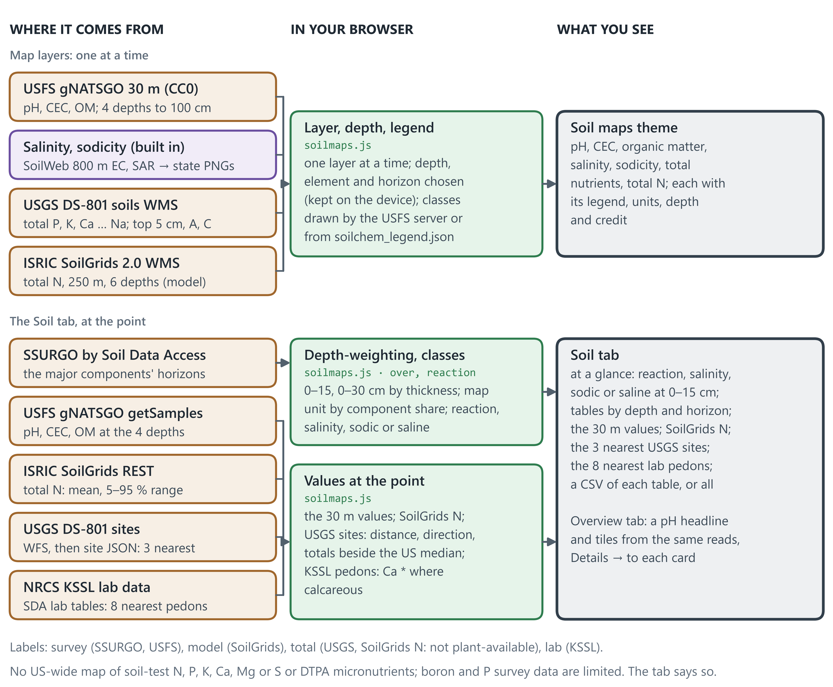
Figure 7. Soil maps: the map layers and the tab at the point.

11. Basins: runoff and soil loss
The Soil maps theme's Basin tab works on the small watershed (HU12) that holds the point. USGS map servers give its outline and its NHDPlus High Resolution catchments; their mean annual runoff comes from NHDPlus HR's EROM model. A design storm's runoff is worked out by the curve number (TR-55) from the HU12's land cover and soil groups, with NOAA Atlas 14 depths built in for every state but Oregon and Washington, and the long-term soil loss by RUSLE, with R built in from USGS RF7100 for every NHDPlus V2 catchment. The point's own land cover, soil group and curve number are shown beside the storm's runoff, and P comes from the support practice you choose. All three are models, and the tab says so.
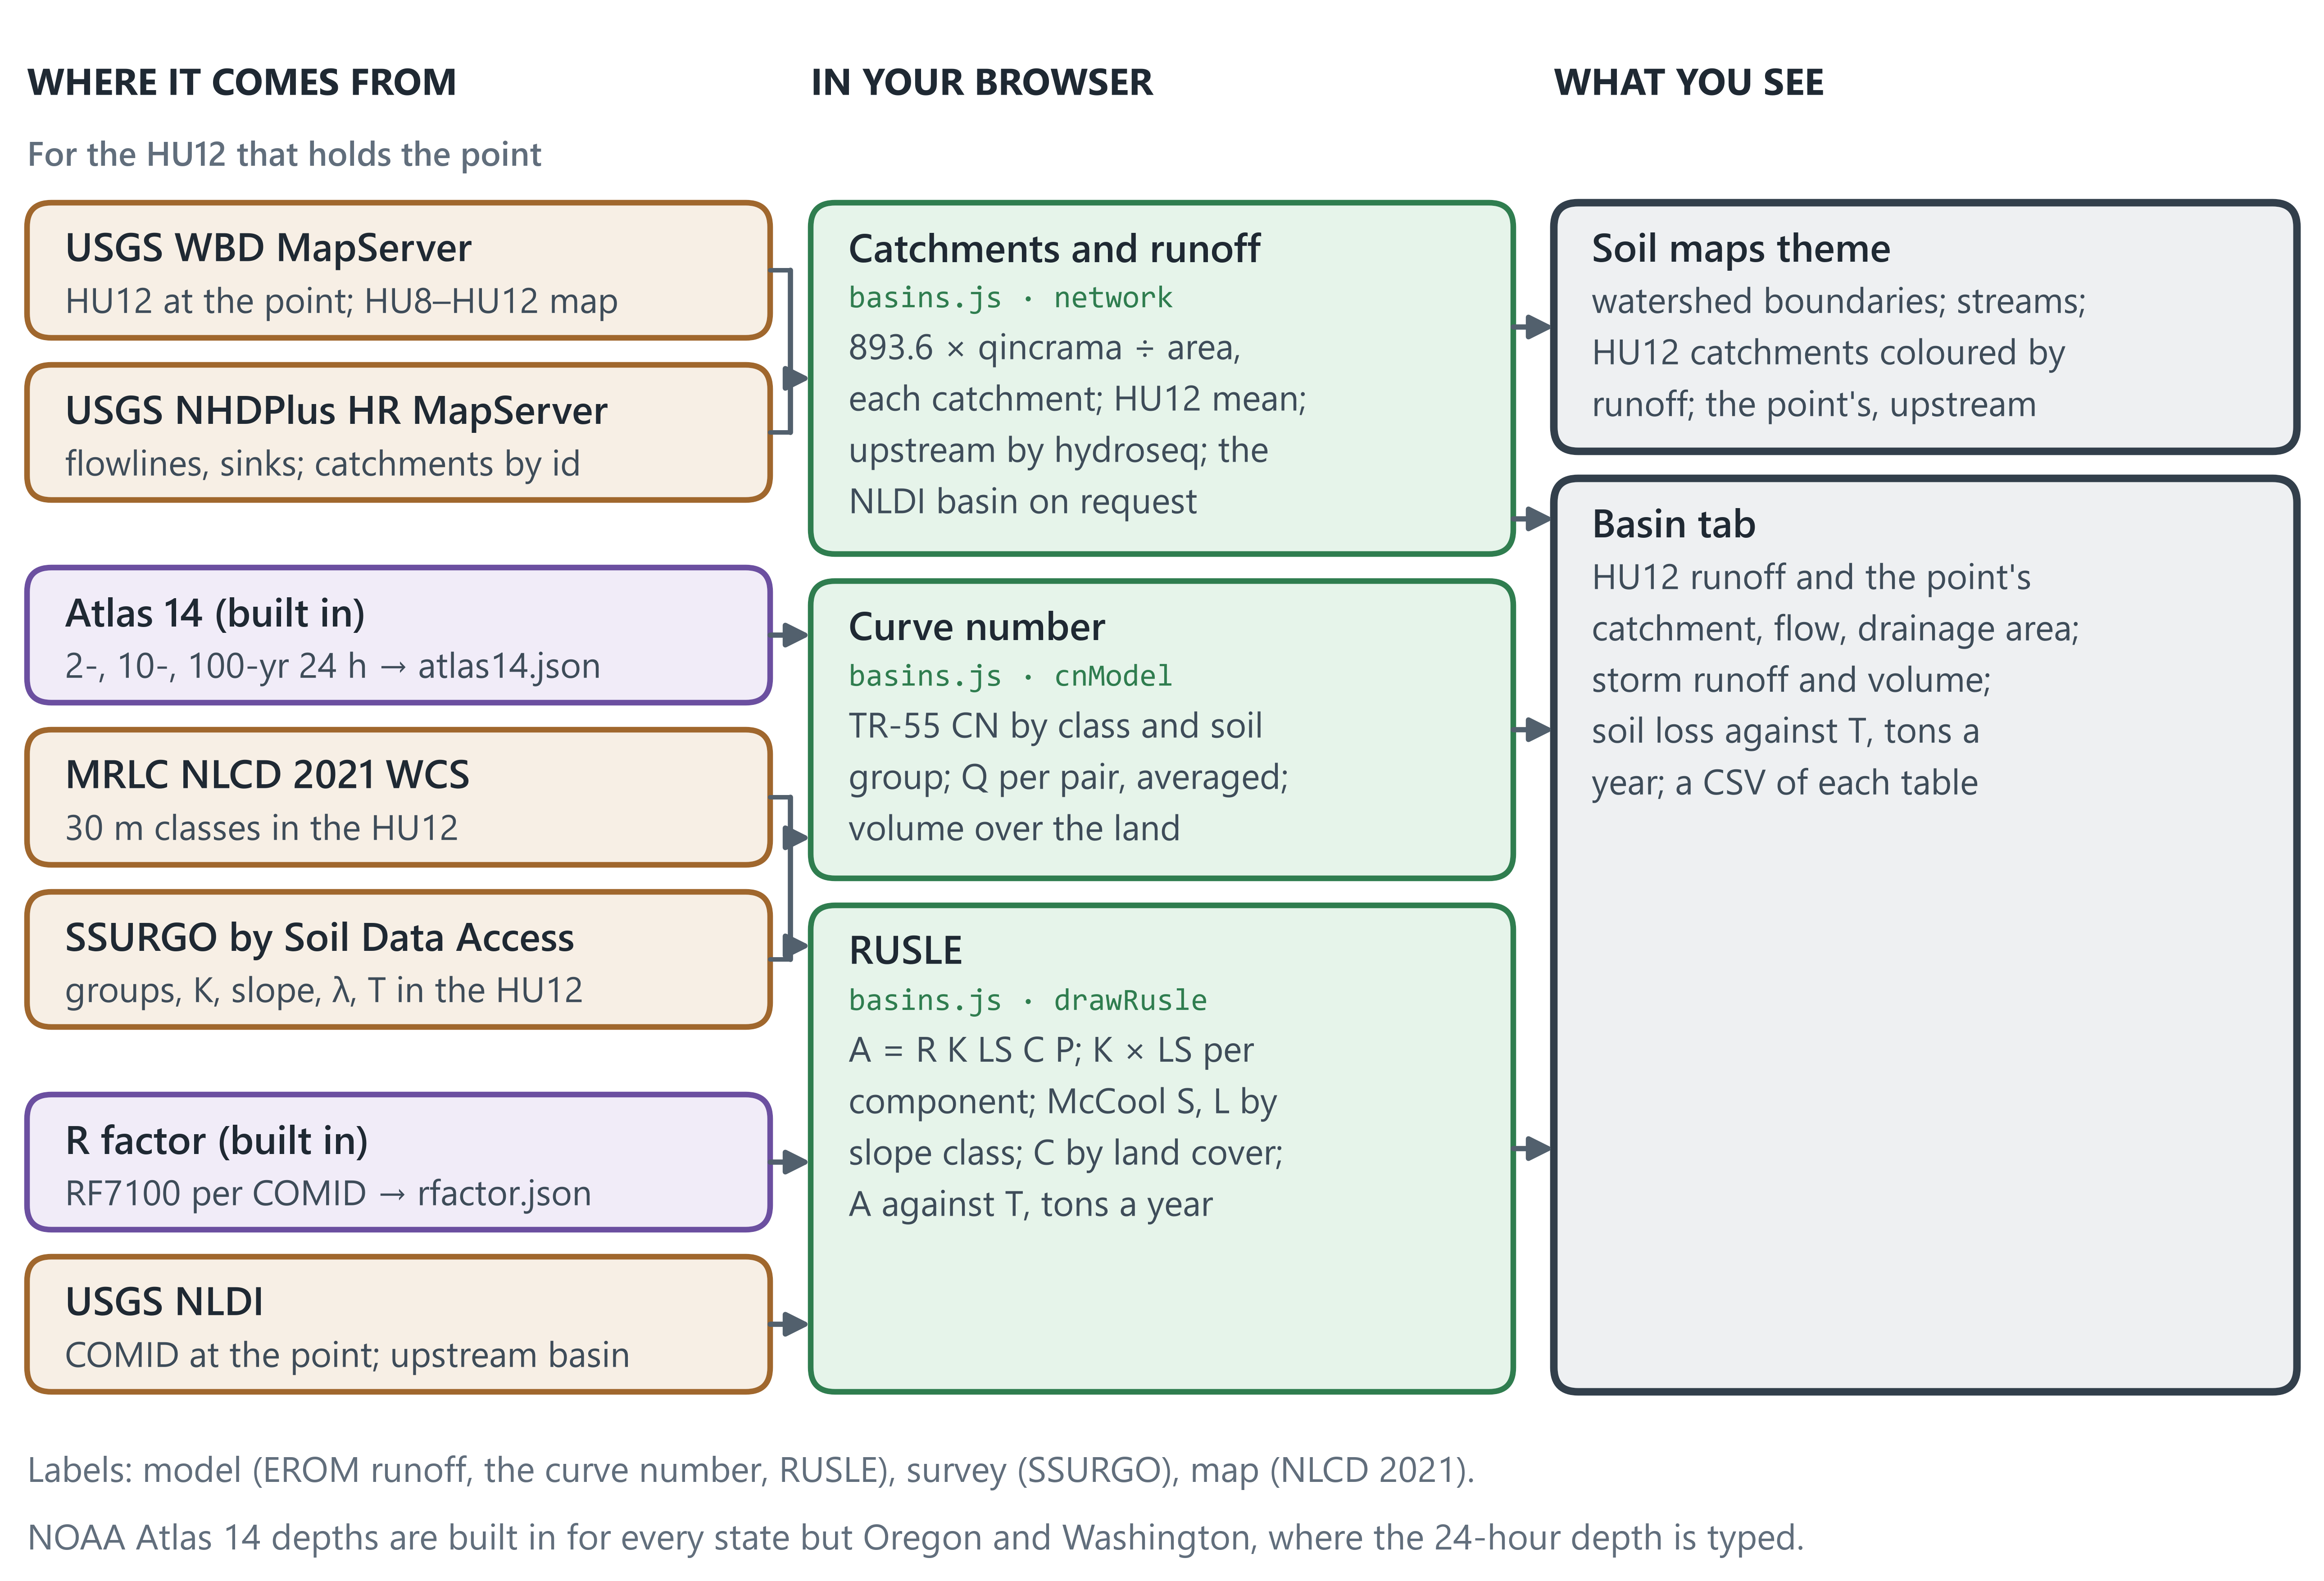
Figure 8. Basins: the HU12 and its catchments, runoff by EROM and by the curve number, and RUSLE soil loss.

12. Soil moisture by depth
Soil moisture comes from three kinds of source, each labelled: models (ERA5-Land and ECMWF IFS through Open-Meteo, the National Water Model), a satellite analysis (NASA SMAP L4, merged into a model) and stations (USDA SCAN and SNOTEL, NOAA USCRN). The map shows SMAP on any day since 2015, the National Water Model's saturation this hour, drought.gov's percentiles and the stations; the Soil moisture tab gives each source by depth at the point over a period you choose, against an average of earlier years. Values are in m³/m³; compare their changes more than their levels.
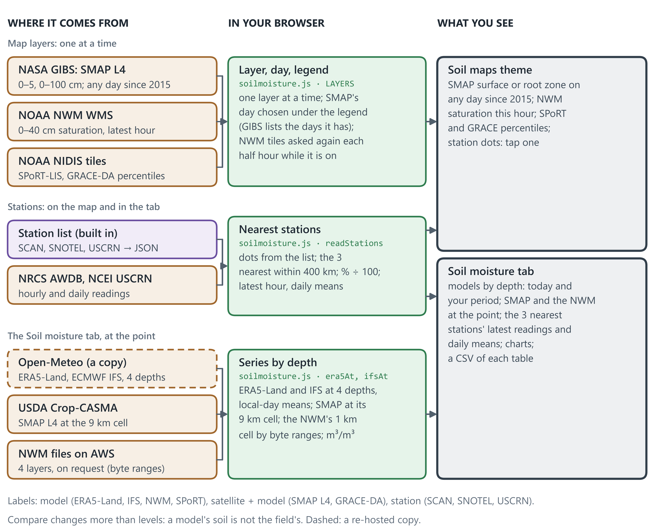
Figure 9. Soil moisture: the map layers and the tab at the point.

13. Calculations, step by step
“Where” names the file and function in the app's code, so each step can be checked against the source. The same equations, with their terms and references, are in the app's Methods sheet and in docs/METHODS.md.

Wind and climate (Figure 2)
Step | Rule or equation | Inputs → output | Where
Period | the last 5, 10 or 20 complete years, or your dates (30 days or more inside the model's record, 20 or more in one month); a month needs 480 hours; months weighted so an uneven period does not tilt the year | choice → dates, months | wind.js · resolvePeriod
Pick the station | 6 nearest within 150 km whose record covers the period; AWOS ranked as if 100 km farther | station list → candidates | wind.js · nearestStations
Clean the airport record | routine FM-15 reports only; drop quality flags 2, 3, 6, 7; wind ≤ 40 m/s, gust ≤ 55 m/s; keep the report nearest each whole hour; need ≥ 60 % of hours | NOAA reports → hourly series, coverage | wind.js · toHourly, ghcnhObs
Calibrate the model | monthly empirical quantile mapping, 101 quantiles from 0.1 to 99.9 %; beyond the ends, scale by the end ratio; gusts the same way (MERRA-2: daily max wind) | model at station + station, same years → mapping applied at your point | wind.js · trainMappers, calibrate
Erosive hours | hours with u ≥ uₜ (default 8 m/s, adjustable), scaled to a full month | hourly wind → hours/month | wind.js · analyze
Erosive energy | Σ u² (u − uₜ) over erosive hours | hourly wind → energy/month | analyze
Dryness | D = (ET₀ − P) / ET₀, limited to 0–1 | monthly rain, ET₀ → D | analyze
Monthly risk and red months | index = energy × D; share = month ÷ year; red ≥ 10 %, amber ≥ 6.7 %; ranked only when the period covers all 12 months | energy, D → 12-month strip | analyze
Wind rose and directions | 16 sectors; prevailing = sector with most erosive energy (neighbours weighted ½); resultant = vector sum of energy toward downwind | speed, direction → rose, directions | analyze
Drift potential | Fryberger: Σ V² (V − 12 kn) for V > 12 kn; RDP = vector sum; RDP/DP | hourly wind → DP, RDP | analyze
FAO climatic index | C = Σ u₂³ · D · days / 100, with u₂ = 0.748 u₁₀ (FAO-56 log law) | monthly wind, D → C | analyze
Gust days | days with daily max gust ≥ 17.9 m/s (40 mph) | daily gust → days/month | analyze
Trend | least-squares slope of yearly erosive hours and mean wind, with significance test | yearly totals → trend | util.js · linreg
Reference ET when gridMET fails | FAO-56 Penman–Monteith from NASA POWER Tmax, Tmin, dew point, 2 m wind and solar radiation (Rn = 0.77 Rs − Rnl, G = 0); Hargreaves 0.0023 Ra (T + 17.8) √(Tmax − Tmin) on days missing an input | NASA POWER daily → ET₀ | wind.js · powerDaily

Soil and erosion risk (Figure 3)
Step | Rule or equation | Inputs → output | Where
Find the map unit | SDA_Get_Mukey_from_intersection_with_WktWgs84 at the point | lat, lon → map unit key | soil.js · fetchSoil
Dominant component, surface layer | component with the largest percentage; its top horizon | components, horizons → sand, silt, clay, OM, CaCO₃ | soil.js
Texture class | USDA texture triangle, refined by sand size | sand, silt, clay → class | soil.js · textureClass, refineCode
Wind Erodibility Group and I | NRCS rules: texture family, clay ≤ 5 %, CaCO₃ ≥ 5 %, OM ≥ 20 %, stones; I from the WEG table | surface layer → WEG 1–8, I (t/ac/yr) | soil.js · wegFromSurface
Climatic factor C | the map unit's SSURGO climate-factor areas (acre-weighted); in a county with no usable C, the state's county estimate (Chepil C from NASA POWER × 1.64); else 0.9 × FAO index C (≤ 300) | SSURGO, county table or wind engine → C | app.js · tableC, cFactor
Bare-soil erosion potential | E = I × C / 100 | I, C → E (t/ac/yr) | app.js · riskModel
Erodibility index | EI = E / T | E, T → EI | riskModel
Risk class | Low < 10, Moderate 10–40, High 40–80, Very high 80–150, Extreme ≥ 150 t/ac/yr; the exact E is classed in every display unit | E → class | riskModel; units.js · cls
Water retention | Saxton & Rawls (2006) pedotransfer equations | sand, clay, OM → LL, DUL, SAT, AWC, Ksat | soil.js · saxtonRawls
RWEQ erodible fraction | EF = (29.09 + 0.31 Sa + 0.17 Si + 0.33 Sa/Cl − 2.59 OM − 0.95 CaCO₃) / 100 | surface layer → EF (cross-check) | soil.js · rweq
RWEQ crust factor | SCF = 1 / (1 + 0.0066 Cl² + 0.021 OM²) | clay, OM → SCF (cross-check) | soil.js · rweq
Slope and aspect | finite differences on the centre and four neighbours ~100 m away | 5 elevations → slope %, aspect | app.js · fetchElevation
Profile parameters | SLU1, SLDR, runoff curve number, root growth factor, albedo per crop-model .SOL format | all horizons → DSSAT .SOL file | writers.js · dssatSol

Field or area analysis (Figure 4)
Step | Rule or equation | Inputs → output | Where
Read the boundary | drawn corners, or a file: shpjs (reprojects with the .prj), togeojson (KML), JSZip (KMZ), GeoJSON; all polygons kept, no size limit (tiles over 500 km²) | file → polygons, acres | area.js · parseFiles, polysArea
Clip the soils | mupolygongeo.STIntersection(boundary) on Soil Data Access (boundary simplified to ≤ 600 vertices); over 500 km² tile by tile (about 20 km, 3 at a time, retried, then split; outlines thinned with Reduce over 1,500 km²); components with WEG, I, %; climate-factor areas and counties per map unit | boundary → soil polygons | area.js · soils
Left-out features | USA Structures footprints; TIGER roads as bands (S1100 15 m, S1200 9 m, S1400 5 m … half-widths); NHD lakes, reservoirs, marshes, estuaries; SSURGO Water units; over 500 km² per tile up to a feature budget, with any part not read named in the panel | boundary box → features | area.js · exclusions
Sample | ≈ 20,000 stratified random points (up to 70,000 on large areas; one per grid cell, seeded) inside the boundary; drop left-out, outside-the-chosen-states and no-soil points | points → kept points | area.js · samples, hitAt
Shares | share = Σ points Σ components (pct/100)·[class] ÷ Σ points Σ components (pct/100); E = I × C / 100; ± 0.7 points at 95 % | kept points → % and acres | area.js · analyse
Map-click check | same layers in a ~180 m box; inside a building or water, or within a road half-width → refused; accepted if the services take > 3.5 s | click → accept or refuse | area.js · excludedAt; app.js · pickSite

Model files (data sheet)
Step | Rule or equation | Inputs → output | Where
Read the weather | gridMET 9 variables, PRISM through ACIS with gridMET's other variables (each calendar day holds PRISM's next date), NASA POWER daily, or your file (columns found by name, units converted, wind moved to 10 and 2 m by the log law); dates cut to the source's record | dates → daily series | wind.js · dailyWeather; models.js · parseWeatherCSV
Fill your file's gaps (optional) | missing days taken from gridMET for the same days, not its ET₀; then ET₀ by FAO-56 from your columns | your series + gridMET → filled series | models.js · fillGaps; datasheet.js
Clean | values no station reports (rain or wind < 0, solar > 50 MJ/m², T outside −60…60 °C, Tmax = Tmin = 0) become missing | series → cleaned series | writers.js · clean
Gap-free copy (DSSAT, APSIM, AquaCrop) | first to last day with Tmax and Tmin; linear Tmax, Tmin, wind; Hargreaves solar; rain 0; ET₀ FAO-56 | cleaned series → complete series | writers.js · complete
Climate statistics | TAV, AMP from 12 monthly means; generator statistics per month; 10 complete years read when the dates lack a month or a variable | series → .WTH header, .met, .WP1, weather-wgn.cli | writers.js · tavAmp, wp1Stats, swatWgn
Soil layers | each model's usual layers, the horizons as they are, or your depths (thickness-weighted means, OM, OC, CaCO3 and N by mass, harmonic Ksat); stops at bedrock | profile → model layers | models.js · relayer; writers.js
Write and pack | each model's fixed-width or JSON layout, a README per folder, NOT_WRITTEN.txt where a model cannot be made; one zip | series, soil → zip | writers.js; datasheet.js · build

Soil maps (Figure 7)
Step | Rule or equation | Inputs → output | Where
Map layer | USFS exportImage for the view at the chosen depth, the classes drawn by the server; the state PNGs near the view; the USGS and SoilGrids WMS | choice → image and legend | soilmaps.js · layers, legendOf
Survey at the point | the map unit's major components and horizons from Soil Data Access | lat, lon → horizons | soilmaps.js · surveyAt
Depth-weighting | thickness-weighted mean over 0–15 and 0–30 cm of the horizons with a value; map unit by component share | horizons → pH, EC, SAR, ESP, CEC, base saturation, OM, CaCO₃, gypsum | soilmaps.js · over
Classes | reaction and salinity by the Soil Survey Manual; sodic at SAR ≥ 13 or ESP ≥ 15, saline at EC ≥ 4 (Handbook 60) | values → classes | soilmaps.js · reaction, salinity, sodicity
Nearest sites and pedons | USGS DS-801: 3 nearest by WFS, then site JSON; KSSL: 8 nearest surface layers from the lab tables; boxes widened once | lat, lon → sites, pedons with distance | soilmaps.js · usgsNearAt, ksslAt
USGS legend (offline) | the national deciles of the DS-801 site values, censored values at their detection limit | DS-801 CSV → data/soilchem_legend.json | tools/build_soilmaps.py

Basins (Figure 8)
Step | Rule or equation | Inputs → output | Where
HU12 and its network | WBD point query; NHDPlus HR flowlines and sinks by the HU12 polygon; catchments by id; inside = centroid of the largest ring | lat, lon → HU12, catchments | basins.js · hu12At, hrIn
EROM runoff, upstream | 893.6 × qincrama / area; HU12 = 893.6 Σq / ΣA; upstream by hydroseq inside the HU12 | catchments → mm/yr, upstream set | basins.js · network
Soils and land cover in the HU12 | SDA intersects the HU12 with map units on its server; NLCD 2021 counted in 30 m cells from the MRLC WCS | HU12 → components, class areas | basins.js · soilsIn; landcover.js · boundaryShares
Curve number runoff | TR-55 Table 2-2 CN per class and group; Q = (P − 0.2S)²/(P + 0.8S) per pair, averaged; P from Atlas 14 (not OR, WA) or typed | groups, classes, P → CN, Q, volume | basins.js · cnModel, a14At, scsQ
RUSLE | R from rfactor.json by NLDI COMID; K, LS (McCool S, L by slope class), T per component; C by class; A = R K LS C P | → t/ac/yr, t/ha/yr, × T, tons/yr | basins.js · rAt, ls, drawRusle
R and Atlas 14 lookups (offline) | RF7100 split by state with StreamCat COMIDs, delta and base-32 coded; Atlas 14 regional 30″ grids to 0.05° means per state | national and regional files → rfactor.json, atlas14.json | tools/build_basins.py

Soil moisture (Figure 9)
Step | Rule or equation | Inputs → output | Where
Map layers | GIBS WMTS by day (DescribeDomains lists the days); NWM WMS asked again each half hour while on; NIDIS tiles; station dots from the list | choice, day → tiles and legend | soilmoisture.js · LAYERS, drawLegend
Models by depth | ERA5-Land daily means (42 days asked); IFS hourly → local-day means; four layers to 255 cm; one retry | lat, lon → series over the period | soilmoisture.js · era5At, ifsAt
SMAP at the cell | Crop-CASMA GetProfileByDate at the EPSG:5070 cell, TOP and SUB | lat, lon → daily m³/m³ | soilmoisture.js · smapAt
NWM on request | latest analysis_assim land file on AWS; LCC cell; SOIL_M (4 layers), SOILSAT_TOP read by byte ranges | lat, lon → 4 layers + saturation | soilmoisture.js · nwmAt; h5range.js
Nearest stations | 3 nearest within 400 km; AWDB daily SMV/SMS and hourly SMS (% ÷ 100); USCRN daily file and hourly tail | lat, lon → latest and daily means per depth | soilmoisture.js · nearest, readStations
Station list (offline) | AWDB stations reporting hourly SMS with live sensor depths; USCRN stations with recent soil moisture | → data/soilmoisture_stations.json | tools/build_moisture.py

14. Data sources
Data | Producer | How the app reads it | Resolution | If it fails
Soil survey: map unit, components, horizons, WEG, I, T, climatic factor C, rainfall R, MLRA, yields, plants | USDA-NRCS SSURGO | Soil Data Access SQL web service (direct) | survey polygons, mapped at 1:12,000–1:24,000 | the Soil tabs show the error; risk cannot be computed
Elevation, slope and aspect | USGS 3DEP | Elevation Point Query Service, 5 points (direct) | best available 3DEP: 1 m lidar where flown, else ~10 m | Copernicus 90 m elevation via Open-Meteo (after 15 s)
Land cover | MRLC NLCD 2021; Esri / Impact Observatory | WMS GetFeatureInfo; ImageServer identify (direct) | 30 m; Sentinel-2 10 m | Sentinel-2 when NLCD is blocked (currently always: MRLC refuses web-page requests)
Daily rain, grass reference ET₀, Tmax, Tmin | University of Idaho gridMET | THREDDS OPeNDAP, one cell (direct) | 4 km, daily, 1979 on; last ~4 days not yet published | NASA POWER daily with Penman–Monteith ET₀ computed in the app, then Open-Meteo daily (ECMWF)
Hourly 10 m wind speed and direction (default) | NASA GMAO MERRA-2 | NASA POWER hourly API (direct) | 0.5° × 0.625° (~50 km), 2001 on; no gust variable | ECMWF via Open-Meteo if NASA POWER errors or has not answered within 20 s
Hourly 10 m wind, daily max gust (backup, or when chosen) | ECMWF: IFS analysis from 2017, ERA5 before | Open-Meteo archive (re-hosted copy) | 9 km from 2017; 0.25° (~28 km) before | NASA MERRA-2
Airport hourly wind and gusts (for calibration) | NOAA NCEI GHCNh | NCEI Access Data Service, one request per year, 6 at a time (direct) | station, hourly | Iowa Environmental Mesonet ASOS copy; then the next station
Airport station list | Iowa Environmental Mesonet networks + NOAA ISD and GHCNh lists | built into each state's file (data/states/XX.json) | 2,478 airports; a state holds those within 150 km | —
Soil polygons inside a drawn or uploaded area | USDA-NRCS SSURGO | Soil Data Access spatial query, clipped to the boundary (direct) | map units, 1:12,000–1:24,000 | —
Building footprints (area tool, map clicks) | FEMA / ORNL USA Structures | ArcGIS feature service (direct) | footprint polygons | not removed; the panel says so
Roads (area tool, map clicks) | U.S. Census Bureau TIGER/Line | TIGERweb map service (direct); widened by road class | road centrelines | not removed; the panel says so
Water bodies (area tool, map clicks) | USGS NHD (lakes, reservoirs, marshes; playas stay in) + SSURGO Water units | NHD map service (direct) | 1:24,000 polygons | Esri's copy of NHD after 5 s (3 s for a click)
Boundary files | your shapefile, KML/KMZ or GeoJSON | read in the browser with shpjs, togeojson, JSZip | as drawn | —
Place suggestions | U.S. Census Bureau 2020 Gazetteer; 2024 population estimates | pre-built list (data/places.txt), matched while typing | each place's inside point | —
Place search | OpenStreetMap Nominatim | search API on Enter, one request a second; 48 states and DC; a place in another state adds it | — | type coordinates instead
Statewide map layers | SSURGO WEG/I (UC Davis SoilWeb), NRCS county C (estimated where missing), NASA POWER wind; built offline | each state's file and PNG overlays (data/states/XX/) | 1 km statewide grid | display only
County climatic factor C | SSURGO county overlaps; Chepil C from NASA POWER × 1.64 where SSURGO gives none | each state's file (data/states/XX.json) | county or soil survey area | —
County at the point | U.S. Census TIGERweb (Census 2020 counties) | map service query (direct) | county | the map unit's county with the most acres
Practice profiles | each state's NRCS Field Office Technical Guide (+ extension pages for a few states) | data/practices/XX.json, loaded with the Practices tab | state, by region | Texas: rules built into practices.js
Base maps; county lines | Esri, USGS, OpenStreetMap; U.S. Census TIGER (county lines) | map tiles; TIGERweb map service drawn per tile | — | switch base map
Daily weather for model files (data sheet) | University of Idaho gridMET; PRISM (Oregon State University); NASA POWER; or your own daily file | THREDDS OPeNDAP, 9 variables (direct); PRISM's rain and temperature through ACIS GridData (NOAA RCC), the rest from gridMET; POWER daily API (direct); your CSV, text or Excel file read in the browser | 4 km, 1979 on; 4 km, 1981 on; 0.5°, 1981 on; your station | NASA POWER; gaps in your file can be filled from gridMET
Drought Monitor (Drought map and tab) | National Drought Mitigation Center (USDM) | NDMC MapServer WMS, this week and any week since 2000; GetFeatureInfo at the point (direct) | weekly polygons | —
Drought Monitor week by week at the point (Drought tab, data sheet) | Esri Living Atlas, U.S. Drought Intensity (a copy of the weekly maps) | FeatureServer point query, pages of 260 | weekly, 2000 on | NDMC GetFeatureInfo on each week's map (direct)
Drought Monitor in the area grid | National Drought Mitigation Center (USDM) | WMS GetMap PNGs, classed by colour (direct) | about 0.001° a pixel | a week not read is left out and named
Drought outlooks (Drought map and tab) | NOAA Climate Prediction Center | NWS map services: WMS layers 5 and 2; REST query of layers 1 and 4 at the point (direct) | monthly; seasonal | the tab says it could not be read
Drought indices (Drought tab) | University of Idaho gridMET Drought | THREDDS OPeNDAP (direct) | 4 km, every 5 days, 1980 on | the same NetCDF-4 files on its file server, read in place by byte ranges: only the chunks that hold the cell (direct)
Soil maps: pH, CEC (pH 7), organic matter | USDA Forest Service gNATSGO 2022 (CC0) | image services: exportImage, getSamples (direct) | 30 m; 0–5, 5–25, 25–50, 50–100 cm | left blank
Soil maps: salinity EC, sodicity SAR | UC Davis SoilWeb grids from SSURGO | per-state PNGs built by tools/build_soilmaps.py | 800 m | —
Soil maps: total P, K, Ca, Mg, S, Zn, Fe, Mn, Cu, Na | USGS DS-801 (Smith et al. 2013) | WMS; WFS and site JSON (direct) | about 1 site per 1,600 km² | the tab says why
Soil maps: total nitrogen | ISRIC SoilGrids 2.0 (CC BY 4.0) | WMS; REST at the point (direct) | 250 m, 6 depths | no value on built-up land and water
Soil tab: chemistry by horizon, lab pedons | USDA-NRCS SSURGO and KSSL | Soil Data Access (direct) | map units; points | the tab says why
Soil maps: watershed boundaries, streams | USGS WBD; USGS NHDPlus HR (public domain) | MapServer export tiles, the app's own symbols (direct) | HU8–HU12; flowlines from zoom 12 | —
Basin tab: basin runoff | NHDPlus HR EROM step A (a model); USGS NLDI | HU12 by point query; flowlines and sinks by its polygon; catchments by id, 500 a request (direct) | HR catchments; HU12 40–250 km² | the card says it could not be read
Basin tab: design-storm runoff | NOAA Atlas 14 Vols. 1, 2, 6, 8–12 (not OR, WA); NLCD 2021; SSURGO | pre-built atlas14.json (tools/build_basins.py); MRLC WCS; Soil Data Access | 0.05°; 30 m; map units | a typed depth (OR, WA)
Basin tab: soil loss (RUSLE) | USGS RF7100 (Wieczorek & LaMotte 2010); SSURGO; NLCD 2021 | pre-built rfactor.json per state (tools/build_basins.py); COMID from NLDI | NHDPlus V2 catchment | a typed R
Soil maps: soil moisture maps | NASA SMAP L4; NOAA NWM 3.0; NASA SPoRT-LIS, GRACE-DA | NASA GIBS WMTS; NOAA WMS; NOAA NIDIS tiles (direct) | 9 km daily since 2015; 1 km hourly; 3 km; 0.125° weekly | —
Soil moisture tab: soil moisture at the point | ERA5-Land, ECMWF IFS (Open-Meteo, CC BY 4.0); SMAP L4 (Crop-CASMA); NWM (AWS) | Open-Meteo APIs (re-hosted copy), one retry; Crop-CASMA WPS GET and NWM NetCDF by byte ranges, on request (direct) | 0.1°; 9 km; 1 km | the card names a source that did not answer
Soil moisture tab: soil moisture stations | USDA NRCS SCAN, SNOTEL; NOAA USCRN | list pre-built (tools/build_moisture.py); AWDB REST, NCEI USCRN files (direct) | the 3 nearest within 400 km, hourly | the station's block says why
Atmospheric CO₂ (APSIM files) | NOAA GML Mauna Loa annual means | built into the app | 1959–2025, +2.5 ppm a year after, the 1959 value before | —
Your soil profile (data sheet) | your lab results or edits | typed into the sheet or read from a CSV in the browser | your layers | blanks estimated with Saxton & Rawls (2006)

15. Where each number on screen comes from
Result on screen | Calculation | Data behind it
Risk class and E (Overview) | E = I × C / 100 | SSURGO: WEG → I; climatic factor C (SSURGO or the state's county table)
Erodibility index EI | E / T | SSURGO soil-loss tolerance T
Erosive hours, mean wind | count of hours ≥ threshold; mean | NASA MERRA-2 (ECMWF via Open-Meteo as backup), calibrated to the NOAA airport
Red and amber months | energy × dryness, share of the year | calibrated wind + gridMET rain and ET₀
Prevailing erosive direction | sector with most erosive energy | calibrated wind direction
Wind Erodibility Group, C, land cover | read as published (WEG recomputed if you edit) | SSURGO; NLCD or Sentinel-2
Soil profile, water properties | Saxton & Rawls for edited layers | SSURGO horizons
Slope | finite differences | USGS 3DEP
Moisture chart | monthly sums | gridMET (or its fallbacks)
Airport vs model card | same-hour comparison | NOAA GHCNh and the model at the station's cell
Practice plan | Texas rules in practices.js; every other state's profile (data/practices/XX.json) | land use and answers, MLRA region, WEG, risk, windy months
Area panel: WEG and risk-class shares, mean I and E | sampled shares, components weighted by % | SSURGO polygons and components; USA Structures, TIGER and NHD left out
Statewide map colours | pre-computed offline | SSURGO WEG/I (UC Davis SoilWeb rasters), NRCS C, NASA POWER monthly wind
Model files (data sheet zip) | each model's layout, gaps filled where the model needs it | gridMET, PRISM, NASA POWER or your file; the survey soil or yours
Soil maps layers | drawn by the source; classes from the survey manual or the USGS deciles | USFS gNATSGO, SoilWeb, USGS DS-801, SoilGrids
Soil tab | depth-weighted means and classes; nearest sites and pedons | SSURGO, USFS getSamples, SoilGrids, USGS DS-801, NRCS KSSL
Basin: HU12 and catchment runoff | 893.6 × qincrama ÷ area (EROM step A, a model); upstream by hydroseq | NHDPlus HR, WBD, USGS NLDI
Design-storm runoff, soil loss | TR-55 curve number; RUSLE A = R K LS C P | NOAA Atlas 14 (not OR, WA) or your depth; NLCD 2021; SSURGO; USGS RF7100
Soil moisture by depth | daily means in m³/m³; the 3 nearest stations | ERA5-Land, ECMWF IFS (Open-Meteo); SMAP L4 (Crop-CASMA); National Water Model; SCAN, SNOTEL, USCRN
Figure and table downloads | charts redrawn at the chosen size and DPI; CSV with units | the results above, in the units chosen

16. Fallbacks, limits and checks
- Texas now. Visitors can choose Texas only for now; the code and data hold the 48 contiguous states and DC, opened by js/config.js. Alaska, Hawaii and Puerto Rico come later (several sources cover the 48 contiguous states only). The outline is the Census 1:5,000,000 boundary, kept within about 0.2 km of that source; a point a few hundred metres from a state line can land on the wrong side. The statewide C is an estimate where SSURGO gives a county none, and the practice profiles outside Texas and Kansas are lighter than Texas's.
- Open-Meteo is a backup. Every default source is direct, except the soil moisture models by depth (ERA5-Land, ECMWF IFS), which only Open-Meteo's copy serves without a personal key. Otherwise Open-Meteo steps in for wind when NASA POWER errors or has not answered within 20 s, for daily weather when gridMET and NASA POWER both fail, for elevation when USGS fails, and when you choose ECMWF (Copernicus's own store needs each user's key and a queued job). After calibration both models give 1,291–1,295 erosive h/yr at Lubbock.
- NLCD is blocked. MRLC's server refuses requests from web pages, so land cover currently always comes from the Sentinel-2 10 m map.
- MERRA-2 has no gusts. Its daily maximum hourly wind stands in for gusts during calibration; without an airport, gust days show n/a.
- gridMET lags a few days. The newest ~4 days are not yet published; a point with less than 80 % of days falls back to NASA POWER and then Open-Meteo.
- Station rules. A station needs at least 60 % of hours in the period (20 % if you pick it yourself). AWOS sites are ranked as if 100 km farther, because several West Texas AWOS anemometers read 40–60 % fewer erosive hours than nearby ASOS sites.
- RWEQ values are cross-checks. EF and SCF are not used in the risk; they get an asterisk when the soil is outside the range the equations were fitted on.
- Area results are estimates. Shares come from about 20,000 sample points (± 0.7 percentage points at 95 %) and from SSURGO components, which are not mapped separately inside a map unit. Buildings, roads and water are only as complete as USA Structures, TIGER and NHD; if one of them does not answer, the panel says it was not removed.
- Statewide layers are fixed. The map colours are pre-computed and do not change with the point you pick.
- Soil maps are not a soil test. Survey values describe the mapped soil; USGS and SoilGrids values are total, not plant-available; KSSL pedons are sparse and often decades old. No map covers the US for soil-test (plant-available) N, P, K, Ca, Mg or S, or DTPA micronutrients; boron and phosphorus survey data is also limited for the US.
- Basins are models. Mean annual runoff is NHDPlus HR's EROM model (1971–2000 climate), not a gauge; other models can differ by a factor of two. The curve number is an event method on average wetness. RUSLE gives gross sheet-and-rill erosion, with LS from survey slopes and C from land-cover classes, not gullies or the sediment that leaves the HU12. NOAA Atlas 14 depths are built for every state but Oregon and Washington, which no volume covers yet; there the depth is typed.
- Soil moisture sources differ. Models, SMAP L4 and stations often differ by 0.1 m³/m³ or more, as a model's soil is not the field's; compare changes more than levels. A station reads its own soil, often tens of km away.
- No SoilGuard server. GitHub Pages only delivers the files. Your browser sends the point's coordinates (and any place name you search for) straight to each service listed above; nothing is stored.

17. Code map
File | What it does
index.html, css/app.css | page layout, tabs, sheets and the phone layout
js/util.js | downloads with time limits (fetchJSON, fetchText), concurrency pool, statistics helpers
js/units.js | the units table: quantities, conversions, metric and US presets, risk classes in every unit
js/export.js | PNG, JPEG and TIFF files with their DPI, CSV, saving files
js/soil.js | SSURGO queries, texture, WEG and I, Saxton & Rawls, RWEQ, CSV export
js/wind.js | wind and moisture downloads with fallbacks, periods, station choice and QC, calibration, monthly analysis, daily weather for model files
js/app.js | map, state picker and per-state files, location check, loading sequence, risk model, elevation and land cover, rendering of every tab
js/charts.js | Chart.js charts, drawn on screen or off screen for downloads
js/downloads.js | the units sheet, figure sheet (size, DPI, format) and CSV tables
js/models.js | weather and soil structures for model files, your weather and soil files, soil re-layering, zip
js/writers.js | DSSAT, SWAT+, EPIC, APEX, APSIM, AquaCrop and plain CSV writers
js/century.js | CENTURY 4.0 and 4.5: monthly weather and the site file for each version
js/datasheet.js | the data sheet: weather source, dates, soil, layers, models; builds the zip
js/preview.js | the data sheet's preview: charts and tables of what a download will hold, before it is saved
js/templates.js | the layout of your own weather and soil files: tick the columns, choose units, download a template
js/grid.js, js/gridfiles.js | the area grid: cells from 20 cm up with soil and weather in each; projections, GeoTIFF and shapefile writers
js/weather.js | the map themes and the Drought theme: live layers, the Drought tab, the Drought Monitor at a point and by week
js/timemap.js | the Drought Monitor on a past week: the week bar on the map, play
js/soilmaps.js | the Soil maps theme, its Overview and Soil tabs: layers, legends, SSURGO chemistry by depth, nearby sites and pedons
js/basins.js | basins in the Soil maps theme, Basin tab: WBD and NHDPlus HR layers, the HU12 and its catchments, EROM runoff, curve-number storm runoff, RUSLE soil loss, CSV
js/soilmoisture.js | soil moisture in the Soil maps theme, Soil moisture tab: SMAP, NWM, SPoRT and GRACE layers, stations, models by depth, SMAP at the cell, NWM on request, nearest stations, charts, CSV
js/config.js | the app's name and the states a visitor can choose (Texas for now)
js/daycent.js | DayCent weather and site files
js/stats.js | visitor counting (Umami Cloud), off until a website ID is added
js/practices.js | practice planner: Texas rules, the engine for other states' profiles, questions, specifications, species tables
js/area.js | field or area analysis: drawing, boundary files, clipped soils, left-out features, sampling, panel, CSV; map-click check
js/methods.js | Methods sheet: sources used at the point, source catalog, equations
data/states.js, data/states/XX.json, data/states/XX/*.png | the state list; each state's outline, airports, statewide layers and county C (made by tools/build_states.py and tools/build_layers.py)
data/practices/XX.json | each state's practice profile (made by tools/fetch_efotg.py and tools/build_practices.py)
data/states/XX/rfactor.json, data/states/XX/atlas14.json | the R factor per NHDPlus V2 catchment and the Atlas 14 depths of 46 states and DC (made by tools/build_basins.py)
data/soilmoisture_stations.json | the soil moisture stations and their sensor depths (made by tools/build_moisture.py)
tools/*.py | offline builders, run by hand, never by the app; tools/build_flow_doc.py makes this document

