WindGuard TX: data flow
Where each dataset comes from, where it is calculated, and how the results reach the screen
App: barsa1ly.github.io/windguard-tx · Code: github.com/barsa1ly/windguard-tx (commit 03671cf) · October 30, 2026

1. In one paragraph
WindGuard TX is a static web page. When you pick a point inside Texas, your browser asks each agency's web service for the data at that point, all at the same time. Every calculation then runs in your browser, in the JavaScript files under js/. There is no WindGuard server: GitHub Pages only delivers the files. The soil survey gives the erodibility (I) and the climatic factor (C), which combine into the bare-soil erosion potential E = I × C / 100. Hourly wind, calibrated to the nearest airport and weighted by how dry each month is, decides which months are risky. The practice planner turns both into a plan.

2. How to read the diagrams
- Columns, left to right: where the data comes from, what the browser calculates, what is combined, and what you see.
- Colours: brown = soil and land data, blue = weather and wind data, purple = built into the app, green = calculated in your browser, orange = combined, dark grey = results on screen, red = refused.
- Borders: a solid border means the app reads the data directly from the agency that produces it; a dashed border means a re-hosted copy (Open-Meteo, Iowa Environmental Mesonet).
- Arrows: solid arrows carry data; dashed arrows are fallbacks, taken only when the source above fails, with the condition written beside them.

3. What happens when you pick a point
- Location check. The map shows only the state chosen in the picker (Texas for now; other states are listed for later), with everything outside it covered. The point is tested against the Texas outline (U.S. Census 1:5,000,000 state boundary). A map click or pin drag is also checked against building footprints (USA Structures), roads (Census TIGER) and water bodies (USGS NHD). If it fails, the app says why and downloads nothing. Place search lists only places inside Texas.
- Soil. Soil Data Access finds the SSURGO map unit under the point, then runs 8 queries at once. The soil engine derives texture, WEG, I and water properties, and the risk card can show E as soon as the soil arrives.
- Elevation and land cover, at the same time. Five USGS 3DEP elevations give slope and aspect (15 s limit, then Copernicus via Open-Meteo). Land cover comes from NLCD (8 s limit) or the Sentinel-2 10 m map.
- Gridded wind and moisture, at the same time. Hourly wind for the chosen period comes straight from NASA (MERRA-2 through NASA POWER, usually 1–3 s). If NASA errors or has not answered within 20 s, the app switches to ECMWF through Open-Meteo. Daily rain and ET₀ come from gridMET, else NASA POWER, else Open-Meteo. The Wind tab first shows the model, uncalibrated.
- Airport calibration, in the background. The app takes up to 6 nearby airports from its built-in list, downloads hourly records from NOAA one year per request, keeps the first station with at least 60 % of hours, downloads the same model at that station's cell, trains the monthly quantile mapping and redraws every result as calibrated.
- Practices. When you choose a land use (the default comes from land cover) and answer 2–5 questions, the planner builds the plan from the risk, soil group, region and windy months.
- Changes. Editing the soil layer, the threshold or the units recalculates in the browser with no new downloads. Changing the period, the model or the calibration station downloads again.
- Downloads. Every chart can be saved as PNG, TIFF or JPEG at a chosen size and DPI, or as CSV. The data sheet reads daily weather for the chosen dates (gridMET, NASA POWER or your file), takes the survey soil or yours, and writes files for DSSAT, SWAT+, EPIC, APEX, APSIM and AquaCrop into one zip (section 8). Its Preview button draws all of that as charts and tables first, with nothing saved.

4. The whole picture
Figure 1. Data sources (left), calculations in the browser (middle) and results on screen (right) for one point.

5. Wind and climate: three sources to monthly risk
Three lanes run at the same time. Each lane is a priority list: the app uses the first source that answers. Lane B only exists to calibrate lane A; if no airport qualifies, the model is used uncalibrated.
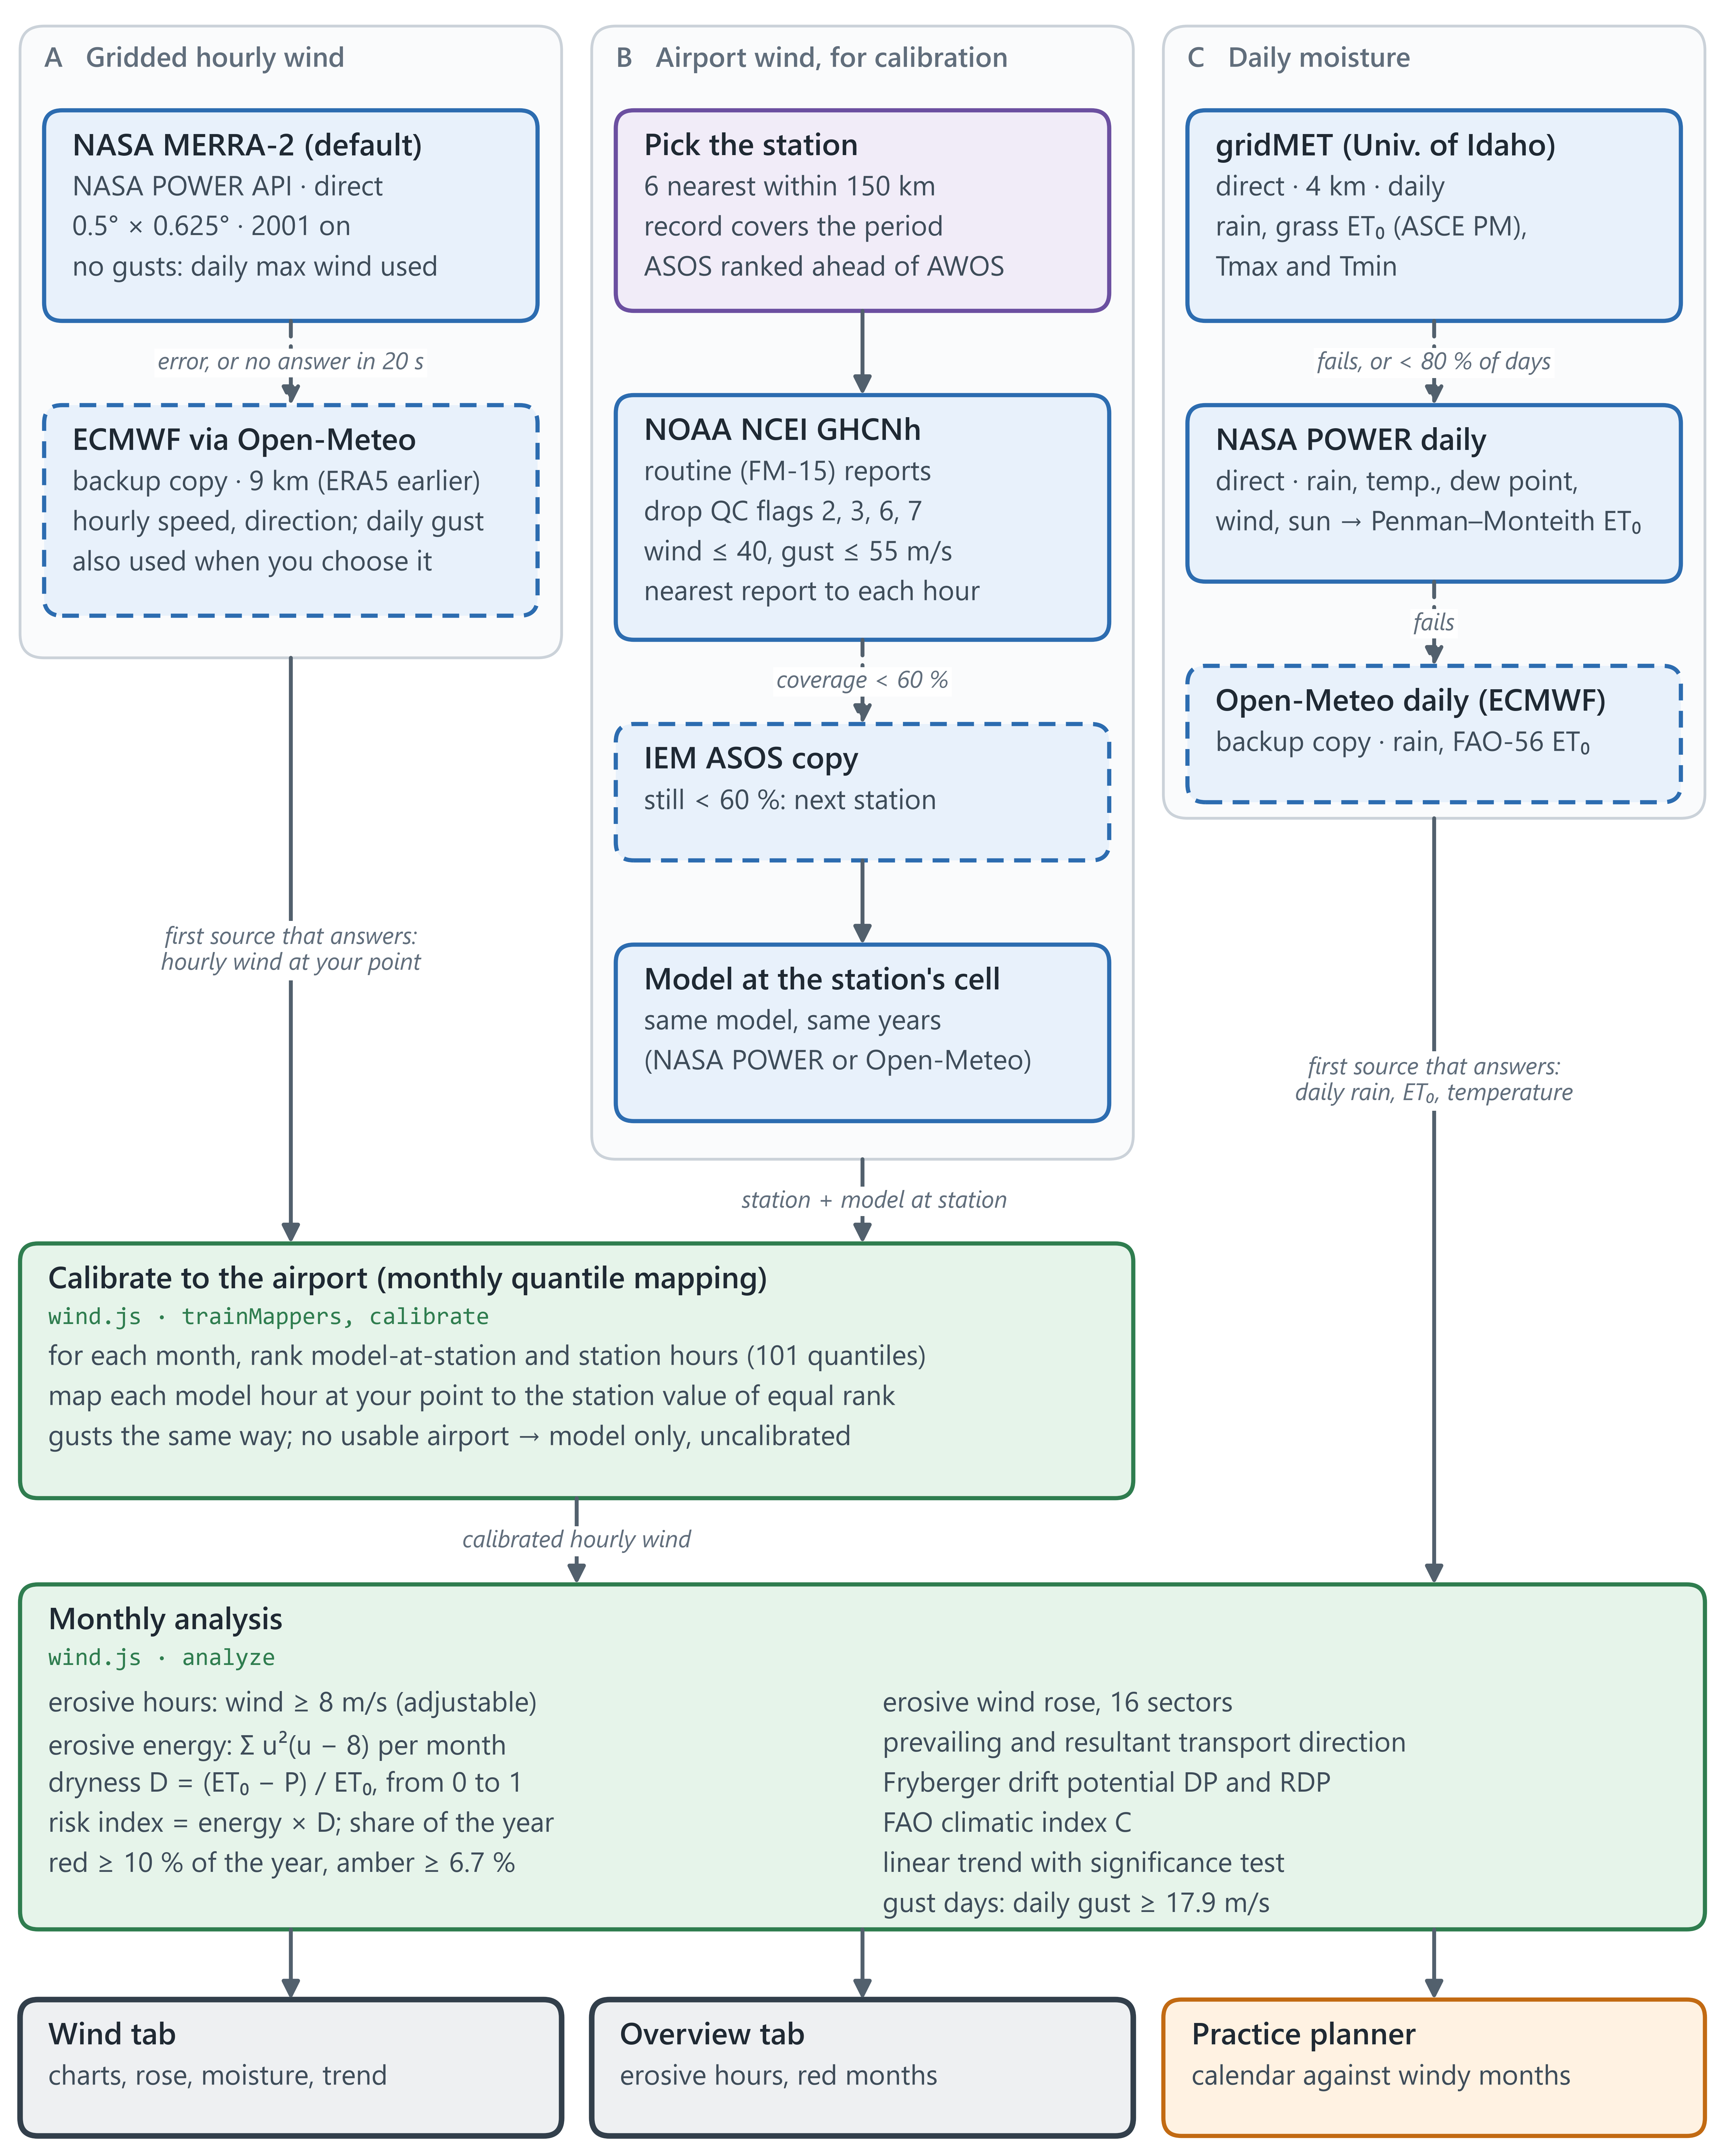
Figure 2. Wind and moisture pipeline with every fallback.

6. Soil survey to erosion risk
The main column is the path to the risk class. The right column holds what the Soil tab adds and the result boxes. Your edits replace the surveyed surface layer, so every value below them is recalculated.
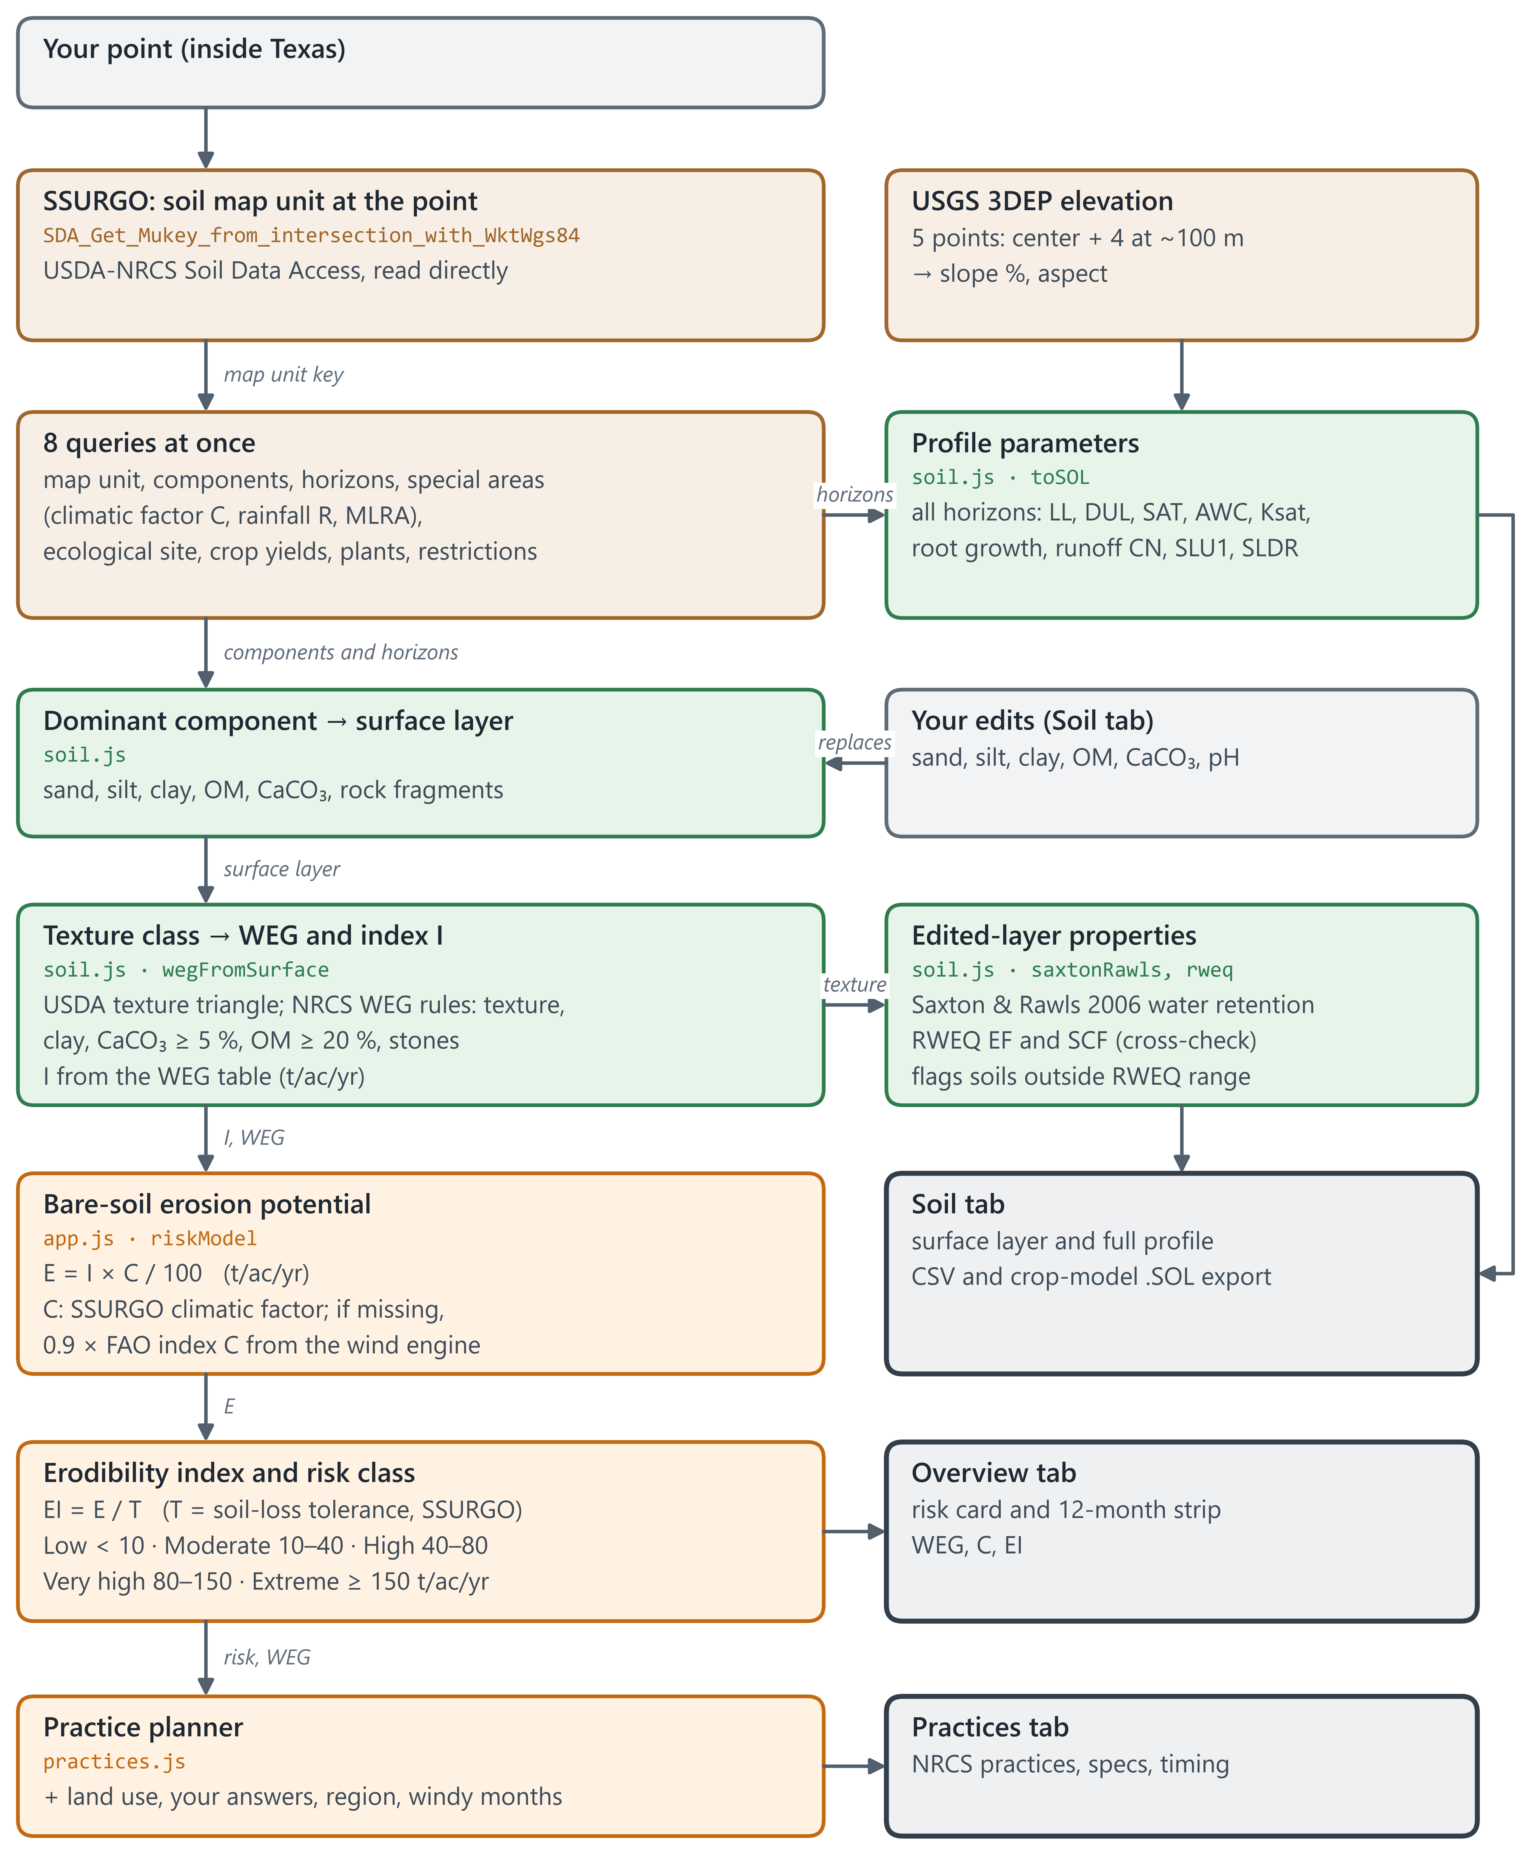
Figure 3. Soil and erosion-risk pipeline.

7. Field or area analysis
The area tool (polygon button on the map) works on a whole field or ranch instead of one point. Four sources are read at once for the boundary; sample points then give the share of the open land in each Wind Erodibility Group and risk class.
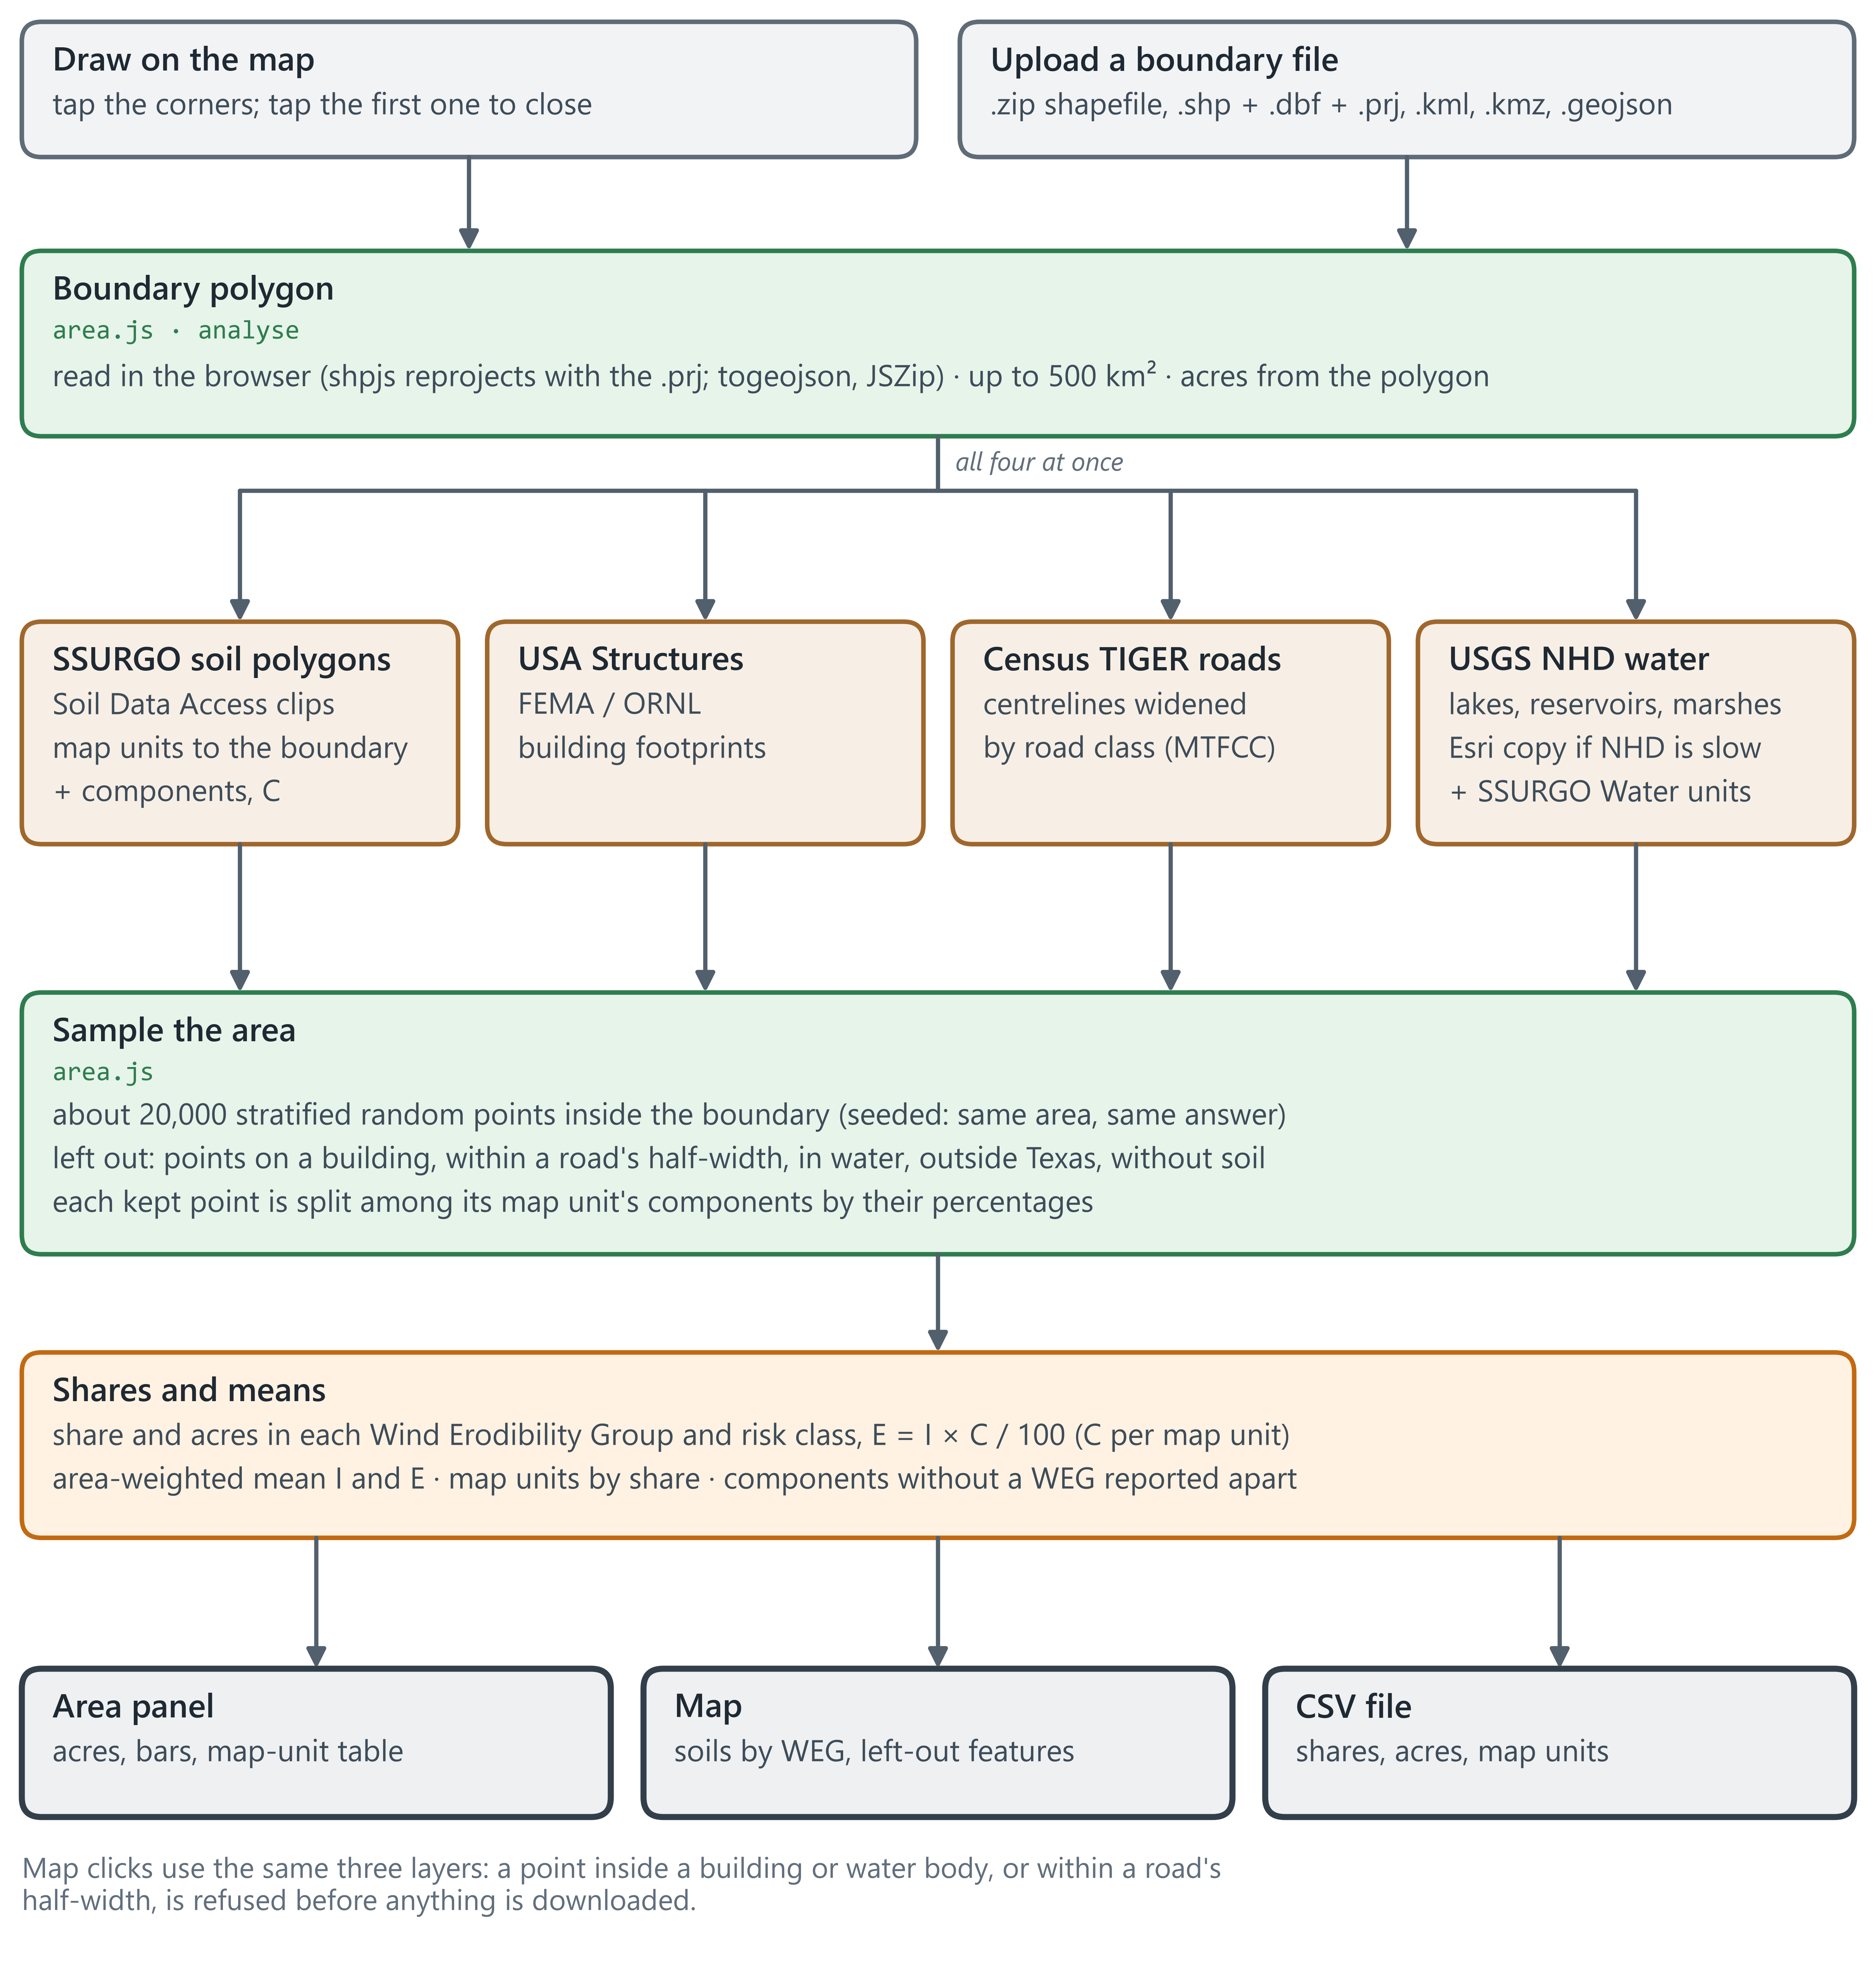
Figure 4. Field or area analysis, and the map-click check.

8. Calculations, step by step
“Where” names the file and function in the app's code, so each step can be checked against the source. The same equations, with their terms and references, are in the app's Methods sheet and in docs/METHODS.md.

Wind and climate (Figure 2)
Step | Rule or equation | Inputs → output | Where
Period | the last 5, 10 or 20 complete years, or your dates (30 days or more inside the model's record, 20 or more in one month); a month needs 480 hours; months weighted so an uneven period does not tilt the year | choice → dates, months | wind.js · resolvePeriod
Pick the station | 6 nearest within 150 km whose record covers the period; AWOS ranked as if 100 km farther | station list → candidates | wind.js · nearestStations
Clean the airport record | routine FM-15 reports only; drop quality flags 2, 3, 6, 7; wind ≤ 40 m/s, gust ≤ 55 m/s; keep the report nearest each whole hour; need ≥ 60 % of hours | NOAA reports → hourly series, coverage | wind.js · toHourly, ghcnhObs
Calibrate the model | monthly empirical quantile mapping, 101 quantiles from 0.1 to 99.9 %; beyond the ends, scale by the end ratio; gusts the same way (MERRA-2: daily max wind) | model at station + station, same years → mapping applied at your point | wind.js · trainMappers, calibrate
Erosive hours | hours with u ≥ uₜ (default 8 m/s, adjustable), scaled to a full month | hourly wind → hours/month | wind.js · analyze
Erosive energy | Σ u² (u − uₜ) over erosive hours | hourly wind → energy/month | analyze
Dryness | D = (ET₀ − P) / ET₀, limited to 0–1 | monthly rain, ET₀ → D | analyze
Monthly risk and red months | index = energy × D; share = month ÷ year; red ≥ 10 %, amber ≥ 6.7 %; ranked only when the period covers all 12 months | energy, D → 12-month strip | analyze
Wind rose and directions | 16 sectors; prevailing = sector with most erosive energy (neighbours weighted ½); resultant = vector sum of energy toward downwind | speed, direction → rose, directions | analyze
Drift potential | Fryberger: Σ V² (V − 12 kn) for V > 12 kn; RDP = vector sum; RDP/DP | hourly wind → DP, RDP | analyze
FAO climatic index | C = Σ u₂³ · D · days / 100, with u₂ = 0.748 u₁₀ (FAO-56 log law) | monthly wind, D → C | analyze
Gust days | days with daily max gust ≥ 17.9 m/s (40 mph) | daily gust → days/month | analyze
Trend | least-squares slope of yearly erosive hours and mean wind, with significance test | yearly totals → trend | util.js · linreg
Reference ET when gridMET fails | FAO-56 Penman–Monteith from NASA POWER Tmax, Tmin, dew point, 2 m wind and solar radiation (Rn = 0.77 Rs − Rnl, G = 0); Hargreaves 0.0023 Ra (T + 17.8) √(Tmax − Tmin) on days missing an input | NASA POWER daily → ET₀ | wind.js · powerDaily

Soil and erosion risk (Figure 3)
Step | Rule or equation | Inputs → output | Where
Find the map unit | SDA_Get_Mukey_from_intersection_with_WktWgs84 at the point | lat, lon → map unit key | soil.js · fetchSoil
Dominant component, surface layer | component with the largest percentage; its top horizon | components, horizons → sand, silt, clay, OM, CaCO₃ | soil.js
Texture class | USDA texture triangle, refined by sand size | sand, silt, clay → class | soil.js · textureClass, refineCode
Wind Erodibility Group and I | NRCS rules: texture family, clay ≤ 5 %, CaCO₃ ≥ 5 %, OM ≥ 20 %, stones; I from the WEG table | surface layer → WEG 1–8, I (t/ac/yr) | soil.js · wegFromSurface
Climatic factor C | SSURGO special-area overlap “climatic factor”; if missing, 0.9 × FAO index C (≤ 200) | SSURGO or wind engine → C | app.js · cFactor
Bare-soil erosion potential | E = I × C / 100 | I, C → E (t/ac/yr) | app.js · riskModel
Erodibility index | EI = E / T | E, T → EI | riskModel
Risk class | Low < 10, Moderate 10–40, High 40–80, Very high 80–150, Extreme ≥ 150 t/ac/yr; the exact E is classed in every display unit | E → class | riskModel; units.js · cls
Water retention | Saxton & Rawls (2006) pedotransfer equations | sand, clay, OM → LL, DUL, SAT, AWC, Ksat | soil.js · saxtonRawls
RWEQ erodible fraction | EF = (29.09 + 0.31 Sa + 0.17 Si + 0.33 Sa/Cl − 2.59 OM − 0.95 CaCO₃) / 100 | surface layer → EF (cross-check) | soil.js · rweq
RWEQ crust factor | SCF = 1 / (1 + 0.0066 Cl² + 0.021 OM²) | clay, OM → SCF (cross-check) | soil.js · rweq
Slope and aspect | finite differences on the centre and four neighbours ~100 m away | 5 elevations → slope %, aspect | app.js · fetchElevation
Profile parameters | SLU1, SLDR, runoff curve number, root growth factor, albedo per crop-model .SOL format | all horizons → DSSAT .SOL file | writers.js · dssatSol

Field or area analysis (Figure 4)
Step | Rule or equation | Inputs → output | Where
Read the boundary | drawn corners, or a file: shpjs (reprojects with the .prj), togeojson (KML), JSZip (KMZ), GeoJSON; all polygons kept, limit 500 km² | file → polygons, acres | area.js · parseFiles, polysArea
Clip the soils | mupolygongeo.STIntersection(boundary) on Soil Data Access (boundary simplified to ≤ 600 vertices); components with WEG, I, %; climatic factor C per map unit | boundary → soil polygons | area.js · soils
Left-out features | USA Structures footprints; TIGER roads as bands (S1100 15 m, S1200 9 m, S1400 5 m … half-widths); NHD lakes, reservoirs, marshes, estuaries; SSURGO Water units | boundary box → features | area.js · exclusions
Sample | ≈ 20,000 stratified random points (one per grid cell, seeded) inside the boundary; drop left-out, outside-Texas and no-soil points | points → kept points | area.js · samples, hitAt
Shares | share = Σ points Σ components (pct/100)·[class] ÷ Σ points Σ components (pct/100); E = I × C / 100; ± 0.7 points at 95 % | kept points → % and acres | area.js · analyse
Map-click check | same layers in a ~180 m box; inside a building or water, or within a road half-width → refused; accepted if the services take > 3.5 s | click → accept or refuse | area.js · excludedAt; app.js · pickSite

Model files (data sheet)
Step | Rule or equation | Inputs → output | Where
Read the weather | gridMET 9 variables, NASA POWER daily, or your file (columns found by name, units converted, wind moved to 10 and 2 m by the log law); dates cut to the source's record | dates → daily series | wind.js · dailyWeather; models.js · parseWeatherCSV
Fill your file's gaps (optional) | missing days taken from gridMET for the same days, not its ET₀; then ET₀ by FAO-56 from your columns | your series + gridMET → filled series | models.js · fillGaps; datasheet.js
Clean | values no station reports (rain or wind < 0, solar > 50 MJ/m², T outside −60…60 °C, Tmax = Tmin = 0) become missing | series → cleaned series | writers.js · clean
Gap-free copy (DSSAT, APSIM, AquaCrop) | first to last day with Tmax and Tmin; linear Tmax, Tmin, wind; Hargreaves solar; rain 0; ET₀ FAO-56 | cleaned series → complete series | writers.js · complete
Climate statistics | TAV, AMP from 12 monthly means; generator statistics per month; 10 complete years read when the dates lack a month or a variable | series → .WTH header, .met, .WP1, weather-wgn.cli | writers.js · tavAmp, wp1Stats, swatWgn
Soil layers | each model's usual layers, the horizons as they are, or your depths (thickness-weighted means, harmonic Ksat); stops at bedrock | profile → model layers | models.js · relayer; writers.js
Write and pack | each model's fixed-width or JSON layout, a README per folder, NOT_WRITTEN.txt where a model cannot be made; one zip | series, soil → zip | writers.js; datasheet.js · build

9. Data sources
Data | Producer | How the app reads it | Resolution | If it fails
Soil survey: map unit, components, horizons, WEG, I, T, climatic factor C, rainfall R, MLRA, yields, plants | USDA-NRCS SSURGO | Soil Data Access SQL web service (direct) | survey polygons, mapped at 1:12,000–1:24,000 | Soil tab shows the error; risk cannot be computed
Elevation, slope and aspect | USGS 3DEP | Elevation Point Query Service, 5 points (direct) | best available 3DEP: 1 m lidar where flown, else ~10 m | Copernicus 90 m elevation via Open-Meteo (after 15 s)
Land cover | MRLC NLCD 2021; Esri / Impact Observatory | WMS GetFeatureInfo; ImageServer identify (direct) | 30 m; Sentinel-2 10 m | Sentinel-2 when NLCD is blocked (currently always: MRLC refuses web-page requests)
Daily rain, grass reference ET₀, Tmax, Tmin | University of Idaho gridMET | THREDDS OPeNDAP, one cell (direct) | 4 km, daily, 1979 on; last ~4 days not yet published | NASA POWER daily with Penman–Monteith ET₀ computed in the app, then Open-Meteo daily (ECMWF)
Hourly 10 m wind speed and direction (default) | NASA GMAO MERRA-2 | NASA POWER hourly API (direct) | 0.5° × 0.625° (~50 km), 2001 on; no gust variable | ECMWF via Open-Meteo if NASA POWER errors or has not answered within 20 s
Hourly 10 m wind, daily max gust (backup, or when chosen) | ECMWF: IFS analysis from 2017, ERA5 before | Open-Meteo archive (re-hosted copy) | 9 km from 2017; 0.25° (~28 km) before | NASA MERRA-2
Airport hourly wind and gusts (for calibration) | NOAA NCEI GHCNh | NCEI Access Data Service, one request per year, 6 at a time (direct) | station, hourly | Iowa Environmental Mesonet ASOS copy; then the next station
Airport station list | NOAA ISD history + GHCNh station list | built into the app (data/stations.js) | 417 Texas-area stations | —
Soil polygons inside a drawn or uploaded area | USDA-NRCS SSURGO | Soil Data Access spatial query, clipped to the boundary (direct) | map units, 1:12,000–1:24,000 | —
Building footprints (area tool, map clicks) | FEMA / ORNL USA Structures | ArcGIS feature service (direct) | footprint polygons | not removed; the panel says so
Roads (area tool, map clicks) | U.S. Census Bureau TIGER/Line | TIGERweb map service (direct); widened by road class | road centrelines | not removed; the panel says so
Water bodies (area tool, map clicks) | USGS NHD (lakes, reservoirs, marshes; playas stay in) + SSURGO Water units | NHD map service (direct) | 1:24,000 polygons | Esri's copy of NHD after 5 s (3 s for a click)
Boundary files | your shapefile, KML/KMZ or GeoJSON | read in the browser with shpjs, togeojson, JSZip | as drawn | —
Place search | OpenStreetMap Nominatim | search API; results outside Texas are dropped | — | type coordinates instead
Statewide map layers | SSURGO WEG/I (UC Davis SoilWeb), NRCS C, NASA POWER wind; built offline | built into the app (data/layers.js and PNG overlays) | statewide grid | display only
Base maps; county lines | Esri, USGS, OpenStreetMap; U.S. Census TIGER (county lines) | map tiles; TIGERweb map service drawn per tile | — | switch base map
Daily weather for model files (data sheet) | University of Idaho gridMET; NASA POWER; or your own daily file | THREDDS OPeNDAP, 9 variables (direct); POWER daily API (direct); your CSV, text or Excel file read in the browser | 4 km, 1979 on; 0.5°, 1981 on; your station | NASA POWER; gaps in your file can be filled from gridMET
Atmospheric CO₂ (APSIM files) | NOAA GML Mauna Loa annual means | built into the app | 1979–2025, +2.5 ppm a year after | —
Your soil profile (data sheet) | your lab results or edits | typed into the sheet or read from a CSV in the browser | your layers | blanks estimated with Saxton & Rawls (2006)

10. Where each number on screen comes from
Result on screen | Calculation | Data behind it
Risk class and E (Overview) | E = I × C / 100 | SSURGO: WEG → I, climatic factor C
Erodibility index EI | E / T | SSURGO soil-loss tolerance T
Erosive hours, mean wind | count of hours ≥ threshold; mean | NASA MERRA-2 (ECMWF via Open-Meteo as backup), calibrated to the NOAA airport
Red and amber months | energy × dryness, share of the year | calibrated wind + gridMET rain and ET₀
Prevailing erosive direction | sector with most erosive energy | calibrated wind direction
Wind Erodibility Group, C, land cover | read as published (WEG recomputed if you edit) | SSURGO; NLCD or Sentinel-2
Soil profile, water properties | Saxton & Rawls for edited layers | SSURGO horizons
Slope | finite differences | USGS 3DEP
Moisture chart | monthly sums | gridMET (or its fallbacks)
Airport vs model card | same-hour comparison | NOAA GHCNh and the model at the station's cell
Practice plan | rule tables in practices.js | land use and answers, MLRA region, WEG, risk, windy months
Area panel: WEG and risk-class shares, mean I and E | sampled shares, components weighted by % | SSURGO polygons and components; USA Structures, TIGER and NHD left out
Statewide map colours | pre-computed offline | SSURGO WEG/I (UC Davis SoilWeb rasters), NRCS C, NASA POWER monthly wind
Model files (data sheet zip) | each model's layout, gaps filled where the model needs it | gridMET, NASA POWER or your file; the survey soil or yours
Figure and table downloads | charts redrawn at the chosen size and DPI; CSV with units | the results above, in the units chosen

11. Fallbacks, limits and checks
- Texas only. The outline is the Census 1:5,000,000 boundary, kept within about 0.2 km of that source; a point a few hundred metres from the state line can land on the wrong side.
- Open-Meteo is only a backup. Every default source is direct. Open-Meteo steps in for wind when NASA POWER errors or has not answered within 20 s, for daily weather when gridMET and NASA POWER both fail, for elevation when USGS fails, and when you choose ECMWF (Copernicus's own store needs each user's key and a queued job). After calibration both models give 1,291–1,295 erosive h/yr at Lubbock.
- NLCD is blocked. MRLC's server refuses requests from web pages, so land cover currently always comes from the Sentinel-2 10 m map.
- MERRA-2 has no gusts. Its daily maximum hourly wind stands in for gusts during calibration; without an airport, gust days show n/a.
- gridMET lags a few days. The newest ~4 days are not yet published; a point with less than 80 % of days falls back to NASA POWER and then Open-Meteo.
- Station rules. A station needs at least 60 % of hours in the period (20 % if you pick it yourself). AWOS sites are ranked as if 100 km farther, because several West Texas AWOS anemometers read 40–60 % fewer erosive hours than nearby ASOS sites.
- RWEQ values are cross-checks. EF and SCF are not used in the risk; they get an asterisk when the soil is outside the range the equations were fitted on.
- Area results are estimates. Shares come from about 20,000 sample points (± 0.7 percentage points at 95 %) and from SSURGO components, which are not mapped separately inside a map unit. Buildings, roads and water are only as complete as USA Structures, TIGER and NHD; if one of them does not answer, the panel says it was not removed.
- Statewide layers are fixed. The map colours are pre-computed and do not change with the point you pick.
- No WindGuard server. GitHub Pages only delivers the files. Your browser sends the point's coordinates (and any place name you search for) straight to each service listed above; nothing is stored.

12. Code map
File | What it does
index.html, css/app.css | page layout, tabs, sheets and the phone layout
js/util.js | downloads with time limits (fetchJSON, fetchText), concurrency pool, statistics helpers
js/units.js | the units table: quantities, conversions, metric and US presets, risk classes in every unit
js/export.js | PNG, JPEG and TIFF files with their DPI, CSV, saving files
js/soil.js | SSURGO queries, texture, WEG and I, Saxton & Rawls, RWEQ, CSV export
js/wind.js | wind and moisture downloads with fallbacks, periods, station choice and QC, calibration, monthly analysis, daily weather for model files
js/app.js | map, Texas check, loading sequence, risk model, elevation and land cover, rendering of every tab
js/charts.js | Chart.js charts, drawn on screen or off screen for downloads
js/downloads.js | the units sheet, figure sheet (size, DPI, format) and CSV tables
js/models.js | weather and soil structures for model files, your weather and soil files, soil re-layering, zip
js/writers.js | DSSAT, SWAT+, EPIC, APEX, APSIM, AquaCrop and plain CSV writers
js/datasheet.js | the data sheet: weather source, dates, soil, layers, models; builds the zip
js/preview.js | the data sheet's preview: charts and tables of what a download will hold, before it is saved
js/templates.js | the layout of your own weather and soil files: tick the columns, choose units, download a template
js/practices.js | practice planner: questions, rules, specifications, species tables
js/area.js | field or area analysis: drawing, boundary files, clipped soils, left-out features, sampling, panel, CSV; map-click check
js/methods.js | Methods sheet: sources used at the point, source catalog, equations
data/stations.js | built-in airport list (made by tools/fetch_stations.py)
data/layers.js, data/*.png | statewide layers and the Texas outline (made by tools/build_layers.py)
tools/*.py | offline builders, run by hand, never by the app; tools/build_flow_doc.py makes this document

