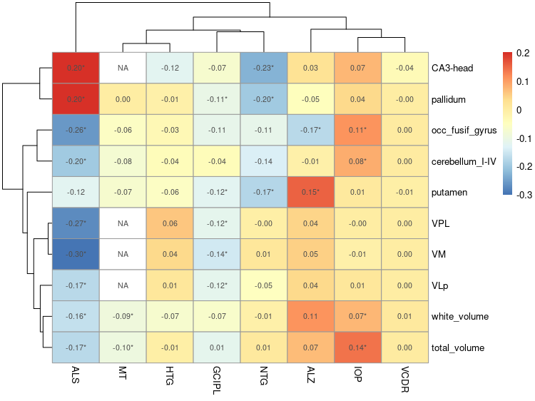

**Supplementary Figure 1.** Genetic correlation between general brain volumes and Amyotrophic lateral sclerosis (ALS), Alzheimer’s disease (ALZ), glaucoma tension subtypes ( high tension glaucoma (HTG) and normal-tension glaucoma (NTG)) and glaucoma endophenotypes; ganglion cell-inner plexiform layer (GCIPL), intraocular pressure (IOP), macular thickness (MT) and vertical cup-disk ratio (VCDR). Nominal significant results are marked with an asterisk ( 0.05 < p > 2.631579e-05). We were unable to assess the genetic correlation between some brain volumes and MT, shown in the graph as NA. Color codes show the magnitude and direction of correlations. CA3-head hippocampal region (CA3-head), occipital fusiform gyrus (occ_fusif_gyrus), VPL thalamic nuclei region (VPL),VM thalamic nuclei region (VM), VLp thalamic nuclei region (VLp).

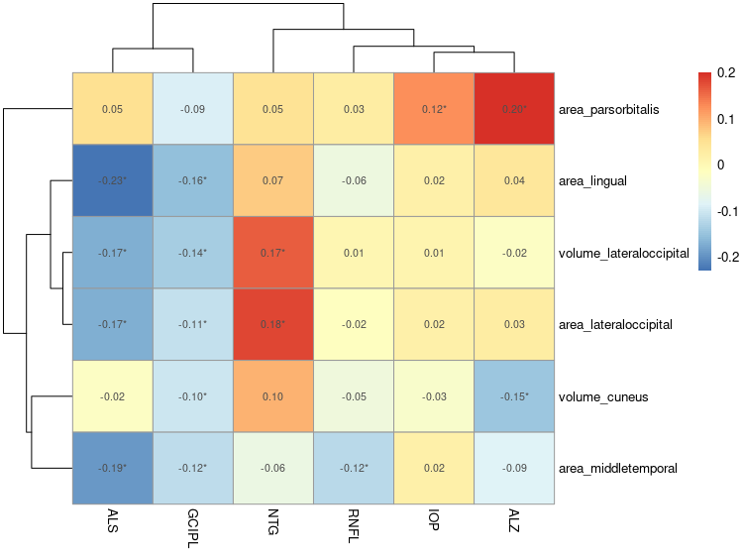

**Supplementary Figure 2**. Genetic correlation between brain structures based on Desikan-Killiany parcellation MRI and Amyotrophic lateral sclerosis (ALS), Alzheimer’s disease (ALZ), normal-tension glaucoma and glaucoma endophenotypes; ganglion cell-inner plexiform layer (GCIPL), intraocular pressure (IOP) and retinal nerve fibre layer (RNFL). Nominal significant results are marked with an asterisk ( 0.05 < p > 2.631579e-05). Color codes show the magnitude and direction of correlations.

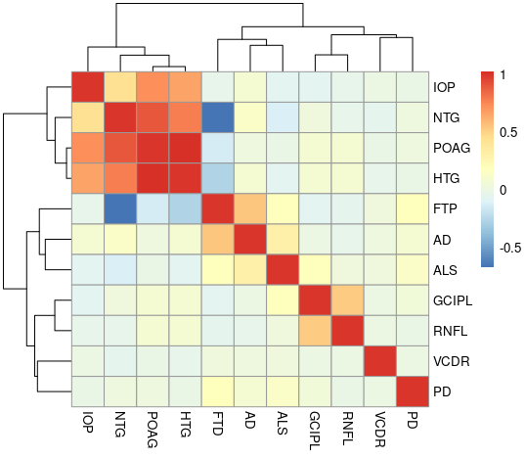

**Supplementary Figure 3.** Genetic correlation between four major neurodegenerative conditions, amyotrophic lateral sclerosis (ALS), Alzheimer’s disease (AD), Parkinson’s disease (PD ) and frontotemporal dementia (FTD) and open-angle glaucoma (POAG), glaucoma tension subtypes ( high tension glaucoma (HTG) and normal-tension glaucoma (NTG)) and glaucoma endophenotypes; ganglion cell-inner plexiform layer (GCIPL), retinal nerve fiber layer (RNFL), intraocular pressure (IOP), macular thickness (MT) and vertical cup-disk ratio (VCDR). Color codes show the magnitude and direction of correlations.