We collaborators used a multimodal image dataset for our project. We fused MRI and CT scan images of Alzheimer to form our dataset.

The first dataset [1] comprises MRI images of four labels: mild demented, moderate demented, not demented, and very mild demented. Each containing images 896, 64, 3200, and 2400, respectively. The other dataset [2] contains CT scan images of labels: AD, CN, EMCI, LMCI, and MCI. Each containing images 171, 580, 240, 72, and 233, respectively.

By carefully understanding the labels of both datasets, we combined the MRI and CT scan images. We joined Non-Demented with CN, Moderate-Demented with AD, Very Mild-Demented with EMCI, and Mild-Demented with MCI and LMCI. This resulted in a dataset containing labels, namely mild demented, moderate demented, non-demented, and very mild demented, with each label having images 1201, 235, 3780, and 2640, respectively.

The labels mild demented and moderate demented had very little data (images); hence, we applied image augmentation to increase the proportion for the mentioned labels.

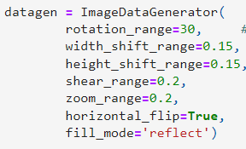

Finally, the multimodal image dataset of MRI and CT scan images comprises four diagnosable labels, namely: Mild Demented, Moderate Demented, Not Demented, and Very Mild Demented, with each having 3342, 2128, 3780, and 2480 images, respectively.

Total images accounted for 11730 images.

Link to the datasets:

[1]

<https://www.kaggle.com/datasets/sachinkumar413/alzheimer-mri-dataset?fbclid=IwAR31q5qysfiCnLt1sqDIE1AsDKi0_ezA2GE3jO3Nec-CMxW6i7BOFn_rSSM>

[2]

<https://github.com/srajan-kiyotaka/Alzheimer-Disease-Prediction/tree/master>