**PKS project 1**

**Packet analyzer**

Márk Bartalos

Seminars with**: Ing. Lukáš Mastiľak**Seminars on**: Thu 14:00-15:50**

# Introduction

As task we got building a packet analyzer which has similar functionality as the popular Wireshark program.

# Programming environment

As programming environment, I chose Python 3.10.8 and Visual Studio Code. I choose Python because it will be a great fit for this task with its versatility ease of use and many libraries.

Application can be started using the command: ***python main.py***

It can be also supplied extra parameters such as: ***python main.py -p PROTOCOL FILE_NAME***(Note that file name can only be supplied if protocol filter is used)

# Used libraries

* scapy.all - for reading the packet capture files
* scapy.compat – for getting the raw data from the read files
* ruamel.yaml – for formatting and writing YAML

# Implementation of task 1

For task 1 we had to implement basic analyzation of packets, we had to extract useful information from them such as their source and destination MAC address, frame type, length of the frame and so on. This extracted we had to serialize to YAML and save to a file and the end of each packet we had to append a hexa frame which is basically the full packet in hexadecimal numbers.

The main analysis was done in the analyze_frames() method

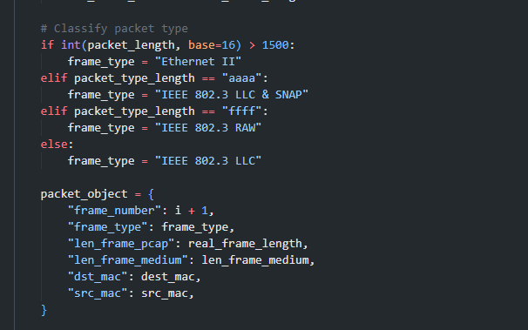

Here we classify the packet based on its length and packet type which is from the packet itself.

After identifying the packet we create the packet object.

Each packet type has its modify function which fills out its type specific properties.

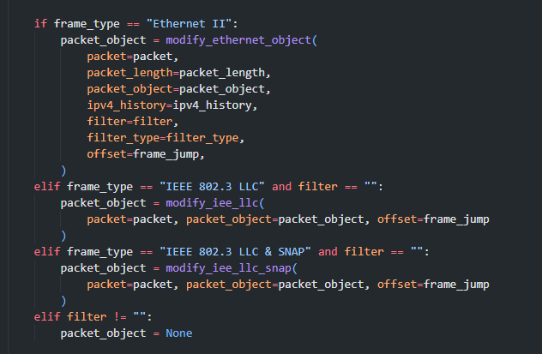

ETHERNET II specific modify function

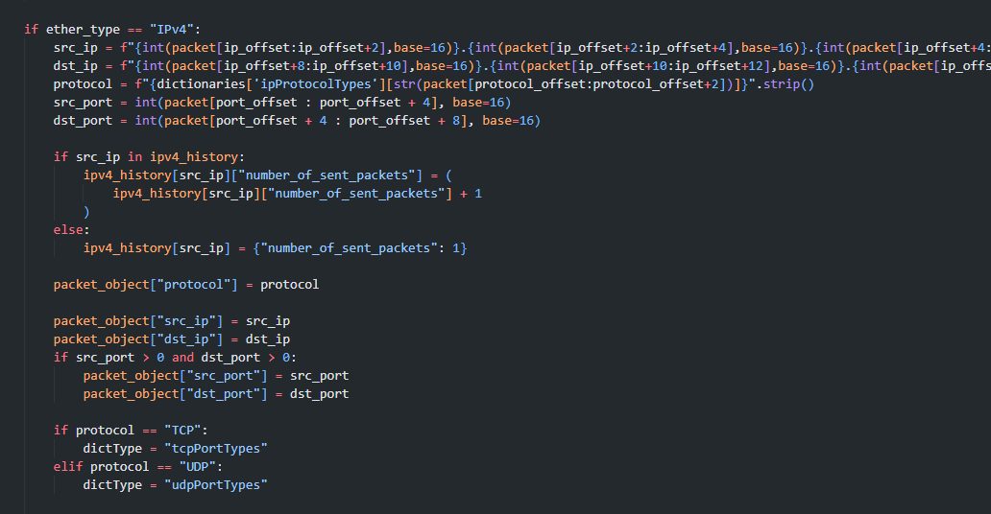

For setting properties such as ether type or app protocol I used .txt files which are loaded into a dictionary at the start of the program

## External file structure

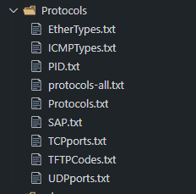

EtherTypes.txt

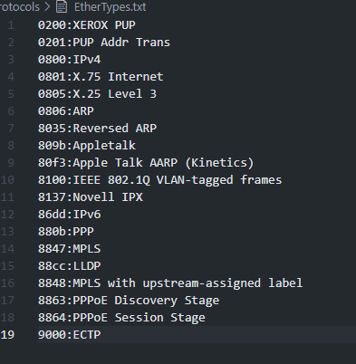

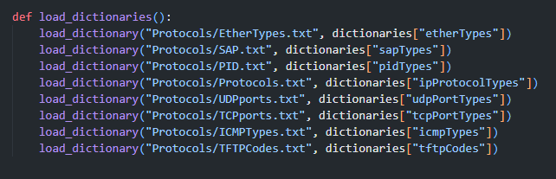

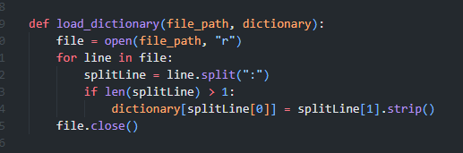

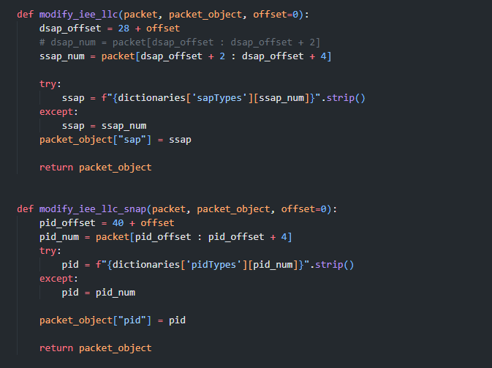

# Flowchart of analyzing packet processing

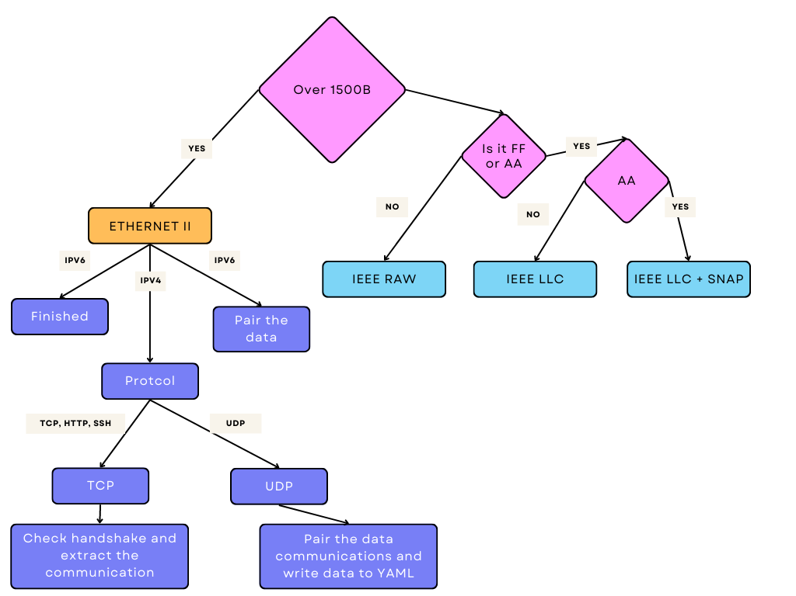

# Task two

Here we had to fill out more and protocol specific information to each protocol in the ETHERNET II frame. Example for ARP:

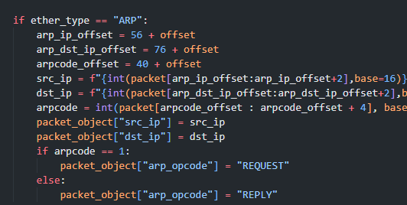

All the well know protocol names are loaded from files and retrieved from a dictionary

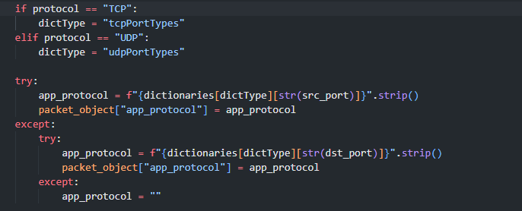

Here we first get the type of protocol to be able the retrieve the appropriate dictionary, because TCP and UDP well know ports are in different txt files.

## Analysis of frames

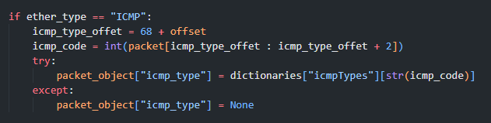

Settings the ICMP type from the ICMP header

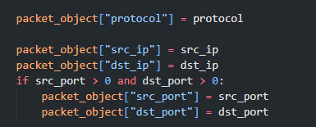

Setting the IP and the port for IPV4

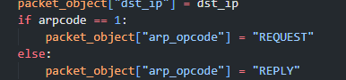

Settings arpcode for arp.

# Task three

Here we had to create statistics of IPV4 packets. I did this using a dictionary where the key was the sender’s ip address and if the same sender sent a packet the packet count was incremented.

Then at the end selected the largest sent packet number and using a for loop I search up the ip addresses which sent the same amount of packets.

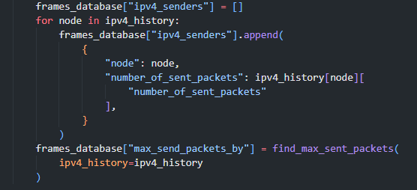

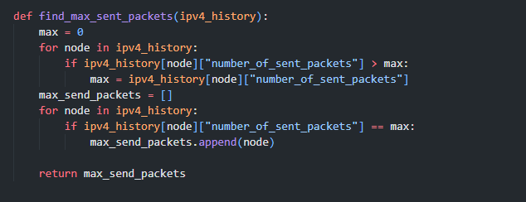

# Task four

## Filtering

Filtering is done using -p argument. When passing a protocol to the filter the filter checks if the protocol exists from external files, then gets the correct type if the protocol is a nested protocol such as HTTP. Then passes these arguments to the analyze_frames() function. It also supports adding file name as additional argument when using -p.

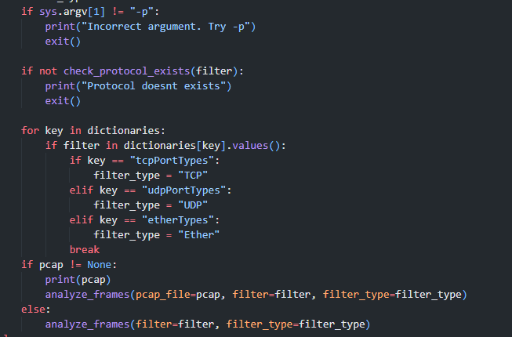

After that the packeges are filtered in the modify_ethernet_object () function.

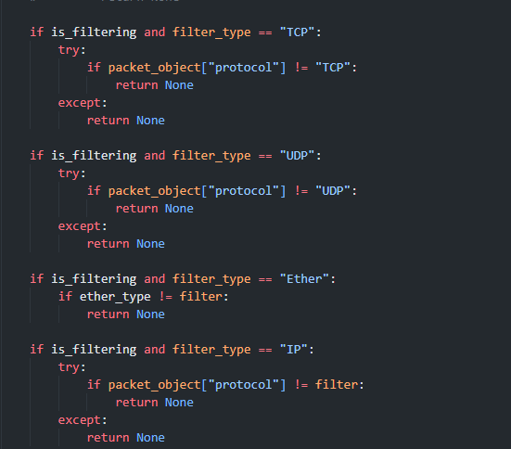

This is done for every packet one by one.

## TCP handshake and communication detection

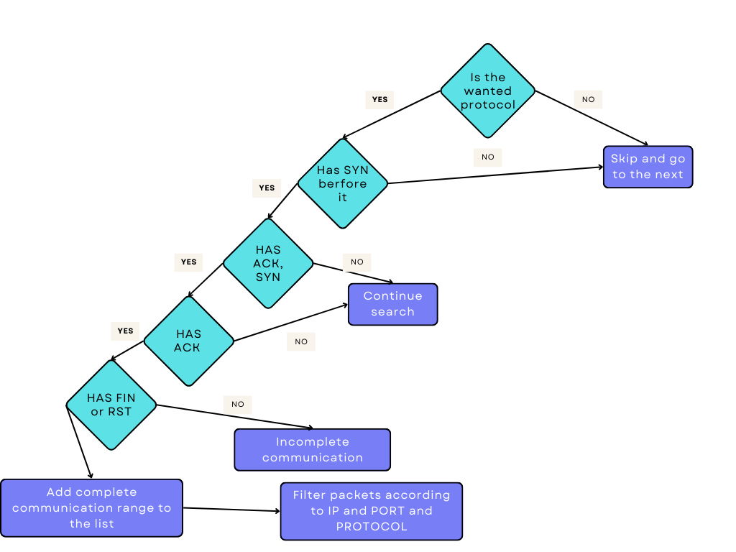

First, I checked the handshake then if a complete connection was the result I added the range of packets inside of that connection, then in the next step I filtered all those packets according to IP, PORT and filter PROTOCOL which was passed into the function.

## UDP communication pairing

With each TFTP packet I added a connection object to the connection list, after the TFTP packet, I saved the ports and IP addresses for the next packet and all following packets were compared to these ports and IP addresses, if they did match than they were part of the same connection.

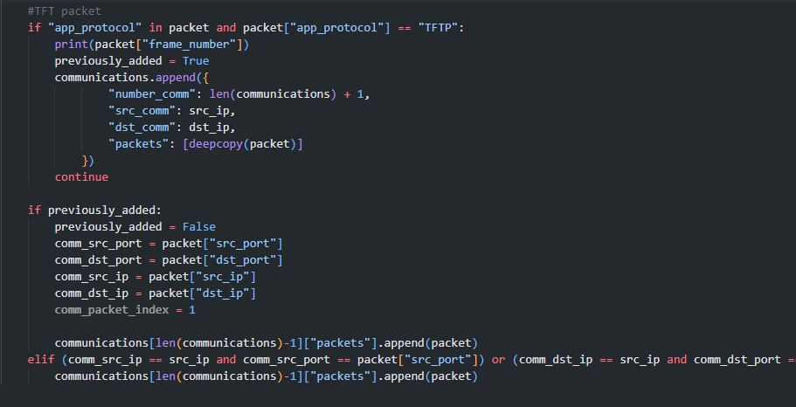

## ARP

In the case of ARP I looped through the ARP packages one by one, if a REQUEST packet is found the program starts another loop from that packet and searches until it finds a REPLY for that exact Ip address. If along the way it finds a REQUEST packet with the same addresses it adds to a temporary list and these are added when a current REPLY if found in that way supporting N*REQUEST. Added REPLY and REQUEST (after the first one) are removed from the list.  
Then these complete communications are appended to the return object, which will contain all communications and will be returned by the function.

