Modeling assignment

Assignment 4

Education Policy

9 November 2011

Seminar Development & Growth

Bart de Geus, s561375

Anne van de Vorst, s787888

Table of Contents

Introduction 3

Overview model 13.3.2 3

Introduction of a subsidy 7

Introduction of a tax 9

Numerical example 11

Sensitivity analysis 12

Reference list 14

Appendices 15

Appendix 1: Model 13.3.2 15

Appendix 2: Introduction subsidy 16

Appendix 3: Introduction tax 17

# Introduction

In this modeling assignment we will introduce a subsidy to education in the model used in section 13.3.2 of Aghion et al. (2009: …). In section 13.3.2. Aghion et al. describe a model that was inspired by Acemoglu and Redding. The model looks at the composition of education spending and the way it interacts with the level of technological development in a country. Individuals make a decision regarding the amount of investment in education in period 1. At the same time, entrepreneurs decide how much they would like to invest in innovation. These decisions depend on the expected level of productivity growth and the expected level of human capital respectively. Thus, the decisions depend on the decision of the other party and as a result of this interaction; there are multiple growth paths; a low-growth equilibrium and a high-growth equilibrium. Since it is hard to leave the low growth equilibrium this equilibrium is often called a low-development trap. Here, we will introduce subsidies on education and see what the result of this subsidy is on the equilibriums and whether this might be a solution for the low-development trap. First, we’ll give an overview of the model in section 13.3.2.

# Overview model 13.3.2

*Individuals*

In this model all individuals live for two periods and are born with a level of human capital that is equal to one. Individuals, as in most models, maximize their utility, with a discount factor for consumption in the future since they value consumption today more than consumption tomorrow.

$\max_{ν}\left\{u\right\}=\max_{ν}\left\{c_{1}+ρc_{2} \right\}$ $(1)$

The consumption functions of the individuals are the earnings of the young in every period. These function are given by the following formulas:

$c_{young, t}=\left(1-ν_{t}\right)A_{t}$ $(2)$

$c_{old, t+1}=βA_{t+1}h_{old, t+1}$ $(3)$

The earnings of individuals when they are young equal the amount of production time times the existing leading-edge technology, since this is the amount they produce when they are self-employed. Human capital is present in equation $(2)$ but it is normalized to one. Here we assume that individuals work for a firm when they are old. Old individuals earn a fraction of the output surplus in which the level of human capital and the level of the leading-edge technology determine this output surplus. Individuals cannot decide upon the level of the leading-edge technology but they can influence their level of human capital when they are old. When they invest in education when they are young, their human capital when they are old will be higher than the level of human capital when they were young. The more they’ll invest in education, the higher the increase in human capital is; this is formulated in equation $(4)$.

$h_{2,t}=1+γν^{θ}$

$h_{2,t}=1+γ{\left({\left[βρθγ\left(μλ+1-μ\right)\right]}^{\frac{1}{1-θ}} \right)}^{θ}$ $(4)$

Thus, there is a trade-off between the costs (decrease in production time when young) and the benefits (increase in human capital when old) of education. When individuals maximize their utility, they make a decision regarding the fraction of their working time they want to invest in education when they are young.

After inserting the equation for human capital $(4)$ in the consumption function $(3)$ and inserting the consumption functions $(2)$ and $(3)$ in the utility function $(1)$ it is possible to maximize the utility function with respect to $ν$. Rewriting this first order condition gives[1]:

Equation $(4)$ shows the optimal fraction of working time individuals invest in education. When individuals invest this fraction in education their utility is maximized. As equation $\left(4\right)$ shows this fraction depends on the *expected* productivity growth in the country. When individuals expect that the productivity growth will be high, they’ll invest more in education. Figure 1 shows this correlation between expected productivity growth and the level of human capital.

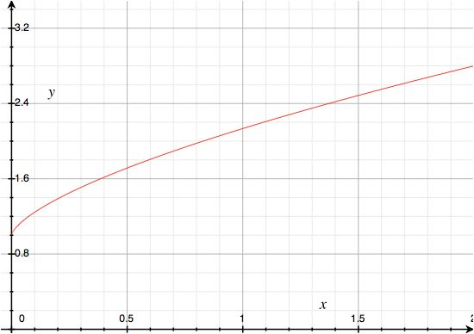

Figure 1

*Entrepreneurs*

Entrepreneurs face a decision regarding the amount they want to invest in innovation. Investing in innovation costs money but it will increase the output surplus. Entrepreneurs maximize their profit that is given by the following formula:

$\max_{μ}{V\left(μ\right)=\left\{-μαA+ρ\left(1-β\right)\left(μλ+1-μ\right)\left(1+γv^{θ}\right)A\right\}}$ $(6)$

Rewriting the first order condition of equation $(6)$ gives the following formula for the optimal amount of investment in innovation:

$μ^{*}\left\{\begin{aligned}1 if α<ρ\left(λ-1\right)\left(1+γv^{θ}\right)\left(1-β\right) \\ 0 if α≥ρ\left(λ-1\right)\left(1+γv^{θ}\right)\left(1-β\right)\end{aligned}\right.$ $(7)$

Equation $(7)$ shows that the first order derivative of the profit function with respect to $μ$, the probability that the innovation happens, does not depend on $μ$. Therefore, investors either invest maximal in innovation or don’t invest at all. When investors invest maximal in innovation it means that they’ll invest an amount until it’s certain the innovation will occur, so $μ=1$.

As equation $(7)$ shows the decision of the entrepreneurs whether or not to invest in innovation depends on the *expected* level of human capital. Above a certain level of human capital, entrepreneurs will invest in innovation because they will make a profit. However, when the human capital level is not high enough, entrepreneurs decide not to invest in innovation since they will lose from this investment. This decision if formulated by the following formula:

$\left(1+γv^{θ}\right)>\frac{α}{ρ\left(λ-1\right)\left(1-β\right)}$ $(8)$

Figure 2 graphically illustrates the decision of the entrepreneurs. When the human capital is above the dotted line, entrepreneurs decide to invest in innovation and the productivity level increases from 1 to 1.5.

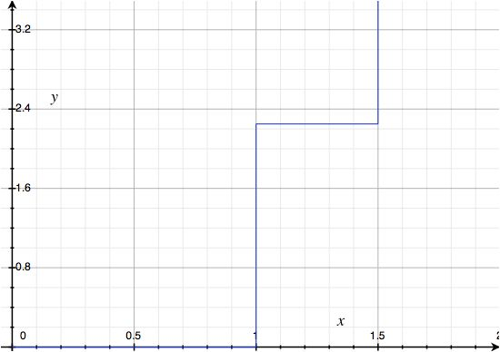

Figure 2

*Equilibria*

The decision of individuals how much to invest in education depends on the expected level of productivity growth. At the same time, the decision of entrepreneurs whether or not to invest in innovation depends on the expected level of human capital. Unfortunately, the expected levels are not given but we can combine both figures when we assume that individuals and entrepreneurs behave rational. When both the individuals and the entrepreneurs hold rational beliefs there are two Nash equilibria. In figure 3 the decision making lines from the entrepreneurs and from the individuals are combined and you see that the lines cross three times. When the human capital line crosses the innovation decision line by the entrepreneurs when the last line is horizontal, there is no equilibrium since entrepreneurs either invest maximal or don’t invest at all. That means, that the equilibria only exists on the vertical parts of the innovation decision line by the entrepreneurs. Figure 3 shows that there is a low-growth equilibrium and a high-growth equilibrium. When the entrepreneurs expect that the level of human capital will be below the horizontal line they won’t invest in innovation and when the individuals expect that the entrepreneurs don’t invest in innovation they will invest a smaller amount in education. This results in the equilibria presented in the figure below. When the economy is in the low-growth equilibria and neither the individuals nor the entrepreneurs expect that the other party invest more in education or innovation the economy can’t get out of this low-growth equilibria.

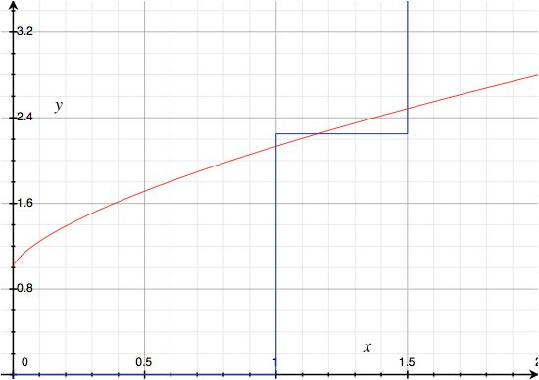

Figure 3

# Introduction of a subsidy

We will now introduce a subsidy to education. Below, we discuss the effects of a subsidy to education, but first we will describe how the subsidy is inserted into the model. In this section, every employee receives a subsidy that depends on the fraction of time that person allocates to education, i.e. a quantity subsidy. Thus, the more one invests in education, the larger the subsidy one receives. Furthermore, we assume for now that no taxes are levied on individuals to pay for the subsidy. The consumption functions for individuals in each period now become:

$c_{young, t}=\left(1-ν_{t}\right)A_{t}+sν_{t}$ $\left(9\right)$

$c_{old, t+1}=βA_{t+1}h_{old, t+1}$ $(10)$

Equation $(9)$ shows that the introduction of the subsidy makes investing in education less expensive. To see whether the subsidy makes individuals more willing to invest more in education, the utility function is maximized with respect to $ν$. Inserting the consumption functions $\left(9\right)$ and $\left(10\right)$ in the utility function $\left(1\right)$ and maximizing this function gives:

$ν_{S}^{*}={\left[\frac{1-\frac{s}{A}}{ρβ\left[μλ+1-μ\right] θγ}\right]}^{\frac{1}{θ-1}}$ $(11)$

When we compare equation $(11)$ with equation $(5)$ we see that the fraction of working time people are willing to invest in education increases with the subsidy when keeping other parameters constant.

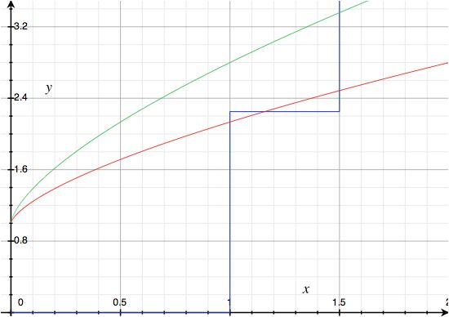

Figure 4

The graph above graphically presents the above-mentioned finding: a positive subsidy increases the fraction of working time people invest in education when the other parameters don’t change. The human capital line shifts upwards due to the introduction of a subsidy on education. When the subsidy on education increases, the human capital line shifts even more upwards. In this specific example the subsidy resulted in only one equilibrium: a high-growth equilibrium. Thus, the low development trap disappeared by introducing the subsidy. We are interested in the level of subsidy for which it is no longer possible to end up in an equilibrium of low growth. The subsidy is optimal when the human capital level goes through the dotted line at the moment where productivity is one. This gives the following equation for the optimal subsidy:

$s^{*}>-{\left[\frac{\frac{α}{ρ\left(λ-1\right)\left(1-β\right)}-1}{γ}\right]}^{\frac{θ-1}{θ}}ρβθγA+A$ $(12)$

Thus, when a government wants to implement a subsidy to prevent the low-development trap from occurring the government should set the subsidy slight above the right hand side of equation 12. It is inefficient for society when the government sets the equilibrium subsidy much higher since this would not result in a higher growth level of the economy.

Figure 5 shows the formula of human capital that includes the optimal subsidy. The human capital line crosses the innovation decision line by the entrepreneurs when $μ=0$ at the corner point. Thus, for every subsidy bigger than the right hand side of equation $(12)$, the human capital line crosses the line representing the choice of the entrepreneurs only once, in the high-growth equilibrium.

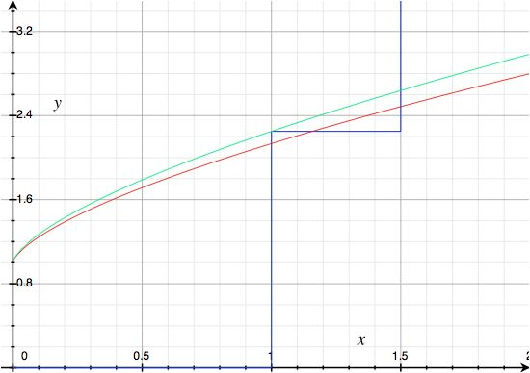

Figure 5

# Introduction of a tax

Up until now we have assumed that the government did not had to levy taxes in order to pay for the subsidy the government gave to the individuals. However, this assumption is not very realistic since the government needs to finance their expenses. Here, we try to make the situation more realistic by levying taxes on the old:

$c_{young, t}=\left(1-ν_{t}\right)A_{t}+sν_{t}$ $(13)$

$c_{old, t+1}=(1-τ)βA_{t+1}h_{old, t+1}$ $(14)$

$τβA_{t+1}h_{old, t+1}=sν_{t}$ $(15)$

The consumption function of the young and the old are now given in equations $(13)$ and $(14)$. Since we assume, for simplicity, that the government’s budget is balanced, equation $(15)$ must hold. Furthermore, we assume that there is no population growth, so the old households should pay the subsidy of the young individuals. Since all individuals are identical in the way that they have the same utility function, they will make the same decision regarding the fraction of working time they’ll invest in education. As a result, individuals will receive an amount of subsidy when they are young and need to pay this same amount to the government in the form of a tax when they are old.

Inserting the consumption functions $(13)$ and $(14)$ and the constraint function $(15)$ in the utility function $(1)$ and maximizing this function gives the following formula:

$ν_{T}^{*}={\left[\frac{1-\frac{(1-ρ)s}{A}}{ρβ\left[μλ+1-μ\right] θγ}\right]}^{\frac{1}{θ-1}}$ $(16)$

When we compare equation $(16)$ with equation $(11)$ and $(5)$ we see that for a given subsidy the fraction of the working time individuals invest in education is smaller than in the case without a tax (but with a subsidy) for all $ρ$’s. Furthermore when $ρ=1$ there is no difference between the situation with a tax (and a subsidy) and without a subsidy. This is logical since when $ρ=1$ people do not give a higher valuation to consumption today compared to consumption tomorrow; thus when people receive an amount today and have to pay an amount tomorrow they won’t change their behavior, so the fraction of the working time individuals invest in education won’t change. However, when $ρ<1$, the fraction invested in education is higher in the case of a subsidy with tax than the situation where individuals won’t receive a subsidy when they invest in education. Thus, the smaller $ρ$ is, the bigger the effect of a subsidy is when the payments need to be collected by levying taxes.

Just as in the case without taxes, we’re interest in the subsidy needed to make sure the low-development trap does not occur. The optimal subsidy is given by the following formula:

$s_{T}^{*}>\frac{-{\left[\frac{\frac{α}{ρ\left(λ-1\right)\left(1-β\right)}-1}{γ}\right]}^{\frac{θ-1}{θ}}ρβθγA+A}{(1-ρ)}$ $(17)$

The optimal subsidy level when the subsidy is paid by levying taxes is higher than in the case without taxes. Again, this is straightforward since the taxes discourage individuals to invest in their human capital since they can only capture $(1-τ)$ of their benefits when they are old instead of the complete amount. The optimal subsidy equation $(17)$ differs from the optimal subsidy equation $(12)$ in one thing. When taxes are introduced, the optimal subsidy as in equation $(12)$ needs to be divided by $(1-ρ)$. Again, this is straightforward since in the hypothetical case where $ρ=0$ there is no difference between both equations since individuals do not attach any value to consumption in the future and don’t care about the amount of taxes they have to pay in the future.

Figure 6 shows the new human capital formula with the optimal subsidy.



Figure 6

# Numerical example

We have used these numbers to construct figure 1 till 6. Here, we will elaborate upon the numbers used and the consequences.

|  |  |  |  |  |
| --- | --- | --- | --- | --- |
| $$β$$ | 0.667 |  | $$μ$$ | 0 or 1 |
| $$γ$$ | 2 |  | $$λ$$ | 1.5 |
| $$θ$$ | 0.4 |  | $$α$$ | 0.3 |
| $$ρ$$ | 0.8 |  | $$A$$ | 1 |

According to Mankiw et al. (1992) the return to human capital is two-thirds, therefore we have set $β=0.667$. Furthermore, we believe individuals don’t discount their future consumption that much and therefore we have set $ρ=0.8$. Since there is no further information about the initial level of productivity we have normalized this level to 1 for simplicity. Theta was chosen to be smaller than 0.5 to make sure there are diminishing returns to human capital. Some other parameters were chosen more in line with the model to make sure the model shows multiple growth paths. For example, we have set $α=0.3$ while in reality we believe $α$ is bigger than 0.3.

Entrepreneurs decide to invest in innovation when the level of human capital is above a certain level; given in equation $\left(8\right)$. When the level of human capital is above $2.25$, entrepreneurs will invest maximally in innovation and when the level of human capital is below $2.25$ they won’t invest at all. When entrepreneurs invest maximal, the innovation will occur with certainty and therefore the new productivity level will be at $λ=1.5$

Without a subsidy, the human capital level is given in equation $\left(4\right)$, and after inserting the numbers it is $h_{t}=1+2{\left(0.4267\left[μλ+1-μ\right]\right)}^{\frac{0.4}{-0.6}}$. When the subsidy is introduced, the question is for which subsidy the economy ends up in the high-growth equilibrium with certainty. Equation $(16)$ is used to answer this question. When the subsidy set by the government is higher than 13.65%, the low-development trap no longer occurs. When the tax is introduced equation $(17)$ is used to calculate the optimal subsidy in case the subsidies are paid by levying taxes on the old individuals. Equation $(17)$ gives that the subsidy should lie slightly above 68.24% in order to be effective, that means, in order to make sure a country is in the high-growth equilibrium for certain.

# Sensitivity analysis

In the numerical example we have used numbers to calculate the model in such a way that there are multiple equilibria before the introduction of the subsidy. Furthermore, the numbers made a subsidy on education useful, even in the case where taxes are levied to finance the subsidy. Now, we’ll discuss what happens when the parameters change and we’ll see that this model is extremely sensitive to certain changes.

*Increase in $α$*

|  |  |  |  |  |
| --- | --- | --- | --- | --- |
| $$β$$ | 0.667 |  | $$μ$$ | 0 or 1 |
| $$γ$$ | 2 |  | $$λ$$ | 1.5 |
| $$θ$$ | 0.4 |  | $$α$$ | ***0.5*** |
| $$ρ$$ | 0.8 |  | $$A$$ | 1 |

When $α$ increases to 0.5, the costs of the entrepreneurs to invest in innovation increases. The result is that entrepreneurs demand a higher level of human capital before they are willing to invest in innovation. In this case, when $α$ increases to 0.5 there is only a low-growth equilibrium in the absence of a subsidy. Even in this case a subsidy could help to escape from the low-growth equilibrium. However, the subsidy needed to make sure the low-growth equilibrium no longer occurs is much higher, 73.54% without a tax and 367.69% in the case with taxes. A subsidy above 100% is not very realistic since this subsidy is financed by levying taxes on the old and this means that the tax rate needs to be extremely high as well. Thus, when $α=0.5$ it isn’t possible to escape the low-growth equilibrium with the use of a subsidy that is paid by levying taxes on the old.

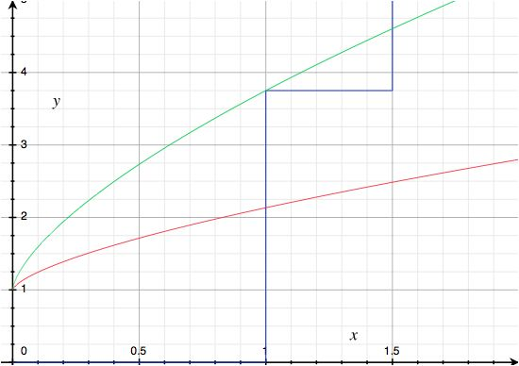

Figure 7

*Increase in $ρ$*

|  |  |  |  |  |
| --- | --- | --- | --- | --- |
| $$β$$ | 0.667 |  | $$μ$$ | 0 or 1 |
| $$γ$$ | 2 |  | $$λ$$ | 1.5 |
| $$θ$$ | 0.4 |  | $$α$$ | 0.3 |
| $$ρ$$ | ***0.95*** |  | $$A$$ | 1 |

When $ρ$ increases from 0.8 to 0.95 the level of human capital the entrepreneurs require in order for the entrepreneurs to decide to invest in innovation is lower than the level of human capital is when entrepreneurs don’t invest in innovation. Thus, the economy is already in the high-growth equilibrium and a subsidy is not necessary. Figure 8 illustrates this situation.

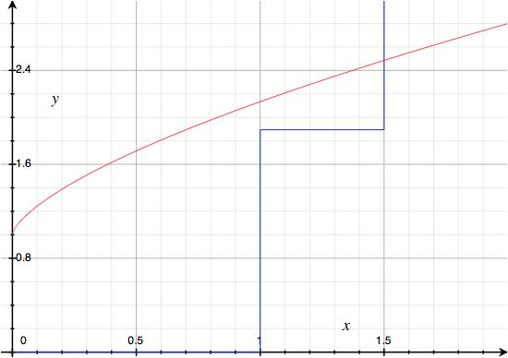

Figure 8

# Reference list

Aghion, P. & Howitt, P. (2009), *The Economics of Growth,* Cambridge MA, The MIT Press

Mankiw, N., Romer, D. & Weil, D. (1992), A contribution to the Empirics of Economic Growth, *The Quarterly journal of Economics,* 102, (2), 407-437

# Appendices

### Appendix 1: Model 13.3.2

$c_{young, t}=\left(1-ν_{t}\right)A_{t}$ $(2)$

$c_{old, t+1}=βA_{t+1}h_{old, t+1}$ $(3)$

$\max_{ν}\left\{u\right\}=\max_{ν}\left\{c_{1}+ρc_{2} \right\}$ $(1)$

$\max_{ν}\left\{\left(1-ν\right)A+ρβ\left[μλ+1-μ\right]\left(1+γv^{θ}\right)A\right\}$

$-A+ρβ\left[μλ+1-μ\right] θγv^{θ-1}A=0$

$ρβ\left[μλ+1-μ\right] θγv^{θ-1}A=A$

$ρβ\left[μλ+1-μ\right] θγv^{θ-1}=1$

$v^{θ-1}=\frac{1}{ρβ\left[μλ+1-μ\right] θγ}$

$ν=\sqrt[θ-1]{\frac{1}{ρβ\left[μλ+1-μ\right] θγ}}$

$ν=\sqrt[θ-1]{\frac{1}{ρβ\left[μλ+1-μ\right] θγ}}$

$ν^{*}={\left[\frac{1}{ρβ\left[μλ+1-μ\right] θγ}\right]}^{\frac{1}{θ-1}}$ $(5)$

$ν^{*}={\left[βρθγ\left(μλ+1-μ\right)\right]}^{\frac{1}{1-θ}}$

$\max_{μ}{V\left(μ\right)=\left\{-μαA+ρ\left(1-β\right)\left(μλ+1-μ\right)\left(1+γv^{θ}\right)A\right\}}$ $(6)$

$\frac{∂V}{∂μ}=-αA+ρ\left(1-β\right)\left(1+γv^{θ}\right)A\left(λ-1\right)=0$

$μ^{*}=1$ if $-αA+ρ\left(1-β\right)\left(1+γv^{θ}\right)A\left(λ-1\right)>0$

$μ^{*}=1$ if $α<ρ\left(λ-1\right)\left(1+γv^{θ}\right)\left(1-β\right)$

$μ^{*}=0$ if $–αA+ρ\left(1-β\right)\left(1+γv^{θ}\right)A\left(λ-1\right)>0$

$μ^{*}=0$ if $α>ρ\left(λ-1\right)\left(1+γv^{θ}\right)\left(1-β\right)$

$μ^{*}\left\{\begin{aligned}1 if α<ρ\left(λ-1\right)\left(1+γv^{θ}\right)\left(1-β\right) \\ 0 if α≥ρ\left(λ-1\right)\left(1+γv^{θ}\right)\left(1-β\right)\end{aligned}\right.$ $(7)$

### Appendix 2: Introduction subsidy

$c_{young, t}=\left(1-ν_{t}\right)A_{t}+sν_{t}$ (9)

$c_{old, t+1}=βA_{t+1}h_{old, t+1}$ (10)

$\max_{ν}\left\{u\right\}=\max_{ν}\left\{c_{1}+ρc_{2} \right\}$

$\max_{ν}\left\{\left(1-ν\right)A+sν_{t}+ρβ\left[μλ+1-μ\right]\left(1+γv^{θ}\right)A\right\}$

$-A+s+ρβ\left[μλ+1-μ\right] θγv^{θ-1}A=0$

$ρβ\left[μλ+1-μ\right] θγv^{θ-1}A+s=A$

$ρβ\left[μλ+1-μ\right] θγv^{θ-1}+\frac{s}{A}=1$

$ρβ\left[μλ+1-μ\right] θγv^{θ-1}=1-\frac{s}{A}$

${ν_{S}^{*}}^{θ-1}=\frac{1-\frac{s}{A}}{ρβ\left[μλ+1-μ\right] θγ}$

$ν_{S}^{*}=\sqrt[θ-1]{\frac{1-\frac{s}{A}}{ρβ\left[μλ+1-μ\right] θγ}}$

$ν_{S}^{*}=\sqrt[θ-1]{\frac{1-\frac{s}{A}}{ρβ\left[μλ+1-μ\right] θγ}}$

$ν_{S}^{*}={\left[\frac{1-\frac{s}{A}}{ρβ\left[μλ+1-μ\right] θγ}\right]}^{\frac{1}{θ-1}}$ $(11)$

$1+γ{\left[\frac{1-\frac{s}{A}}{ρβθγ}\right]}^{\frac{θ}{θ-1}}>\frac{α}{ρ\left(λ-1\right)\left(1-β\right)}$

$γ{\left[\frac{1-\frac{s}{A}}{ρβθγ}\right]}^{\frac{θ}{θ-1}}>\frac{α}{ρ\left(λ-1\right)\left(1-β\right)}-1$

${\left({\left[\frac{1-\frac{s}{A}}{ρβθγ}\right]}^{\frac{θ}{θ-1}}\right)}^{\frac{θ-1}{θ}}>{\left[\frac{\frac{α}{ρ\left(λ-1\right)\left(1-β\right)}-1}{γ}\right]}^{\frac{θ-1}{θ}}$

$\frac{1-\frac{s}{A}}{ρβθγ}>{\left[\frac{\frac{α}{ρ\left(λ-1\right)\left(1-β\right)}-1}{γ}\right]}^{\frac{θ-1}{θ}}$

$1-\frac{s}{A}>{\left[\frac{\frac{α}{ρ\left(λ-1\right)\left(1-β\right)}-1}{γ}\right]}^{\frac{θ-1}{θ}}ρβθγ$

$-\frac{s}{A}>{\left[\frac{\frac{α}{ρ\left(λ-1\right)\left(1-β\right)}-1}{γ}\right]}^{\frac{θ-1}{θ}}ρβθγ-1$

$-s>{\left[\frac{\frac{α}{ρ\left(λ-1\right)\left(1-β\right)}-1}{γ}\right]}^{\frac{θ-1}{θ}}ρβθγA-A$

$s^{*}>-{\left[\frac{\frac{α}{ρ\left(λ-1\right)\left(1-β\right)}-1}{γ}\right]}^{\frac{θ-1}{θ}}ρβθγA+A$ $(12)$

### Appendix 3: Introduction tax

1. Extensive calculations can be found in the appendixes