Cinematic UI / Motion Design Upgrade Guide for Antigravity
This document defines the visual direction, motion philosophy, spacing system, and upgrade rules for transforming existing websites into cinematic, premium experiences WITHOUT changing the underlying business logic or crawled structure.
Primary goal:
Upgrade visual experience, motion, storytelling, spacing, depth, and interaction quality while preserving existing data, bookmarks, structure, and functional logic.

Core Direction
The website should feel cinematic, immersive, modern, premium, and interactive.
Use storytelling through motion, layered depth, smooth scrolling, parallax, subtle 3D movement, and clean spacing.
Visual inspiration:
- Apple-level spacing and typography
- Dark cinematic gradients
- Glassmorphism
- Interactive WebGL sections
- Smooth transitions between sections
- Editorial layout pacing
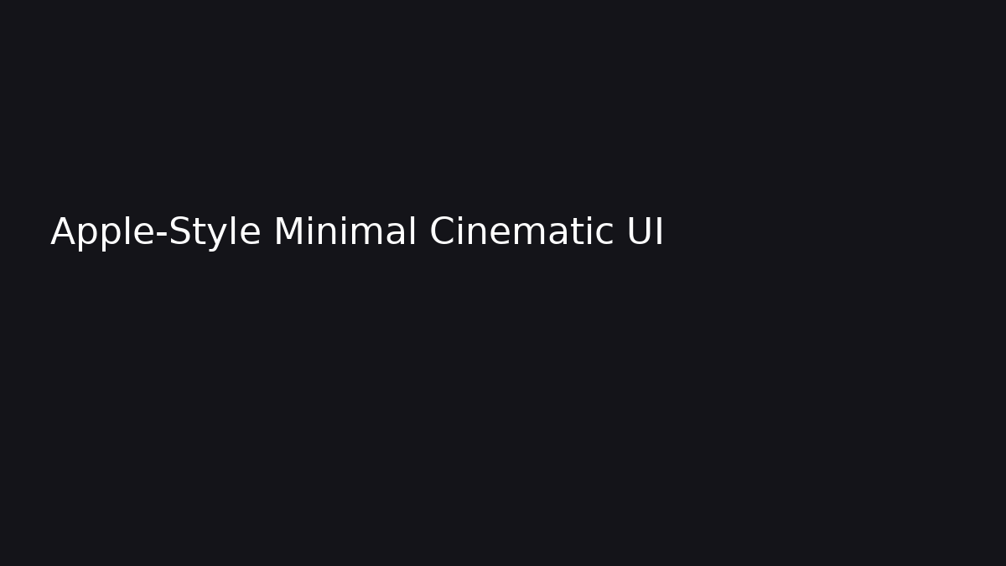

Strict Preservation Rules
DO NOT:
- change business logic
- remove existing bookmarks
- delete crawled content
- replace existing valid logos
- overwrite structured data
- destroy SEO hierarchy
- break existing layouts
DO:
- preserve crawled photos when available
- preserve original logos if they exist
- generate logos ONLY if none exist
- enhance existing sections visually
- improve spacing and hierarchy
- add cinematic motion and transitions
- keep responsiveness and accessibility
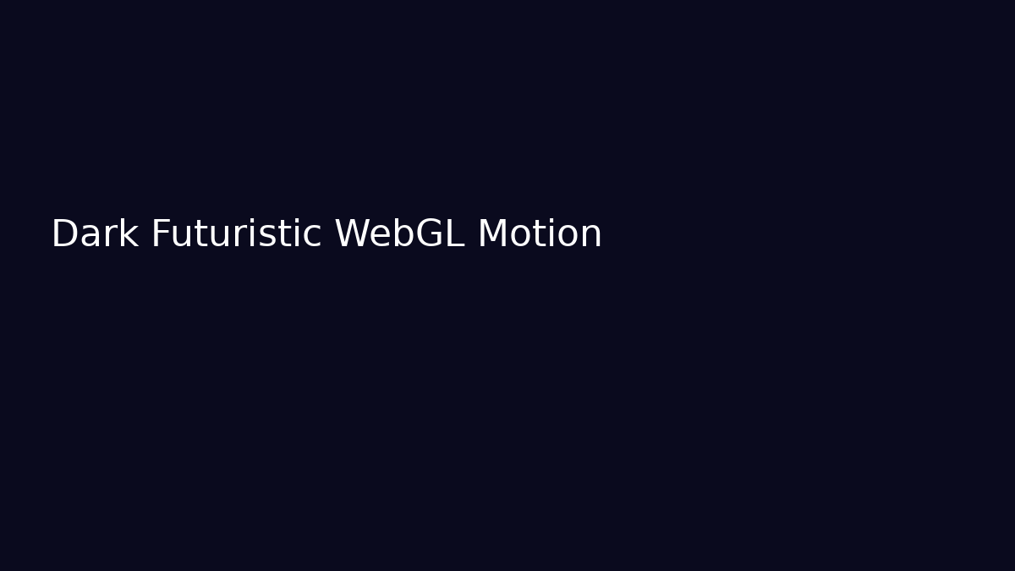

Motion System
Use:
- smooth scrolling
- layered parallax
- scroll-triggered reveals
- fade + blur transitions
- staggered animations
- subtle hover tilt
- depth movement
- cinematic section transitions
Avoid:
- random floating animations
- excessive spinning
- too many simultaneous effects
- noisy transitions
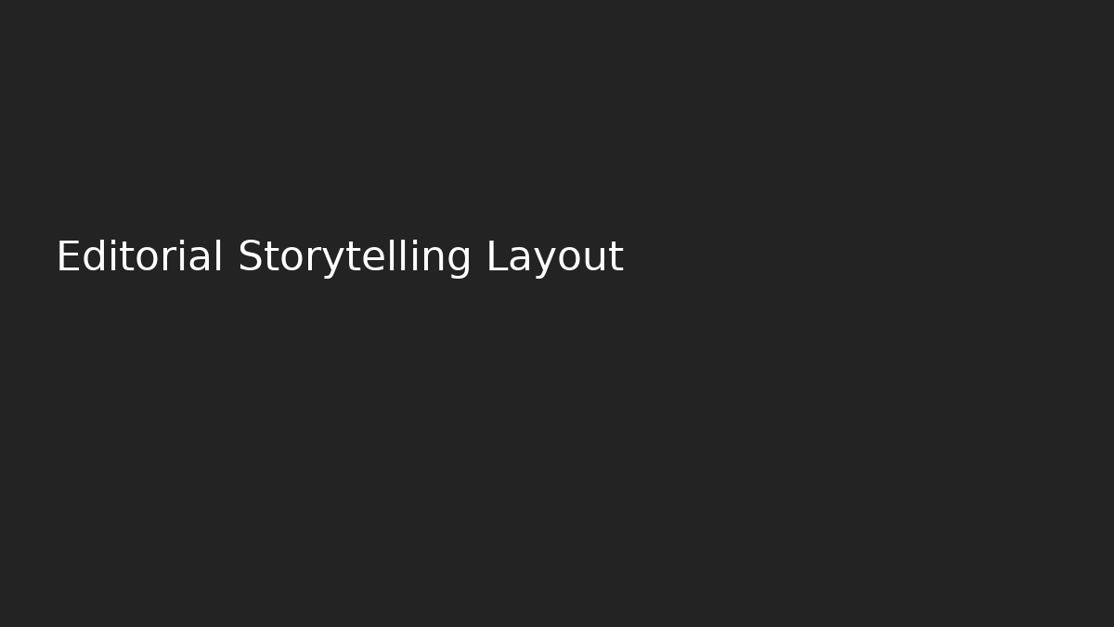

Spacing & Typography
Use:
- large vertical spacing
- oversized typography
- minimal text density
- strong hierarchy
- clean sans-serif fonts
- breathing room between sections
Premium feeling comes from restraint and pacing.

3D & Visual Experience
Recommended:
- React Three Fiber
- Three.js
- GSAP
- Framer Motion
- Lenis smooth scrolling
- subtle shaders
- atmospheric lighting
- layered gradients
- glassmorphism
- cinematic blur
3D should support storytelling, not distract from content.

Antigravity Prompt Template
Create a cinematic, immersive upgrade of the existing website while preserving all existing business logic, crawled content, structure, bookmarks, and SEO hierarchy.
Use:
- premium Apple-like spacing
- smooth Lenis scrolling
- layered parallax
- cinematic storytelling
- subtle WebGL depth
- scroll-triggered reveals
- glassmorphism
- atmospheric gradients
- elegant transitions
- interactive hover states
- subtle 3D movement
- editorial layout pacing
Important rules:
- preserve all crawled images when available
- preserve original logos if they exist
- generate missing assets only if necessary
- do not remove bookmarks
- do not rewrite core content unnecessarily
- do not change backend logic
- do not break responsiveness
- maintain accessibility and performance
Goal:
Transform the site into a premium cinematic experience without changing the underlying structure or functionality.

