# Dog/Breed Lab and Exercise

## Joshua C. Bartels

## NOTES:

1. *I went with the ViewSet model after having troubles with the snippets*
   1. *Because of this, I could not get my admin URL into the router. I tried a few different ways to do this and also decided to move on, commenting out the router if I wanted to use the admin and uncommenting the traditional URL path way we learned with the admin.*
   2. *We breed size limit constraint is not working (tiny, small, etc…). The int constraints do work for other breed characteristics. I intended to look at this more*
2. *I did this in Visual code studio on a Mac and PC, using and env that can run on both machines to accommodate my work travel. Yes, I could have used a VM, coud, docker, etc. But I like my 4 monitors at home, and my Mac when sitting in an airport.*

## GET/POST /api/dogs/

POST – Create CrazyDog

## GET/POST /api/breeds/

POST – Create CrazyBreed

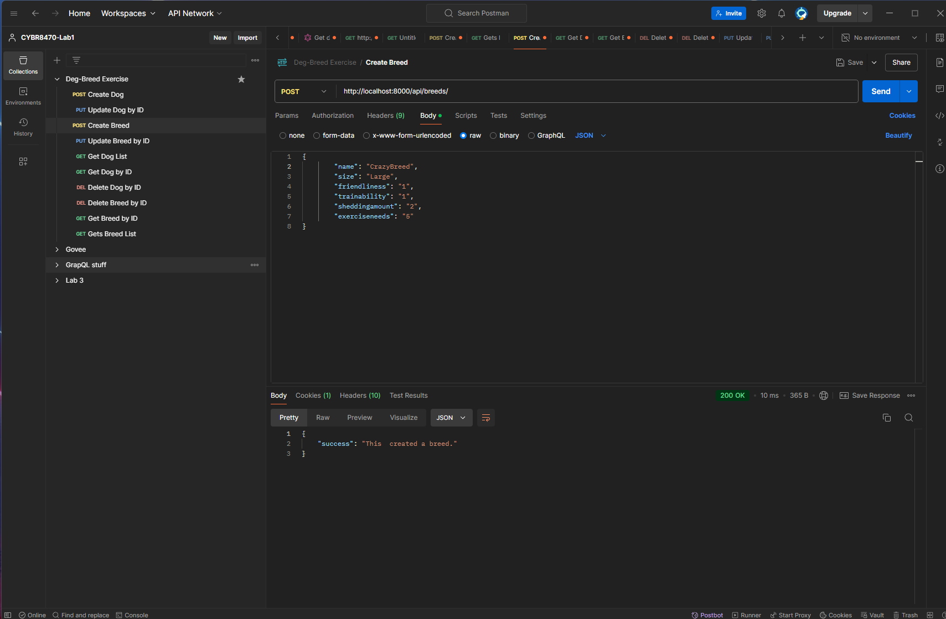

GET – All breed (now we have crazy bnrred as id=15) Yes there are a lot of velociraptors

## GET/PUT/DELETE to /api/dogs/<id>

GET - our CrazyDog by its ID=26

PUT - Not lets update CrazyDog to like Pretzels instead of Pizza, and football instead of beachball or lets update everything, even the name

Looks updated, even the name ☹

## GET/PUT/DELETE to /api/breeds/<id>

*NOTE : Since breeds operates basically the same as dogs just with a different view, and url path, etc., I will skip the validation screen shots after the 3 actions as they all work, just as they did for dogs.*

GET – So lets get our Crazy breed with id=15

