Getting things setup, mainly node.js, which is required for Ember of React. I liked the squirrel so I went with Ember.

The first thing I noticed was after creating my Ember project and getting it in GitHub, it has an astonishing numbers of files and size. Which explains why it takes a long time to create it and start it.  
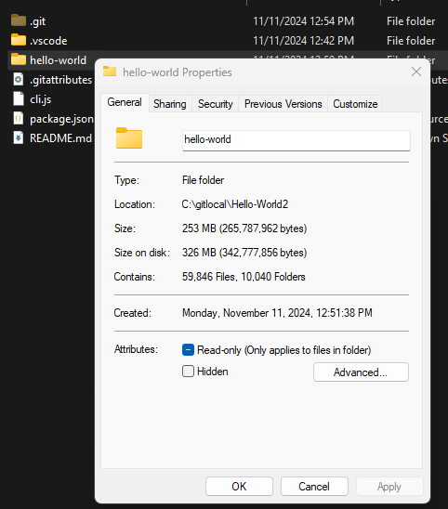

I guess this is a start.

