Baseline 1: Breaking Through the Haze
An Advanced Non-Homogeneous Dehazing Method based on Fast Fourier Convolution and ConvNeXt

Paper Summary
The paper proposes a two-branch GAN-style dehazing network for non-homogeneous haze, where haze is spatially irregular and much harder than standard homogeneous haze.

The authors argue that existing methods struggle mainly because:
- non-homogeneous haze is structurally complex and hard to restore in dense regions, and
- The available datasets are too small for reliable supervised learning.

The network has two main branches:

- DWT-FFC Frequency Branch

- This branch is responsible for learning the mapping from hazy image → clear image. It is an encoder–decoder with skip connections, and it uses:

  - DWT (Discrete Wavelet Transform) – to preserve and propagate high-frequency information like edges and fine textures,
  - FFC (Fast Fourier Convolution) – residual blocks to give the model a large/global receptive field by combining local spatial processing with frequency-domain processing.

This branch is basically trying to solve:
“How do we reconstruct image structure and details when haze is spatially irregular and sometimes very dense?”

- Prior Knowledge Branch

- This is the transfer-learning branch.
- It uses the first three stages of an ImageNet-pretrained ConvNeXt encoder, with a decoder that upsamples features back to image resolution using pixel shuffle and attention blocks.
- This branch injects prior visual knowledge to reduce overfitting on small dehazing datasets.

Final Output

The outputs of the two branches are fused, and a discriminator is used during training to improve perceptual realism via adversarial loss.

Baseline 1 Questions

Understand how to build the model
At a high level, the model is:
- Branch A: DWT-based encoder-decoder + FFC residual blocks
  - DWT = Preserve local detail / high frequency components
  - FFC = inject global context / frequency-domain awareness
- Branch B: pretrained ConvNeXt encoder + lightweight decoder
  - ConvNeXt = strong pretrained prior for better generalization on small datasets.
- Fusion: combine both branch outputs
- Discriminator: used during training for adversarial supervision.

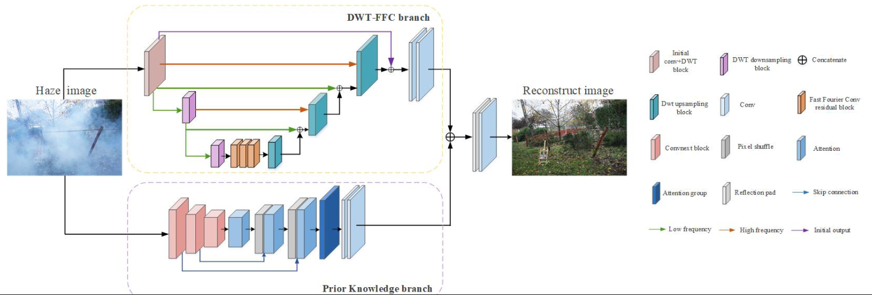

How to set up the optimization details
Total loss used to supervise the training (from paper):
- α = 0.2
- β = 0.01
- γ = 0.0005

Experimental settings (training data for model):
- uses 384 x 384 crops
  - accompanied by random rotation at 90, 180 or 270 degrees, as well as vertical or horizontal flip.
- Adam Optimizer, with default betas (0.9, 0.999)
- Specialized decay strategy, initiates with learning rate of e⁻⁴
  - Undergoes decay of 0.5 times at 3000, 5000, and 8000 epochs
- Training stops at 10 000 epochs
- Discriminator uses the same optimizer and training strategy

Hardware used:
- RTX 2080 Ti

How to construct the dataset and dataloader
Constructing the dataset/dataloader means building the input pipeline for training and testing.

Dataset – the thing that knows how to load one sample.
- A training sample is a paired hazy image and clean image.
- A test sample is not a hazy/clear pair; it is one hazy image split into multiple tiles for inference.

Dataloader – PyTorch wrapper around that dataset which batches samples, shuffles them for training, and feeds them into the model loop.
- Handles iteration, batching and shuffling.

Datasets:
- RESIDE ITS for training, SOTS for testing
- NH-HAZE
- NH-HAZE2
- HD-NH-HAZE

Ans: dataset

For training the dataset class, train_dataset_384.py. It expects a prepared folder that looks like this:

Train/
Train.txt
Hazy/
Clean/

Where,
- Train.txt lists the filenames.
- The code loads the same filename from hazy/ and clean/
- Repo expects paired supervision

Test/
Hazy/

Then it loads one hazy image and splits into 9 overlapping tiles in test_dataset_for_testing.py.

Ans: dataloader

The actual training dataloader is created in train.py. That is the part that wraps the dataset into batched iteration with batch_size = train_batch_size and shuffle = True.

The test dataloader is created in test.py and similarly in validation.py.

What should we do if the test image is too large (e.g. How to avoid an OOM issue?)
Ans: Dataset loader cuts each large image into a fixed 3x3 grid with overlap, and the test scripts average the overlap regions before concatenating the full output back together.

In the paper:
- Authors had limited GPU memory and couldn’t process full 6000x4000 HD-NH-HAZE images directly, used a block-based testing strategy:
  - Split the image into 9 blocks,
  - Each block is 1600x2432,
  - Run inference on each block separately,
  - Merge the outputs back together,
    - There is a 400-pixel overlap vertically and 632/664-pixel horizontally.
  - Average the overlapping regions.

OOM – out of memory, usually GPU VRAM running out during inference.

Note: this implementation is hard coded for the challenge image sizes and orientations. For different images, this repo would need a more general sliding-window implementation instead of the fixed crop coordinates.

What is the benefit of using ConvNeXt here?
Ans: ConvNeXt is used in this baseline as a pretrained prior-knowledge encoder to compensate for the small size of non-homogeneous dehazing datasets (for transfer learning).

- Paper argues ConvNeXt, compared to older pretrained backbones such as Res2Net, provides stronger feature representations and inherits useful design ideas from vision transformers while keeping convolutional advantages.
  - Paper backs this up experimentally: In ablation, replacing Res2Net with ConvNeXt improves the final model’s PSNR (pixel level fidelity) and SSIM (compares structural similarity rather than pixel difference).

In short:
- Better pretrained prior,
- Better generalization on small datasets,
- Strong high-level semantic/contextual features,
- Empirically better than Res2Net in this framework.

How does it fit into the workflow?

- In model_convnext.py:
    - loads ConvNeXt-XLarge weights
    - keeps first three encoder stages
    - decodes them with pixel shuffle + channel/spatial attention.
    - Produces 28-channel feature map
    - Fuse with DWT-FFC branch (3 channel)
  - Gives stronger generic visual priors and better generalization than learning everything from scratch.

What is ConvNeXt?

- Is a modernized CNN backbone, not a transformer.
- It keeps convolution but updates the old ResNet-style design with larger depthwise kernels, LayerNorm, GELU, pointwise channel mixing, and stage-wise downsampling.
- Goal is to get transformer-era representation quality while staying fully convolutional.

Code Analysis

Model Architecture Map
The main architecture file for this repo is: model_convnext.py.
- actual generator used in training, testing and validation,
- Instantiated from the files: train.py, test.py and validation.py.
- defines the GAN discriminator.

Top Level

Top level generator: fusion_net() in model_convnext.py
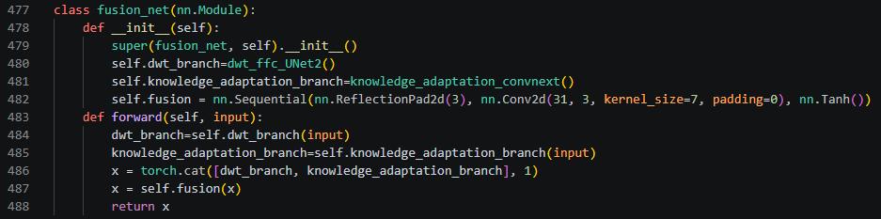
- The real entry point
- Builds branch A: dwt_ffc_UNet2()
- Builds branch B: knowledge_adaptation_convnext()
- Concatenates their outputs.
- Applies final 31-to-3 convolution to produce final dehazed image.

Branch A

Branch A, DWT-FFC branch: dwt_ffc_UNet2() in model_convnext.py
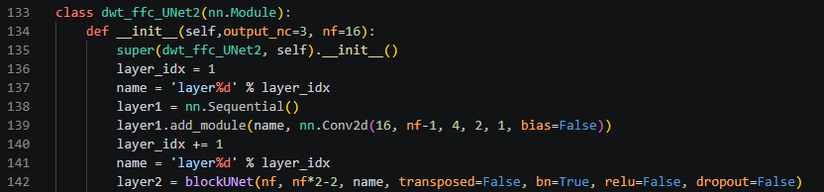
- This is the DWT/U-Net-style encoder-decoder branch.
- Direct helpers:
  - Dwt_init()
  - DWT()
  - DWT_transform()
  - blockUNet()

Branch A, FFC Bottleneck: myFFCResBlock() in myFFCResBlock0.py
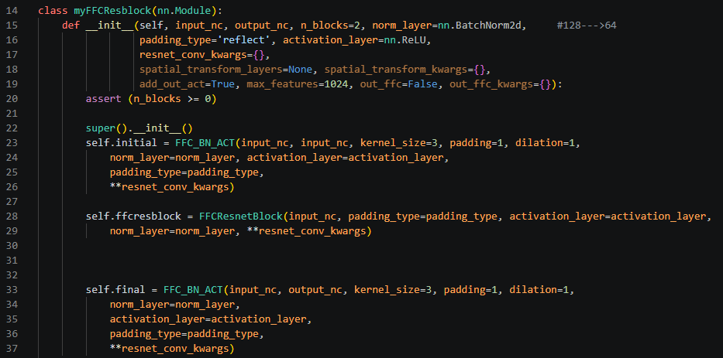
- Imported into model_convnext.py as PreConv and used within the dwt_ffc_Unet2() class as the frequency-domain residual module.

Branch A, lower-level FFC internals: FourierUnit(), SpectrialTransform(), FFC_BN_ACT() and FFCResnetBlock() in ffc0.py which is in saicinpainting folder.
- The actual Fourier/FFC implementation.

Branch B

Branch B, ConvNeXt prior-knowledge branch: knowledge_adaptation_convnext() in model_convnext.py.
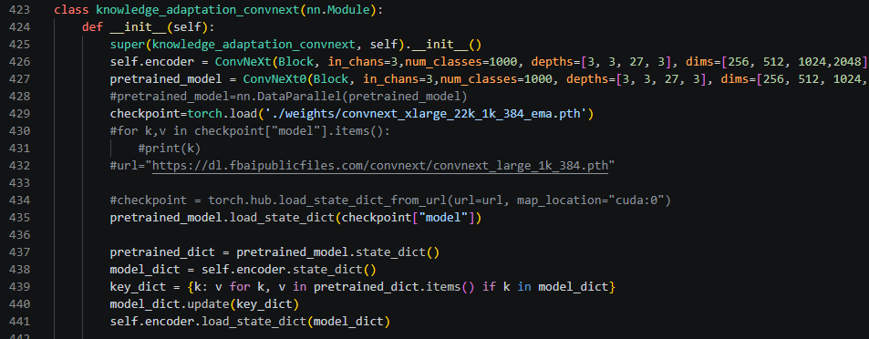
- This wrapper loads pretrained ConvNeXt weights, runs the encoder, then upsamples with PixelShuffle and attention blocks.

Branch B, encoder backbone pieces: ConvNeXt() in model_convnext.py
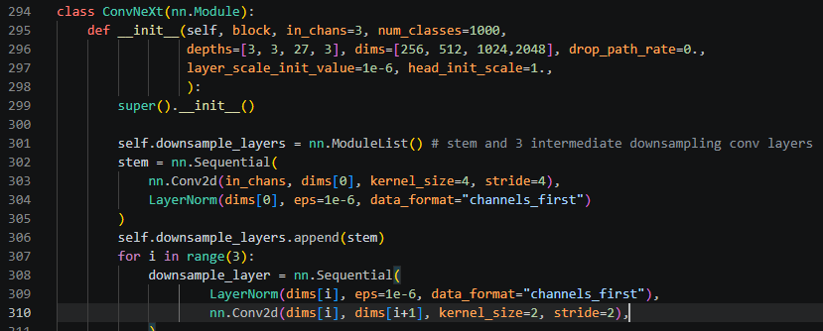
- Encoder actually used in the forward pass.
- Block() class, is the actual ConvNeXt block
- LayerNorm(), is the custom normalization layer.

Branch B, pretrained-weight scaffold: ConvNeXt0() in model_convnext.py
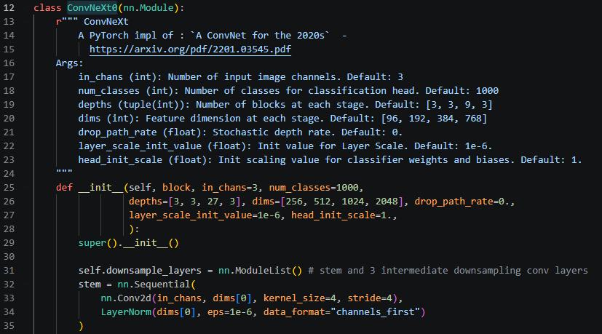
- mainly there so the repo can load the full pretrained checkpoint and copy matching weights into the truncated encoder.
- It is not the top-level model you run at inference time.

Branch B, decoder/attention helpers: model_convnext.py
- PALayer()
- CALayer()
- CP_Attention_block()
- Default_conv()

Adversarial

Training-only Adversarial module: Discriminator() in model_convnext.py
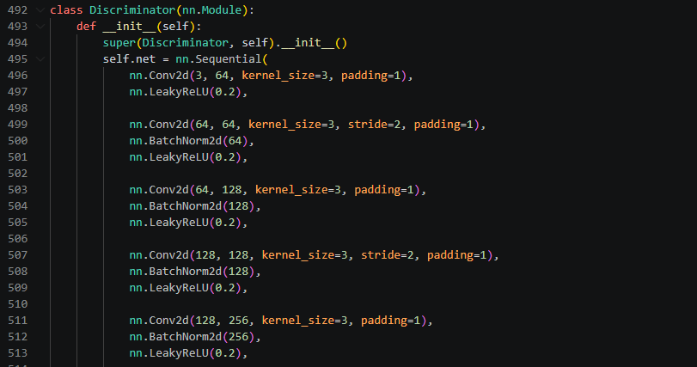
- Instantiated in train.py
- Part of training, not the inference generator.

Notes:
- Branch B does not directly output a final RGB image in the current code, it returns a 28-channel feature map and fusion_net() fuses that with the 3-channel output from Branch A.
- Dwt_ffc_UNet2() declares deeper encoder/decoder layers, but several of those calls are commented out inside its forward path, so the active branch A is shallower than constructor first suggests.
- Convnext.py appears to be a leftover/reference file and is not imported by the current working model code.

Optimization Code

The optimizer and scheduler are in train.py:
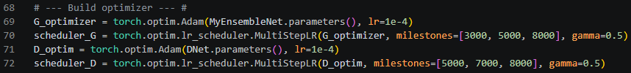

Total loss is assembled in train.py (matches paper exactly):
- The perceptual loss helper is LossNetwork() in perceptual.py
  - Using VGG16 features prepared in “Define the perceptual loss network” train.py

Data augmentation and 384x384 patch cropping are in train_dataset_384.py.
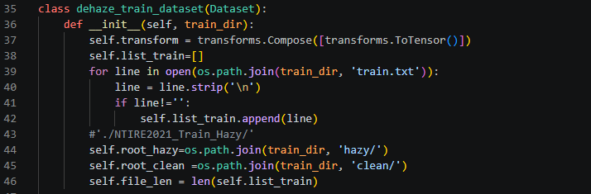

Large 9-block testing logic is in test_dataset_for_testing.py and test.py (repeated in validation.py).

Notes:
- Train.py defines a learning rate argument but the optimizer is still hard-coded to 1e-4.
- Paper says the discriminator uses the same decay strategy, but the code gives the discriminator different scheduler milestones in train.py.

Dataset and Dataloader
Expects specific file and folder format, as defined in train_dataset_384.py:
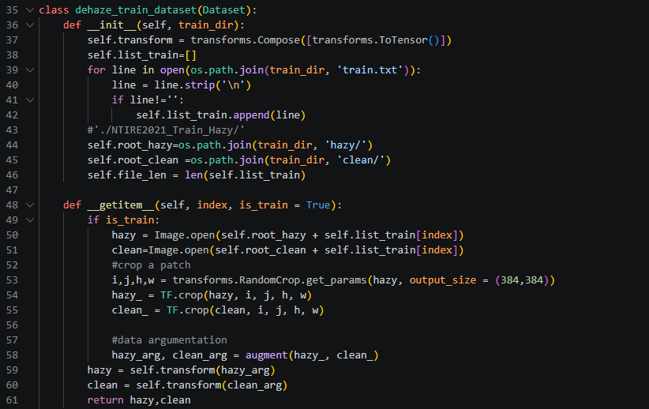

The actual training dataloader is created in train.py:

The test dataloader is created in test.py:

Note:
- The released training code is more generic than the paper’s dataset list, but also narrower than the paper’s experiments.
- No code that actually builds the gamma-corrected combined dataset; the paper describes that preprocessing, but the repo appears to expect the prepared dataset to already exist.

Image Splitting on Inference (OOM Issue)
The responsible code:
- Test_dataset_for_testing.py cuts each large image into a fixed 3x3 grid of overlapping crops.
- Test.py and validation.py receive those 9 crops and run the model on each one.
- The stitching code is the large merge block and final concatenation is also in test.py and validation.py.

ConvNeXt
The core ConvNeXt block: block() in model_convnext.py
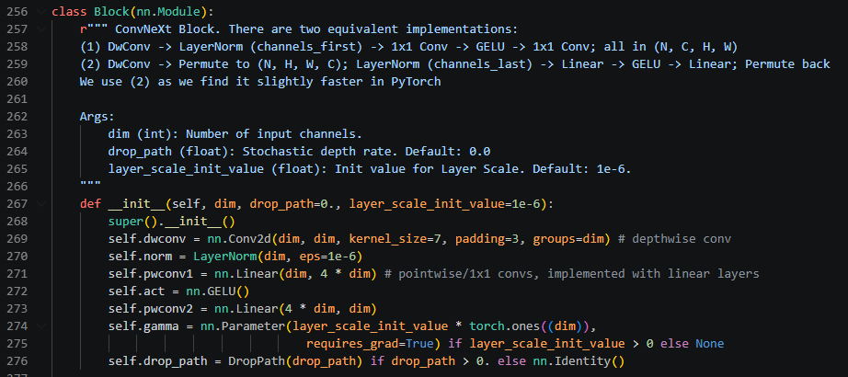

The truncated encoder used by the dehazing model: ConvNeXt() in model_convnext.py
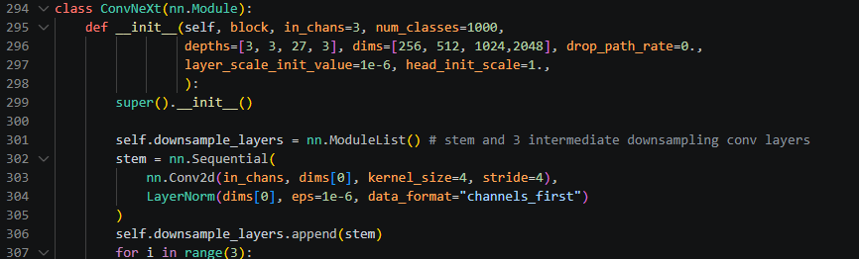

- Not using the full classification model.
- Keep only the first three ConvNeXt stages and return multiscale features.
- Makes ConvNeXt a feature encoder for restoration, not an ImageNet classifier.

The transfer learning step: knowledge_adaptation_convnext() in model_convnext.py
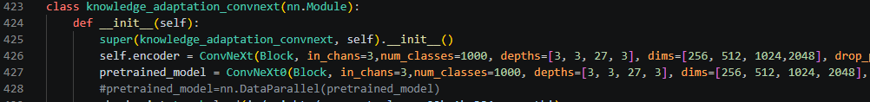

- Convnext0() is the full model shape used just to load the official pretrained checkpoint.
- Convnext is the smaller encoder actually used in the branch.
  - Copy only matching weights from the full pretrained model into the truncated encoder.
  - This is transfer learning.

The convnext decoder is also in knowledge_adaptation_convnext(), and the attention models are defined in:
- PALayer()
  - Spatial or pixel attention – learns a single spatial mask telling the network where to focus.
  - “where in the image should I emphasize them?”
- CALayer()
  - Channel attention – uses global average pooling + 1x1 convolutions to learn which channels matter more.
  - “what feature matters?”
- CP_attention_block()
  - Applies convolution, then channel attention, then spatial attention.

Final fusion happens: fusion_net() in model_convnext.py
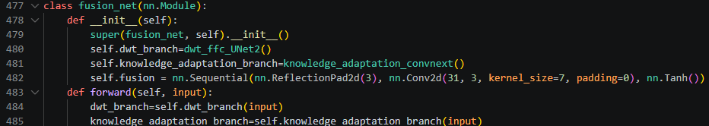

Output:
- DWT-FFC branch outputs 3 channels
- ConvNeXt branch outputs 28 channels
- They concatenate to 31 channels, then a final 7x7 convolution produces the RGB image.

Inference
Test Images found on: pixelbay.com

Running inference using test.py
- Generic inference path
- Accepts any supported image file, lets you choose the checkpoint, and runs sliding-window tiled inference.

Running inference using validation.py
- Old challenge-specific path
- Hard-codes validation_best.pkl, assumes cuda:0, and reconstructs outputs only for the original NTIRE-style fixed crop layout.

Results:

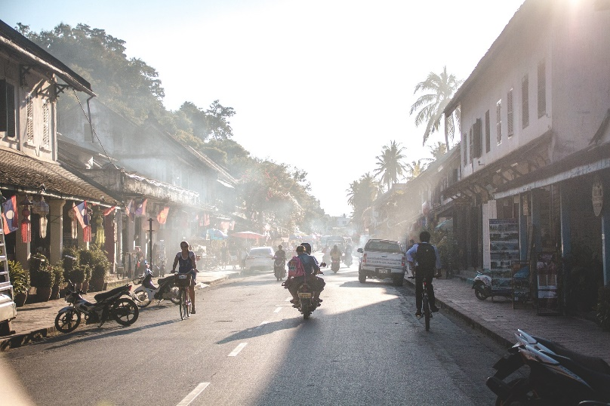
Picture 1
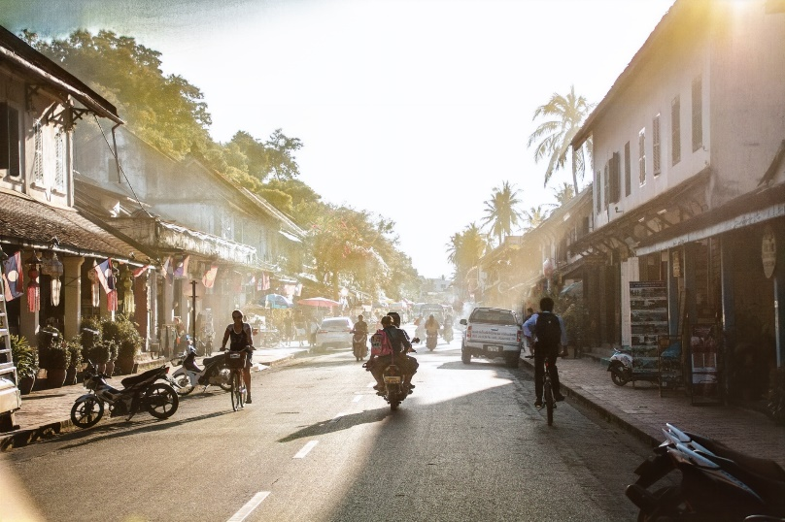

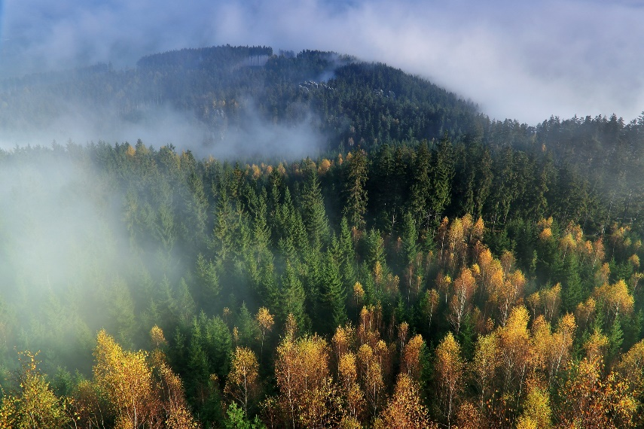
Picture 2
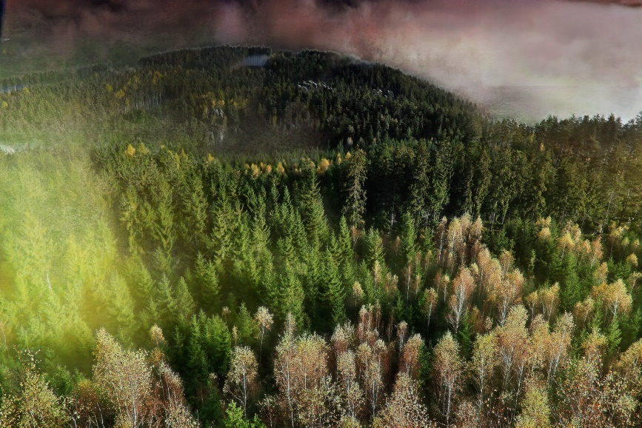

Terminal:
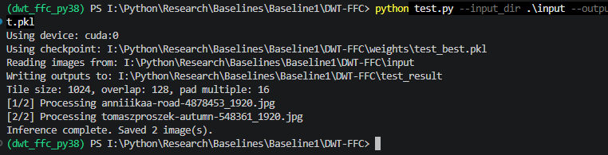
- Tile size 1024: the image is processed in 1024x1024 chunks instead of one huge forward pass.
- Overlap 128: neighboring tiles overlap by 128 pixels so seams are reduced when outputs are stitched back together.
- Pad multiple 16: each tile is padded so its heigh and width are divisible by 16, which matches the models downsampling and wavelet/UNet-style structure.

Note:
- AMP error: the model’s FFC path uses FFT at ffc0.py. With “—amp”, PyTorch tried to run that path in half precision (float16), and my build does not support that FFT op in half precision.
- Original repo used a hard-coded 3x3 split for very specific massive challenge images. Patched test.py uses a generic sliding window tiling: it creates however many tiles are needed based on the actual image size, with overlap, then averages them back together.
  - Makes it work on arbitrary images instead of only NTIRE crop geometry.

Baseline 2: DehazeDCT
Towards Effective Non-Homogeneous Dehazing via Deformable Convolutional Transformer

Paper Summary
High level overview: Baseline 2 keeps the core intuition of Baseline 1; non-homogeneous haze needs both strong global/contextual modeling and frequency-aware restoration.
- it changes the main representation-learning mechanism from FFC + ConvNeXt to a deformable-convolution-based transformer-like architecture,
- then adds a separate lightweight refinement transformer for color/detail cleanup.

What baseline 2 is trying to solve
Same problem setting as Baseline 1: non-homogeneous dehazing, where haze is spatially irregular, dense in some regions, and much harder than standard homogeneous haze handled by the atmospheric scattering model (ASM).

Existing methods still struggle because high-resolution hazy images are expensive to process, and common architectures each have limitations:
- CNNs often rely on large fixed kernels and strong inductive bias,
- while transformers capture long-range dependencies but are often too memory/computation heavy for very large images like 4000×6000.

Core Architecture
Baseline 2 is composed of two modules, not just a single two-branch generator as in Baseline 1:

- Dehazing module
- Refinement module

Inside the Dehazing module, there are two branches:
- a main transformer-like dehazing branch built from DCNFormer blocks, and
- a frequency-aware branch (borrowed conceptually from prior frequency-aware / DWT-FFC style designs).

Then, after preliminary dehazing, the output is passed to a separate lightweight Retinex-inspired transformer refinement module that improves color correction and structure/detail refinement.

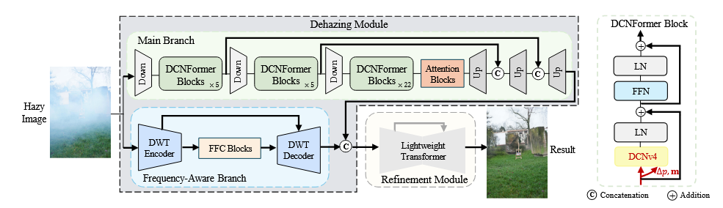
- In the Dehazing module, we introduce a transformer-like dehazing branch based on deformable convolution (DCNv4)
- In each DCNFormer block, DCNv4 is utilized to calculate the offset (∆p) and modulation scalar (m).
- Besides, the frequency-aware branch is also adopted as an auxiliary branch.
- In the Refinement module, we leverage a lightweight retinex-inspired transformer network to further reduce the color deviation and enhance texture details.

- Dehazing module - engineer transformer-like dehazing branch that incorporates multiple DCNFormer blocks.
- DCNFormer blocks utilize Deformable Convolution v4
  - ensuring our model benefits from both long-range dependency and adaptive spatial aggregation capabilities.
  - DCNFormer architecture demonstrates faster convergence and forward speed than traditional DCN

- Refinement module - enact a lightweight Retinex-inspired transformer for color correction and structure refinement.
- our DehazeDCT is capable to achieve color and detail consistency, essential for visually compelling results

Key New Idea
The key new idea is the DCNFormer block. Instead of using:
- standard convolution only, or
- full self-attention as in a normal transformer,

The paper uses Deformable Convolution v4 (DCNv4) as the core operator inside a transformer-like block. The paper’s argument is that DCNv4 gives them two things at once:

- Long-range dependency
  - Haze is not purely local — recovering one region may depend on scene-wide context, illumination, and global degradation patterns.
- Adaptive spatial aggregation
  - Unlike fixed-grid convolution, deformable convolution learns offsets for where to sample features.
  - Means the network can adaptively focus on the spatial structures that matter for a given input image/region, which is useful for irregular haze patterns.

Note:
- Traditional CNNs with large fixed kernels can be powerful but are computationally expensive and less adaptive.
- Standard self-attention is flexible but has quadratic cost in resolution.
- solution is to replace attention with DCNv4, which is more efficient route to transformer-like behavior on high-res dehazing.

DCNFormer Block
The DCNFormer block is designed to resemble a transformer block structurally, but instead of self-attention as the core mixing operation, it uses DCNv4.

More specifically, deformable convolution learns:
- offsets - that shift the sampling points away from the regular convolution grid, and
- modulation scalars - that control the importance of those sampled features.

DCNv4 removes the softmax normalization on the modulation scalars that was used in DCNv3. According to the paper, this gives:
- unbounded dynamic weights,
- faster convergence, and
- faster forward speed.

Why Baseline 2 calls itself a Deformable Convolutional Transformer rather than a standard transformer. It wants the:
- benefits of adaptive, long-range modeling,
- but with better efficiency for restoration on large images.

Frequency Aware Branch
Similarly to baseline 1, baseline 2 uses frequency information.
- keeps a frequency-aware branch as an auxiliary branch in the dehazing module.
- Related to the earlier DWT-FFC frequency branch idea from Baseline 1 / related work.

The Refinement Module
Baseline 1 produces the final result through fusion of the DWT-FFC branch and the ConvNeXt prior branch, supervised with a GAN discriminator.
Baseline 2 instead does:
- preliminary dehazing via the dehazing module,
- then refinement via a lightweight Retinex-inspired transformer.

The refinement module is used for:
- color correction
- structural/detail refinement

Training and Optimization Strategy
Stage I: Train the dehazing module
- Adam Optimizer (0.9, 0.999)
- Initial learning rate 1e-4
- Total 5000 epochs
- Learning rate decay by 0.5x (1500, 3000 and 4000 epochs)

Stage II: Train refinement
- Train refinement module for 500 epochs
- Then train whole module for another 500 epochs
- Fixed learning rate of 1e-5

Note:
- meaningful change from Baseline 1:
  - Baseline 1 uses a single overall objective for the whole model,
  - Baseline 2 has a staged optimization plan because the architecture itself is now functionally separated into dehazing first, refinement second.

Results
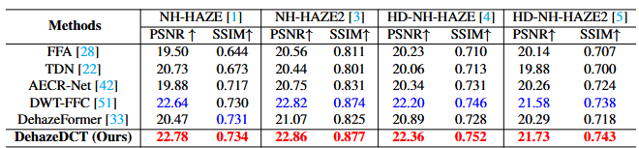

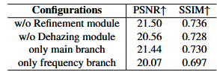
- removing the refinement module hurts performance,
- removing the dehazing module hurts even more,
- using only the main branch is worse than full dehazing module,
- using only the frequency branch is worse still.

Differences between Baseline 1 and 2
Baseline 1 | Baseline 2
- solving the representation + small-data problem  - using DWT + FFC + pretrained ConvNeXt | - solving the “how do we model long-range structure efficiently on very high-res images?” problem  - using DCNv4-based transformer-like blocks.

Main branch changed from FFC-based CNN branch to DCNv4-based transformer-like branch

Baseline 1
The first branch is a DWT-FFC encoder–decoder:
- DWT captures high-frequency information,
- FFC captures global context through frequency-domain processing.

Baseline 2
The main branch becomes a DCNFormer transformer-like branch:
- deformable convolution v4 is used instead of self-attention,
- it provides adaptive spatial sampling and long-range dependency,
- it is intended to be more efficient for high-resolution images.

Reasoning:
- FFC is good at introducing global context, it still does not fully solve the challenge of adaptive spatial aggregation and efficient high-resolution dehazing.

ConvNeXt prior branch is replaced by a dedicated refinement transformer

Baseline 1
The second branch is a pretrained ConvNeXt encoder-decoder whose purpose is transfer learning / prior knowledge from ImageNet, especially because the datasets are small.

Baseline 2
There is no ConvNeXt prior branch. Instead, the second major component is a lightweight Retinex-inspired transformer refinement module for color correction and detail enhancement after the main dehazing.

Reasoning:
- Baseline 1 is heavily concerned with small-data generalization via a pretrained backbone.
- Baseline 2 is more concerned with effective/efficient dehazing itself and then post-dehazing perceptual refinement.

Frequency information stays, but becomes auxiliary

Baseline 1
Frequency-domain modeling is extremely central: DWT + FFC are core defining blocks.

Baseline 2
Frequency information is still kept through a frequency-aware branch, but it is now supporting the DCNFormer main branch rather than being the primary identity of the whole model.

Reasoning:
- frequency information is necessary but not sufficient. It helps restoration, but stronger spatially adaptive/contextual modeling is needed as the primary driver for challenging dense high-res haze.

Single integrated GAN-style optimization becomes staged optimization
Baseline 1
The architecture is trained as a single two-branch GAN framework with a combined total loss.

Baseline 2
Training is explicitly two-stage:
- train the dehazing module,
- then train/attach the refinement module.

Reasoning:
- potentially easier optimization
- Let’s the refinement network focus on a better intermediate image rather than learning everything jointly from scratch.

Code Analysis

Main Difference
*what model_convnext.py was to baseline 1, model_flashinterimage.py is to baseline2.

In baseline 2, the dehazing core keeps the same DWT-FFC branch, but swaps the second branch to FlashInternImage, which is DCNv4-based, in model_flashinterimage.py.
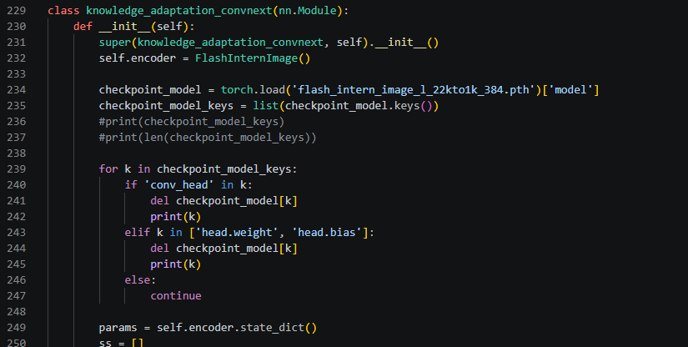
- Kinda weird – keeps same name from baseline 1 second branch (convnext prior branch)
  - The encoder is now FlashInternImage.
    - That model is built around DCNv4 in flash_intern_image.py (below).

And in flash_intern_image.py (under FlashInternImage and models folder):
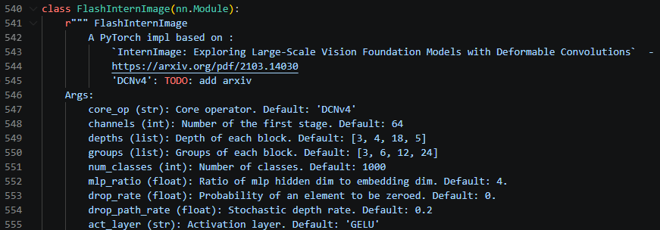

Adds a separate RetinexFormer refinement stage in model.py:
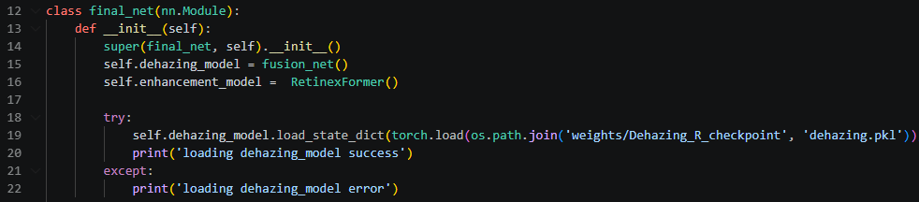

And in RetinexFormer_arch.py:
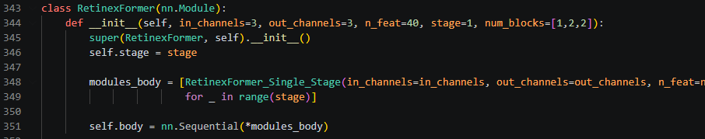

Practical motivation is:
- Keep the frequency-aware restoration that already worked in baseline 1, replace the older pretrained prior branch with a stronger adaptive resolution feature extractor, and move final color/detail clean up into a dedicated refinement module.

Second big motivation:
- Separate dehazing from perceptual clean up
- Baseline 1 trains a single GAN style generator with joint L1, perceptual, MS-SSIM and adversarial losses in train.py.
- Baseline 2 has staged training.

Thirdly:
- OOM handling and challenge scale images.
- Baseline 1’s older inference path pre-splits each test image into 9 overlapping crops inside dataloader.
- Baseline 2 simplifies the dataset loader, so it just returns the full hazy image in test_dataset_for_testing_nosplit.py.
  - Then performs targeted overlapping splits inside the model itself for 4000x6000 images.

Note:
- That second branch in baseline 1 was more dominant. It fused 31 channels down to RGB.
- Baseline 2 second module fuses only 11 channels.
  - Suggests the model is relying less on a heavy prior branch and more on a cleaner division of labor.

In-depth Architecture Analysis
Model_flashinterimage.py contains the same basic branch A + B+ fusion_net structure as baseline 1. But baseline 2 adds one more layer above that in models.py, so fusion_net is no longer the final model.
- Baseline 2 final system is: final_net = fusion_net + RetinexFormer.

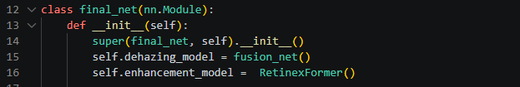

File Analysis
Test.py
- Inference entry point
- Builds the dataset, instantiates final_net, loads the final checkpoint, runs inference and saves outputs.

Model.py
- True top-level file
- Final_net contains fusion_net as the dehazing stage and RetinexFormer as the refinement stage.

Model_flashinterimage.py
- Baseline 1 style “main generator file”
- Defines branch A, dwt_ffc_UNet2, and branch B, knowledge_adaptation_convnext, and the coarse dehazing generator fusion_net.
- Closest to model_convnext.py

RetinexFormer_arch.py
- New refinement module
- Explains what happens after fusion_net produces a coarse dehazed image

Flash_intern_image.py
- Defines FlashInternImage, the imported DCNv4 backbone used inside branch B

Test_dataset_for_testing_nosplit.py
- Test loader
- Load the full hazy image and return it

Class Analysis
Final_net() in Model.py

- Full baseline 2 model

Fusion_net() in model_flashinterimage.py
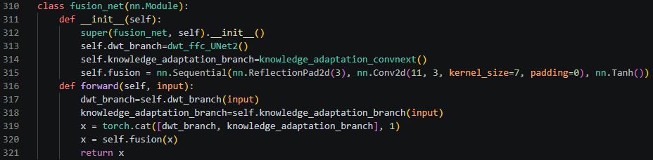
- Fuses branch A and B into a coarse RGB dehazed result

Dwt_ffc_UNet2() in model_flashinterimage.py
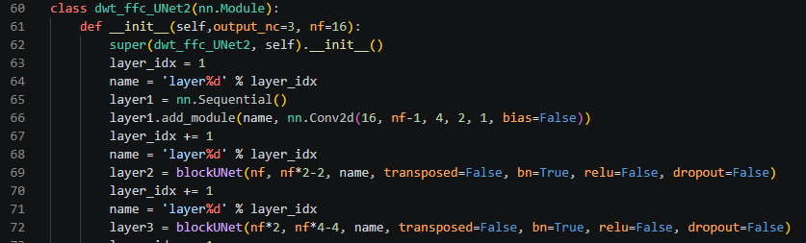
- Branch A basically carried over DWT-FFC frequency branch from baseline 1

Knowledge_adaptation_convnext() in model_flashinterimage.py
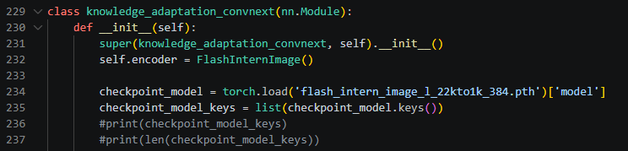
- Now wraps FlashInternImage in model_flashinterimage.

Retinex_Former() in RetinexFormer_arch.py
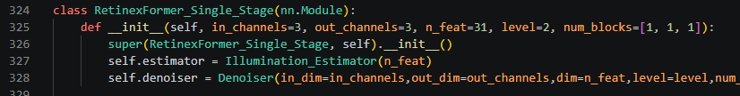
- New second stage
- Does not replace dehazer, it refines the dehazer output

FlashInternImage() in flash_intern_image.py

- The actual DCNv4-based feature extractor behind branch B

Cleanest mental model
Test
-> final_net
-> fusion_net
-> branch A dwt_ffc_UNet2() + branch B knowledge_adaptation_convnext() / FlashInternImage
-> coarse dehazed image
-> RetinexFormer
-> final refined output.

Inference

DCNv4 Build Issue Summary
Why inference cannot run
- This model is not pure Python or pure PyTorch.
- It calls into DCNv4, which is a compiled CUDA extension.
- If DCNv4 does not build, the Dehazing_R model cannot execute inference.

Current situation
- Dehazing_R inference is blocked because the project depends on the custom CUDA extension under DCNv4_op.
- The extension must compile successfully before the model can run its forward pass.
- Because DCNv4 does not build on this Windows machine, I cannot run inference for this baseline yet.

What I verified
- The Conda environment dehazedct activates correctly.
- PyTorch sees CUDA and reports version 11.3.
- nvcc is installed and found on PATH.
- cl.exe is now found from the Visual Studio Build Tools install.
- Pure Python dependencies from requirements-inference.txt install correctly.

What failed earlier
- At first, DCNv4 failed because CUDA toolkit discovery was incomplete.
- Then it failed because cl.exe was not available in the shell.
- Then it failed because the Visual C++ environment was active but DISTUTILS_USE_SDK was not set.

What the current build log shows
- The build now gets into actual C++ and CUDA compilation.
- The compiler path being used is an x86 toolchain, not an x64 one.
- The build folder in the log is win32-cpython-38, which indicates a 32-bit compile path is being used during the extension build.
- The errors also show a toolchain compatibility problem between CUDA 11.3 and the installed Microsoft C++ standard library / compiler version.

Important error signals from the current build log
- The compiler path points to Hostx86/x86 cl.exe.
- The build output path is temp.win32-cpython-38.
- The STL header reports: error STL1002: Unexpected compiler version, expected CUDA 12.4 or newer.
- Many follow-on errors then appear in Visual Studio and CUDA headers, including redeclarations of size_t, repeated template definitions, and intrinsic mismatch errors.

Most likely root causes now:
1. The active MSVC toolchain is x86 instead of x64.
2. The installed Visual Studio toolset and STL are too new for CUDA 11.3.
3. CUDA 11.3 is old enough that it is sensitive to compiler and STL version mismatches on modern Windows toolchains.

Baseline 3: Low-Light Image Enhancement with Normalization Flow

Paper Summary
Introduces normalizing flows + a sophisticated training pipeline.

In the paper they introduce:
- conditional normalizing flow to model the conditional distribution of normally exposed images.
- A novel module to extract the illumination invariant color map inspired by the Retinex theory
  - prior for the low-light image enhancement task, which enriches saturation and reduces color distortion.

What problem the paper solves
The paper addresses low-light image enhancement (related to but different from dehazing). Low light images suffer from:
- low visibility,
- severe noise,
- color distortion,
- loss of detail in dark regions.

Low-light enhancement is ill-posed:
- many possible well-lit images could correspond to the same dark image.
- This ill-posedness is central to why the authors move away from deterministic CNN mappings and instead use probabilistic modeling via normalizing flows.

Core idea of normalizing flows
Most CNN-based enhancement methods learn a deterministic mapping:
$$I_{low} → I_{enhanced}$$

But this ignores uncertainty:
- noise amplification,
- ambiguous color recovery,
- multiple valid brightness distributions.

Key idea:

Instead of predicting one enhanced image, model the conditional distribution:
$$p(I_{normal}|I_{low})$$

Normalizing flows allow:
- exact likelihood computation,
- invertible mapping between image space and latent space,
- stable training compared to GANs,
- sampling multiple plausible outputs (in theory).

Normalization flow fundamentals (core math)
A normalizing flow models a complex distribution by transforming it into a simple one (usually Gaussian) via a sequence of invertible functions.

Let:
- x = target image (normal-light image)
- z = latent variable, typically z ~ Ν(0,I)
- $f_{θ}$ = invertible neural network

Forward transformation:
$$z=f_{θ}(x)$$

Inverse transformation:
$$z=f_{θ}^{-1}(x)$$

Using the change of variables formula, the log-likelihood is:
$$\log{p\left(x\right)}=logp\left(z\right)+log\left|det\frac{∂f_{θ}(x)}{∂x}\right|$$

This equation is the mathematical backbone of the paper.

Conditional normalization flow for low-light enhancement
The paper models a conditional distribution: p(x|y)
Where:
- x = normal-light image
- y = low-light image (conditioning input)

The flow becomes;
$$z=f_{θ}(x;y)$$

And:
$$\log{p\left(x|y\right)}=logp\left(z\right)+log\left|det\frac{∂f_{θ}(x;y)}{∂x}\right|$$

This means:
- the flow is conditioned on the low-light image,
- the conditioning enters via feature extractors and affine coupling layers.

Architecture: LLFlow (high level)
(a) Feature extractor
A CNN extracts multi-scale features from the low-light input y.
These features condition the flow:
- via affine coupling layers,
- via scale/shift parameters.

b) Flow network
Built from:
- affine coupling layers,
- invertible 1X1 convolutions,
- multi-scale architecture (split latents at different resolutions).

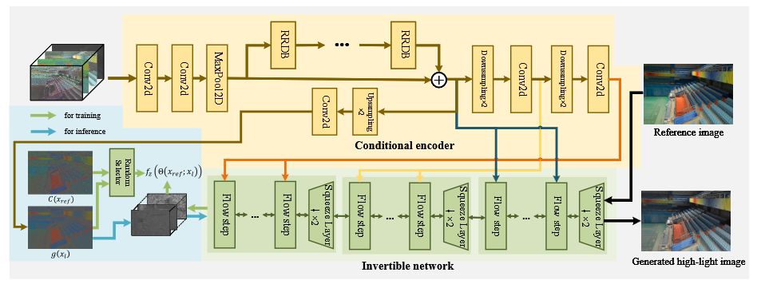
In summary, proposed framework includes two components:
- an encoder g which takes a low-light image xl as input and output illumination invariant color map g(xl) (which can be regarded as reflectance map inspired by Retinex theory),
- and an invertible network that maps a normally exposed image to a latent code z. The details of the two components are introduced in the following subsections.

Forward vs. Inverse passes

Training (forward flow)

Given:
- paired data (x,y) (normal-light, low-light)

Compute:
$$z=f_{θ}(x;y)$$

Optimize negative log-likelihood:
$$L_{NLL}=-logp(x|y)$$

Fully supervised and probabilistic.

Inference (inverse flow)

At test time:
- sample z ~ Ν(0,I)
- compute:
$$\hat{x}=f_{θ}^{-1}(z;y)$$

This produces an enhanced image.

This is very different from CNNs:
- CNNs only run forward,
- flows must run both forward and inverse correctly.

Additional Losses (not just likelihood)
Pure likelihood optimization often leads to:
- overly smooth results,
- weak perceptual quality.

The paper introduces additional constraints.

(a) Reconstruction loss
A pixel-wise loss between predicted and ground truth images.

(b) Perceptual loss
Computed in VGG feature space to preserve:
- texture,
- semantic structure.

(c) Noise modeling
The flow explicitly models noise in dark regions rather than suppressing it blindly.
The final loss is a weighted combination:
$$L=L_{NLL}+λ_{1}L_{rec}+λ_{2}L_{perc}$$

LLFlow is not a “pure flow” model — it is a hybrid likelihood + perceptual training setup.

Why normalization flow is well-suited for low-light enhancement
Key advantages:
- Explicit uncertainty modeling
  - dark regions are ambiguous,
  - flow can represent distributions, not single outputs.
- Noise-aware enhancement
  - noise is part of the generative process,
  - avoids aggressive denoising artifacts.
- Exact likelihood
  - unlike GANs,
  - no mode collapse,
  - stable training.
- Invertibility
  - preserves information,
  - avoids irreversible detail loss common in CNNs.

Training pipeline
(1) Paired data
The model is trained on paired:
- low-light images,
- normal-light ground truth.

(2) Multi-scale training
Latents are split across resolutions:
- improves stability,
- reduces computational burden,
- improves global–local modeling.

(3) Conditioning everywhere
Low-light features condition:
- every coupling layer,
- every scale.
This is not optional — without conditioning, the model collapses.
(4) Careful loss balancing
Likelihood alone is insufficient. Perceptual losses are necessary to get visually pleasing results.

(5) Stable optimization
Flows are:
- memory heavy,
- sensitive to numerical instability.

The pipeline carefully manages:
- learning rates,
- initialization,
- loss weights.

Comparison to baseline 1 and 2
Aspect | Baseline 1 (DWT-FFC) | Baseline 2 (DehazeDCT) | Baseline 3 (LLFlow)
Task | Dehazing | Dehazing | Low-light enhancement
Core idea | Frequency + CNN + prior | Deformable transformer | Probabilistic modeling
Deterministic? | Yes | Yes | No
Generative? | GAN-based | GAN-based | Likelihood-based
Uncertainty modeling | NO | NO | YES
Invertible | NO | NO | YES
Training stability | Medium | Medium | High (no GAN collapse)

