Backup/Recovery
In this assignment we were tasked with creating a backup plan for a corporation of 3 database administrators. We had to describe the types of backups, as well as different database backup schedules. I have also included support protocols for is something were to happen to the main DBA. The recovery process is very detailed and outlines what should happen if a server were to go down. There are metrics for improvement with each restoration and backup, as well as examples of scripts to restore, backup, and kill users who may be logged into the database. Documentation is also included with the wizard in SSMS to be able to use the wizard for backups and restorations.

Backups done locally should have a physical backup that can be implemented to the database if they fail. Backups done over the cloud should be copied in many different locations such as one cloud backup being stored in Dallas Texas, and one being stored in Charlotte North Carolina. These are similar because you can store it to multiple different locations, and can also have backups of backups.

Robust Model for Full and Transaction Backups
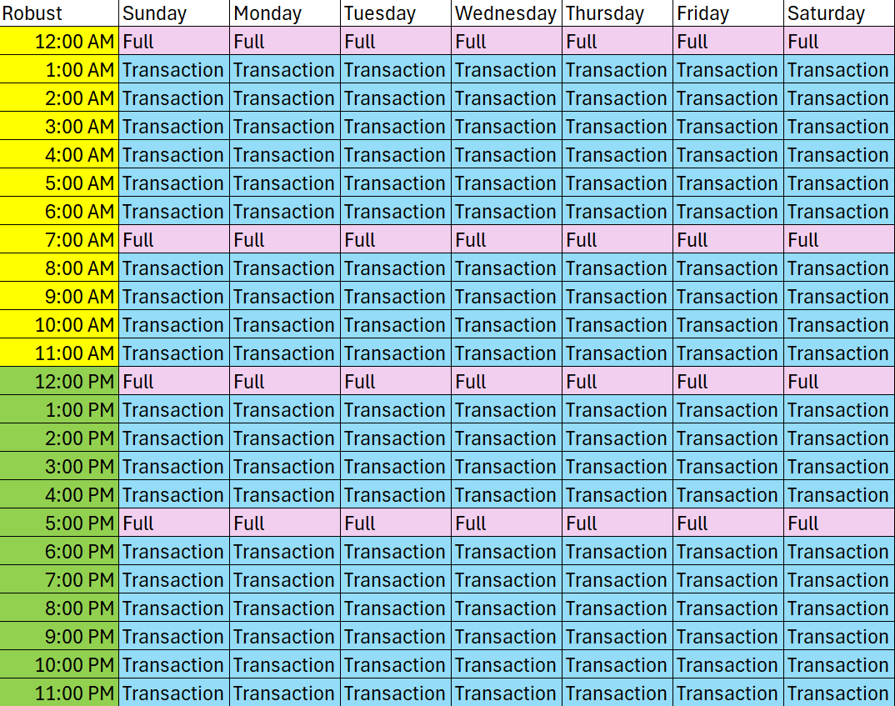
This is a very robust backup that has 20 transaction/log database backups. With 4 full backups. One being done at midnight before any changes are made during the early morning. Then a full backup is done at 7am before anyone starts working on the database to save or detect any changes before the day starts to make sure we don’t have to revert back to the midnight backup. There is also a full backup done at 12PM to save from the morning sessions. Lastly I did a full backup at 5PM to save all of the data from the day.

Intermediate Backup for Full and Transactions
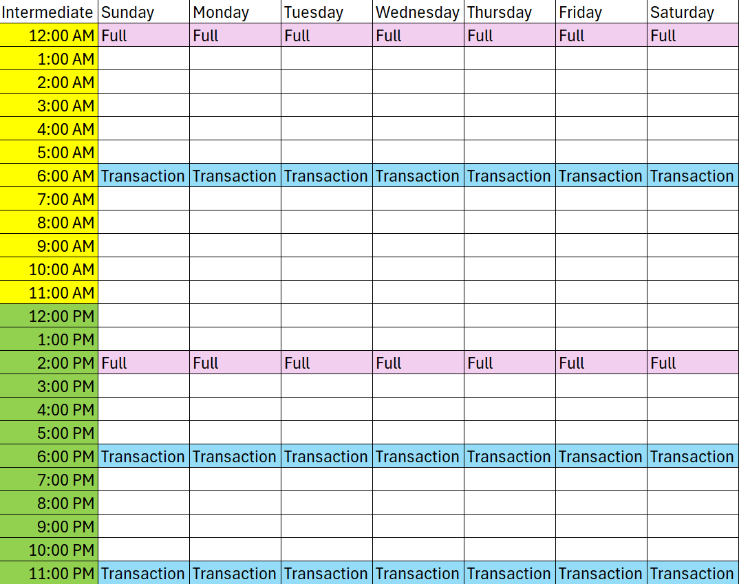
This is an intermediate design, with 2 full backups each day, with 3 transaction backups each day. This will give lots of rooms for lost logs, and lost database information.

Simple Backup for Full and Transactions
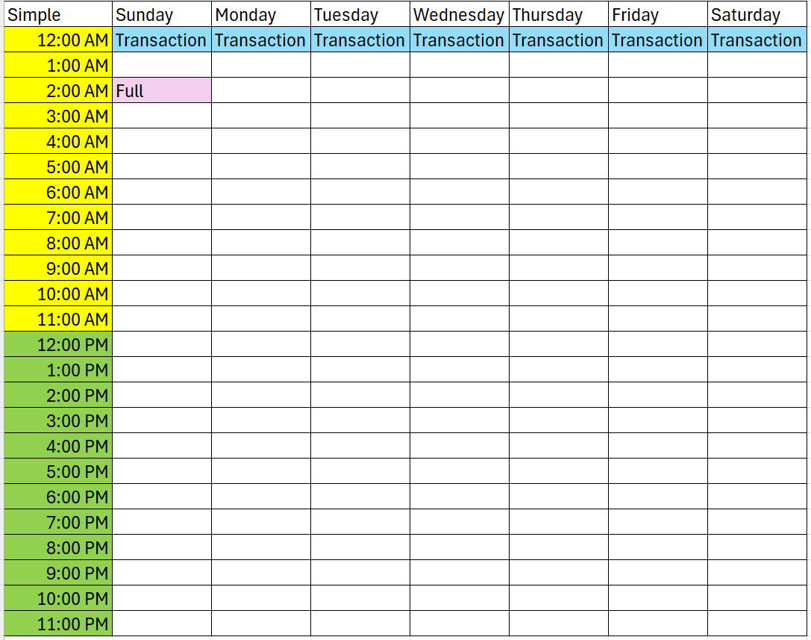
This backups schedule is very lacking, and if something goes wrong with the database there would be lots of information lost. With only one full database for the week, if something goes wrong on Saturday then all of the data since Sunday is lost. As well as any log data would be lost from each day.
Support Protocol
In the event that the main DBA is not available to do the backup, the team should look into the hierarchy of the DBA’s working form highest to lowest on the team. The recovery process should be followed as set forth. Notify everyone involved and communicate efficiently. Backups should be stored on a encrypted NAS, as well as in the cloud software. We will be backing up the main databases with the most data and then moving down to the least important.

Recovery
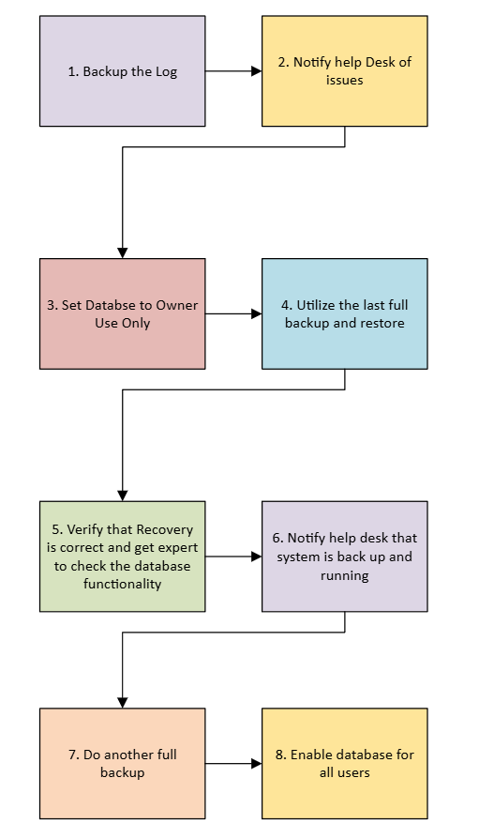

Metrics
- How long does it take to backup database? Transaction log?
- Size of database?
- Approximate size of tables in database?
- How long does it take to restore?
- How long was the system down?
- When did you begin the recovery?
- How many users were impacted?
- How often does the system go down?
- Who did it affect?
- Business cost?
- How?
- Impact(s)
When evaluating the backup we will be looking at all of these metrics. We need to be looking into ways to make backups faster, and figure out where our failures are coming from. We also want to figure out how many users each loss affected, and if we can reduce that number to not have as many people lose their work.

Change Over Request Form
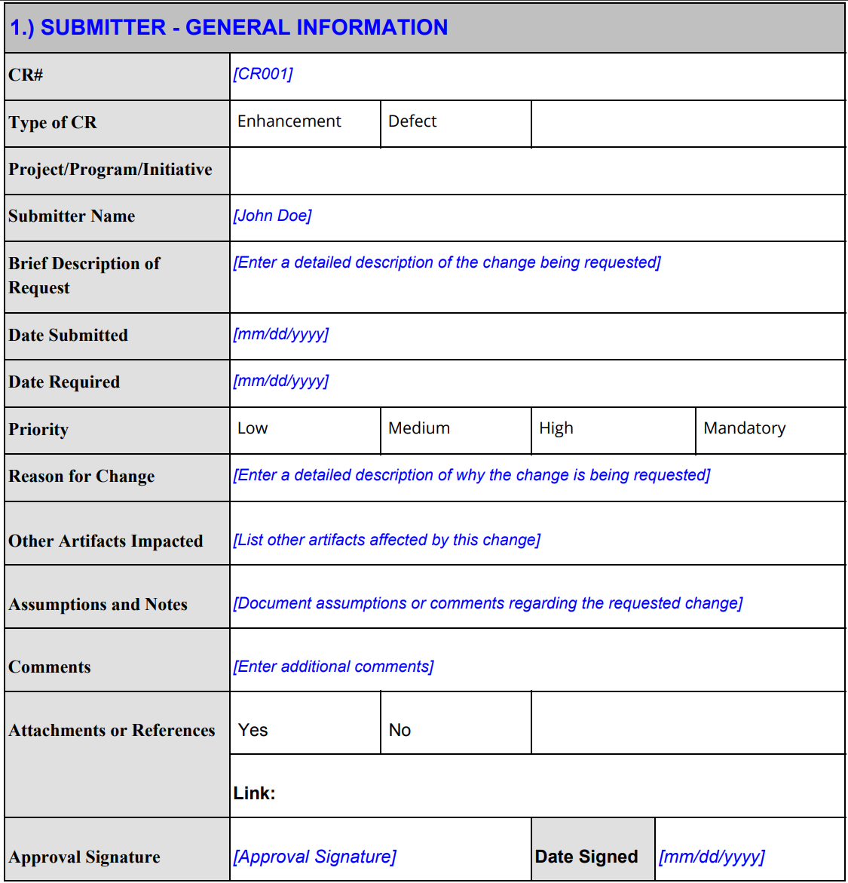

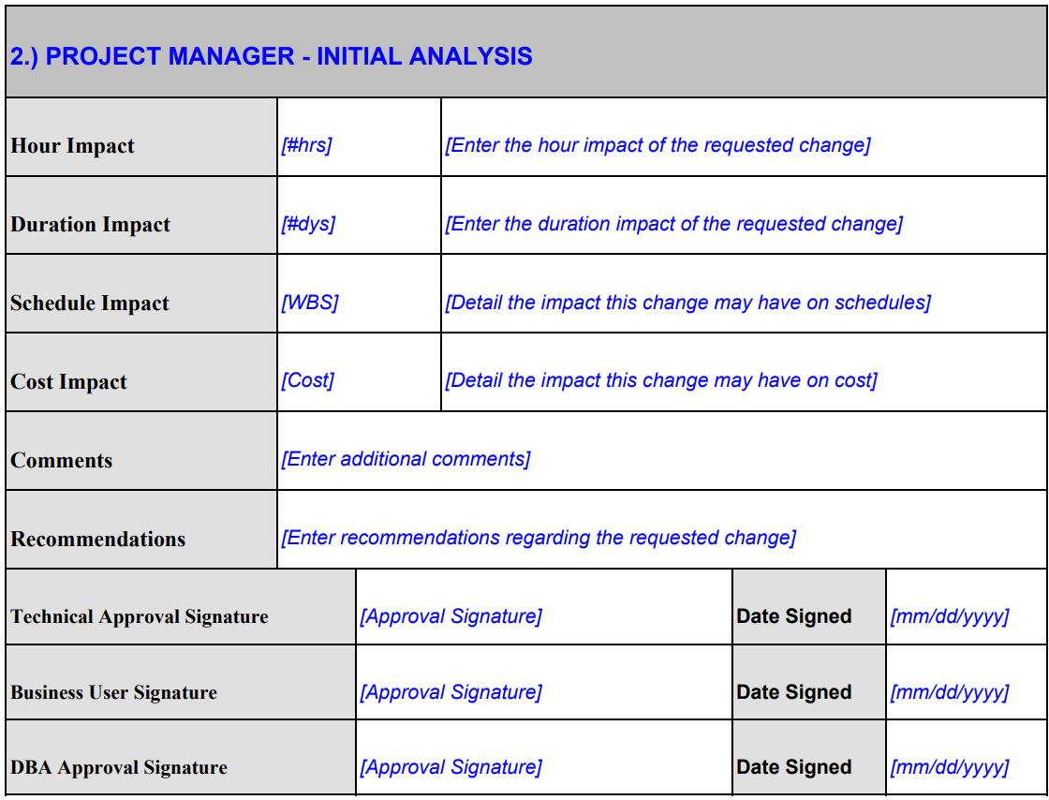
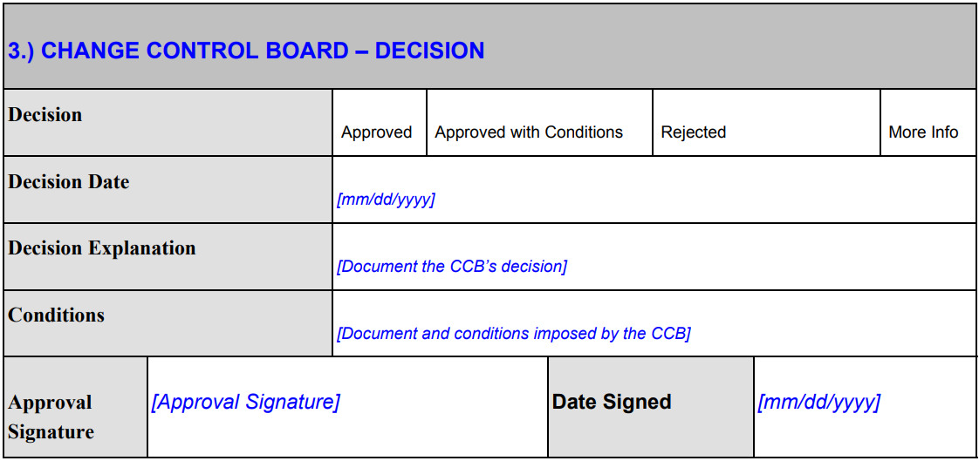

Change Over Protocol
Change over requests must be submitted at least 3 hours prior to end of workday and or the change needs to be implemented. Emergent changes can be made 1 hour prior. All areas of the change forms needs to be filled out, and submitted to approvers.
Script to Kill and See Who is Logged in
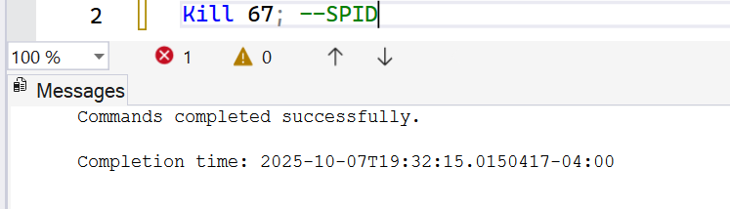
Script to kill
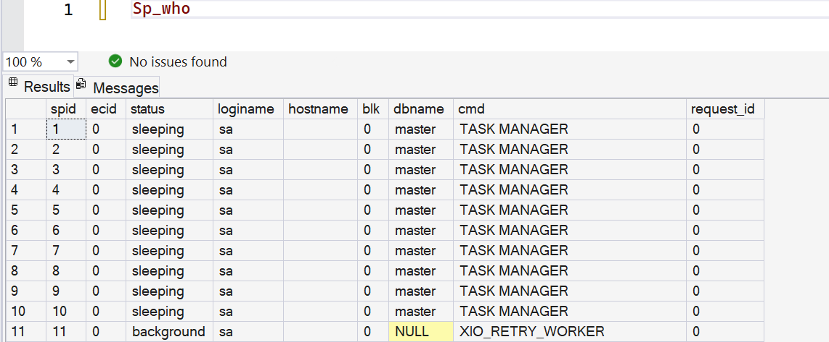
First script to see who is logged in
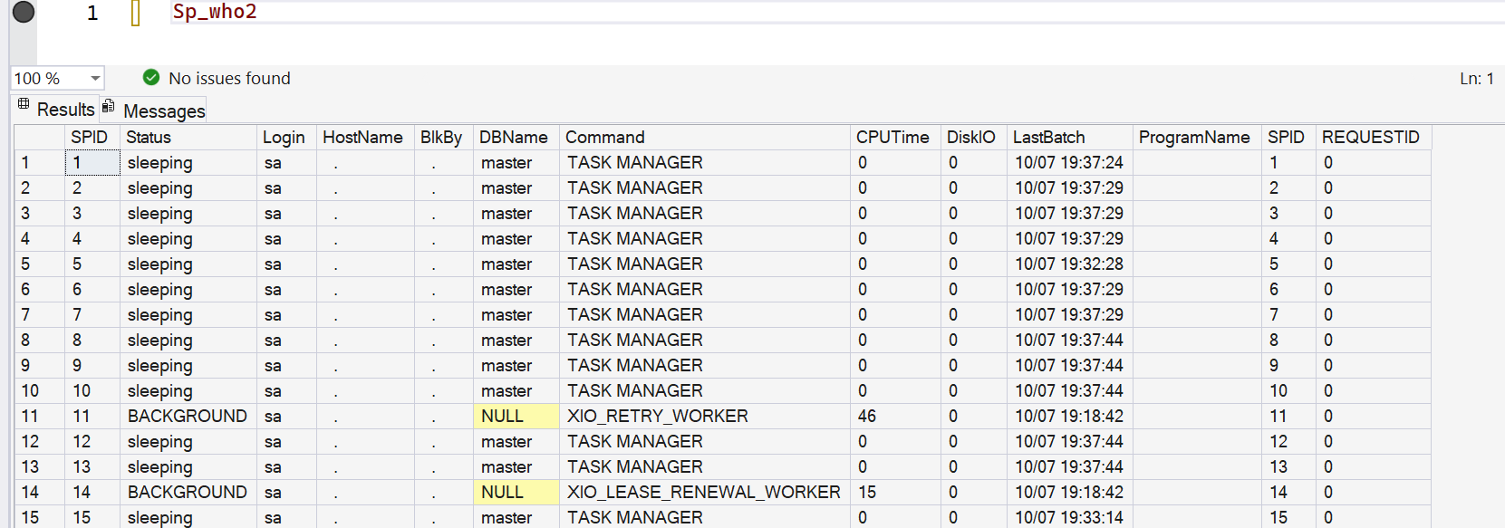
Second script of who is logged in with more detail
Backup via Scripts
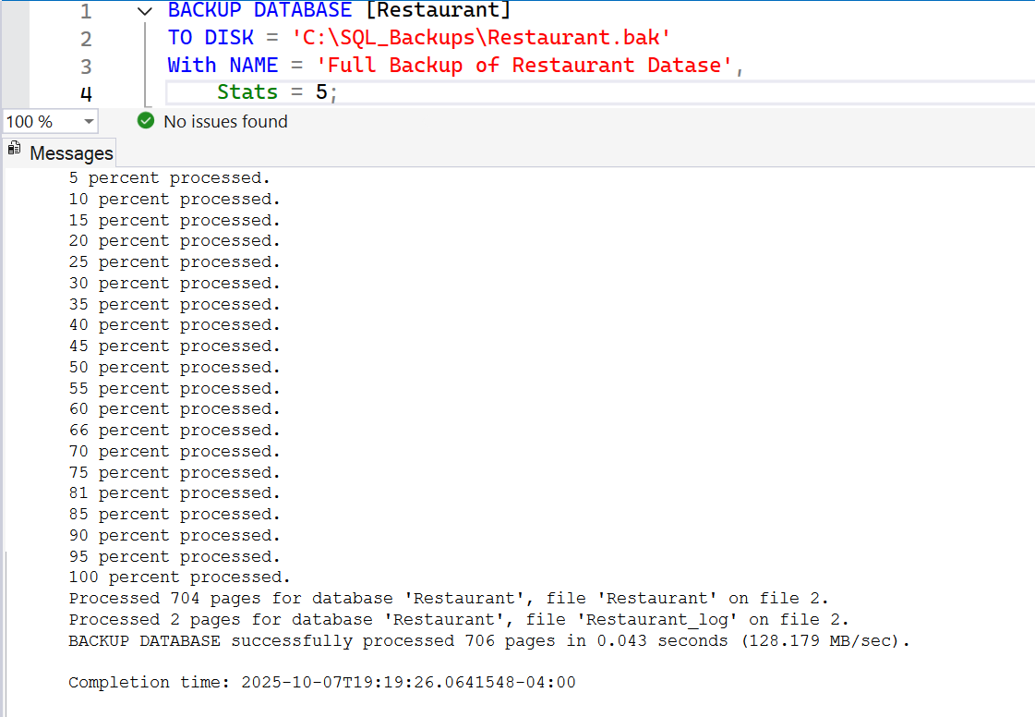
Script to be able to backup a database
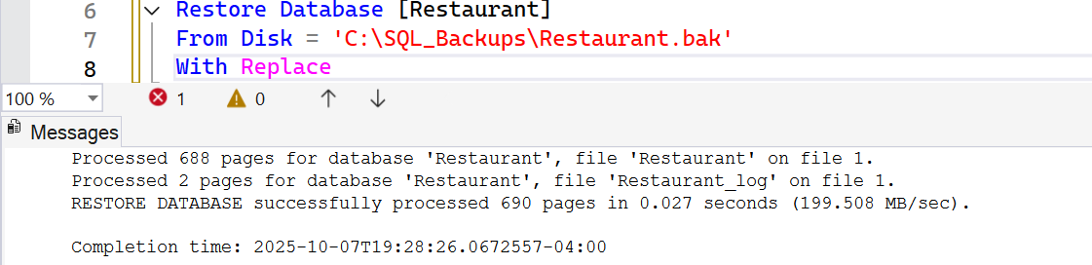
Script to restore database

Backup with Wizard
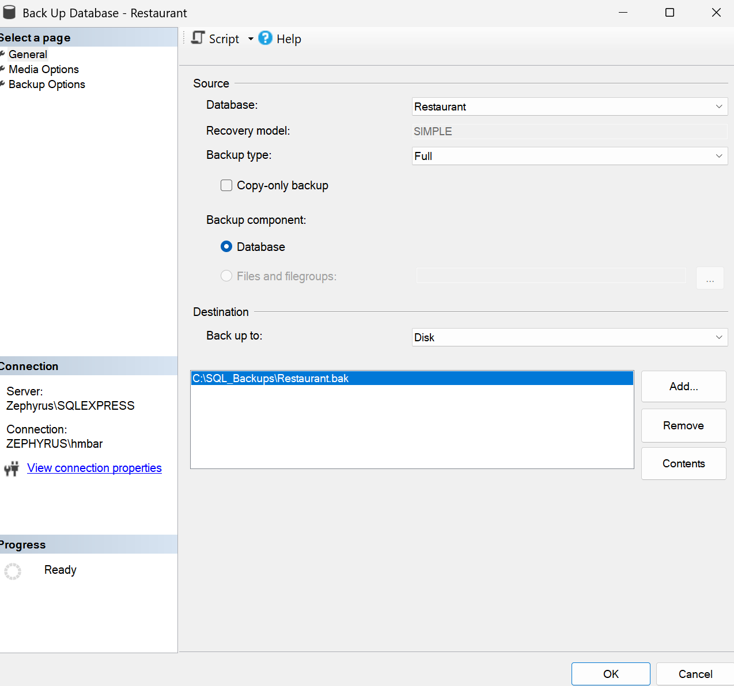
How to Backup using the wizard
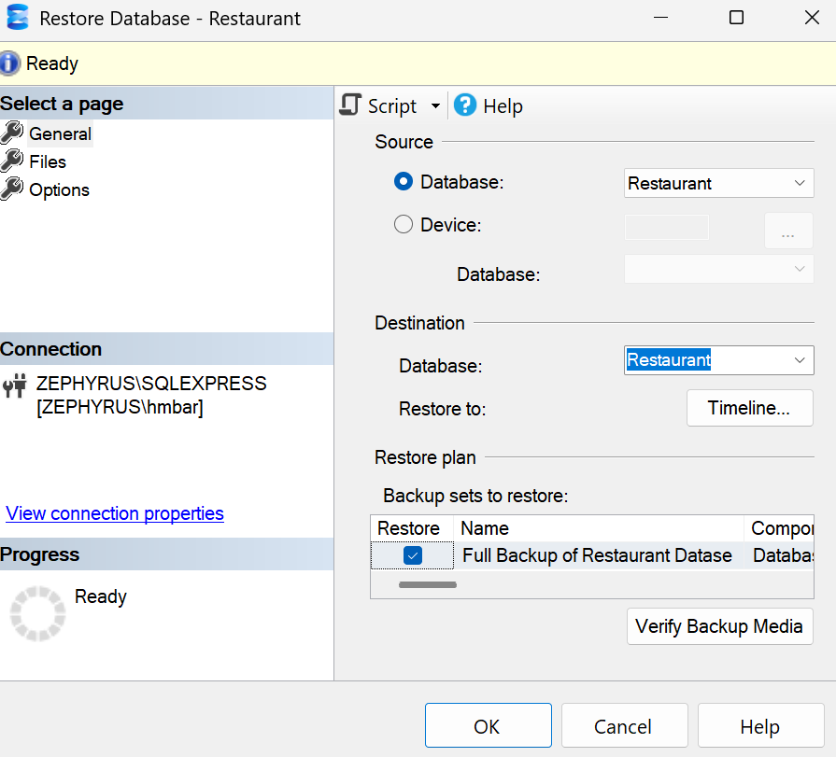
Restore Database using wizard
Restricts access to owner only
Narrative
To do this we will go to the database, right click, and select tasks, backup to backup the database. To restore the database we will also right click on the database, select tasks, and then restore database. To select the owner only role we will go to the options and select restrict access to restored database.

