Prompt 5: Preparation for the Translation of the “Calculation” Worksheet
This is a screenshot of a tariff calculator in Excel. Can you provide me with a list of the input and output parameters?
< Insert screenshot of the premium calculator here>

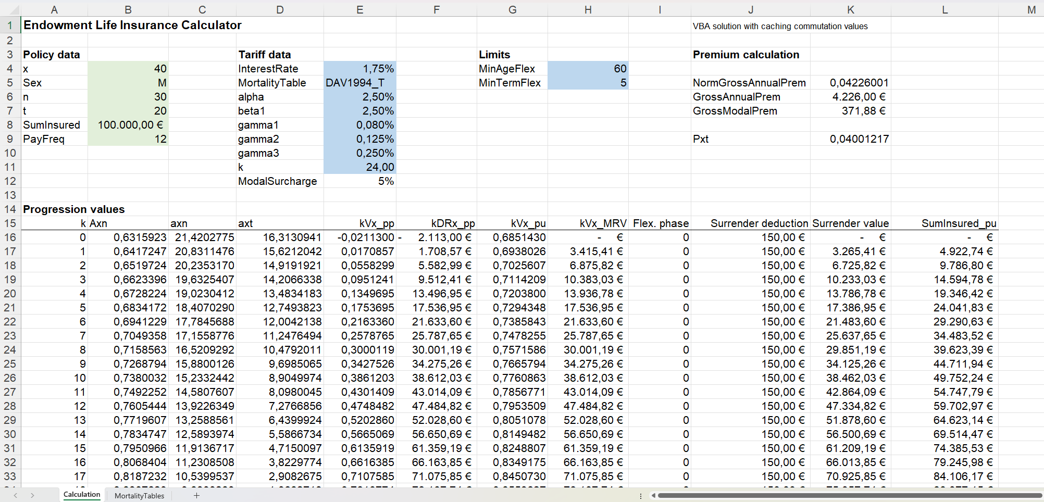

Result: Description of the input and output parameters

Prompt 6: Translation of the Formulas of the “Calculation” Worksheet
Next, I would like you to transform the formulas that appear under “Premium Calculation” and in the table “Progression Values” into Python functions. The formulas are as follows:
"
NormGrossAnnualPrem=(act_nGrAx(x;n;Sex;MortalityTable;InterestRate)+Act_Dx(x+n;Sex;MortalityTable;InterestRate)/Act_Dx(x;Sex;MortalityTable;InterestRate)+gamma1*Act_axn_k(x;t;Sex;MortalityTable;InterestRate;1)+gamma2*(Act_axn_k(x;n;Sex;MortalityTable;InterestRate;1)- Act_axn_k(x;t;Sex;MortalityTable;InterestRate;1)))/((1-beta1)*Act_axn_k(x;t;Sex;MortalityTable;InterestRate;1)-alpha*t)
GrossAnnualPrem=SumInsured*K5
GrossModalPrem=(1+ModalSurcharge)/PayFreq*(K6+k)
Pxt=(act_nGrAx(x;n;Sex;MortalityTable;InterestRate)+Act_Dx(x+n;Sex;MortalityTable;InterestRate)/Act_Dx(x;Sex;MortalityTable; InterestRate)+t*alpha*NormGrossAnnualPrem)/Act_axn_k(x;t;Sex;MortalityTable;InterestRate;1)
Axn=IF(A16<=n;act_nGrAx(x+$A16;MAX(0;n-$A16);Sex;MortalityTable;InterestRate)+Act_Dx(x+n;Sex;MortalityTable;InterestRate) / Act_Dx(x+$A16;Sex;MortalityTable;InterestRate);0)
axn=Act_axn_k(x+$A16;MAX(0;n-$A16);Sex;MortalityTable;InterestRate;1)
axt= Act_axn_k(x+$A16;MAX(0;t-$A16);Sex;MortalityTable;InterestRate;1)
kVx_pp = B16-P_xt*D16+gamma2*(C16-Act_axn_k(x;n;Sex;MortalityTable;InterestRate;1)/Act_axn_k(x;t;Sex;MortalityTable; InterestRate;1)*D16)
kDRx_pp= SumInsured*E16
kVx_pu=B16+gamma3*C16
kVx_MRV= F16+alpha*t* GrossAnnualPrem *Act_axn_k(x+A16;MAX(5-A16;0);Sex;MortalityTable;InterestRate;1)/Act_axn_k(x; 5; Sex; MortalityTable; InterestRate;1)
Flex. phase=IF(AND(x+A16>=MinAgeFlex;A16>=n-MinTermFlex);1;0)
Surrender deduction=IF(OR(A16>n;I16);0;MIN(150;MAX(50;1%*(SumInsured-F16))))
Surrender value =MAX(0;H16-J16)
SumInsured_pu=IFERROR(IF(A16>n;0;IF(A16<t;H16/G16;SumInsured));0)
"
You may assume that the VBA functions used in the formulas are already available as Python functions. The functions act_nGrAx and Act_axn_k are defined in the module presentvalues.py, and the function Act_Dx is located in the module commvalues.py.
Create a Python module that calculates the premium calculation and the progression values exactly as in the Excel premium calculator. The module should be named premium_and_progress_values. We will create the main program for this later.

Result: premium_and_progress_values.py

Prompt 7: Generation of the Main Program
Thank you. The module has been implemented as "premium_and_progress_values.py". Please create a main program that calculates the values from the “Premium Calculation” section and all progress values, and outputs them to the screen.
The main program should read the input parameters from the Excel file "Tariff_Calculator.xlsm", worksheet "Calculation".
The output file should be named “tariff_calculator.py”
To read the input parameters from the correct cells, please refer to the screenshot.
< Insert screenshot of the tariff calculator here >

Result: tariff_calculator.py

Prompt 8: Generation of a Comparison Program
Thank you very much. I would now like to create a program that checks whether the results produced by the Python code match the values in the Excel file. The program should read the input parameters from the Excel file "Tariff_Calculator.xlsm", worksheet "Calculation".
To read the input parameters from the correct cells, please refer again to the screenshot.
The output file should be named compare.py.
< Insert screenshot of the tariff calculator here >

Result: compare.py

