Assignment 109

Pool in 2D. Write a program simulating the movement of balls in a 2D billiard game. Results should be presented as an animation (use the Allegro library). Details to discuss.

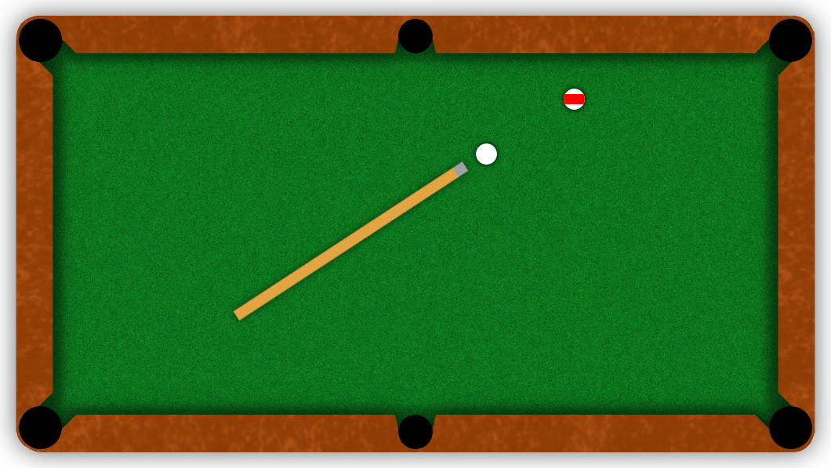

The program simulates simple game of eight-ball pool. There are 16 balls - cue ball (white), eighth ball (black), seven solid colored balls and seven striped ones. Initially all of the balls except cue ball are set up in triangle on the table. There are two players involved. Player 1. begins with "break shot" scattering the balls on the table. First ball pocketed after the break shot decides who plays with solids and who plays with stripes. On the beginning of each turn player sets the direction in which he wants to move the ball by moving the cue, then he decides how hard he wants to strike it using power bar on the right. If player succeeds to pocket his ball he gets another turn unless he also commits a foul. Foul is committed when: player fails to strike his own ball first, no ball hits the cushion, cue ball doesn't hit any other ball or cue ball is pocketed. Committing foul allows the opponent to move the cue ball in the beginning of his next turn. Pocketing black ball after "break shot" ends the game. If player pocketing it has previously pocketed all of his balls and doesn't commit a foul he wins.

The cue ball is going to have some initial velocity resulting from the cue strike. Any collision will be modeled as fully elastic collision, which means, that both momentum and kinetic energy are going to be conserved. In case of ball-ball collision it means that some of the energy will be transferred to other ball and their trajectories are going to be deflected, when ball collides with cushion it bounces away. In addition, balls are going to be susceptible to deceleration resulting from contact with the cloth.