Transcriptomic changes following mutations in comA and rapA in Bacilus subtilis

**Samples and experiment.**This RNAseq experiment aims to compare transcriptomic changes between 5 biological replicates of two *Bacillus subtilis*strains **NRS6942** (Control NCIB 3610 *amyE::Phy-spank-gfp mut2 (cml)*) and **NRS7771** (Experimental NCIB 3610*amyE::Phy-spank-gfp mut2 (cml) ΔrapP ΔcomA::spec*). The strains were grown in the same conditions at 30oC on MSgg media agar plates for 20h.

The control strain NRS6942 is a mutant of the lab strain NCIB 3610, containing a GFP tag to amyE; the experimental strain NRS7771 is a mutant of that strain, in which the genes *rapP*and *comA*have also been knocked out.

The experiment should be quite easy to analyse as there's only one contrast group (NRS6942-NRS7771).

**Biological background.***B. subtilis*NCIB 3610 outcompetes other *Bacillus*strains; the project aimed to identify genetic changes that might allow the outcompeted strains to better compete and endure NCIB 3610. Through an untargeted evolution approach, the NSW lab generated various strains that were able to better compete. Analysis of these better-competing strains indicated that a mutation in the *comP*gene increased their survivability. To further analyse this, the NSW knocked out other genes (eg the transcription factor *comA*) in the *comQXPA* gene cluster to which *comP*belongs, as well as the *rapP*gene, another gene critical to quorum sensing and bacterial competition.

One such mutant, a *comA rapP*mutant line (NRS7771), was found to grow differently to its WT (NRS6942( (Figure below), indicating that both comA and rapP are important to *Bacillus* growth. We aimed to characterise the transcriptomic changes contributing to the changes in development.

The biological question is, how is the *Bacillus*transcriptome altered by mutation of *comA*and *rapP*? We are expecting there to be differences in cell division and reproduction, as well as in quorum sensing. Given the visual phenotype differences, we may also see changes in transcripts associated to biofilm development eg exopolysaccharides.

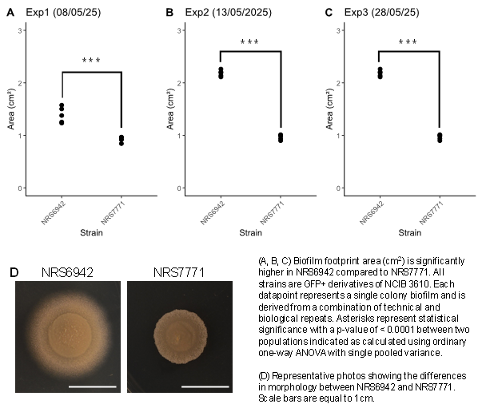

**What we're looking for.**A full start-to-finish analysis for the RNAseq data. The reads will need checking via MD5s, trimming, and aligning to the reference genome for NCIB3610 (accessions are CP020102 for the chromosome and CP020103 for the plasmid pBS32- I think these are stored here Y:\nrstanleywall\fasta_genomes) and a fastQC to check they're ideal, followed by quantification for differential analysis.

Any tools and output showing significantly up- or down-regulated genes in the comparison group, ideally with**adjP<0.05 and with a log2 fold chance of 1**. I'd love to see the various outputs eg volcano plots we can generate using your tool suite!

For a first pass, a GO analysis would be helpful for painting a broad picture of the affected processes, after which we can hone in on interesting changes in operons and known regulatory pathways. I don't know offhand where the annotation gff file for the GO terms and gene names for each transcript is, however, and will get it from Nicola when she's back from annual leave.