Steering mechanisms on a front-wheel drive cargo bike

The ‘double link’ steering mechanism
There have been a few cargo bikes and motorbikes produced in a new kind of steering mechanism, for now called the ‘double link’. One very well-documented example of a motorcycle is the ‘EsCargo’, from an Australian industrial design student. You can find many build pictures on the website and here in action. Another example is the cometa cargobike, which also seems a startup/DIY project. In short; the mechanism consists of two rotating arms, left and right, that suspend the wheel. The main advantage is that there is no longer a need to build a strong frame above the front wheel, making the centre of mass lower.
A disadvantage that comes out clearly from this review, is the unexpected lateral movement of the wheel while steering. When the wheel is steered one way, say clockwise (as in the Cometa cargobike top view picture), then the wheel rotates in that direction, but also moves entirely out (direction up in the picture). This effect is enhanced when the hub width of the suspension is large with respect to the link length. The rotation axes is thus not fixed (as in conventional steering setups), but is moving away from the direction the bike is driving towards (So: driving to the left will move the wheel to the right with respect to the bike frame).
If the brake is applied when steering the bike around a corner, the response of the steering mechanism will be to increase the steering angle. The other way around, when an electric hub motor accelerates the bicycle in a corner, the wheel will tend to straighten with respect to the bike frame.
In conclusion, the hub width is to be as low as possible in this steering geometry, to achieve a ‘cleaner’ rotation around an axis that minimizes the sideways movement, and to prevent braking- and driving-induced steering.

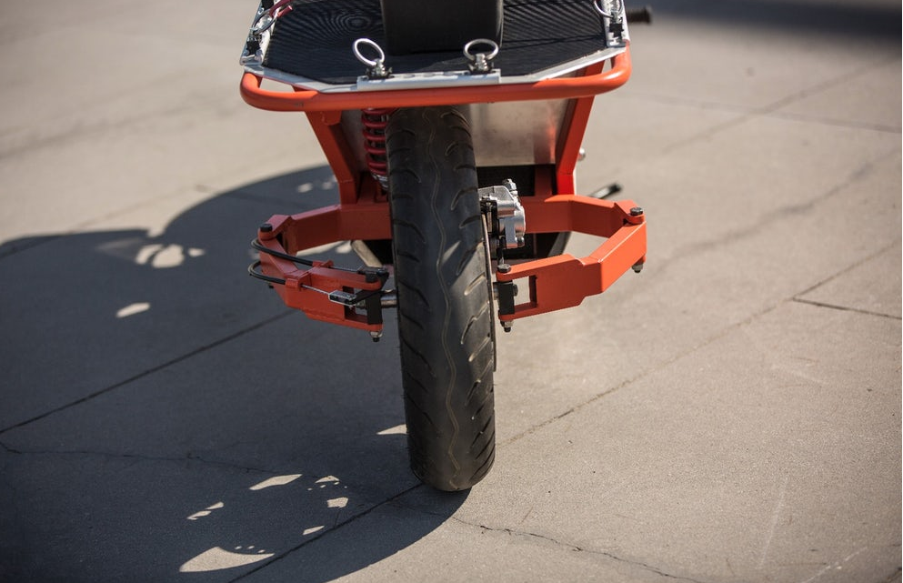Illustration 1: Escargo steering front view
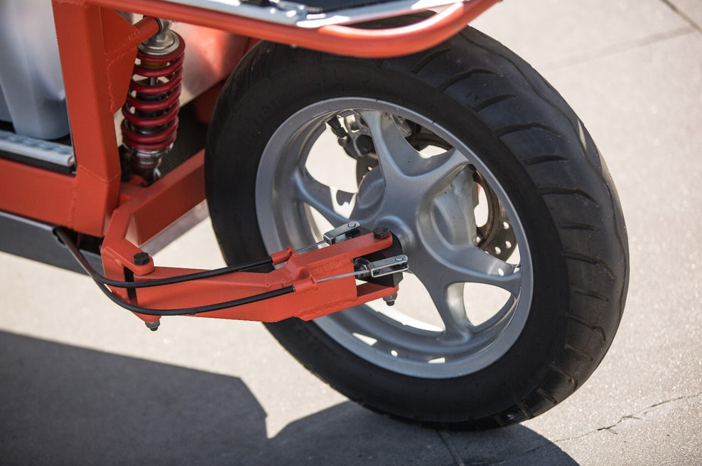Illustration 2: Escargo steering side view
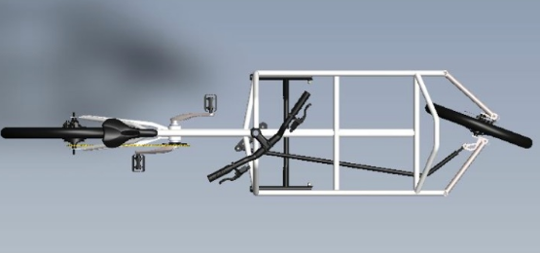Illustration 4: Cometa cargobike top view
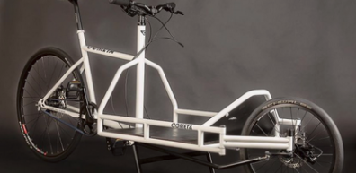Illustration 3: Cometa cargobike

Trail
Conventionally, trail is defined as the horizontal distance between the contact point of the front wheel to the road, and the projected rotation axis to the road. This is illustrated in the picture below.
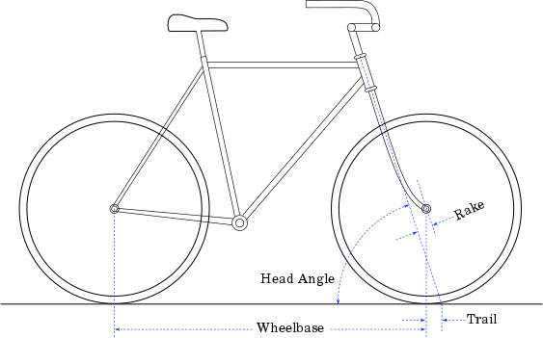Illustration 5: Trail on a regular bike
It is often argued that the trail needs to be positive (the contact position needs to be behind the projected axis crossing), but the python recumbant bicycle and the two-mass skate bicycle are examples that show that it needs not be to form a stable bike. However, the stability of a moving bicycle is a hard thing to pinpoint to one aspect of the frame geometry or mass distribution.
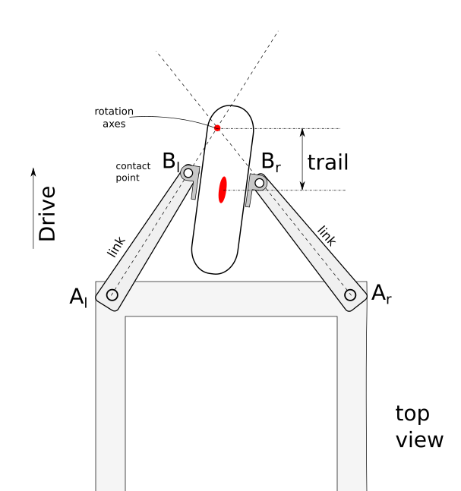Illustration 6: Schematic drawing of the double-link steering mechanism in top view, with the trail indicated.
In the double-link mechanism, the trail can still be defined as the projected distance between the contact point and the (moving) rotation axis. Minimizing the trail requires minimizing the B_{l}-B_{r} distance, which is restricted by the width of the wheel hub.

Front wheel steering, driving and braking

The front wheel electric drive, in combination with the coaster brakes, set requirements on the trail. In order to prevent steering induced by accelerating or decelerating, the trail is to be kept as low as possible.

