[Project Management Templates](http://www.projectmanagementdocs.com)

**Project Management Plan**

**Bot Cat Search**

**1.04.2024**

**Table of Contents**

Introduction 2

Project Management Approach 2

Project Scope 3

Milestone List 3

Schedule Baseline and Work Breakdown Structure 4

Change Management Plan 4

Communications Management Plan 5

Cost Management Plan 7

Procurement Management Plan 9

Project Scope Management Plan 9

Schedule Management Plan 10

Quality Management Plan 11

Risk Management Plan 13

Risk Register 13

Staffing Management Plan 13

Resource Calendar 15

Cost Baseline 15

Quality Baseline 16

Sponsor Acceptance 17

**Introduction**

Many people dream of a new car, but constantly checking sales websites just isn't an option. And it's up-to-date information that becomes crucial for a successful purchase.

**That's exactly the problem we're solving!**

Instead of endless searching, our bot will track fresh car sale ads and send you notifications. It's fast, convenient, and you won't miss out on your perfect car again!

**Project Management Approach**

The Project Manager, Sozanska Tetiana, has the overall authority and responsibility for managing and executing this project according to this Project Plan. The project team will consist of 4 more people, business analytic, developer and quality assurance engineer . The project manager will work with all resources to perform project planning. All project and subsidiary management plans will be reviewed and approved by the project sponsor. Any delegation of approval authority to the project manager should be done in writing and be signed by both the project sponsor and project manager.

The project manager is responsible for communicating with organizational managers on the progress and performance of each project resource.

**Project Scope**

Included in scope:  
Data source: Getting ads from popular car sales websites like Auto.ria. Notification method: Sending notifications to users about new announcements via Telegram. Filters: The bot includes searches based on the filters you choose on Auto.ria. This will allow you to receive notifications only about those ads that meet your needs.

Excluded from scope:   
Сar buying process: Unless your bot helps users complete the purchase itself, exclude this step.

Integration with external services: If the bot won't connect to financing or car history platforms, mention it here. Advanced features: If there are functionalities you might consider for later versions (e.g., price negotiation assistance), list them here.

**Milestone List**

| Milestone | Description | | Date |
| --- | --- | --- | --- |
| Task Definition. | All requirements for the project must be determined to base design upon | | 6.02.2024 |
| Completed Product Concept. | This is the theoretical design for the software and its functionality | | 10.03.2024 |
| Alpha Version Presentation. | All coding completed resulting in software prototype | | 05.04.2024 |
| Beta Version Presentation. | All functionality tested and all identified errors corrected | | 01.05.2024 |
| Project Release. | Completed software and documentation transitioned to operations group to begin production | | 19.05.2024 |

**Schedule Baseline and Work Breakdown Structure**

The WBS for the Bot Car Search is comprised of work packages which do not exceed 40 hours of work but are at least 4 hours of work. Work packages were developed through close collaboration among project team members.

The WBS Dictionary defines all work packages for the Bot Car Search. These definitions include all tasks, resources, and deliverables. Every work package in the WBS is defined in the WBS Dictionary and will aid in resource planning, task completion, and ensuring deliverables meet project requirements.

The Bot Car Search schedule was derived from the WBS and Project Charter with input from all project team members. The schedule was completed, reviewed by the Project Sponsor, and approved and base-lined. Any proposed changes to the schedule will follow TSI’s change control process. If established boundary controls may be exceeded, a change request will be submitted to the Project Manager. The Project Manager and team will determine the impact of the change on the schedule, cost, resources, scope, and risks. If it is determined that the impacts will exceed the boundary conditions then the change will be forwarded to the Project Sponsor for review and approval.

If the change is approved by the Project Sponsor then it will be implemented by the Project Manager who will update the schedule and all documentation and communicate the change to all stakeholders in accordance with the Change Control Process.

The Project Schedule Baseline and Work Breakdown Structure are provided in Appendix A, Project Schedule and Appendix B, Work Breakdown Structure.

**Change Management Plan**

The following steps comprise TSI’s organization change control process for all projects and will be utilized on the Bot Car Search:

Step #1: Identify the need for a change (Any Stakeholder)

Requestor will submit a completed TSI change request form to the project manager

Step #2: Log change in the change request register (Project Manager)

The project manager will maintain a log of all change requests for the duration of the project

Step #3: Conduct an evaluation of the change (Project Manager, Project Team, Requestor) The project manager will conduct an evaluation of the impact of the change to cost, risk, schedule, and scope

Step #4: Submit change request to Change Control Board (CCB) (Project Manager)

The project manager will submit the change request and analysis to the CCB for review

Step #5: Implement change (Project Manager)

Project manager will update and re-baseline project documentation as necessary as well as ensure any changes are communicated to the team and stakeholders

**Communications Management Plan**

This Communications Management Plan sets the communications framework for this project. It will serve as a guide for communications throughout the life of the project and will be updated as communication requirements change. This plan identifies and defines the roles of Bot Car Search team members as they pertain to communications. It also includes a communications matrix which maps the communication requirements of this project, and communication conduct for meetings and other forms of communication. A project team directory is also included to provide contact information for all stakeholders directly involved in the project.

The Project Manager will take the lead role in ensuring effective communications on this project. The communications requirements are documented in the Communications Matrix below. The Communications Matrix will be used as the guide for what information to communicate, who is to do the communicating, when to communicate it, and to whom to communicate.

| **Communication Type** | **Description** | **Frequency** | **Format** | **Participants/ Distribution** | **Deliverable** | **Owner** |
| --- | --- | --- | --- | --- | --- | --- |
| Weekly Project Team Meeting | Meeting to review action register and status | Weekly | In Person | Project Team | Updated Action Register | Project Manager |
| Project Gate Reviews | Present closeout of project phases and kickoff next phase | As Needed | In Person | Project Sponsor, Team and Stakeholders | Phase completion report and phase kickoff | Project Manager |
| Technical Design Review | Review of any technical designs or work associated with the project | As Needed | In Person | Project Team | Technical Design Package | Project Manager |

Project team directory for all communications is:

| **Name** | **Title** | **E mail** | **Cell Phone** |
| --- | --- | --- | --- |
| Vitaliy Dorosh | Project Sponsor | [j.davis@tsi.com](mailto:j.davis@tsi.com) | xxx-xxx-xxxx |
| Tetiana Sozanska | Project Manager | tetianasozanska@gmail.com | 380956373156 |
| Vita Katsydym | Business Analyst | vitakatsydym04@gmail.com | 380980146037 |
| Vitalii Dehod | Programmer | degod123.a@gmail.com | 380957778313 |
| Andrii Balitskiy | Quality Specialist | unconquerable2004@gmail.com | 380668651669 |
| Andrii Cheremchynskiy | Quality Specialist | dhdjdideajsh@gmail.com | 380990035718 |

Communications Conduct:

Meetings:

The Project Manager will distribute a meeting agenda at least 2 days prior to any scheduled meeting and all participants are expected to review the agenda prior to the meeting. Meeting minutes will be distributed no later than 24 hours after each meeting is completed.

Informal Communications:

While informal communication is a part of every project and is necessary for successful project completion, any issues, concerns, or updates that arise from informal discussion between team members must be communicated to the Project Manager so the appropriate action may be taken.

**Project Scope Management Plan**

Scope management for the Bot Car Search will be the sole responsibility of the Project Manager. The Project Manager, Sponsor, and Stakeholders will establish and approve documentation for measuring project scope which includes deliverable quality checklists and work performance measurements.

Proposed scope changes may be initiated by the Project Manager, Stakeholders or any member of the project team. All change requests will be submitted to the Project Manager who will then evaluate the requested scope change. Upon acceptance of the scope change request the Project Manager will submit the scope change request to the Change Control Board and Project Sponsor for acceptance. Upon approval of scope changes by the Change Control Board and Project Sponsor the Project Manager will update all project documents and communicate the scope change to all stakeholders. Based on feedback and input from the Project Manager and Stakeholders, the Project Sponsor is responsible for the acceptance of the final project deliverables and project scope.

The Project Sponsor is responsible for formally accepting the project’s final deliverable. This acceptance will be based on a review of all project documentation, testing results, beta trial results, and completion of all tasks/work packages and product functionality.

**Schedule Management Plan**

Project schedules for the Bot Car Search will be created using Trello. Activity definition will identify the specific work packages which must be performed to complete each deliverable. Activity sequencing will be used to determine the order of work packages and assign relationships between project activities.

Once a preliminary schedule has been developed, it will be reviewed by the project team and any resources tentatively assigned to project tasks. The project team and resources must agree to the proposed work package assignments, durations, and schedule.

The project manager will be responsible for facilitating work package definition, sequencing, and estimating duration and resources with the project team. The project manager will also create the project schedule using MS Project 2007 and validate the schedule with the project team, stakeholders, and the project sponsor. The project manager will obtain schedule approval from the project sponsor and baseline the schedule.

The project team is responsible for participating in work package definition, sequencing, duration, and resource estimating. The project team will also review and validate the proposed schedule and perform assigned activities once the schedule is approved.

**Quality Management Plan**

All members of the project team will play a role in quality management. It is imperative that the team ensures that work is completed at an adequate level of quality from individual work packages to the final project deliverable. The following are the quality roles and responsibilities for the Bot Car Search:

The Project Sponsor is responsible for approving all quality standards for the Bot Car Search. The Project Sponsor will review all project tasks and deliverables to ensure compliance with established and approved quality standards.

The Project Manager is responsible for quality management throughout the duration of the project. The Project Manager is responsible for implementing the Quality Management Plan and ensuring all tasks, processes, and documentation are compliant with the plan. The Project Manager will work with the project’s quality specialists to establish acceptable quality standards. The Project Manager is also responsible for communicating and tracking all quality standards to the project team.

The remaining member of the project team, as well as the stakeholders will be responsible for assisting the Project Manager and Quality Specialists in the establishment of acceptable quality standards. They will also work to ensure that all quality standards are met and communicate any concerns regarding quality to the Project Manager.

Quality assurance for the Bot Car Search will ensure that all processes used in the completion of the project meet acceptable quality standards. These process standards are in place to maximize project efficiency and minimize waste. For each process used throughout the project, the Project Manager will track and measure quality against the approved standards with the assistance of the Quality Specialists and ensure all quality standards are met. If any changes are proposed and approved by the Project Sponsor and CCB, the Project Manager is responsible for communicating the changes to the project team and updating all project plans and documentation.

**Risk Management Plan**

The approach for managing risks for the Bot Car Search includes a methodical process by which the project team identifies, scores, and ranks the various risks. Every effort will be made to proactively identify risks ahead of time in order to implement a mitigation strategy from the project’s onset. The most likely and highest impact risks were added to the project schedule to ensure that the assigned risk managers take the necessary steps to implement the mitigation response at the appropriate time during the schedule.

Upon the completion of the project, during the closing process, the project manager will analyze each risk as well as the risk management process.

**Staffing Management Plan**

All work will be performed internally. Staffing requirements for the Bot Car Search include the following:

Project Manager (1 position) – responsible for all management for the Bot Car Search. The Project Manager is responsible for planning, creating, and/or managing all work activities, variances, tracking, reporting, communication, performance evaluations, staffing, and internal coordination with functional managers.

Programmer (1 position) – responsible for oversight of all coding and programming tasks for the Bot Car Search as well as ensuring functionality is compliant with quality standards. Responsible for working with the Project Manager to create work packages, manage risk, manage schedule, identify requirements, and create reports.

Senior Quality Specialist (1 position) – responsible for assisting the Project Manager in creating quality control and assurance standards. The Senior Quality Specialist is also responsible for maintaining quality control and assurance logs throughout the project. The Senior Quality Specialist will be managed by the Project Manager who will also provide feedback to the functional manager for performance evaluations.

Quality Specialist (1 position) – responsible for assisting the Project Manager and Senior Quality Specialist in creating and tracking quality control and assurance standards. The Quality Specialist will have primary responsibility for compiling quality reporting and metrics for the Project Manager to communicate. The Quality Specialist will be managed by the Project Manager who will provide feedback, along with the Senior Quality Specialist to the functional manager for performance evaluations.

Business analyst (1 position)

The Business Analyst will be appropriate for understanding the business need for Bot Car Search, documenting functional requirements, collaborating with the Project Manager and programmer, identifying risks, facilitating communication, creating and maintaining project documents, and analyzing project success.

**Resource Calendar**

The Bot Car Search will require all project team members for the entire duration of the project although levels of effort will vary as the project progresses. The Project is scheduled to last one year with standard 40 hour work weeks. If a project team member is not required for a full 40 hour work week at any point during the project, their efforts outside of the Bot Car Search will be at the discretion of their Functional Manager.

**Gantt Chart Graph**

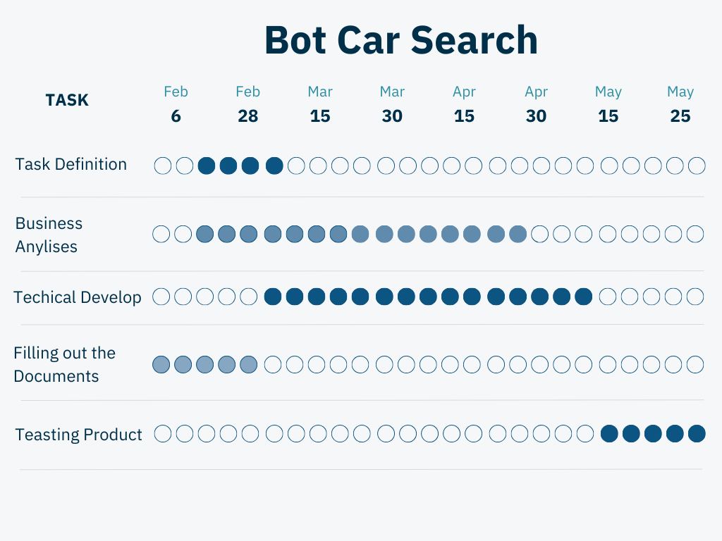

**Quality Baseline**

The SmartVoice Project must meet the quality standards established in the quality baseline. The quality baseline is the baseline which provides the acceptable quality levels of the SmartVoice Project. The software must meet or exceed the quality baseline values in order to achieve success.

| **Item** | **Acceptable Level** | **Comments** |
| --- | --- | --- |
| Convenience | :Users can be notified of new listings without having to spend time searching manually. |  |
| Save time | The bot can quickly find ads that meet the specified criteria. |  |
| Personalization | Personalization: Users can customize the bot according to their needs. |  |
| Timeliness | The bot can send notifications about new ads immediately after they are published. |  |

**Sponsor Acceptance**

Approved by the Project Sponsor:

Date: 1.04.2024

Vitaliy Dorosh

Project Sponsor