Short description of the microservices/unit tests approach projects in Visual Studio 2019/MS SQL 2019

Table of Contents
1. General information 1
2. Persistent representation of the requirements 5
3. Architecture of the project DogCueMicroservices 7
4. Architecture of the project DogCueWriteMicroserives 8
5. Idea of pure unit test and architecture of examplary project 9
6. Unit test without mock references and architecture of exemplary project 9
7. Integration text and architecture of exemplary project 10

1. General information

Current solution is based on C# .net core framework. It contains 5 projects:

2 for microservices:
- DogCueMicroservices (R microservices[list and details on objects])
  - operations on Customer datasource
  - operations on Contact datasource
- DogCueWriteMicroservices (CDU microservices)
  - operations on Customer datasource
  - operations on Contact datasource
3 for tests:
- DogCueMicroservicesTestMock – pure component test based on builders. nUnit test project .
- DogCueMicroservicesTest – component test without mocking(elements of integration tests). nUnit test project .
- DogCueMicroservicesXT – integration test. xUnit project.

Additionally in order to rely on complete environment were installed:

- Desktop Docker as target platform in developper environment:

- MS SQL 2019 & MS SQL Management Console 2018 as database engine with necessary user interface.
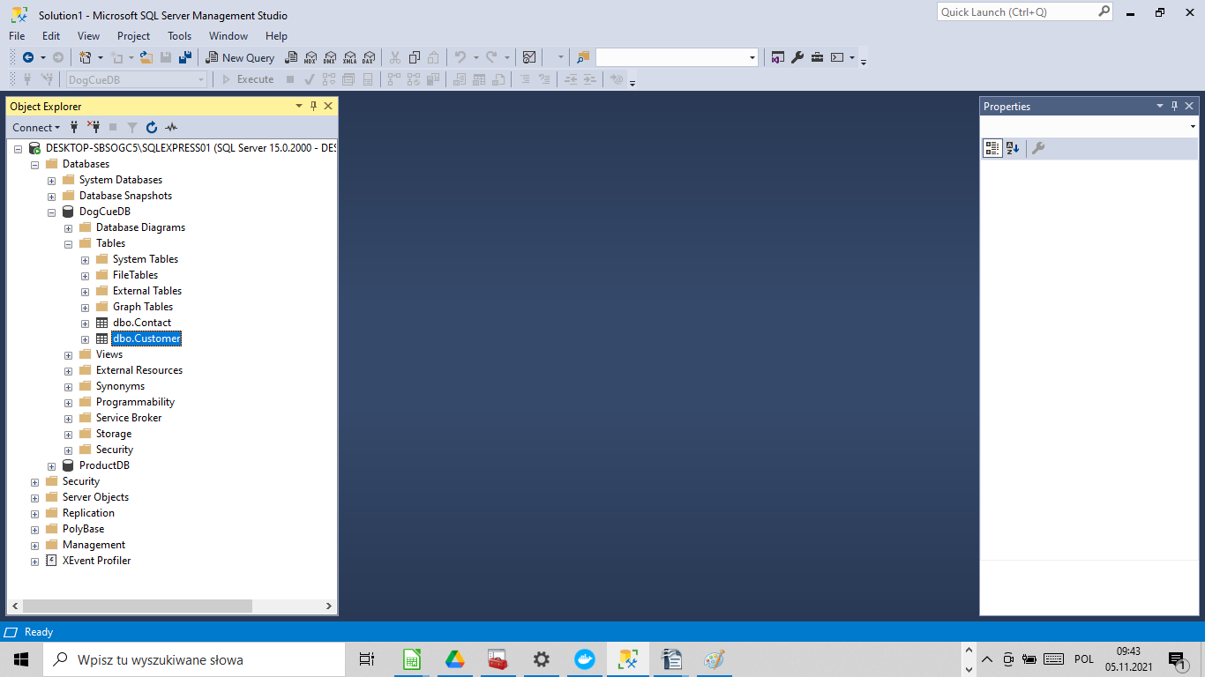
- Microservices consumer – Swagger UI

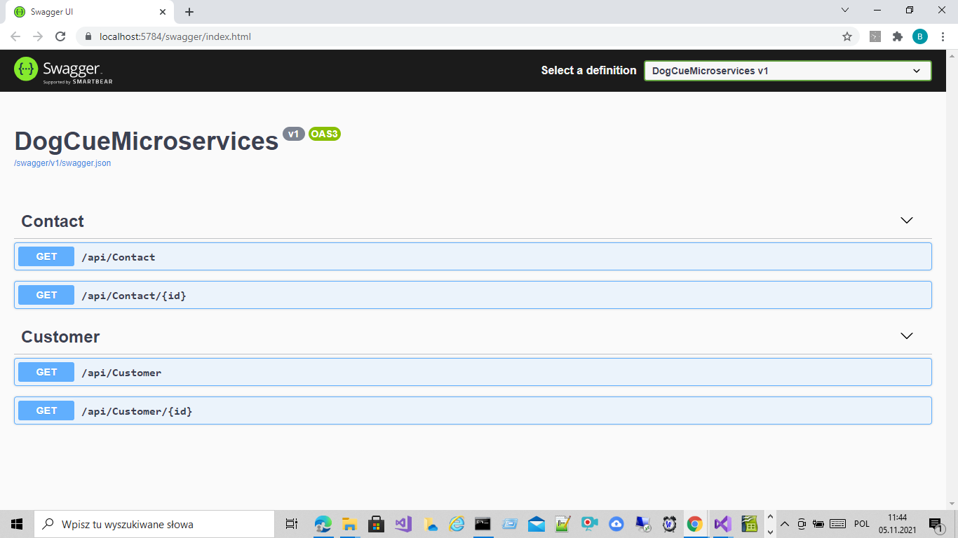
- Automated tests – execution

2. Persistent representation of the requirements
Database was created in Ms SQL 2019, based on EntityFramework. This approach enables TDD. First were created classes representing persistent aspects of the system than database and its objects.
For the sake of the simplicity we assumed use of 2 objects in the database:
Customer:
unique number in the database (Id)
first name (FirstName)
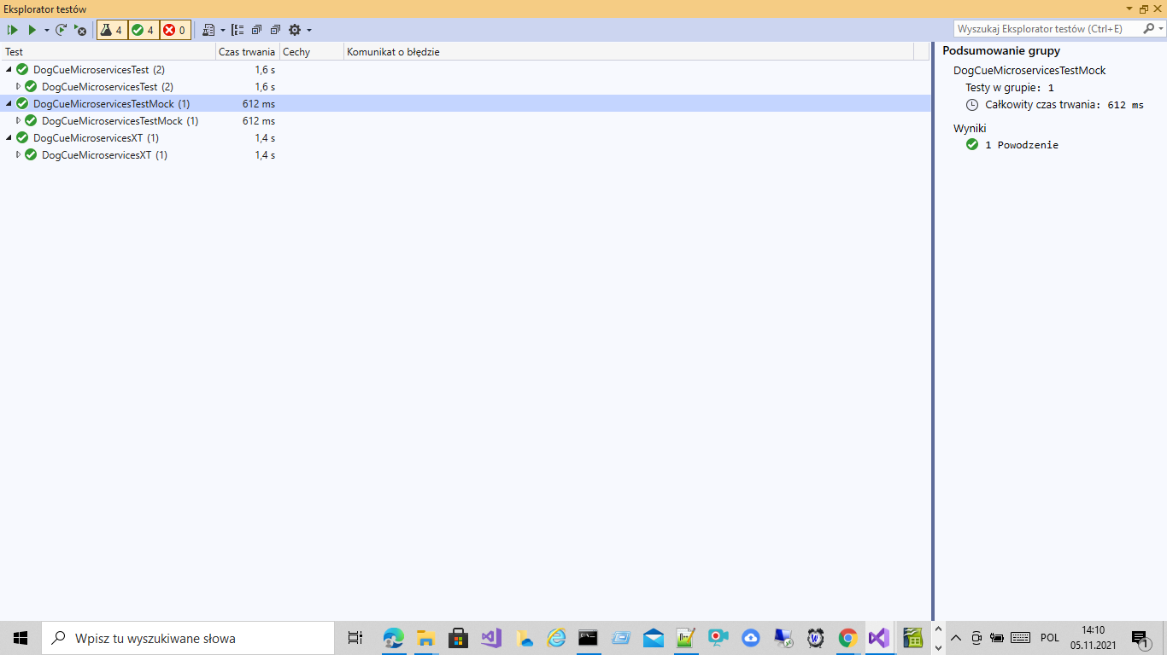
last name (LastName)

Contact:
unique number in the database (Id)
Adress (Adress)
Customer identyfier in the database (CustomerID)
Type of adress (Type).
Below we present view on objects in the database:

3. Architecture of the project DogCueMicroservices
Project is based on MVC approach, and in this case particular elements are used for the following purposes:
- model: reference of the database in the form of the adequate classes structure
- controller: entry points for the microservices linked with classes from model
- view: not used in this project.

Display of the folders:

a. Parameters for communication with database (appsettings.json) – connection string "DogCueDB"
b. dynamic configuration of running application based on parameters – startup.cs (including launching stagger UI)
c. Data access layer:
  - Definition of DBContext for communication with persistent objects in tee database: DogCueDBEntities.cs
  - Interfaces and classes accessing tables in database:
    - Customer: IcustomerRepository.cs, CustomerRepositiory.cs
    - Contact: IcontactRepository.cs, ContactRepository.cs
  - Implementation of abstract classes from Model prospect: Model/Customer.cs, Contact.cs

d. Implementation of entrypoints for services:
  - Customer: CustomerController.cs
  - Contract: ContractController.cs.
Methods in the classes are down to 2 implementing functionalities of list of records of given type and details of records of given Id passes in the parameter.

4. Architecture of the project DogCueWriteMicroserives
Similar to DogCueWriteMicroservices, except with 2 classes, which declare entrypoints:

  - Customer: CustomerController.cs
  - Contract: ContractController.cs.

Extend of delivered methods comprises record creation, record update(based on Id) and record deletion (CUD).

5. Idea of pure unit test and architecture of examplary project
The idea of 'pure' unit tests is to implement the tests and avoid any reference to infrastructure element: database, network, docker, etc.
In the solution we replace references to objects representing database and tables by mock structures.
In the test we call method from entry point of micro service.
Project's structure of folders is as follows:

Class implementing test is named 'UnitTestControllers', exemplary test is CustomerController_Index_OK().

6. Unit test without mock references and architecture of exemplary project

Next stage is idea of unit tests having elements of integration test. In this purpose we call method of the tested class using context of real database which is beneath.
Structure of project's folder is as follows:

Class implementing test is named 'UnitTestControllers', exemplary test is CustomerController_Index_OK().

7. Integration text and architecture of exemplary project
Presented solution has the character of the mixed one – a real database is explored, but micro service is deployed into the environment established based on pre build test server.

The structure of project's folder is as follow:

