CP5: Solving equations like , real number system

*Finding the square root of 2*

1) Show that you can find a positive integer  such that

.

Just start trying numbers for *a1* . Soon you find that

.

Show that

.

Just compute

.

2) Show that you can find a positive integer  such that

.

From the first step we know that

.

so that *a2* must lie between *140* and *149*. Trying those numbers in order we quickly see that

.

Show that

.

Just compute

.

3) Show that, for any positive integer *n*, no matter how large, you can find a positive integer  so that



and

.

By induction we can assume that we have found  so that



We can rewrite this as

.

So there must be a number  greater than or equal to  and less than  so that

.

For the second part notice that



since even its square is less than or equal to *2*. Remember that and use it to compute

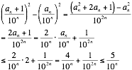.

*The real number system*

The system of real numbers is the system of infinite decimals, that is the set of all (infinite) polynomial expressions of the form



where *x = 10*  and all of the *ai*  are non-negative integers less than *x*. We add, subtract, multiply and divide them just like we do polynomials.

We call two real numbers equivalent (or equal) if the numerical value of their difference eventually gets smaller than  no matter how large *n* is. (You have to start your subtraction of the two polynomial expressions *from the left* to make sense of this.)

4) Show that

.

We just calculate beginning with

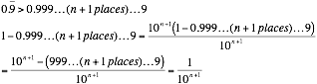

So the difference of  and  eventually gets smaller than  no matter how large *n* is. So the two expressions correspond to the same real number.