DOKUZ EYLÜL ÜNİVERSİTESİ

BİL 2004 VERİTABANI YONETİMİ

BARTU BOZKURT

2017280013

BİLGİSAYAR BİLİMLERİ

**SORGULAR**

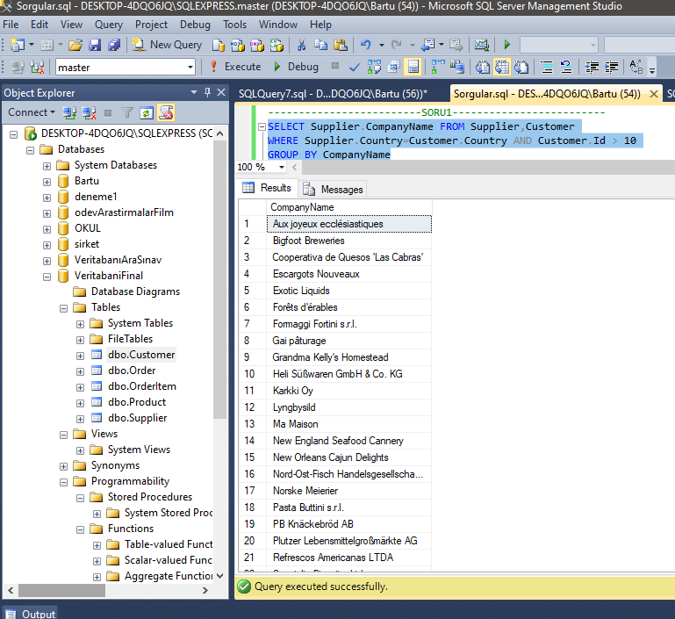

-------------------------SORU1-------------------------

Select Supplier.CompanyName from Supplier,Customer

where Supplier.Country=Customer.Country AND Customer.Id > 10

Group By CompanyName

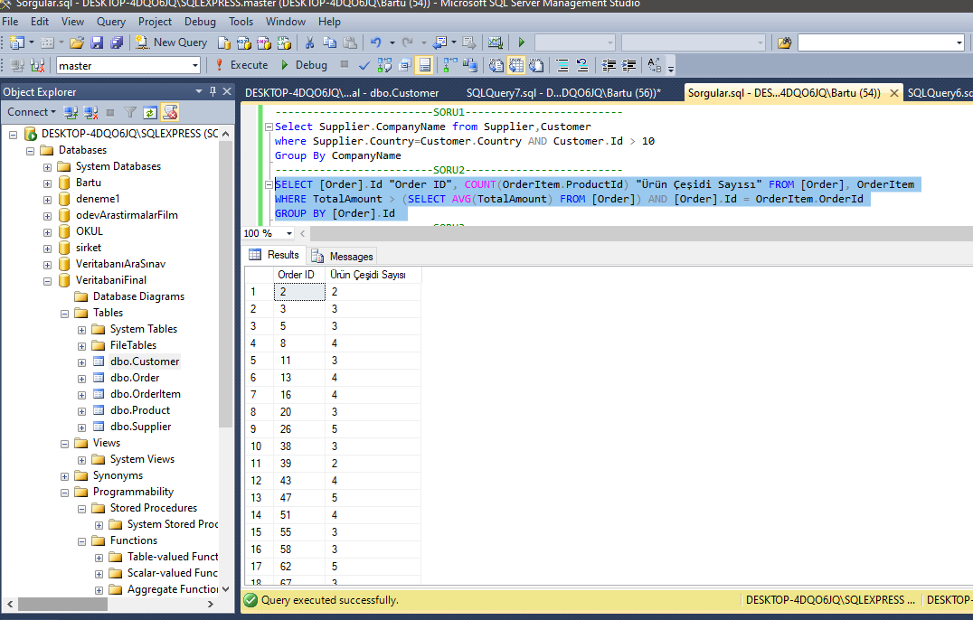

-------------------------SORU2-------------------------

SELECT [Order].Id "Order ID", COUNT(OrderItem.ProductId) "Ürün Çeşidi Sayısı" FROM [Order], OrderItem

WHERE TotalAmount > (SELECT AVG(TotalAmount) FROM [Order]) AND [Order].Id = OrderItem.OrderId

GROUP BY [Order].Id

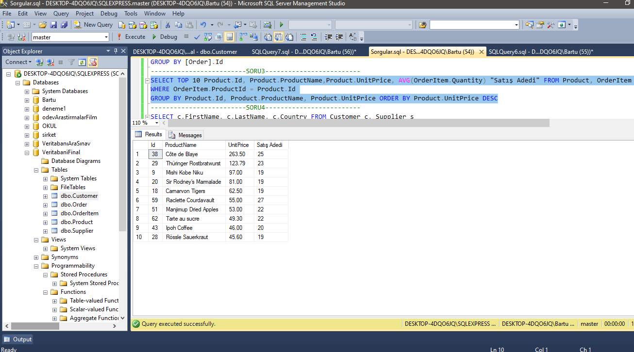

-------------------------SORU3-------------------------

SELECT TOP 10 Product.Id, Product.ProductName,Product.UnitPrice, AVG(OrderItem.Quantity) "Satış Adedi" FROM Product, OrderItem

WHERE OrderItem.ProductId = Product.Id

GROUP BY Product.Id, Product.ProductName, Product.UnitPrice ORDER BY Product.UnitPrice DESC

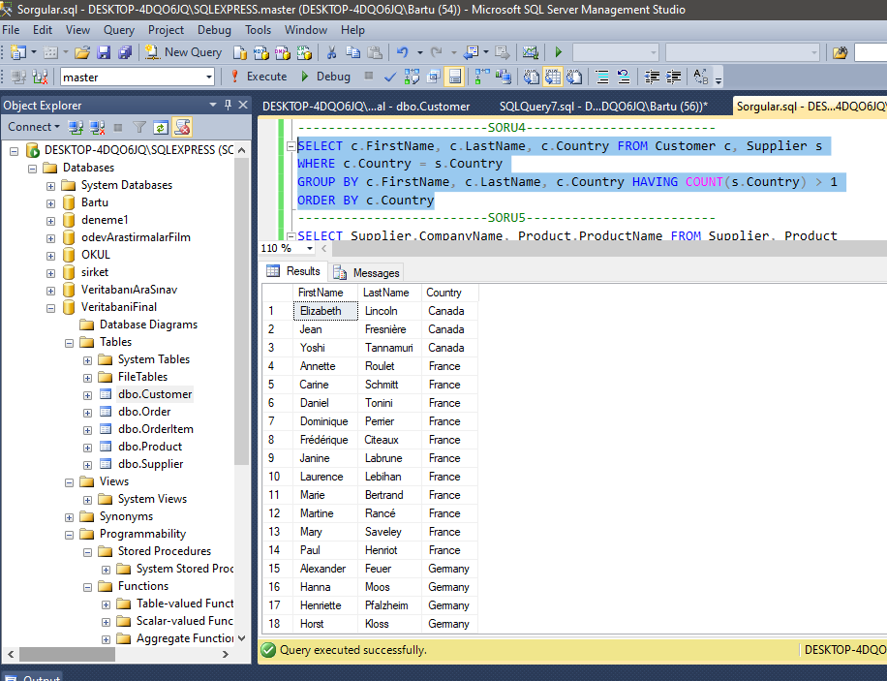

-------------------------SORU4-------------------------

SELECT c.FirstName, c.LastName, c.Country FROM Customer c, Supplier s

WHERE c.Country = s.Country

GROUP BY c.FirstName, c.LastName, c.Country HAVING COUNT(s.Country) > 1

ORDER BY c.Country

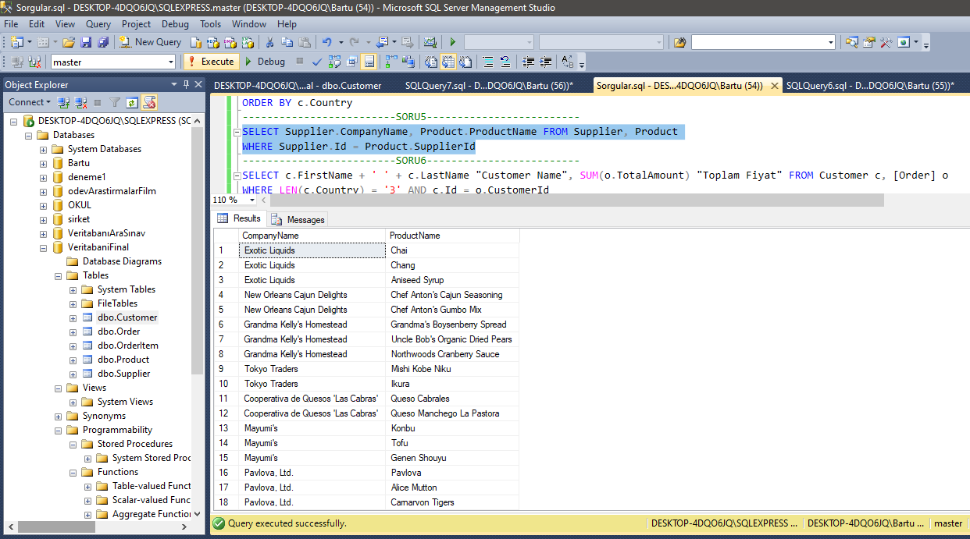

-------------------------SORU5-------------------------

SELECT Supplier.CompanyName, Product.ProductName FROM Supplier, Product

WHERE Supplier.Id = Product.SupplierId

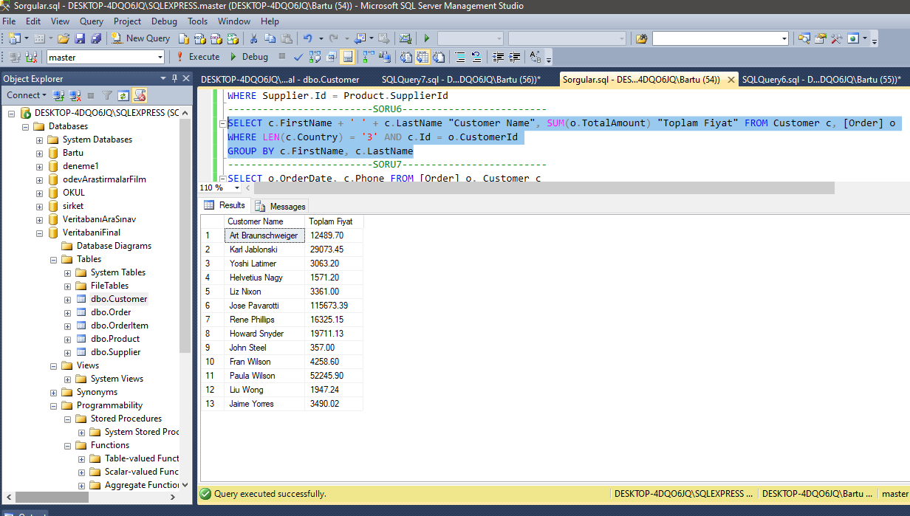

-------------------------SORU6-------------------------

SELECT c.FirstName + ' ' + c.LastName "Customer Name", SUM(o.TotalAmount) "Toplam Fiyat" FROM Customer c, [Order] o

WHERE LEN(c.Country) = '3' AND c.Id = o.CustomerId

GROUP BY c.FirstName, c.LastName

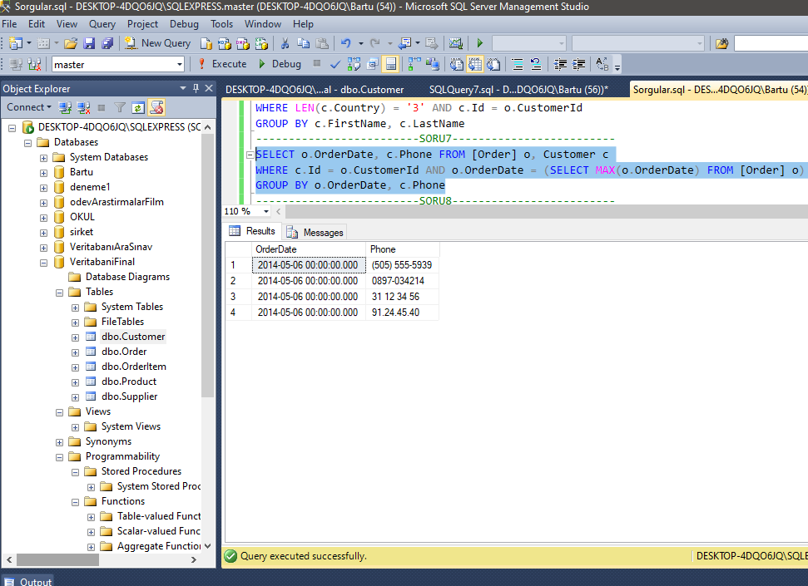

-------------------------SORU7-------------------------

SELECT o.OrderDate, c.Phone FROM [Order] o, Customer c

WHERE c.Id = o.CustomerId AND o.OrderDate = (SELECT MAX(o.OrderDate) FROM [Order] o)

GROUP BY o.OrderDate, c.Phone

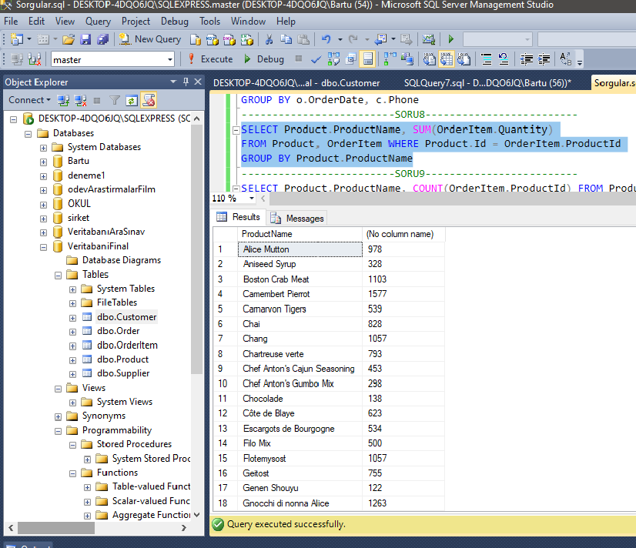

-------------------------SORU8-------------------------

SELECT Product.ProductName, SUM(OrderItem.Quantity)

FROM Product, OrderItem WHERE Product.Id = OrderItem.ProductId

GROUP BY Product.ProductName

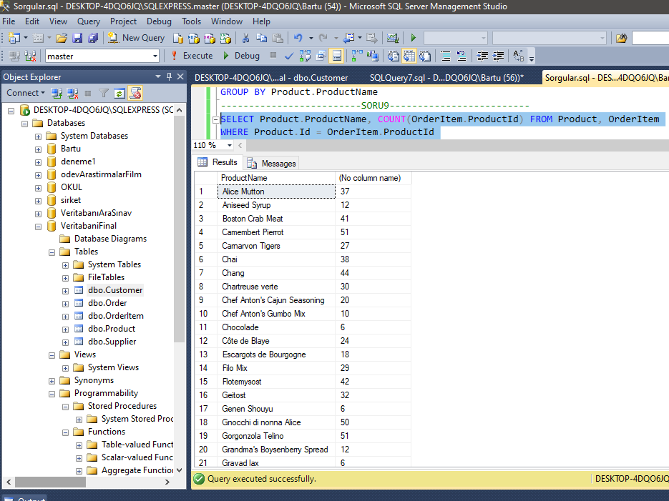

-------------------------SORU9-------------------------

SELECT Product.ProductName, COUNT(OrderItem.ProductId) FROM Product, OrderItem

WHERE Product.Id = OrderItem.ProductId

GROUP BY Product.ProductName

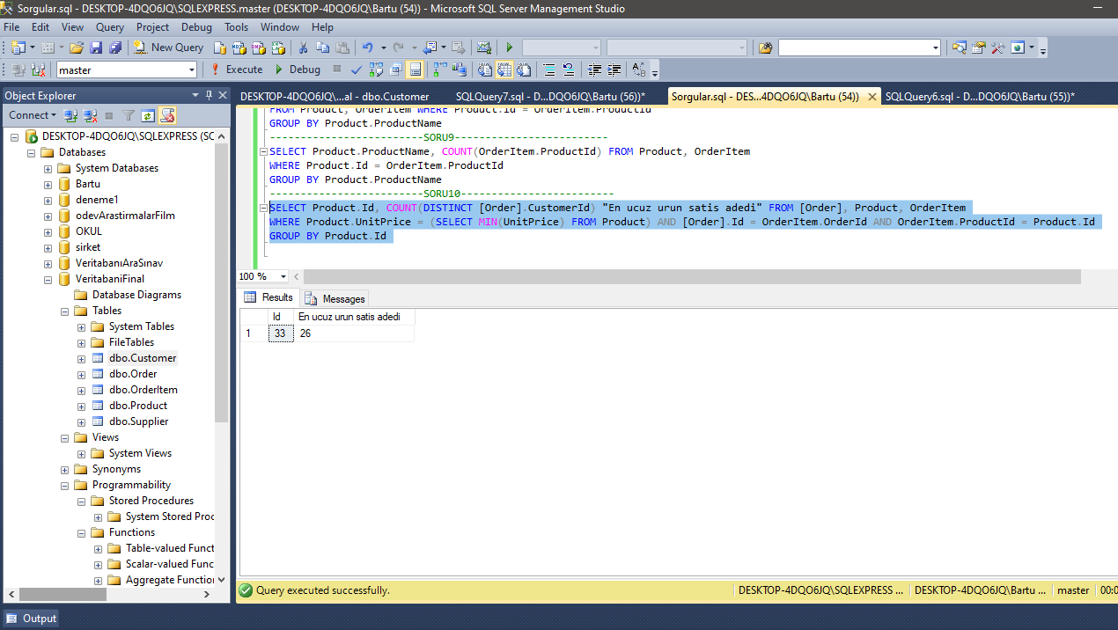

-------------------------SORU10-------------------------

SELECT Product.Id, COUNT(DISTINCT [Order].CustomerId) "En ucuz urun satis adedi" FROM [Order], Product, OrderItem

WHERE Product.UnitPrice = (SELECT MIN(UnitPrice) FROM Product) AND [Order].Id = OrderItem.OrderId AND OrderItem.ProductId = Product.Id

GROUP BY Product.Id

**SANAL TABLOLAR**

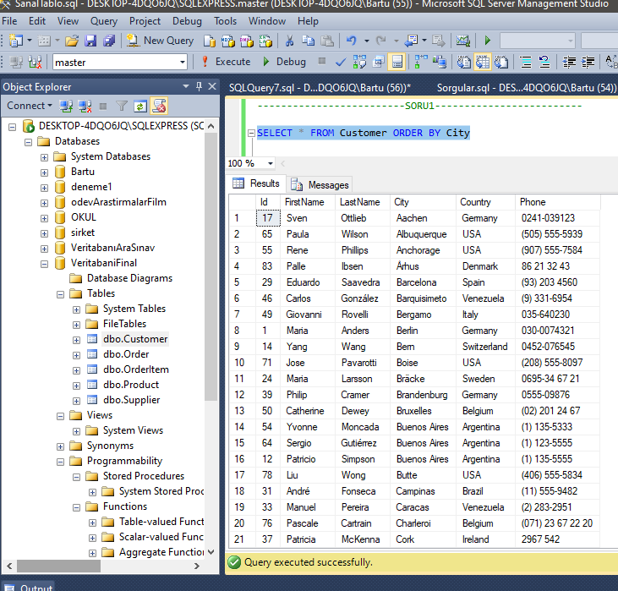

-------------------------SORU1-------------------------

SELECT * FROM Customer ORDER BY City

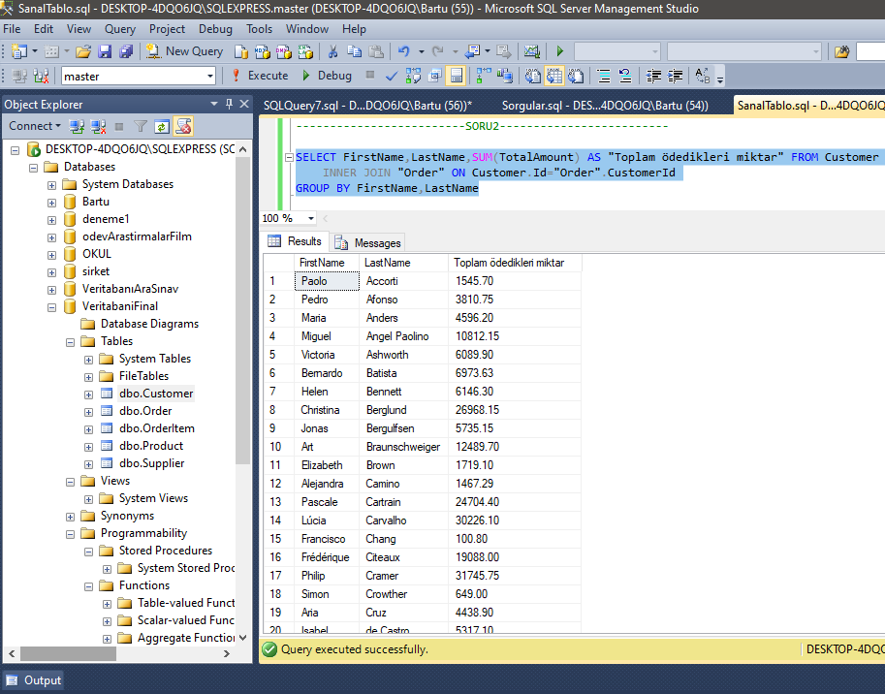

-------------------------SORU2-------------------------

SELECT FirstName,LastName,SUM(TotalAmount) AS "Toplam ödedikleri miktar" FROM Customer

INNER JOIN "Order" ON Customer.Id="Order".CustomerId

GROUP BY FirstName,LastName

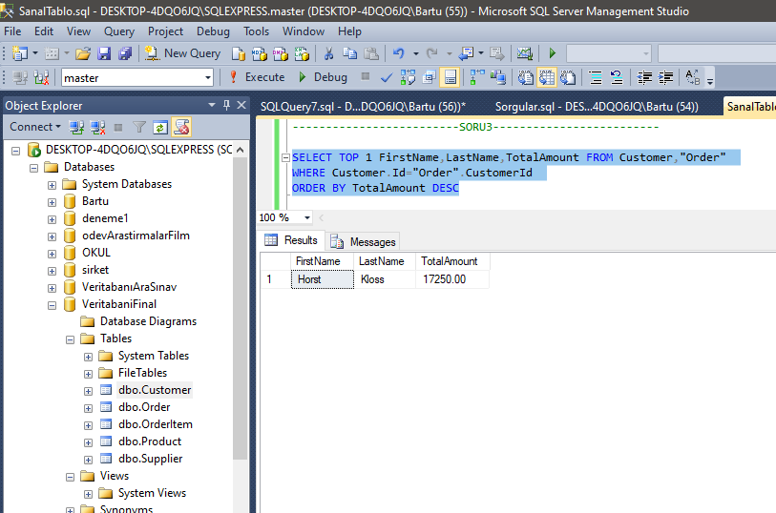

-------------------------SORU3-------------------------

SELECT TOP 1 FirstName,LastName,TotalAmount FROM Customer,"Order"

WHERE Customer.Id="Order".CustomerId

ORDER BY TotalAmount DESC

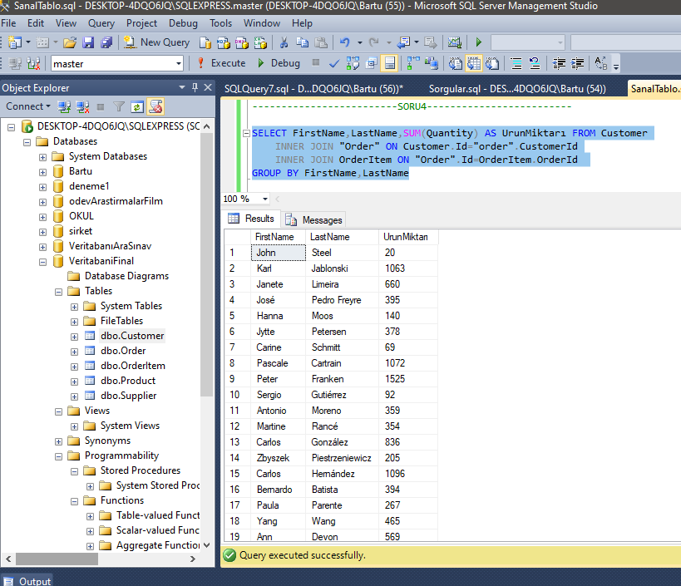

-------------------------SORU4-------------------------

SELECT FirstName,LastName,SUM(Quantity) AS UrunMiktarı FROM Customer

INNER JOIN "Order" ON Customer.Id="order".CustomerId

INNER JOIN OrderItem ON "Order".Id=OrderItem.OrderId

GROUP BY FirstName,LastName

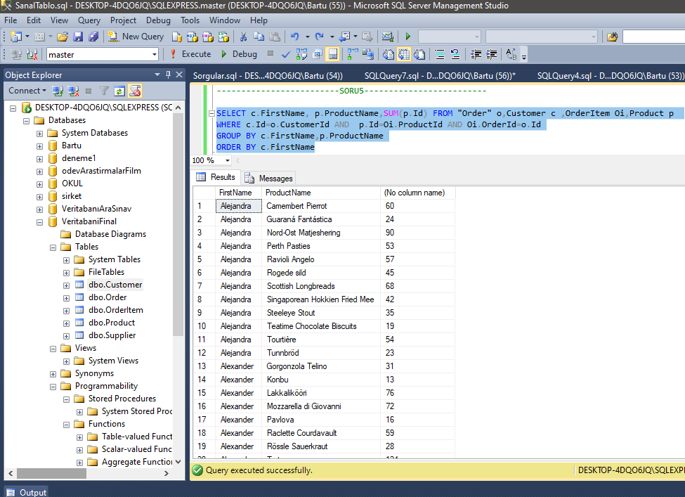

-------------------------SORU5-------------------------

SELECT c.FirstName, p.ProductName,SUM(p.Id) FROM "Order" o,Customer c ,OrderItem Oi,Product p

WHERE c.Id=o.CustomerId AND p.Id=Oi.ProductId AND Oi.OrderId=o.Id

GROUP BY c.FirstName,p.ProductName

ORDER BY c.FirstName

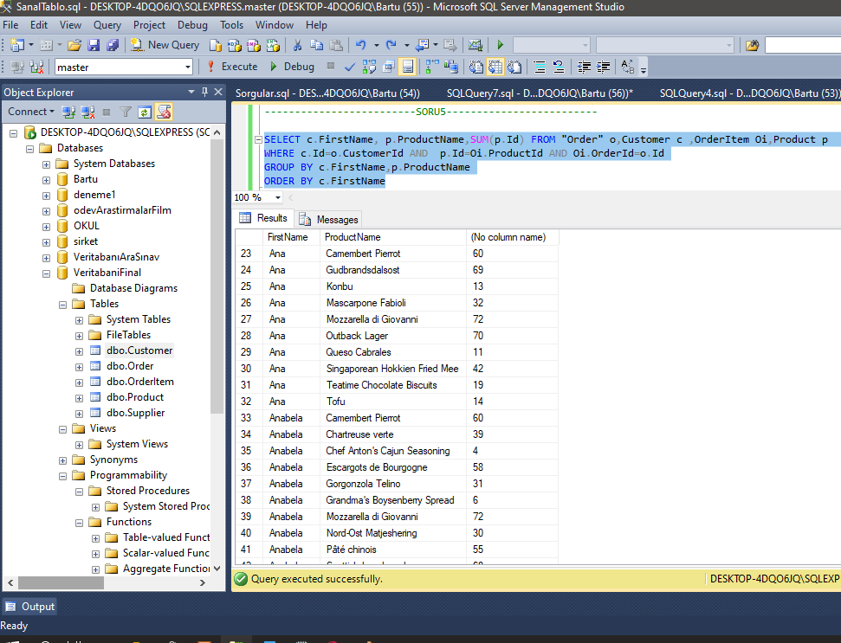

**5 te tablonun devamı farklı firstNameleride alıyor yanlışlık olmasın diye bunu da koydum hocam

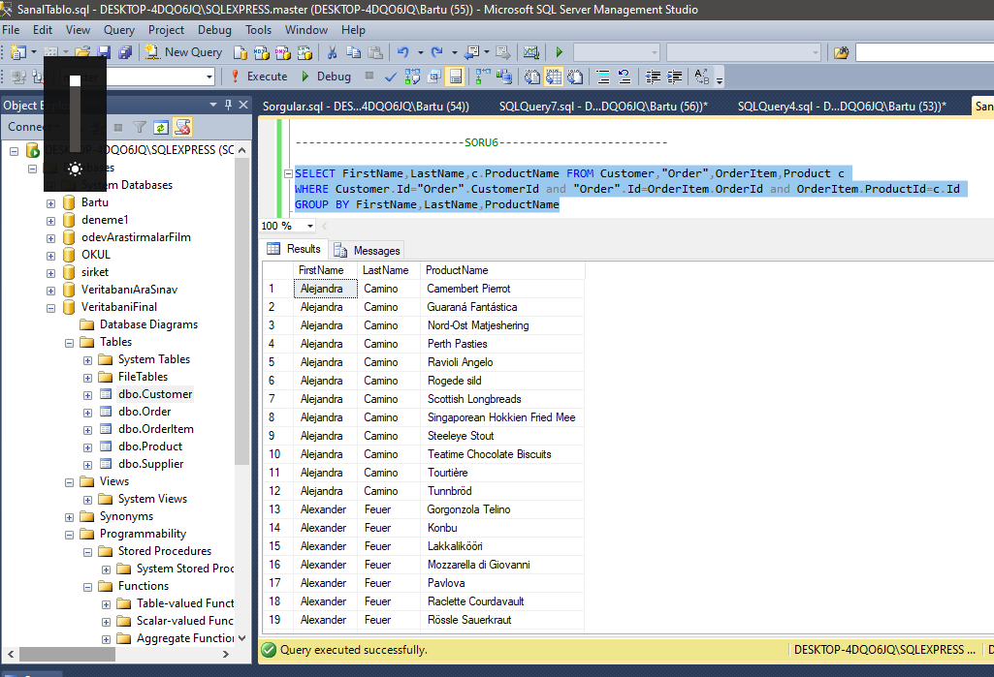

-------------------------SORU6-------------------------

SELECT FirstName,LastName,c.ProductName FROM Customer,"Order",OrderItem,Product c

WHERE Customer.Id="Order".CustomerId and "Order".Id=OrderItem.OrderId and OrderItem.ProductId=c.Id

GROUP BY FirstName,LastName,ProductName

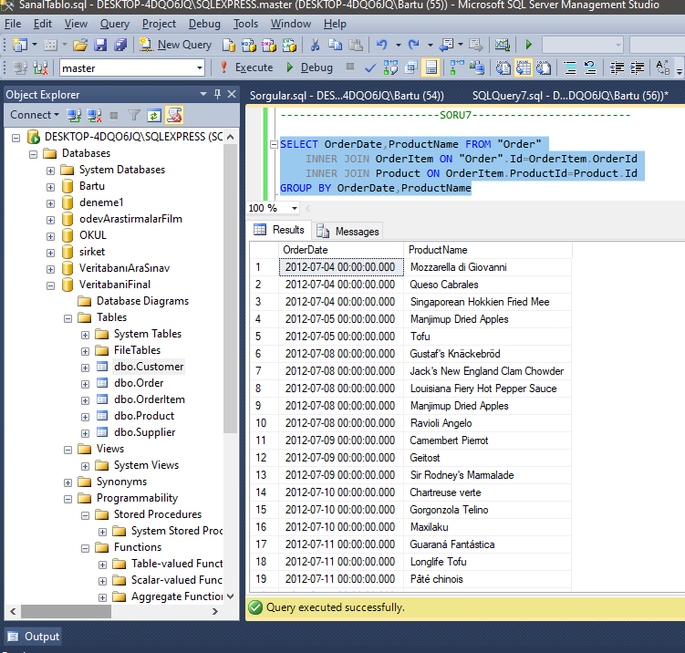

-------------------------SORU7-------------------------

SELECT OrderDate,ProductName FROM "Order"

INNER JOIN OrderItem ON "Order".Id=OrderItem.OrderId

INNER JOIN Product ON OrderItem.ProductId=Product.Id

GROUP BY OrderDate,ProductName

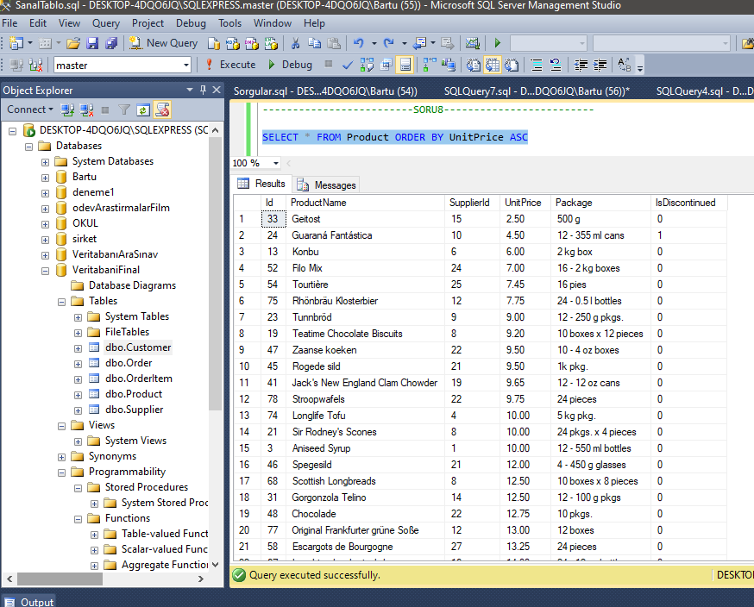

-------------------------SORU8-------------------------

SELECT * FROM Product ORDER BY UnitPrice ASC

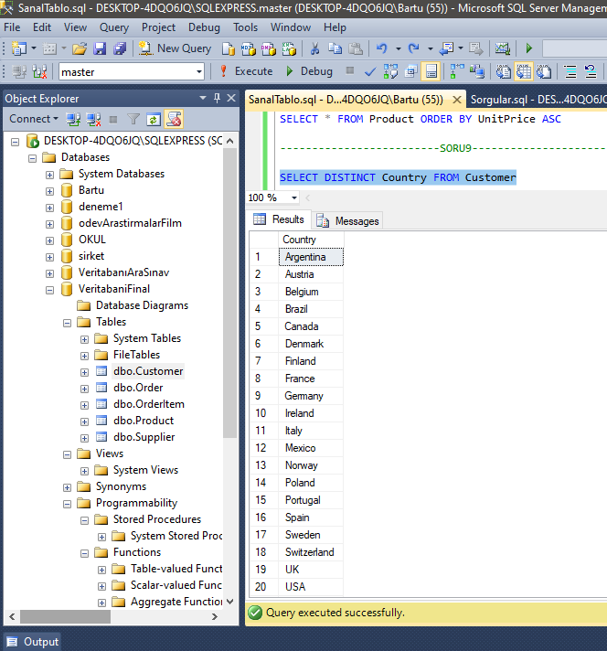

-------------------------SORU9-------------------------

SELECT DISTINCT Country FROM Customer

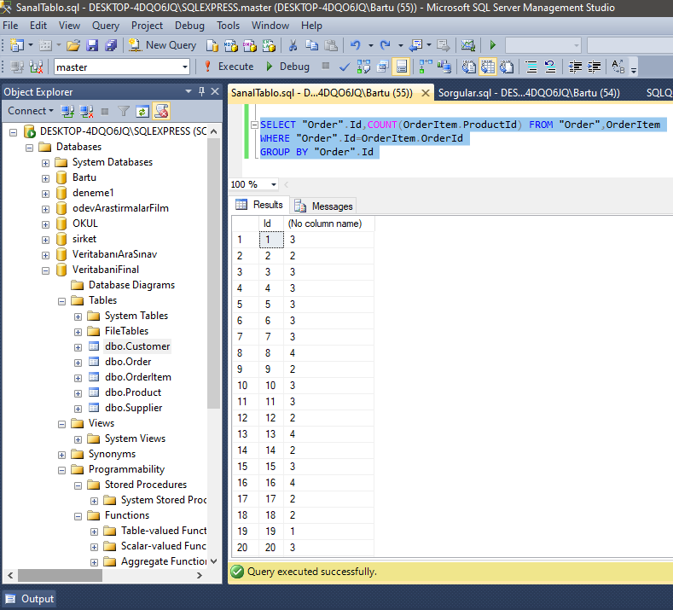

-------------------------SORU10-------------------------

SELECT "Order".Id,COUNT(OrderItem.ProductId) FROM "Order",OrderItem

WHERE "Order".Id=OrderItem.OrderId

GROUP BY "Order".Id

**SAKLI YORDAMLAR**

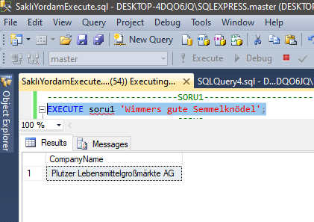

**-------------------------SORU1-------------------------**

CREATE PROC soru1(@urun varchar(30) = 'Wimmers gute Semmelknödel')

AS

BEGIN

SELECT s.CompanyName FROM Supplier s,Product p

WHERE s.Id=p.SupplierId and p.ProductName = @urun

END

**-------------------------SORU1-------------------------**

EXECUTE soru1 'Wimmers gute Semmelknödel';

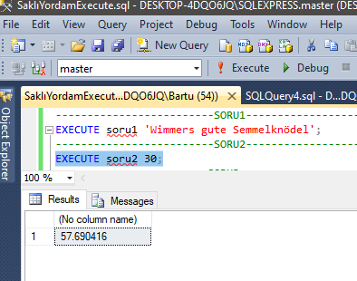

**-------------------------SORU2-------------------------**

CREATE PROC soru2(@fiyat int = 30)

AS

BEGIN

SELECT AVG(p.UnitPrice) FROM Product p

WHERE p.UnitPrice > @fiyat

END

**-------------------------SORU2-------------------------**

EXECUTE soru2 30;

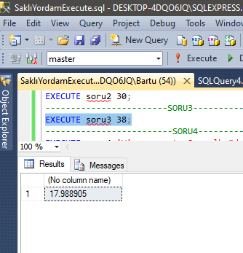

**------------------------SORU3--------------------------**

CREATE PROC soru3(@fiyat int = 38)

AS

BEGIN

SELECT AVG(p.UnitPrice) FROM Product p ,Customer c ,"Order" o , OrderItem oi

WHERE o.CustomerId=c.Id AND p.Id=oi.ProductId AND p.UnitPrice < @fiyat

END

**------------------------SORU3--------------------------**

EXECUTE soru3 38;

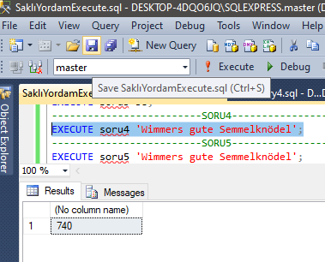

**-------------------------SORU4-------------------------**

CREATE PROC soru4(@urun nvarchar(30) = 'Wimmers gute Semmelknödel')

AS

BEGIN

SELECT SUM(o.Quantity) FROM Product p,OrderItem o

WHERE o.ProductId=p.Id AND @urun = p.ProductName

END

**-------------------------SORU4-------------------------**

EXECUTE soru4 'Wimmers gute Semmelknödel';

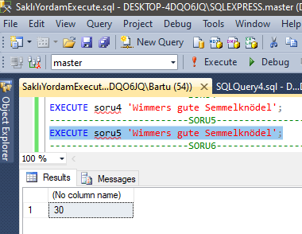

**-------------------------SORU5-------------------------**

ALTER PROC soru5(@urun nvarchar(30) = 'Wimmers gute Semmelknödel')

AS

BEGIN

SELECT COUNT(o.OrderId) FROM Product p,OrderItem o

WHERE o.ProductId=p.Id AND @urun = p.ProductName

END

**-------------------------SORU5-------------------------**

EXECUTE soru5 'Wimmers gute Semmelknödel';

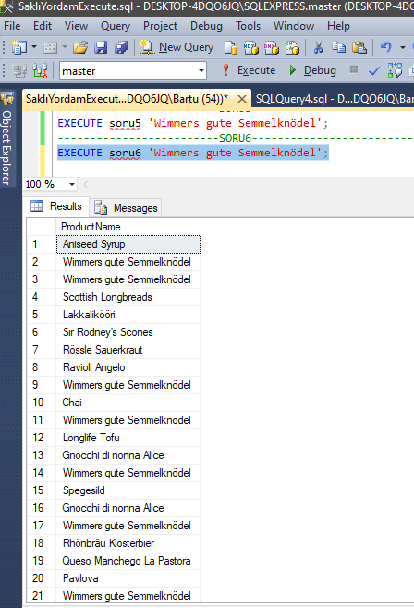

**-------------------------SORU6-------------------------**

ALTER PROC soru6(@urun nvarchar(30) = 'Wimmers gute Semmelknödel')

AS

BEGIN

SELECT p.ProductName FROM Product p,OrderItem o

WHERE o.ProductId=p.Id AND @urun=p.ProductName

GROUP BY o.OrderId,p.ProductName

END

**-------------------------SORU6-------------------------**

EXECUTE soru6 'Wimmers gute Semmelknödel';

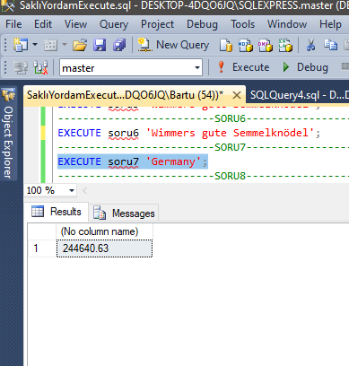

**-------------------------SORU7-------------------------**

CREATE PROC soru7(@ulke nvarchar(15) = 'Germany')

AS

BEGIN

SELECT SUM(o.TotalAmount) FROM "Order" o,Customer c

WHERE c.Id=o.CustomerId AND c.Country = @ulke

END

**-------------------------SORU7-------------------------**

EXECUTE soru7 'Germany';

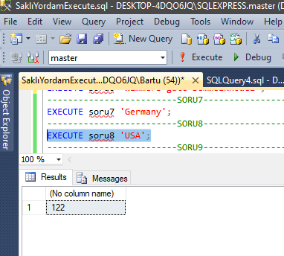

**-------------------------SORU8-------------------------**

CREATE PROC soru8(@ulke nvarchar(15) = 'USA')

AS

BEGIN

SELECT COUNT(o.Id) FROM "Order" o,Customer c

WHERE c.Id=o.CustomerId AND c.Country = @ulke

END

**-------------------------SORU8-------------------------**

EXECUTE soru8 'USA';

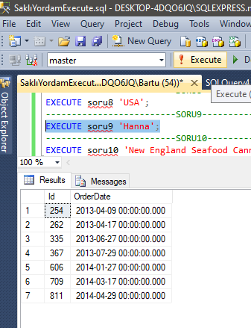

**-------------------------SORU9-------------------------**

CREATE PROC soru9(@musteri nvarchar(50) = 'Hanna')

AS

BEGIN

SELECT o.Id , o.OrderDate FROM "Order" o,Customer c

WHERE c.Id=o.CustomerId and c.FirstName = @musteri

ORDER BY o.OrderDate

END

**-------------------------SORU9-------------------------**

EXECUTE soru9 'Hanna';

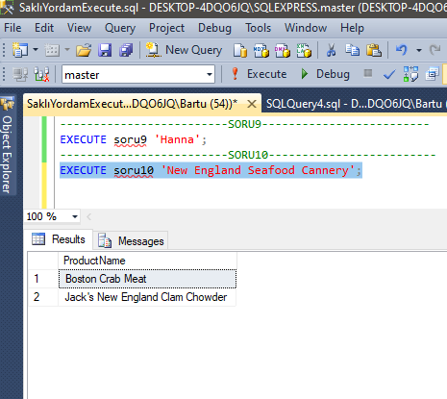

**-------------------------SORU10-------------------------**

CREATE PROC soru10(@sirketİsmi nvarchar(20) = 'New England Seafood Cannery')

AS

BEGIN

SELECT p.ProductName, o.OrderDate FROM "Order" o, Customer c, OrderItem oitem, Product p

WHERE c.Id = o.CustomerId and c.FirstName = @sirketİsmi AND oitem.OrderId = o.Id AND oitem.ProductId = p.ProductName

ORDER BY o.OrderDate

END

**-------------------------SORU10-------------------------**

EXECUTE soru10 'New England Seafood Cannery';