EC2 en una VPC

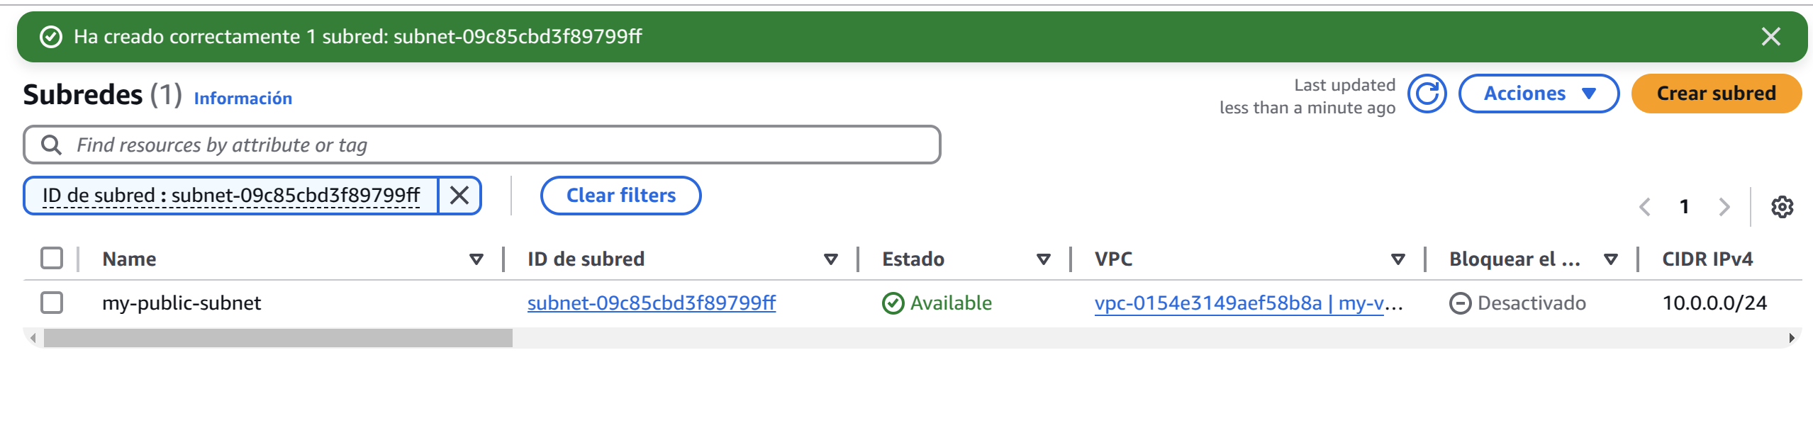
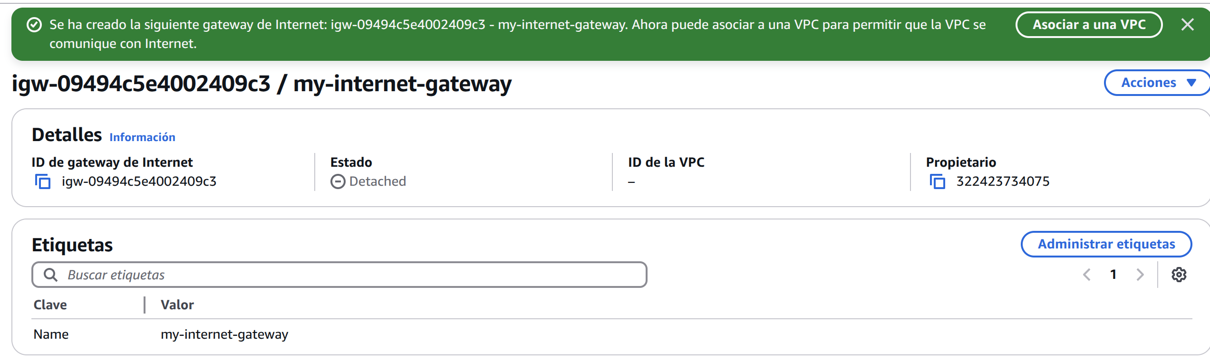
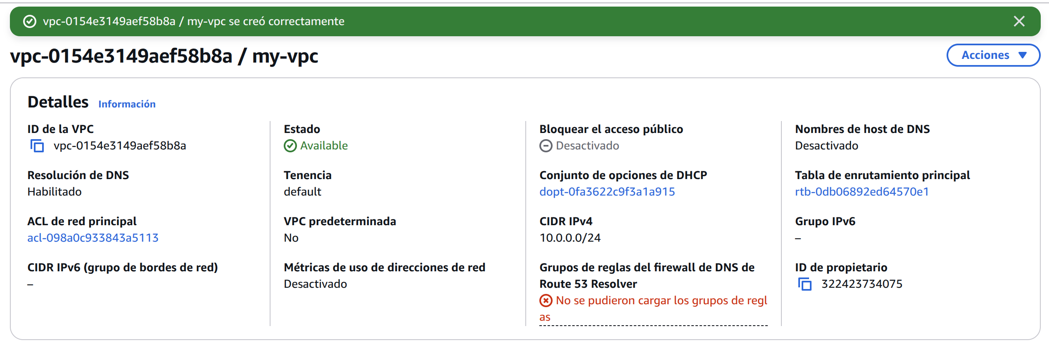
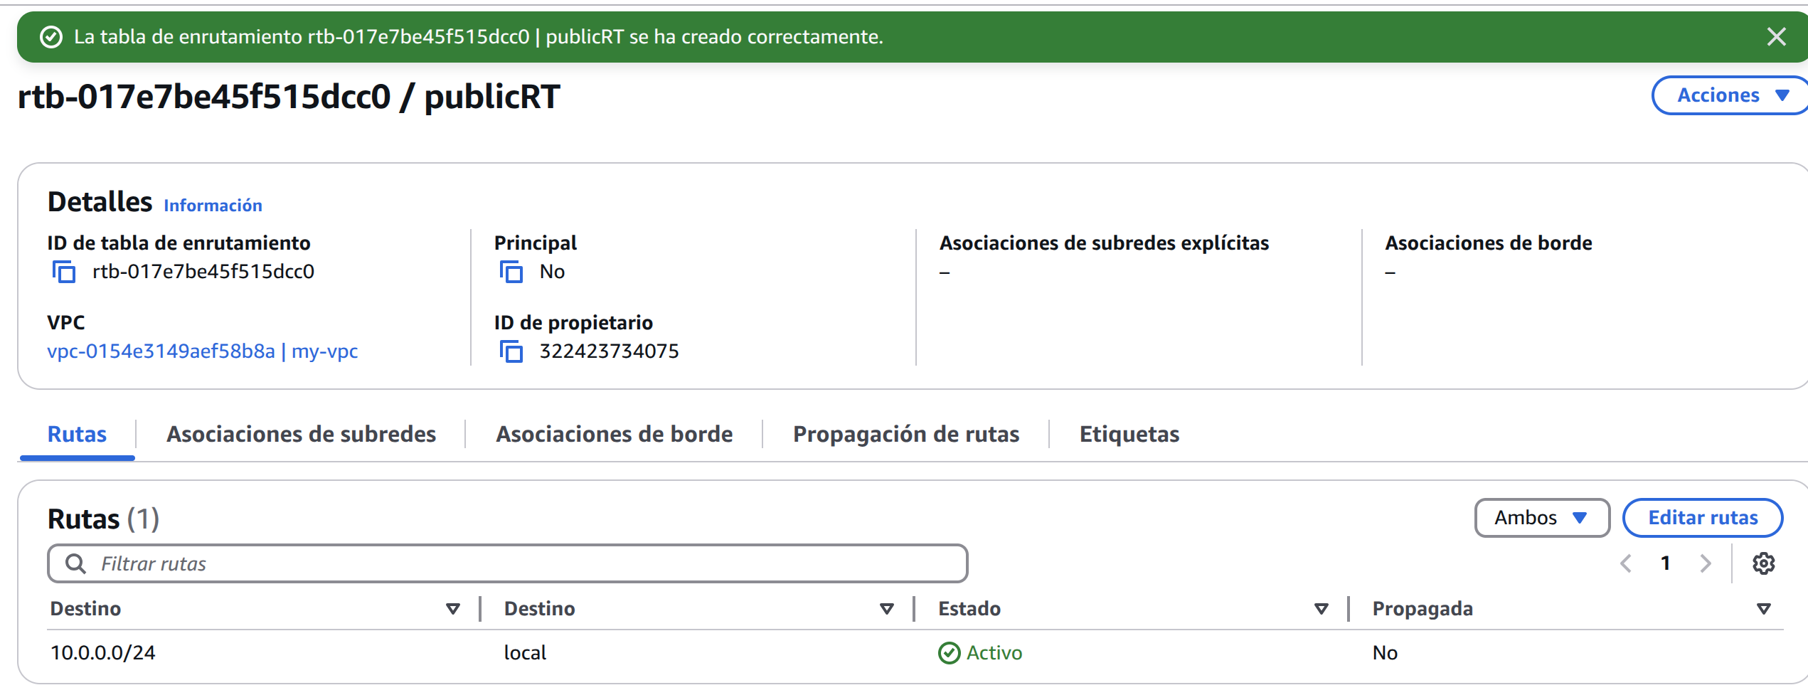
Create a VPC
Create a Public Subnet
Create Routes and Configure Internet Gateway
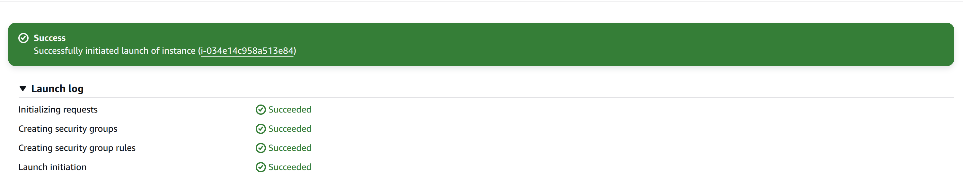
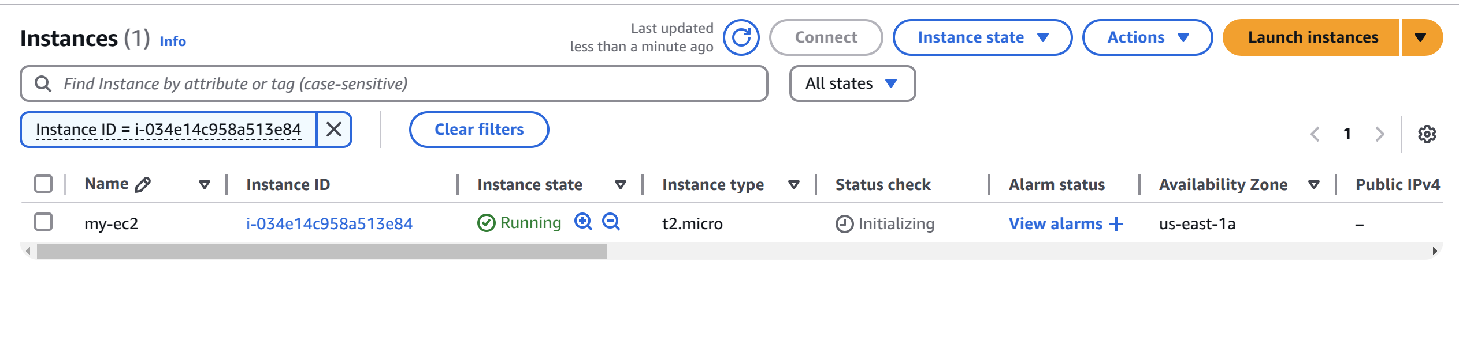
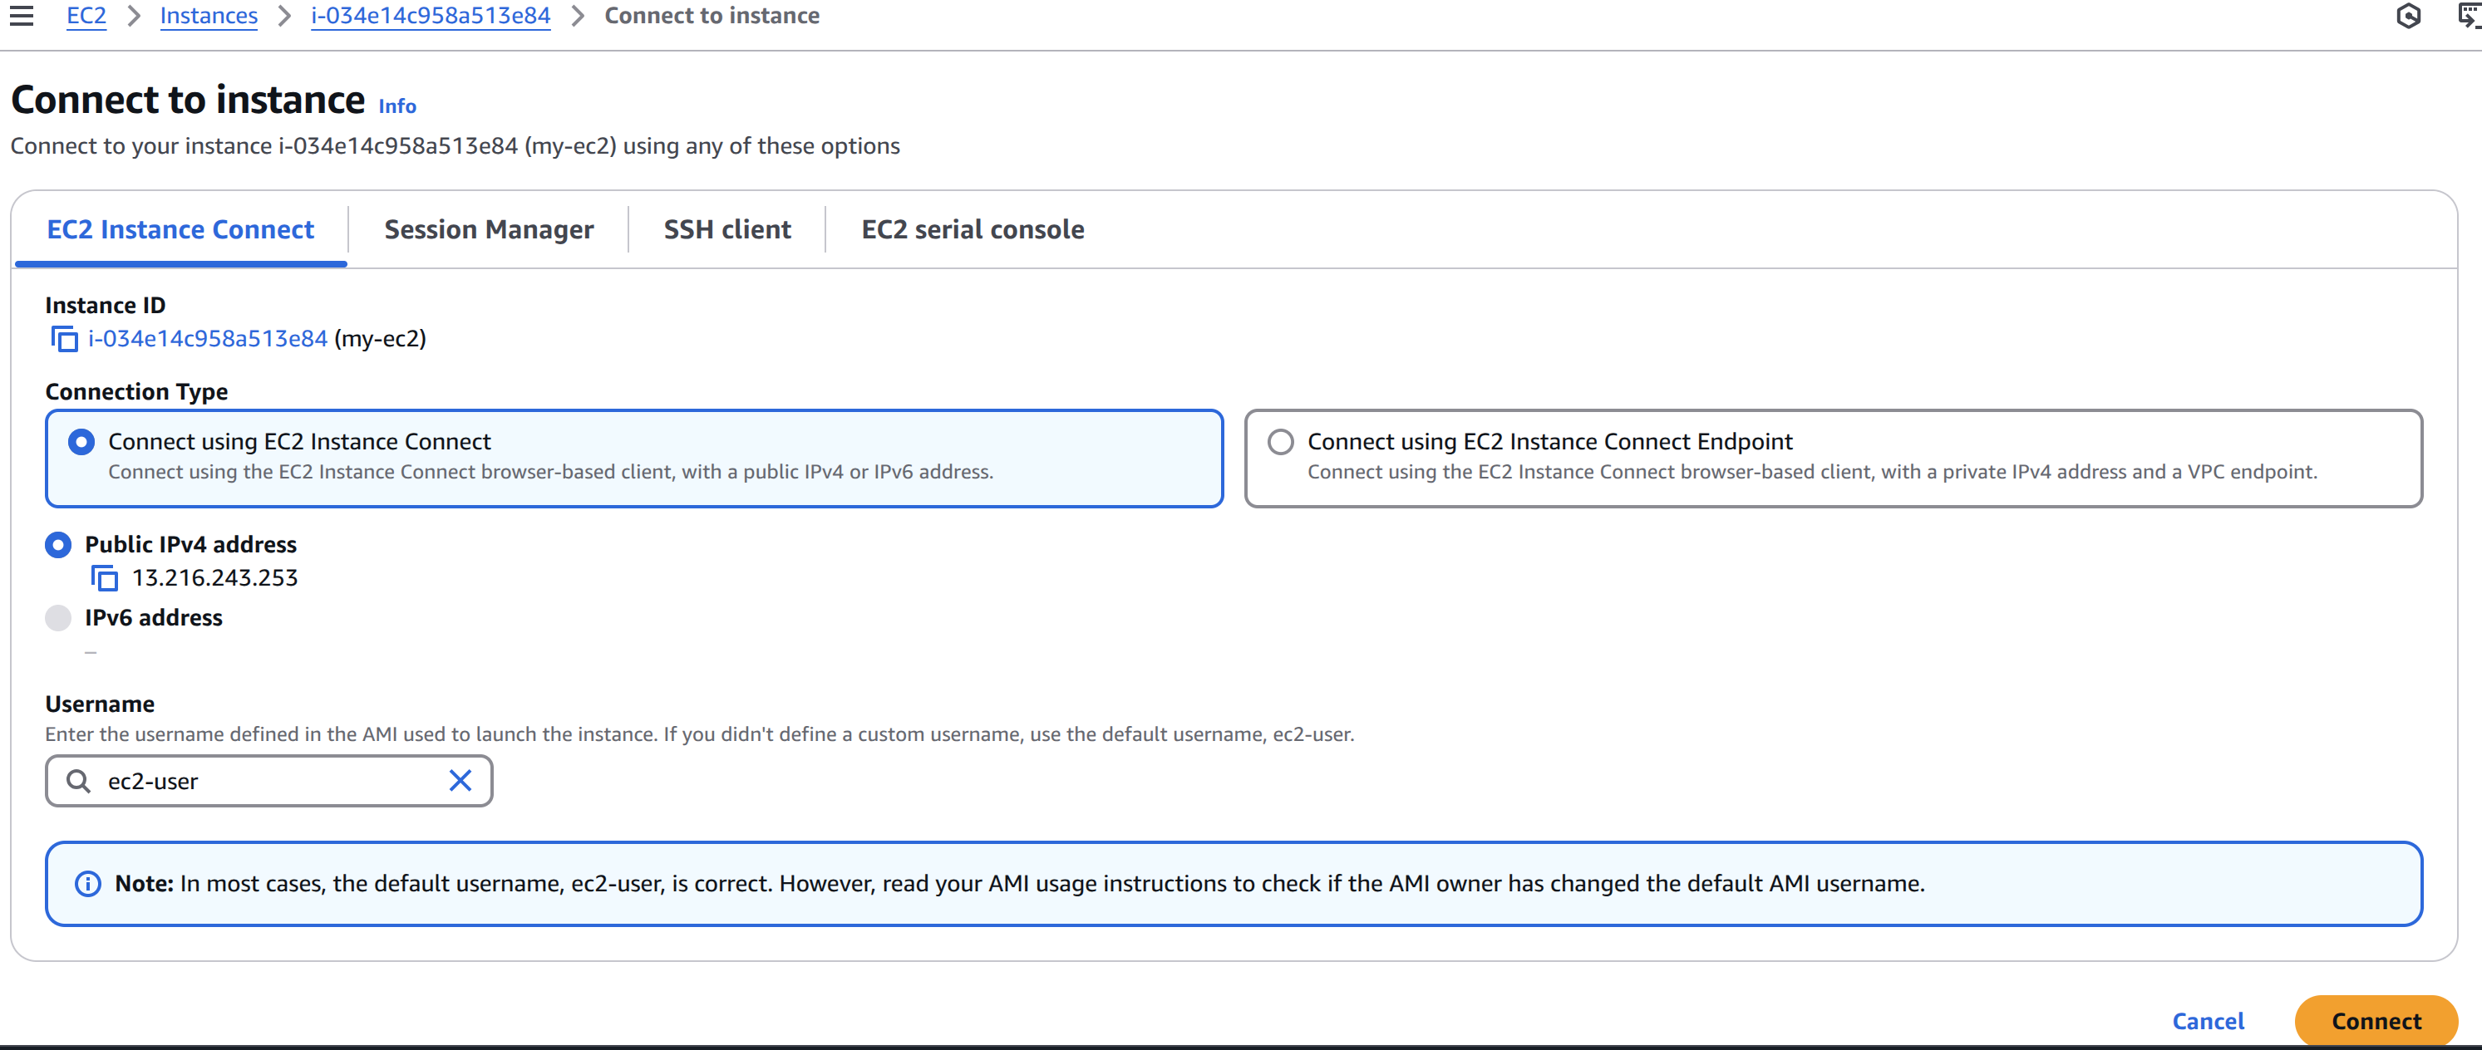
Launch EC2 Instance in Subnet
Access EC2 Instance
