Oracle e-Business Suite (EBS) - Blueprint Information

1. OVERVIEW

The purpose of this document is to describe the Oracle EBS Suite blueprint in detail. The goal of the blueprint is to allow for provisioning and configuration of an EBS instance in an automated and repeatable fashion.

The following components and versions are installed as part of the EBS instance:

(1) Oracle Database 10gR2 (10.2.0.5.0) on Database Tier

(2) Oracle EBS 11i (11.5.10.2) on Application tiers (one Concurrent Manager node and one Web/Forms server node - uses Shared Application tier feature)

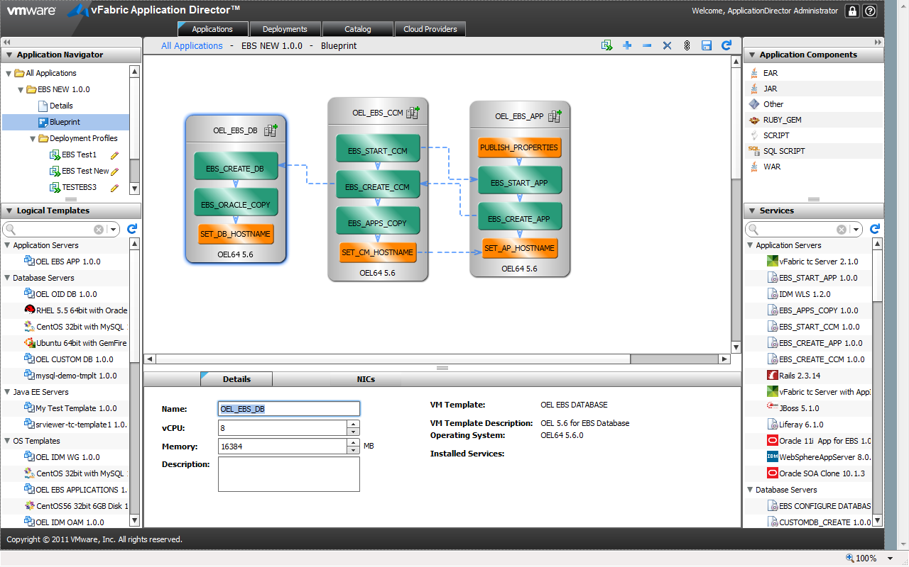

2. HIGH LEVEL BLUEPRINT DESIGN

Conceptually, the blueprint design consists of the tasks described below. These tasks are

listed in chronological order:

(1) Prepare OS (Database node & Application node)

(2) Copy Oracle Database Binaries (Database node)

(3) Restore Oracle Database Backup (Database node)

(4) Copy Oracle Application Binaries (Application node)

(5) Create Database (Database node)

(6) Configure Applications (Concurrent Manager & Web/Forms node)

2.1 Files

Access to create the following file repository that contains the necessary scripts is needed. This repository will be referred as the Dropbox Home in this document.

$DROPBOX_HOME/EBS_SCRIPTS:

* Create_DB.sh & DB_Config.sh To Create Database
* Create_CM.sh & APPS_Config_CM.sh To Configure Concurrent Manager node
* Create_AP.sh & APPS_Config_AP.sh To Configure Web/Forms server node
* AutoConfig.sh To run Autoconfig
* txksohm.sh To configure Shared Application Tier

2.2 Prepare OS Properties

The Prepare OS task sets the hostname for the machine that’s provisioned and Register the IP Address & Hostname in DNS. The following properties govern the execution of the blueprint:

|  |  |  |
| --- | --- | --- |
| **Property** | **Description** | **Notes** |
| HOST_NAME_PATTERN | Set this to be a hostname pattern based on the environment (for e.g., dev1). | %e in the pattern will be substituted by the environment name |
| IP_ADDRESS | Set this property to the IP address of the machine | Self:NIC0_ip |
| DOMAIN_NAME | Set this property to be the domain name |  |
| HOST_NAME | The eventual hostname will be set in this property. Therefore, you can use this property within other modules in this blueprint |  |

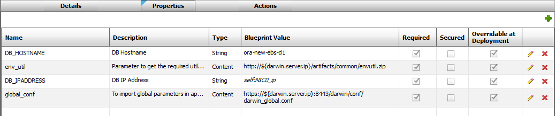

Actions:

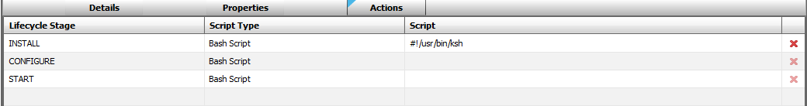

Install Script:

Please refer to file **SET_DB_HOSTNAME_INSTALL.txt** to copy the script as the INSTALL Bash Script.

2.3 Copy Oracle Database Software and Restore Database Backup

This is to Copy Oracle Database Binaries and Data files. The following properties are required.

|  |  |  |
| --- | --- | --- |
| **Property** | **Description** | **Notes** |
| SID | EBS Database Name (SID) |  |

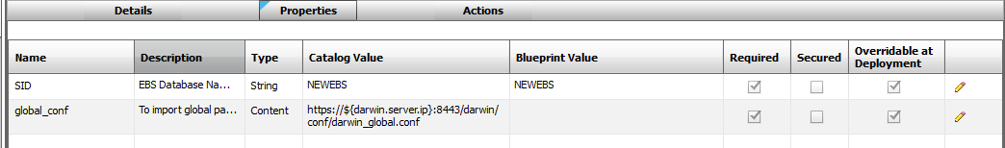

Actions:

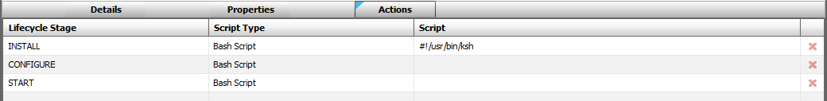

Install Script:

Please refer to file **EBS_ORACLE_COPY_INSTALL.txt** to copy the script as the INSTALL Bash Script.

2.4 Create Database

This is to Create Oracle Database and change important Database users passwords. The following properties are required.

|  |  |  |
| --- | --- | --- |
| **Property** | **Description** | **Notes** |
| SID | EBS Database Name (SID) |  |
| PORT_POOL | EBS Port Pool | This is the port pool number which is used for DB Listener, Web Server, Forms Server... |
| NEW_APPS_PASS | New APPS Password | The APPS password will be reset to this value after cloning |
| SYS_PASS | SYS Password | Password will be changed to this value after provisioning |
| SYSADMIN_PASS | SYSADMIN Password | Password will be changed to this value after provisioning |
| CUR_APPS_PASS | Current Apps Password | This is the existing APPS password |
| DB_HOSTNAME | EBS Database Server Hostname |  |
| DBSNMP_PASS | DBSNMP Password | Password will be changed to this value after provisioning |
| XXVM_PASS | XXVM Password | Password will be changed to this value after provisioning |
| APPSRDONLY_PASS | APPSRDONLY Password | Password will be changed to this value after provisioning |
| VERTEX_PASS | VERTEX Password | Password will be changed to this value after provisioning |
| XXVMPORTAL_PASS | XXVMPORTAL Password | Password will be changed to this value after provisioning |
| XXVM_MYLEARN_PASS | XXVM_MYLEARN Password | Password will be changed to this value after provisioning |
| EBS_INTGR_PASS | EBS_INTGR Password | Password will be changed to this value after provisioning |
| PORTAL_READONLY_PASS | PORTAL_READONLY Password | Password will be changed to this value after provisioning |
| XXVM_HR_BPC_USER_PASS | XXVM_HR_BPC_USER Password | Password will be changed to this value after provisioning |
| CSSHT_PASS | CSSHT Password | Password will be changed to this value after provisioning |
| FINBI_LOAD_USER_PASS | FINBI_LOAD_USER Password | Password will be changed to this value after provisioning |
| HRREADONLY_PASS | HRREADONLY Password | Password will be changed to this value after provisioning |
| global_conf | To import global parameters in app director |  |

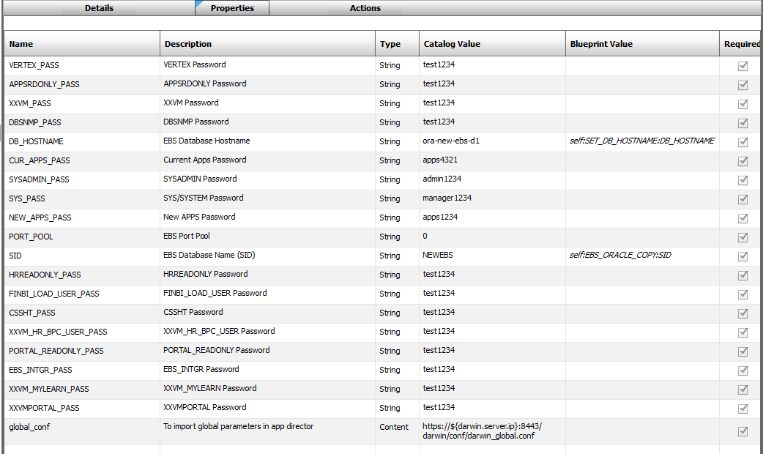

Actions:

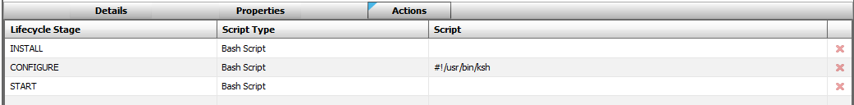

Configure Script:

Please refer to file **EBS_CREATE_DB_CONFIGURE.txt** to copy the script as the CONFIGURE Bash Script.

Additional scripts required for database node can be found in repo under folder “EBS_SCRIPTS\db\”

1) Create_DB.sh

2) DB_Config.sh

2.5 Copy Oracle EBS Application Binaries

This is to copy Oracle EBS Application Binaries onto shared NFS drive to make use of Shared Application Tier. The following properties are required.

|  |  |  |
| --- | --- | --- |
| **Property** | **Description** | **Notes** |
| SID | EBS Database Name (SID) |  |
| global_conf | To import global parameters in app director |  |

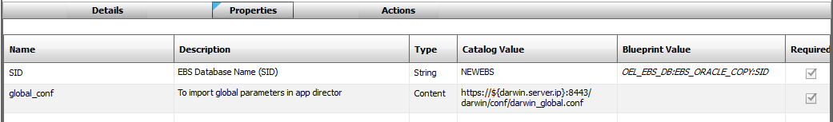

Actions:

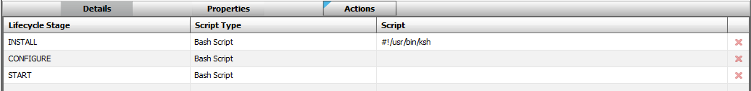

Install Script:

Please refer to file **EBS_APPS_COPY_INSTALL.txt** to copy the script as the INSTALL Bash Script.

2.6 Configure Concurrent Manager Tier

This is to configure Concurrent Manager Tier. The following properties are required.

|  |  |  |
| --- | --- | --- |
| **Property** | **Description** | **Notes** |
| SID | EBS Database Name (SID) |  |
| global_conf | To import global parameters in app director |  |
| PORT_POOL | EBS Port Pool |  |
| NEW_APPS_PASS | New APPS Password |  |
| SYS_PASS | SYS/System Password |  |
| SYSADMIN_PASS | SYSADMIN Password |  |
| CUR_APPS_PASS | Current Apps Password |  |
| DB_HOSTNAME | EBS Database Server Hostname |  |
| CM_HOSTNAME | EBS CM Tier Hostname |  |
| AP_HOSTNAME | EBS Apps Tier Hostname |  |

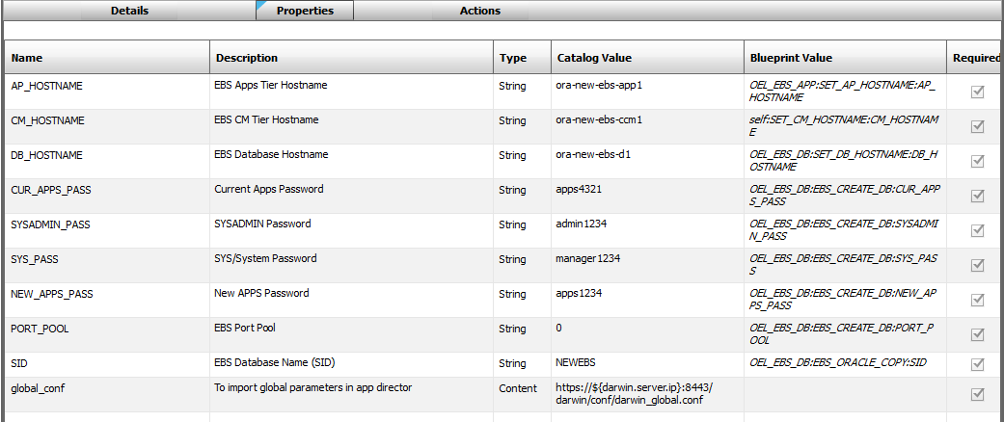

Actions:

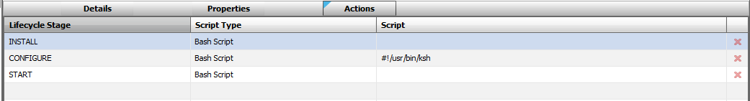

Configure Script:

Please refer to file **EBS_CREATE_CCM_CONFIGURE.txt** to copy the script as the CONFIGURE Bash Script.

Additional scripts required for concurrent manager node can be found in repo under folder “EBS_SCRIPTS\cm\”

Files Required:

1) Create_CM.sh

2) APPS_Config_CM.sh

3) AutoConfig.sh

4) txksohm.sh

5) Start_CCM.sh

2.7 Configure Web/Forms Server Tier

This is to configure Web/Forms server Tier. The following properties are required.

|  |  |  |
| --- | --- | --- |
| **Property** | **Description** | **Notes** |
| SID | EBS Database Name (SID) |  |
| global_conf | To import global parameters in app director |  |
| PORT_POOL | EBS Port Pool |  |
| NEW_APPS_PASS | New APPS Password |  |
| SYS_PASS | SYS/System Password |  |
| SYSADMIN_PASS | SYSADMIN Password |  |
| CUR_APPS_PASS | Current Apps Password |  |
| DB_HOSTNAME | EBS Database Server Hostname |  |
| CM_HOSTNAME | EBS CM Tier Hostname |  |
| AP_HOSTNAME | EBS Apps Tier Hostname |  |

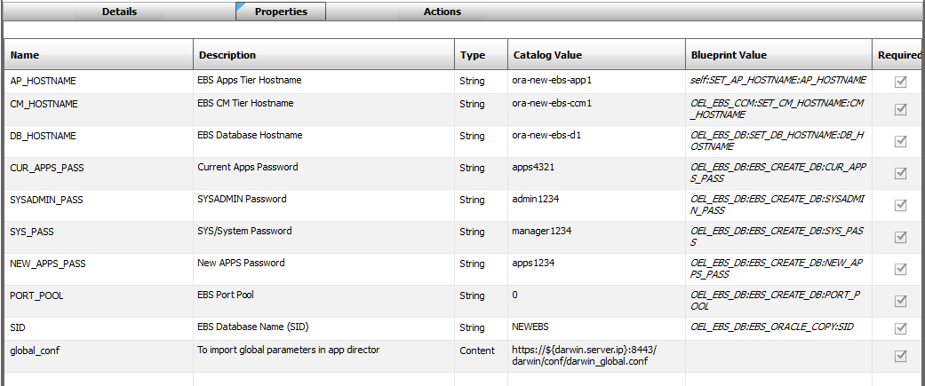

Actions:

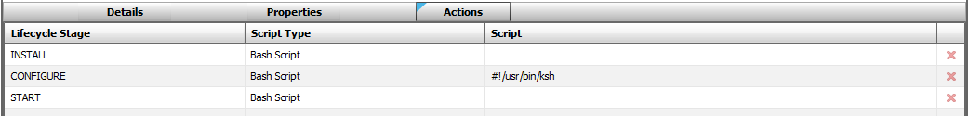

Configure Script:

Please refer to file **EBS_CREATE_APP_CONFIGURE.txt** to copy the script as the CONFIGURE Bash Script.

Additional scripts required for Application node can be found in repo under folder “EBS_SCRIPTS\ap\”

Files Required:

1) Create_AP.sh

2) APPS_Config_AP.sh

3) AutoConfig.sh

4) txksohm.sh

5) Start_APP.sh

2.8 Start EBS Apps

This is to start Web/Forms server. No properties required

Action:

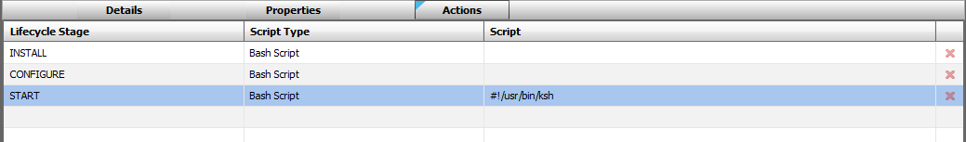

Start Script:

|  |
| --- |
| #!/usr/bin/ksh  # Import global conf  . $global_conf  R_SCRIPTDIR="/oracle/clone/scripts"  R_APPSTARTSCRIPT="$R_SCRIPTDIR/Start_APP.sh"  # Start Apache and Forms Services  su - applmgr -c $R_APPSTARTSCRIPT |

2.9 Start EBS CCM

This is to start configure Concurrent Manager. No properties required

Action:

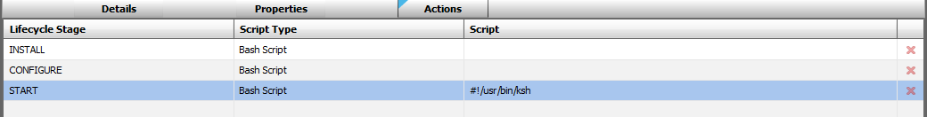

Start Script:

|  |
| --- |
| #!/usr/bin/ksh  # Import global conf  . $global_conf  R_SCRIPTDIR="/oracle/clone/scripts"  R_CCMSTARTSCRIPT="$R_SCRIPTDIR/Start_CCM.sh"  # Start Concurrent Manager  su - applmgr -c $R_CCMSTARTSCRIPT |