MacroVision FLEXlm - Blueprint Information

# Overview

The purpose of this document is to describe the MacroVision FLEXlm blueprint in detail. The goal of the blueprint is to allow for provisioning and configuration of a MacroVision FLEXlm instance in an automated and repeatable fashion.

The following components and versions are installed as part of the MacroVision FLEXlm instance:

1. MacroVision FLEXlm 6.1
2. Tomcat 5.0.18

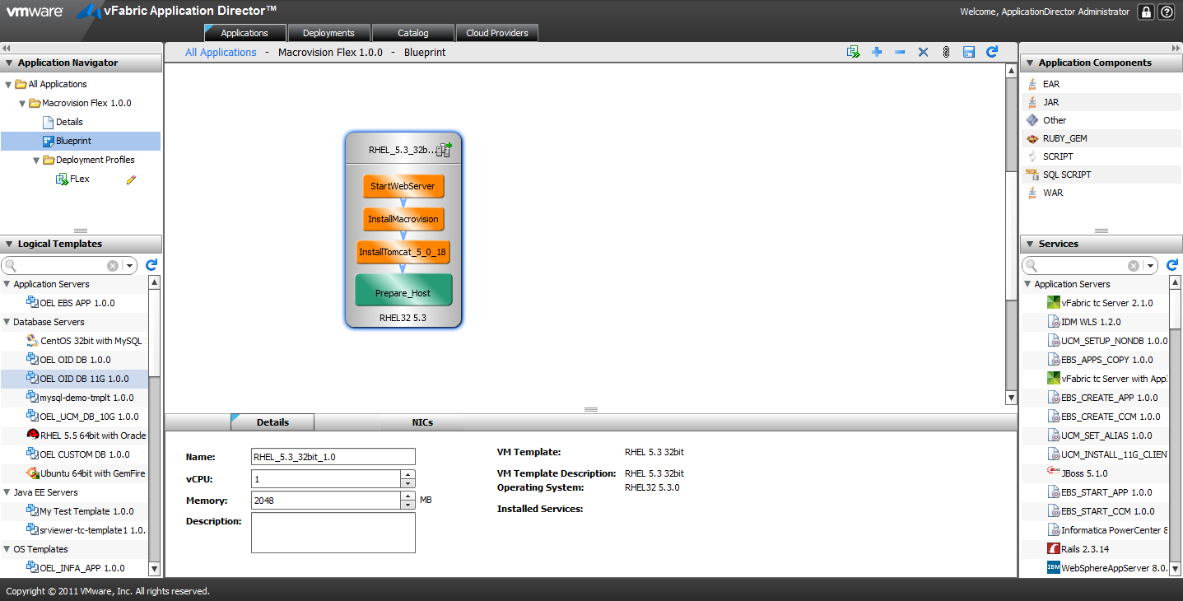

# High level BLUEPRINT Design

Conceptually, the blueprint design consists of the tasks described below. These tasks are listed in chronological order:

1. Prepare Host
2. Install Tomcat 5.0.18
3. Install MacroVision FLEXlm 1.6
4. Start Webserver

## Files

You will need access to create the following file repository that contains the necessary installers and configuration files needed. We will refer to this repository as the Dropbox Home in this document.

$DROPBOX_HOME/Macrovision:

Flexlm Installation files

$DROPBOX_HOME/Macrovision_FlexWS:

Gtlweb, cust-fulfill.war, cust-integration.war

$DROPBOX_HOME/jakarta-tomcat:

jakarta-tomcat-5.0.18.tar.gz

## Prepare OS Properties

The Prepare OS task sets the hostname for the machine that’s provisioned. The following properties govern the execution of the blueprint:

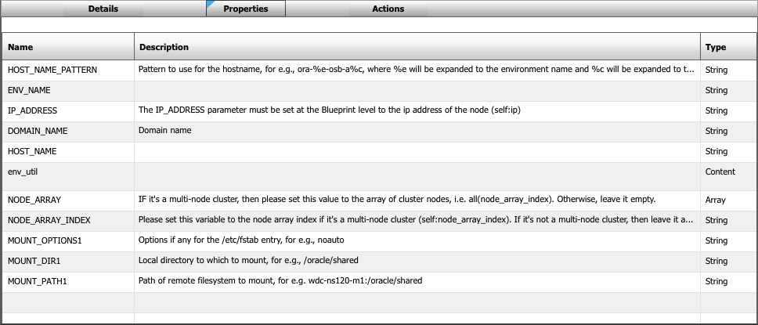

Actions:

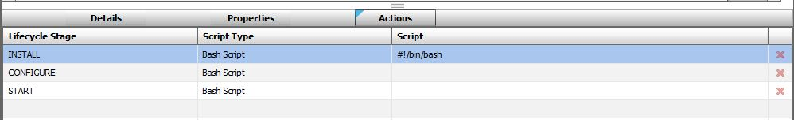

Install Script:

#!/bin/bash

# Set path variables

export PATH=$PATH:/opt/java/jdk1.6.0_19/bin:/usr/java/default/bin:/usr/java/jdk1.6.0_29/bin

# Get cluster number. If we are in a cluster, then get the cluster index value.

# Otherwise, use 1 for non-cluster environments

if [ ${#NODE_ARRAY[@]} -gt 1 ]; then

CNUMBER=`expr $NODE_ARRAY_INDEX + 1`

else

CNUMBER=1

fi;

# Set hostname variable

HOST_NAME=`echo $HOST_NAME_PATTERN | sed "s/%e/$ENV_NAME/g" | sed "s/%c/$CNUMBER/g"`

echo "Setting hostname to $HOST_NAME.$DOMAIN_NAME"

# Change VM hostname

hostname $HOST_NAME

# Replace hostname in /etc/hosts

sed -i.bak "s/$IP_ADDRESS.*/$IP_ADDRESS $HOST_NAME.$DOMAIN_NAME $HOST_NAME/g" /etc/hosts

sed -i.bak "s/HOSTNAME=.*/HOSTNAME=$HOST_NAME.$DOMAIN_NAME/g" /etc/sysconfig/network

# set HOST_NAME INCLUDING DOMAIN

HOST_NAME="$HOST_NAME"."$DOMAIN_NAME"

# Perform mount commands, if specified.

if [ -n "$MOUNT_PATH1" -a -n "$MOUNT_DIR1" ]; then

echo "Mounting $MOUNT_PATH1 to $MOUNT_DIR1 with options $MOUNT_OPTIONS1"

test -d "$MOUNT_DIR1" || mkdir -p $MOUNT_DIR1

test -z "$MOUNT_OPTIONS1" && MOUNT_OPTIONS1="defaults"

mount -o $MOUNT_OPTIONS1 $MOUNT_PATH1 $MOUNT_DIR1

if [ $? -eq 0 ]; then

echo "$MOUNT_PATH1 $MOUNT_DIR1 nfs $MOUNT_OPTIONS1 1 2" >> /etc/fstab

else

exit $?

fi;

fi;

## Install Tomcat

The Install Tomcat task installs Tomcat 5.0.18 on the machine. It’s governed by the following properties:

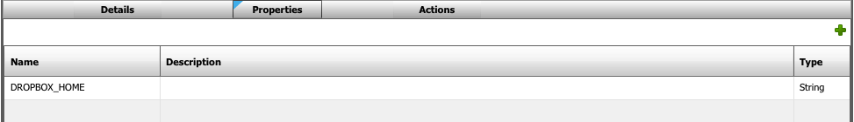

Actions:

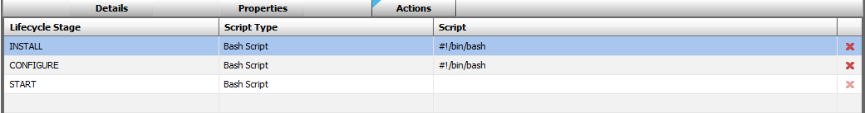

Install Script:

|  |
| --- |
| #!/bin/bash  # copy tomcat tar file to /usr/local  cp $DROPBOX_HOME/jakarta-tomcat/jakarta-tomcat-5.0.18.tar.gz /usr/local/  cd /usr/local  # extract tomcat files  tar -zxvf jakarta-tomcat-5.0.18.tar.gz  # create link 'tomcat' on /usr/local/jakarta-tomcat-5.0.18  ln -s /usr/local/jakarta-tomcat-5.0.18 tomcat |

Configure Script:

|  |
| --- |
| #!/bin/bash  # copy Custom server.xml to tomcat/conf  /bin/cp -rf $DROPBOX_HOME/jakarta-tomcat/custom_conf/* /usr/local/tomcat/conf/  #Modify the bash profile root user  echo "export JAVA_HOME=/usr/java/jdk1.6.0_32" >> ~/.bash_profile  echo "export CATALINA_HOME=/usr/local/tomcat" >> ~/.bash_profile |

## Install Macrovision FLEXlm 6.1

The Install Macrovision task installs Macrovision FLEXLm 6.1 on the machine. It’s governed by the following properties:



Actions:

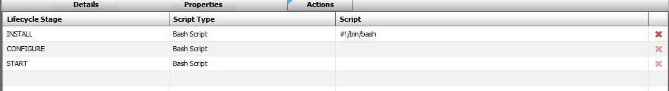

Install Script:

|  |
| --- |
| #!/bin/bash  # create user & group for fnpom  /usr/sbin/groupadd fnpom  /usr/sbin/useradd fnpom -d /opt/fnpom -g fnpom  cp -r $DROPBOX_HOME/Macrovision/ /opt/fnpom/  # change owner & group of installed Macrovision files  cd /opt  chown -R fnpom:fnpom fnpom/  # install Custom web applications created for Macrovision Flex  cp -r $DROPBOX_HOME/Macrovision_FlexWS/* /usr/local/tomcat/webapps/ |

## Start WebServer

The Start Webserver task starts tomcat webserver on the machine. It’s governed by the following Action:

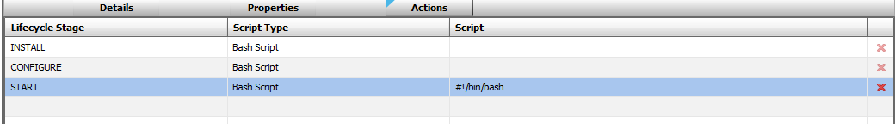

Start Script:

|  |
| --- |
| #!/bin/bash  #Start the Tomcat Services  cd /usr/local/tomcat/bin  ./startup.sh & |