ModelN - Blueprint Information

# Overview

The purpose of this document is to describe the ModelN blueprint in detail. The goal of the blueprint is to allow for provisioning and configuration of a ModelN instance in an automated and repeatable fashion.

The following components and versions are installed as part of the ModelN instance:

1. ModelN for High Tech 8.2.1
2. Oracle WebLogic Server 10.3.5
3. Oracle Database 11.2 (both client and server)
4. JDK 1.6.0

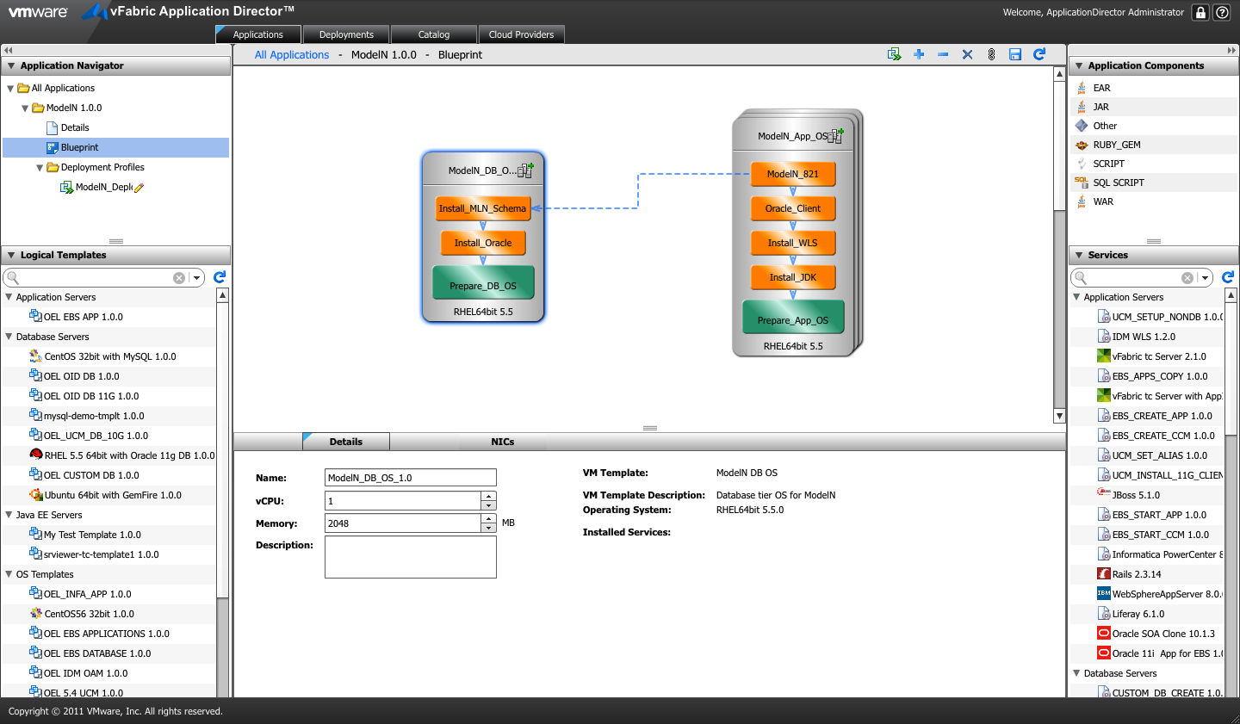

# High level BLUEPRINT Design

Conceptually, the blueprint design consists of the tasks described below. These tasks are listed in chronological order:

1. Prepare OS (common to DB & App tier)
2. Install JDK 1.6 (App tier)
3. Install WLS 11g (App tier)
4. Install Oracle 11g (server on DB tier & client on App tier)
5. Install MLN Schema (DB tier)
6. Install ModelN (App tier)

## Files

You will need access to create the following file repository that contains the necessary installers and configuration files needed. We will refer to this repository as the Dropbox Home in this document.

$DROPBOX_HOME/MLN:

build.xml Ant-based build file for installation

runner.sh Main driver file

$DROPBOX_HOME/MLN/config:

db_install.rsp Database install response file (full install of server)

db_install_swonly.rsp Database install response file for software only (client)

install-mln-schemas.sh Shell script to install ModelN schema

license.xml Valid ModelN license file

silent.xml WebLogic silent installation file

$DROPBOX_HOME/MLN/installer:

jdk-6u25-linux-x64.bin JDK 1.6 installation file

wls1035_generic.jar WebLogic 10.3.5 installer

$DROPBOX_HOME/MLN/installer/clone:

cust-dev.zip Zip file containing cust information

mn821-dev.zip Zip file containing cloned ModelN software

vmdata-dev.dmp Oracle export file of ModelN schema data

## Prepare OS Properties

The Prepare OS task sets the hostname for the machine that’s provisioned. The following properties govern the execution of the blueprint:

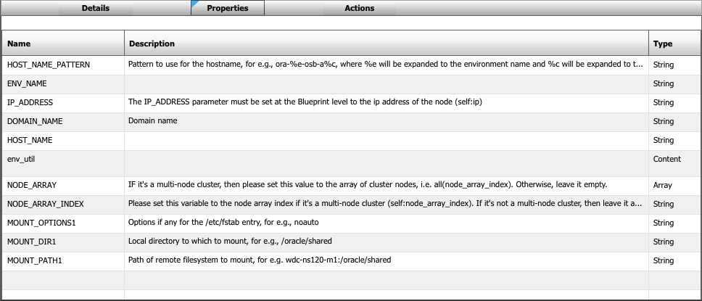

Actions:

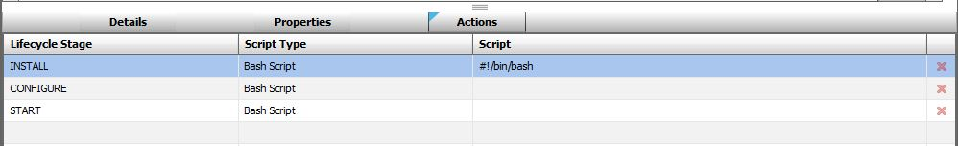

Install Script:

#!/bin/bash

# Set path variables

export PATH=$PATH:/opt/java/jdk1.6.0_19/bin:/usr/java/default/bin:/usr/java/jdk1.6.0_29/bin

# Get cluster number. If we are in a cluster, then get the cluster index value.

# Otherwise, use 1 for non-cluster environments

if [ ${#NODE_ARRAY[@]} -gt 1 ]; then

CNUMBER=`expr $NODE_ARRAY_INDEX + 1`

else

CNUMBER=1

fi;

# Set hostname variable

HOST_NAME=`echo $HOST_NAME_PATTERN | sed "s/%e/$ENV_NAME/g" | sed "s/%c/$CNUMBER/g"`

echo "Setting hostname to $HOST_NAME.$DOMAIN_NAME"

# Change VM hostname

hostname $HOST_NAME

# Replace hostname in /etc/hosts

sed -i.bak "s/$IP_ADDRESS.*/$IP_ADDRESS $HOST_NAME.$DOMAIN_NAME $HOST_NAME/g" /etc/hosts

sed -i.bak "s/HOSTNAME=.*/HOSTNAME=$HOST_NAME.$DOMAIN_NAME/g" /etc/sysconfig/network

# set HOST_NAME INCLUDING DOMAIN

HOST_NAME="$HOST_NAME"."$DOMAIN_NAME"

# Perform mount commands, if specified.

if [ -n "$MOUNT_PATH1" -a -n "$MOUNT_DIR1" ]; then

echo "Mounting $MOUNT_PATH1 to $MOUNT_DIR1 with options $MOUNT_OPTIONS1"

test -d "$MOUNT_DIR1" || mkdir -p $MOUNT_DIR1

test -z "$MOUNT_OPTIONS1" && MOUNT_OPTIONS1="defaults"

mount -o $MOUNT_OPTIONS1 $MOUNT_PATH1 $MOUNT_DIR1

if [ $? -eq 0 ]; then

echo "$MOUNT_PATH1 $MOUNT_DIR1 nfs $MOUNT_OPTIONS1 1 2" >> /etc/fstab

else

exit $?

fi;

fi;

## Install JDK 1.6

The Install JDK task installs JDK 1.6.0 on the machine. It’s governed by the following properties:

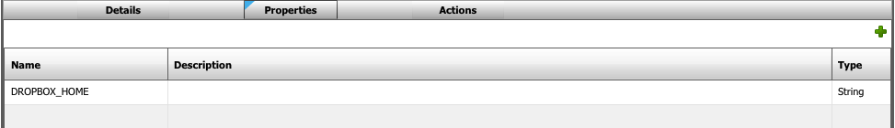

Actions:

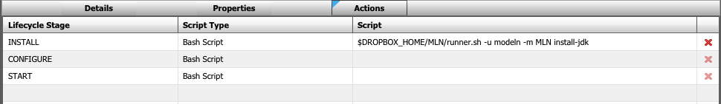

Install Script:

$DROPBOX_HOME/MLN/runner.sh -u modeln -m MLN install-jdk

## Install WLS 11g

The Install WLS task installs WLS 11g on the machine. It uses the JDK that’s installed in the previous step. It’s governed by the following properties:

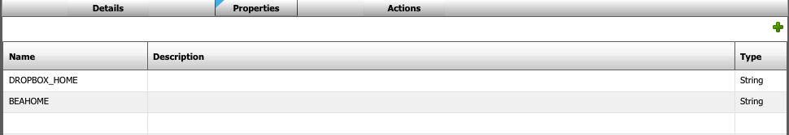

Actions:

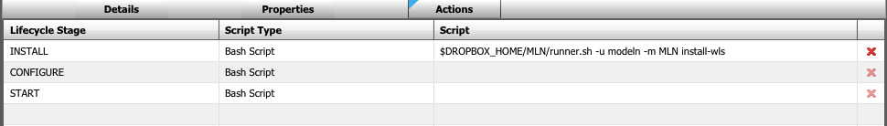

Install Script:

$DROPBOX_HOME/OSB/runner.sh –u modeln –m MLN install-wls

## Install Oracle 11g (client on App tier and server on DB tier)

This task installs Oracle database 11g client or server. It’s called twice in the blueprint, once to install the server on the DB tier and again to install the client on the App tier.

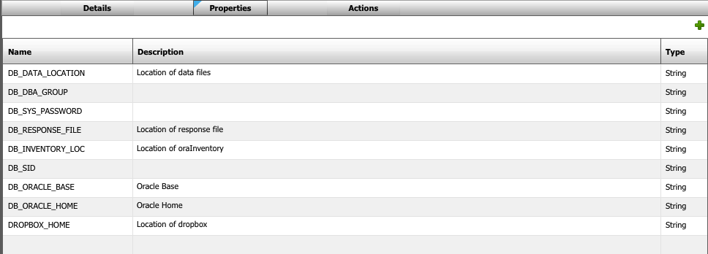

Actions:

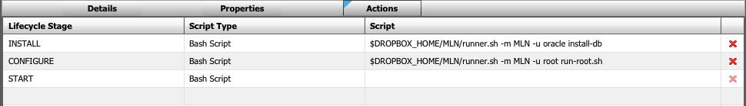

Install Script:

$DROPBOX_HOME/MLN/runner.sh –m MLN –u oracle install-db

Configure Script:

$DROPBOX_HOME/MLN/runner.sh –m MLN –u root run-root.sh

## Install ModelN schema

This task installs the ModelN schema (also called VMDATA in this blueprint) on the Oracle database 11g installation.

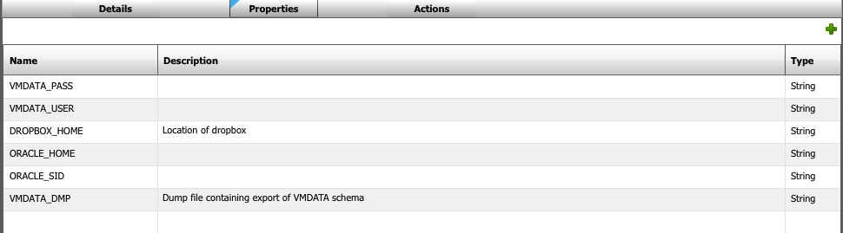

Actions:

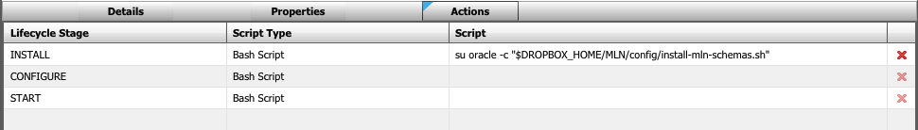

Install Script:

su oracle -c "$DROPBOX_HOME/MLN/config/install-mln-schemas.sh"

## Install ModelN 8.2.1

This task installs ModelN v8.2.1 on the App tier. It takes software and data from an existing clone and reproduces the environment on the App tier.

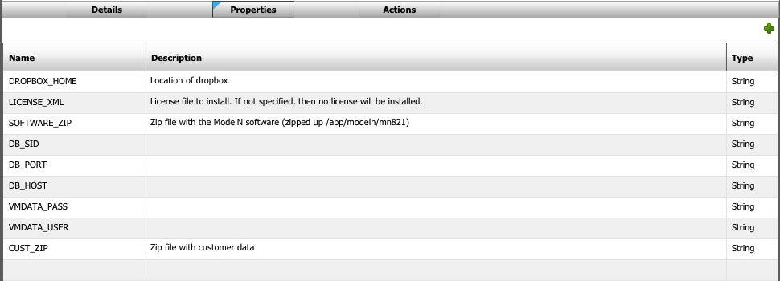

Actions:

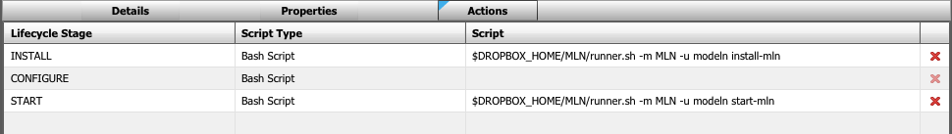

Install Script:

$DROPBOX_HOME/MLN/runner.sh –m MLN –u modeln install-mln

Start Script:

$DROPBOX_HOME/MLN/runner.sh –m MLN –u modeln start-mln