Topic of the project:
Project name: "ASIC design with open source tools"
Developing of an low resolution ADC. As example an 4-Bit ADC with conversion of the thermometer code into binary code.
Steps:
A small CMOS inverter with xschem and the sky130a technology (PDK) and simulate the circuit with ngspice:
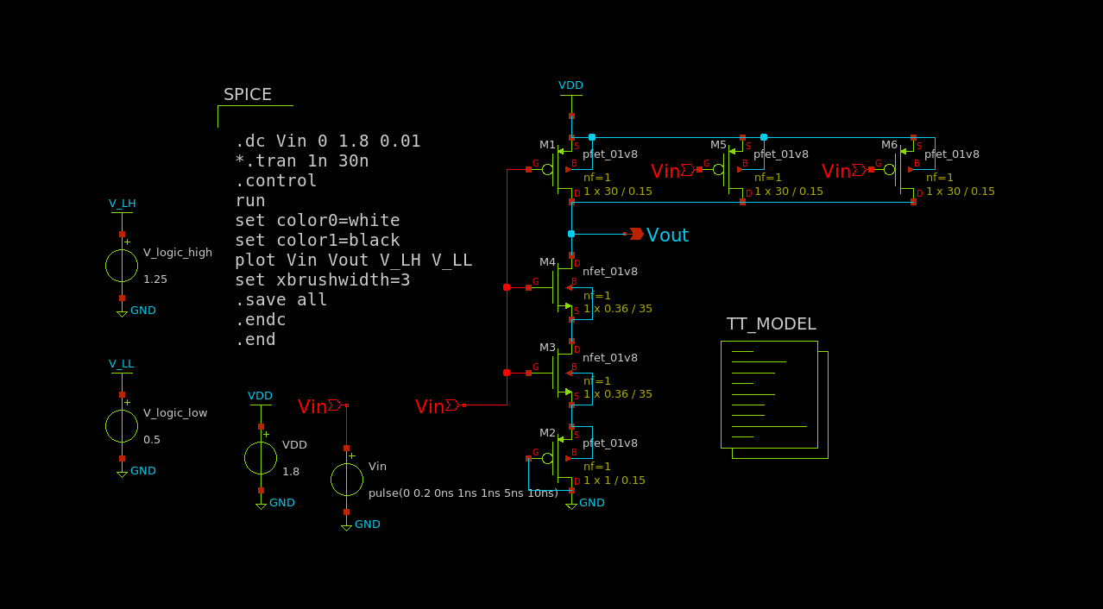
the above figure is the schematic for 15th threshold point of the analogue part of the ADC. The plot is as follows:
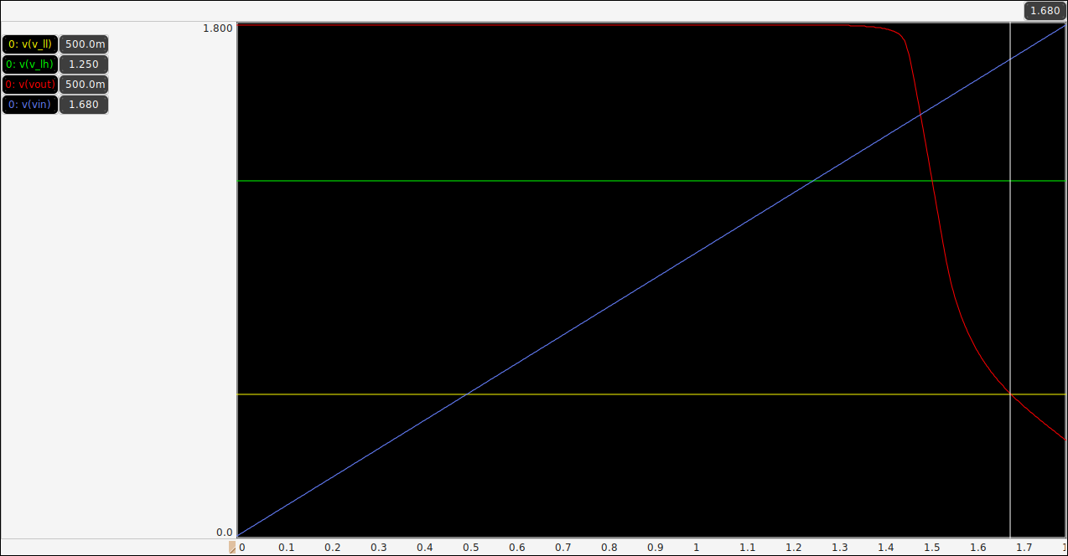
Binary Logic level assumption
https://en.wikipedia.org/wiki/Logic_level
Technology | L Voltage | H Voltage | note
CMOS | 0 to 30% of Vdd | 70% of Vdd to Vdd | Vdd = Supply voltage
 | ≈0.5 Volt | ≈1.25 Volts | Vdd = 1.8 Volts

Magic=>before importing netlist to ngspice check LVS net
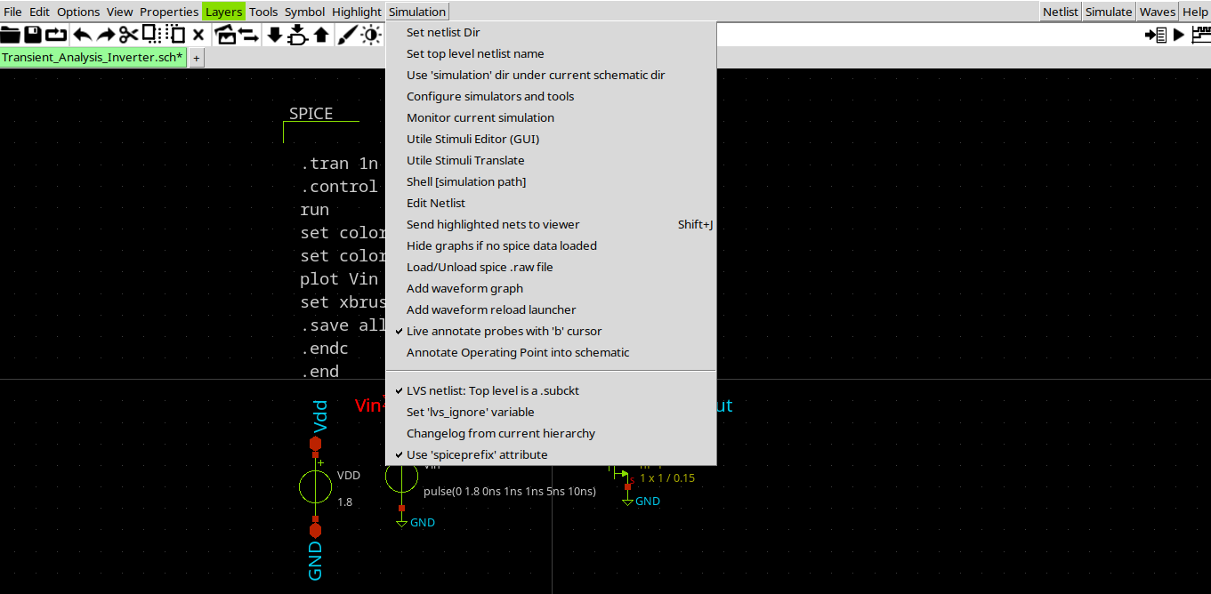
http://web02.gonzaga.edu/faculty/talarico/vlsi/xschemTut.html
https://ngspice.sourceforge.io/ngspice-control-language-tutorial.html
Alter subckt tutorial—
https://sourceforge.net/p/ngspice/discussion/133842/thread/5ad086c79f
https://sourceforge.net/p/ngspice/discussion/133842/thread/9a75acf2/#bf90/45b3/ea48
Pyspice ngspice interpreter
https://pyspice.fabrice-salvaire.fr/releases/v1.3/examples/ngspice-shared/ngspice-interpreter.html
https://github.com/ashwith/ngspicepy
Read spice raw output data
https://gist.githubusercontent.com/snmishra/27dcc624b639c2626137/raw/742fe0dd59c7b2c41b71a1c8c1c2506d13affc53/rawread.py
ngspice wrapper for python
https://github.com/eps82/lyngspice/wiki
- write some verilog code to convert the thermometer code (from the inverter stages) into the binary code
http://www.asic-world.com/verilog/veritut.html
https://www.youtube.com/playlist?list=PLfGJEQLQIDBN0VsXQ68_FEYyqcym8CTDN
https://github.com/Swagatika-Meher/msvsd2bitcomp
https://www.youtube.com/playlist?list=PLvXKBnlvcSm30Y0zu1765oG_x-ECU8tVG
https://learning.edx.org/course/course-v1:HarveyMuddX+ENGR85A+3T2021/home
https://www.vlsiuniverse.com/digital-thermometer-code-in-verilog-vhdl-flash-adc-binary-encoder/
https://www.classcentral.com/subject/vlsi?free=true
https://www.eng.biu.ac.il/temanad/digital-vlsi-design/
https://www.youtube.com/playlist?list=PLZU5hLL_713x0_AV_rVbay0pWmED7992G
https://youtu.be/BIqLk23hE90?list=PLZU5hLL_713x0_AV_rVbay0pWmED7992G
- get familiar with the yosis syntesis tool to convert the verilog code into a CMOS circuit
- simulate the complete (ultra small) ADC

References:
https://github.com/bluecmd/learn-sky130/blob/main/schematic/xschem/getting-started.md
- What is Schematic Capture and why do we need it?
- What is a process?

-----------------
Run iverilo/icarus
iverilog file.v
vvp a.out
---------------------------
Vdd = 5 Volt
Vsat_max = 4.616
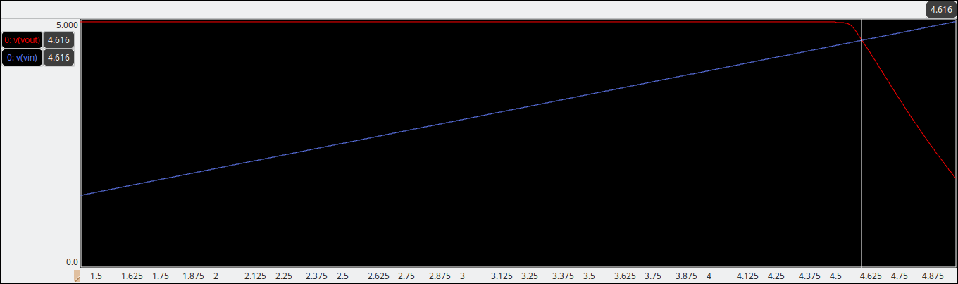

Vsat_min = 481.3mV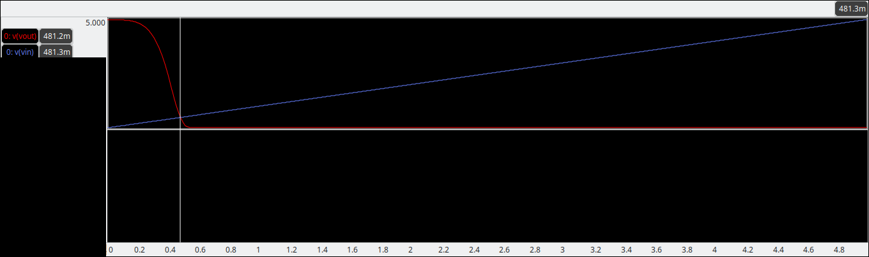
Voltage range = 4.616 – 0.4813 = 4.1347 V
Step voltage = 4.1347/15 = 0.275647
Set. 1: 0.4813
Set. 2: 0.756947
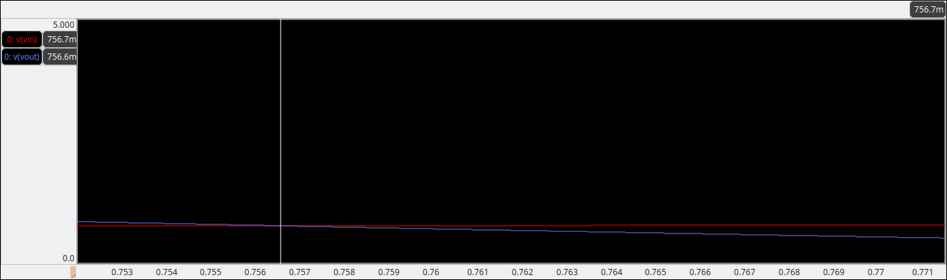
Set. 3: 1.032594
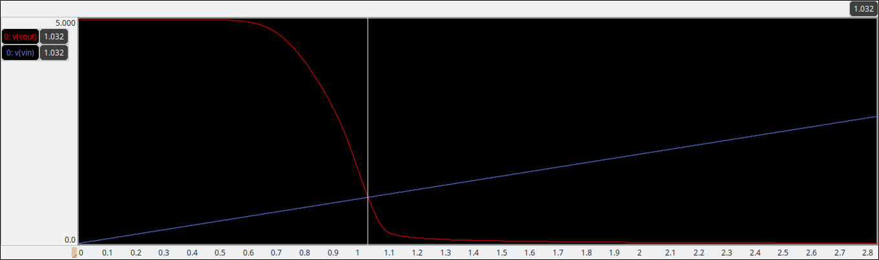
Set. 4: 1.308241
Set. 5: 1.583888
Set. 6: 1.859535
Set. 7: 2.135182
Set. 8: 2.410829
Set. 9: 2.686476
Set. 10: 2.96212
Set. 11: 3.23777
Set. 12: 3.513417
Set. 13: 3.789064
Set. 14: 4.064711
Set. 15: 4.340358
Set. 16: 4.616005
Vdd = 1.8 V
Sat. 1: 0.353900000
Sat. 2: 0.432773300
Sat. 3: 0.511646600
Sat. 6:0.748266500
Sat. 5:0.669393200
Sat. 4: 0.590519900
Sat. 7:0.827139800
Sat. 8:0.906013100
Sat. 9:0.984886400
Sat. 10:1.063759700
Sat. 11:1.142633000
Sat. 12:1.221506300
Sat. 13:1.300379600
Sat. 14:1.379252900

