Front-End-Design
Spezifikation
Chip-Architektur-Design
RTL Design
Verifizierung
Synthesis
LEC
Simulation auf Gate-Level
DFT

Specification
z.B.
8-Bit Serial-in-Parallel Converter (SIPO)
Clock > 1,5 GHz
Process node: 130nm etc.

Chip Architecture Design
This is for advanced chip design. It is not relevant for this exercise. The design of SIPO in a general approach would not be sufficient to achieve a high clock speed in the 130nm process. In this case, a simple multi-clock domain or pipelined design is considered.
RTL Design (HDL/Verilog)
Design Entry (HDL Verilog file)
Plain Text File:
The input of the design in the form of an HDL/Verilog file can be done in a simple text file with the extension “*.v”. In this case, the compilation can be done by calling the design in XCELIUM.
In Virtuoso Studio:
As with a typical analog design, a “New cell view” can be created via the “File” menu. The type should be “Verilog” and opened with the “Text Editor”.
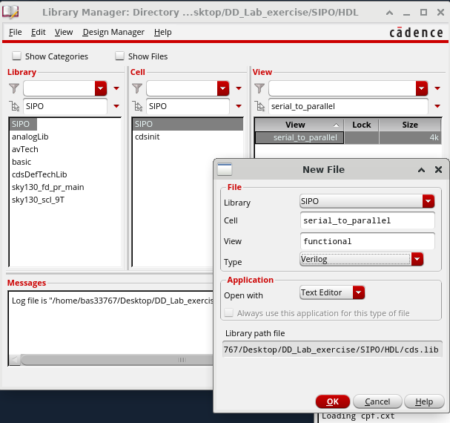
The “Text Editor” should look like this—
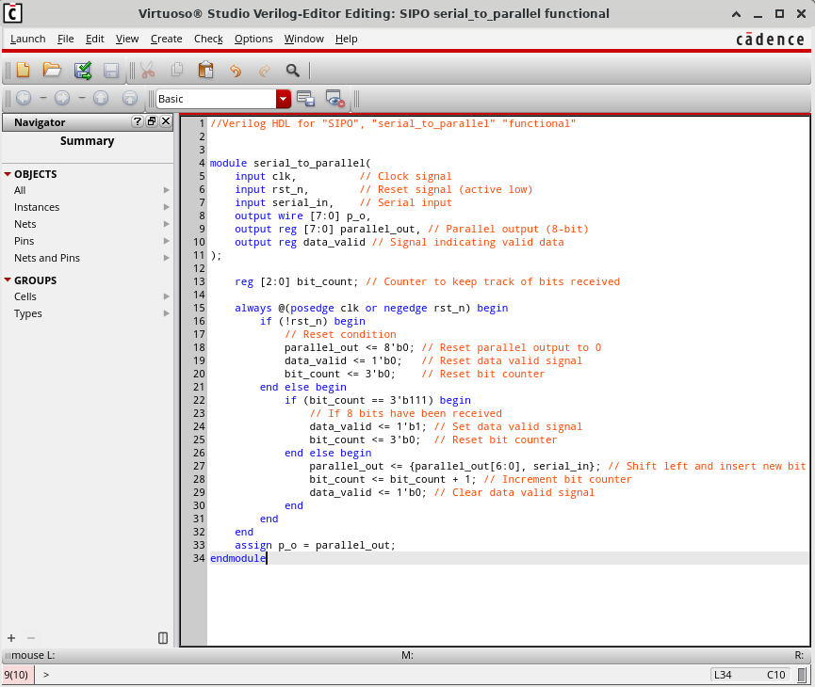
Note: The code in the illustration is not used in the actual simulation.
The design can be created and checked using the “Build” () button. If there is a syntax error, it will be highlighted as follows—
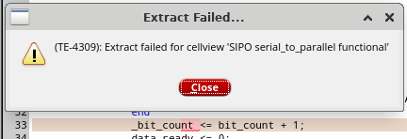
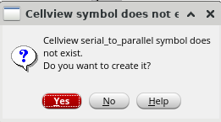
If everything is OK, an symbol is created for the design (only for new “cellview” - if no symbol has been created yet).
It could be useful for mixed signal design/analysis, which is out of the scope of this exercise.
A testbench can be created in a similar way. However, it does not make sense to use a testbench in Virtuoso.
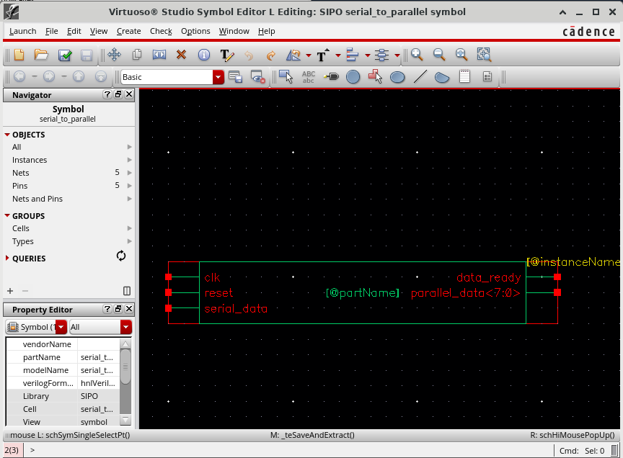

Verification:
HDL/Verilog is now available. The next step is verification. Verification can be formal or functional. Advanced formal verification can be done with Cadence JasperGold, which is not available at the moment. Basic verification can be performed with XCELIUM.
Pre-Synthese Verification:
XCELIUM is used for verification. Provided that the Verilog file and the Testbench are available, the following command can invoke the SimVision control panels:
>> xrun SIPO1_tb.v -access +rwc -64bit -gui &
Here SIPO1_tb.v is the testbench file that instantiates and includes the SIPO_Multi-Clock_Domain.v file. It can also be written as follows if the SIPO_Multi-Clock_Domain.v file is not included in the testbench but is instantiated:
>> xrun SIPO1_tb.v SIPO_Multi-Clock_Domain.v -access +rwc -64bit -gui &
The specification “-64bit” is optional. May be necessary if the design is too large.
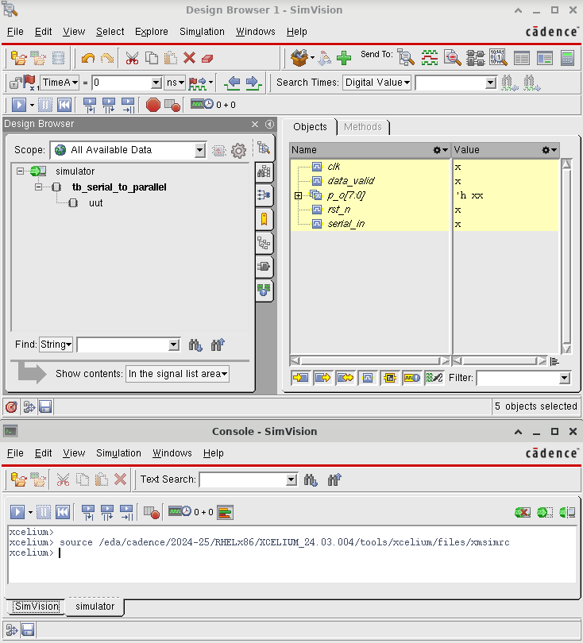
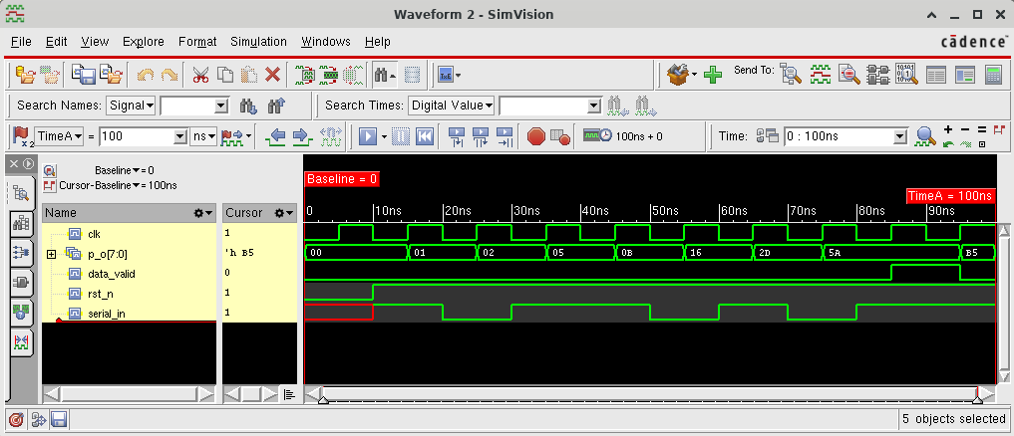

Synthesis
For Synthesis, first SDC file and Liberty file from PDK are needed. A basic SDC file is like this:
## SDC Version
set sdc_version 2
set_units -time 1ps
# Define Clock period
create_clock -period 400 -name clk -waveform {0.0 200} [get_ports clk]
# Load capacity for the output connections (a load of 0.5 is assumed for demonstration purposes)
set_load 0.5 [get_ports p_o]
# Setting the maximum transition time for the output ports
set_max_transition 0.2 [get_ports p_o]
# Setting the clock transition time
set_clock_transition 0.03 [get_clocks clk]
# Setting the clock uncertainty for setup and hold
set_clock_uncertainty -setup 0.06 [get_clocks clk]
set_clock_uncertainty -hold 0.03 [get_clocks clk]
# Setting the input delay for the input connections (assuming a maximum input delay of 1 ps)
set_input_delay -max 1.0 -clock clk [get_ports {serial_in rst_n}]
# Setting the output delay for the output connections (assuming a maximum output delay of 2 ps and a minimum of 1.5 ps)
set_output_delay -max 2.0 -clock clk [get_ports p_o]
set_output_delay -min 1.5 -clock clk [get_ports p_o]
# Set false path for the reset signal to avoid timing issues
set_false_path -from [get_ports rst_n]
Liberty file can be found at “https://github.com/IHP-GmbH/IHP-Open-PDK/tree/main/ihp-sg13g2/libs.ref/sg13g2_stdcell/lib”.

Synthesis without DFT:
Provided that the SDC, Liberty and HDL files are available, a TCL file can be written and the GENUS consol can be invoked. The TCL file (without DFT) is as follows:
# Loads the standard cell library for synthesis (IHP sg13g2 PDK, typical corner, 1.8V, 25°C)
read_libs /home/bas33767/Desktop/IHP-Open-PDK/ihp-sg13g2/libs.ref/sg13g2_stdcell/lib/sg13g2_stdcell_typ_1p20V_25C.lib
# Reads the Verilog HDL file for the SIPO design (Serial-In-Parallel-Out)
read_hdl ../../Verification/Pre-Synthesis/SIPO_Multi-Clock_Domain.v
# Elaborate the top-level module “serial_to_parallel” from the HDL
elaborate serial_to_parallel
# Reads the Synopsys Design Constraints (SDC) file for timing and other constraints
read_sdc SDC/SIPO.sdc
# Configures the high effort for three synthesis stages: Generic synthesis (technology-independent), technology mapping, optimization
set_db syn_generic_effort high
set_db syn_map_effort high
set_db syn_opt_effort high
# Performs the three synthesis steps
syn_generic
syn_map
# Writing the hdl file after the mapping for the intermediate LEC (optional)
write_hdl -lec > outputs/lec_src/SIPO2mapped_lec.v
# LEC do-file for the main RTL design (Golden Design) compared to the interim design (Mapped Design)
# e.g. write_do_lec -golden_design [golden/file/path==>optional if the golden is the main design] -revised_desgn [revised_design/file/path] -logfile <log/file/path] > [do/file/path]
write_do_lec -revised_design output/lec_src/SIPO2mapped_lec.v -logfile outputs/lec_src/SIPO2mapped_lec.log > outputs/lec_src/SIPO2mapped_lec.do
syn_opt
#Reports
report_timing > reports/report_timing.rpt
report_power > reports/report_power.rpt
report_area > reports/report_area.rpt
report_qor > reports/report_qor.rpt
#outputs
write_hdl > outputs/SIPO_netlist.v
write_sdc > outputs/post_synth_SIPO.sdc
write_sdf -timescale ns -nonegchecks -recrem split -edges check_edge -setuphold split > outputs/delays.sdf
write_design -base_name innovus_src/SIPO
# LEC do-file for intermediate design (mapped) and final design
write_do_lec -golden_design output/lec_src/SIPO2mapped_lec.v -revised_design outputs/SIPO_netlist.v -logfile outputs/lec_src/mapped2final_lec.log > outputs/lec_src/mapped2final_lec.do
# LEC do-file for the main RTL design (golden design) compared to the final design
write_do_lec -revised_design outputs/SIPO_netlist.v -logfile outputs/lec_src/SIPO2final_lec.log > outputs/lec_src/SIPO2final_lec.do
The GENUS Consol can be called with the following (and synth.tcl file) command:
genus -f synth.tcl
All the data required for the next step is generated.s
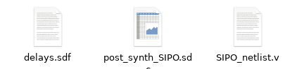
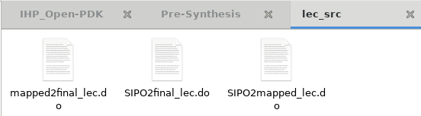

Synthesis with DFT
Synthesis with DFT requires additional commands, which are contained in the new TCL file.
# Loads the standard cell library for synthesis
read_libs /home/bas33767/Desktop/IHP-Open-PDK/ihp-sg13g2/libs.ref/sg13g2_stdcell/lib/sg13g2_stdcell_typ_1p20V_25C.lib
# Reads the Verilog HDL file for the SIPO design (Serial-In-Parallel-Out)
read_hdl ../../Verification/Pre-Synthesis/SIPO_Multi-Clock_Domain.v
# Elaborates the top-level module “serial_to_parallel” from the HDL
elaborate serial_to_parallel

# Reads the Synopsys Design Constraints (SDC) file for timing and other constraints
read_sdc SDC/SIPO.sdc
# Configures the high effort for three synthesis stages: Generic synthesis (technology-independent), technology mapping, optimization
set_db syn_generic_effort high
set_db syn_map_effort high
set_db syn_opt_effort high
# Performs the three synthesis steps in sequence
syn_generic
############# DFT ################
# DFT scan FF style for scan replacement
set_db dft_scan_style muxed_scan
# Prefix to name DFT logic
set_db dft_prefix DFT_/
# Define the test signals
define_dft shift_enable -name {scan_en} -active {high} -create_port {scan_en}
# Check DFT rules (multiple times)
check_dft_rules
check_dft_rules
check_dft_rules
#Configure the number of scan chains required to connect all FFs (1 scan chain used, multiple chains can be tested to see if clock speed can be improved)
set_db current_design .dft_min_number_of_scan_chains 1
# Specification of the input and output ports of the scan chain
define_dft scan_chain -name top_chain -sdi scan_in -sdo scan_out -create_ports
syn_map
syn_opt
# Connect the Scan chains using connect_scan_chains RC command. This will include all original FF’s that were mapped to scan flops.
connect_scan_chains -auto_create_chains
#Reports
report dft_chains > reports/report_dft_chains
report_timing > reports/report_timing.rpt
report_power > reports/report_power.rpt
report_area > reports/report_area.rpt
report_qor > reports/report_qor.rpt
#Outputs
write_hdl > outputs/SIPO_netlist.v
write_sdc > outputs/post_synth_SIPO.sdc
write_sdf -timescale ns -nonegchecks -recrem split -edges check_edge -setuphold split > outputs/delays.sdf
write_design -base_name innovus_src/SIPO
write_dft_atpg -library /home/bas33767/Desktop/IHP-Open-PDK/ihp-sg13g2/libs.ref/sg13g2_stdcell/verilog/sg13g2_stdcell.v -directory outputs/modus_src
# LEC do file for main RTL (golden) design design vs Final design
write_do_lec -revised_design outputs/SIPO_netlist.v -logfile outputs/lec_src/SIPO2final_lec.log > outputs/lec_src/SIPO2final_lec.do
It will generate all necessary file for LEC along with basic ATPG files for MODUS. LEC can be done similarly as described before.
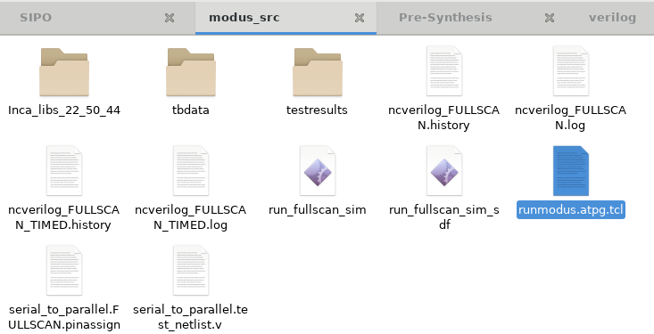
Post-Synthesis Verification

LEC:
The Logic Equivalent Check (LEC) is part of the basic formal verification. During the syntheses, some ‘do’ file is generated. This do file can be used for LEC directly from the GENUS console.
>> lec -xl -dofile outputs/lec_src/SIPO2final_lec.do
By default, the tcl script will exit the COFORMAL console after execution. To see the result in the GUI, the “exit” command must be commented or deleted in the very last line of the script.
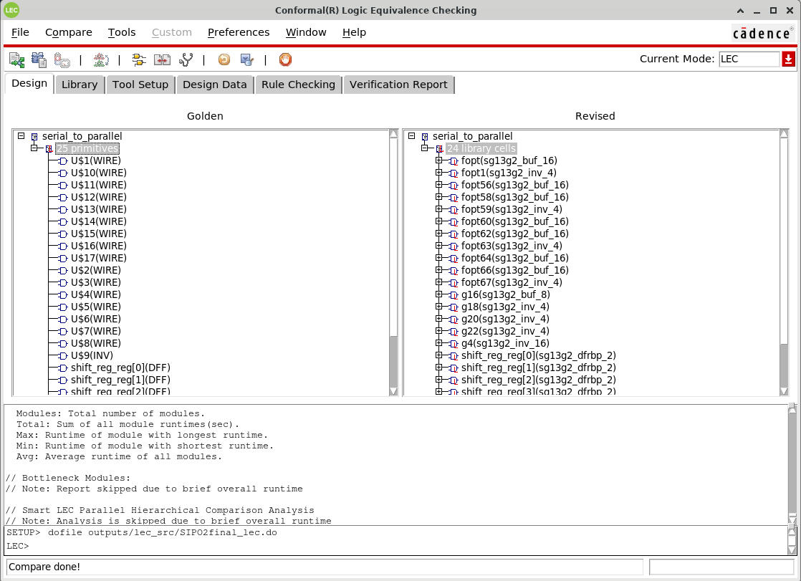
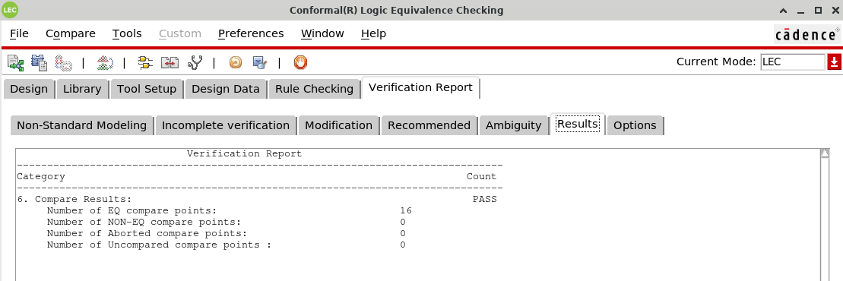

Gate-Level Simulation:
This is a basic functional test. In this step, the testbench must be annotated with the SDF data.
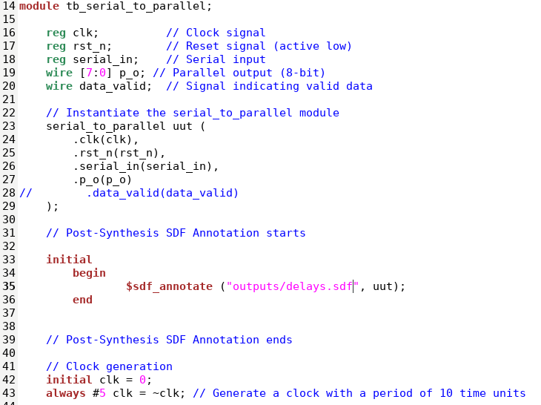
>> xrun SIPO_gate-level_tb.v /home/bas33767/Desktop/IHP-Open-PDK/ihp-sg13g2/libs.ref/sg13g2_stdcell/verilog/sg13g2_stdcell.v -access +rwc -64bit -gui &
If the PDK Verilog data is included in the testbench:
>> xrun SIPO_gate-level_tb.v -access +rwc -64bit -gui &
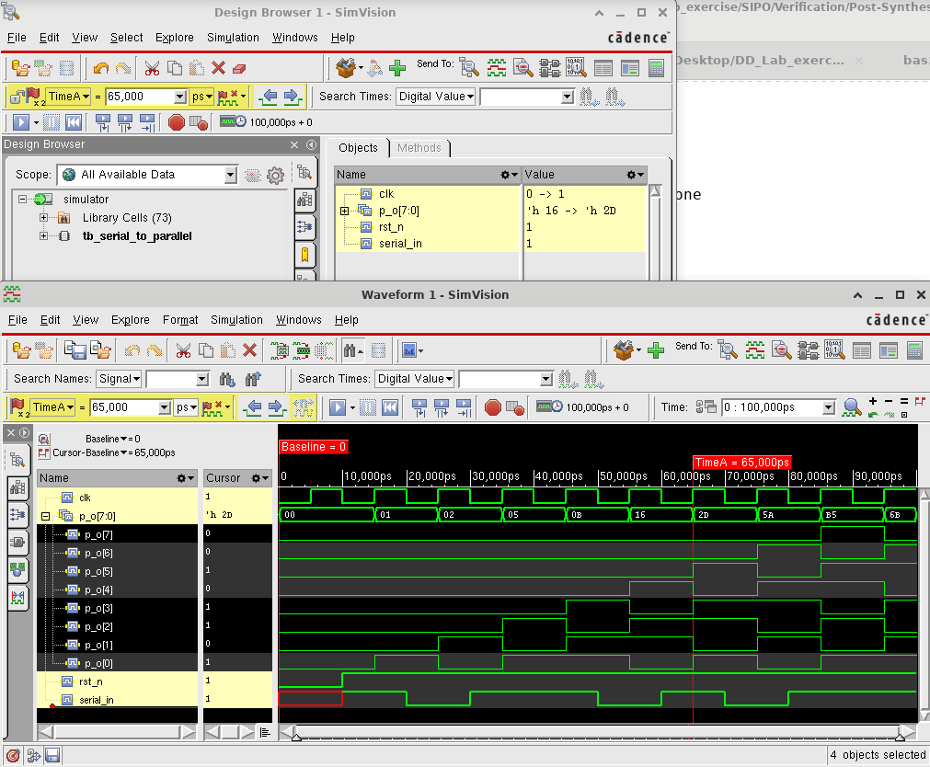
The netlist has added scan chain FF, the scan_en pin must be low to enable functional verification with XCELIUM. Otherwise, the resulting waveform will be inconsistent as shown in the figure below:
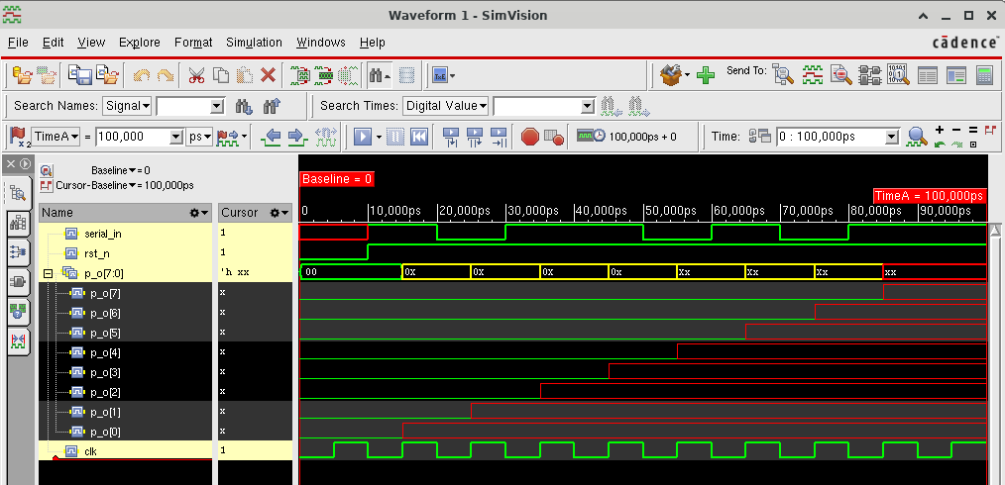
To avoid this, the testbench must be modified (add scan_n port and keep it parmanently low).
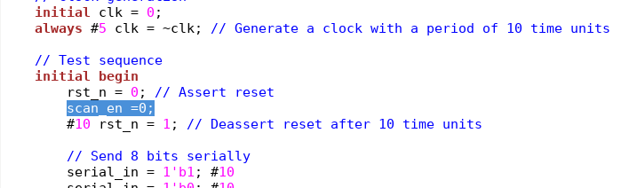

DFT:
Modus can be run from genus consol as well.
>> modus
>> source outputs/modus_src/runmodus.atpg.tcl
The “runmodus.atpg.tcl” script will cause (same as in “SIPO2final_lec.do”) the Modus consol to exit. To avoid it the “exit” line need to be deleted or commented.
>> gui_open
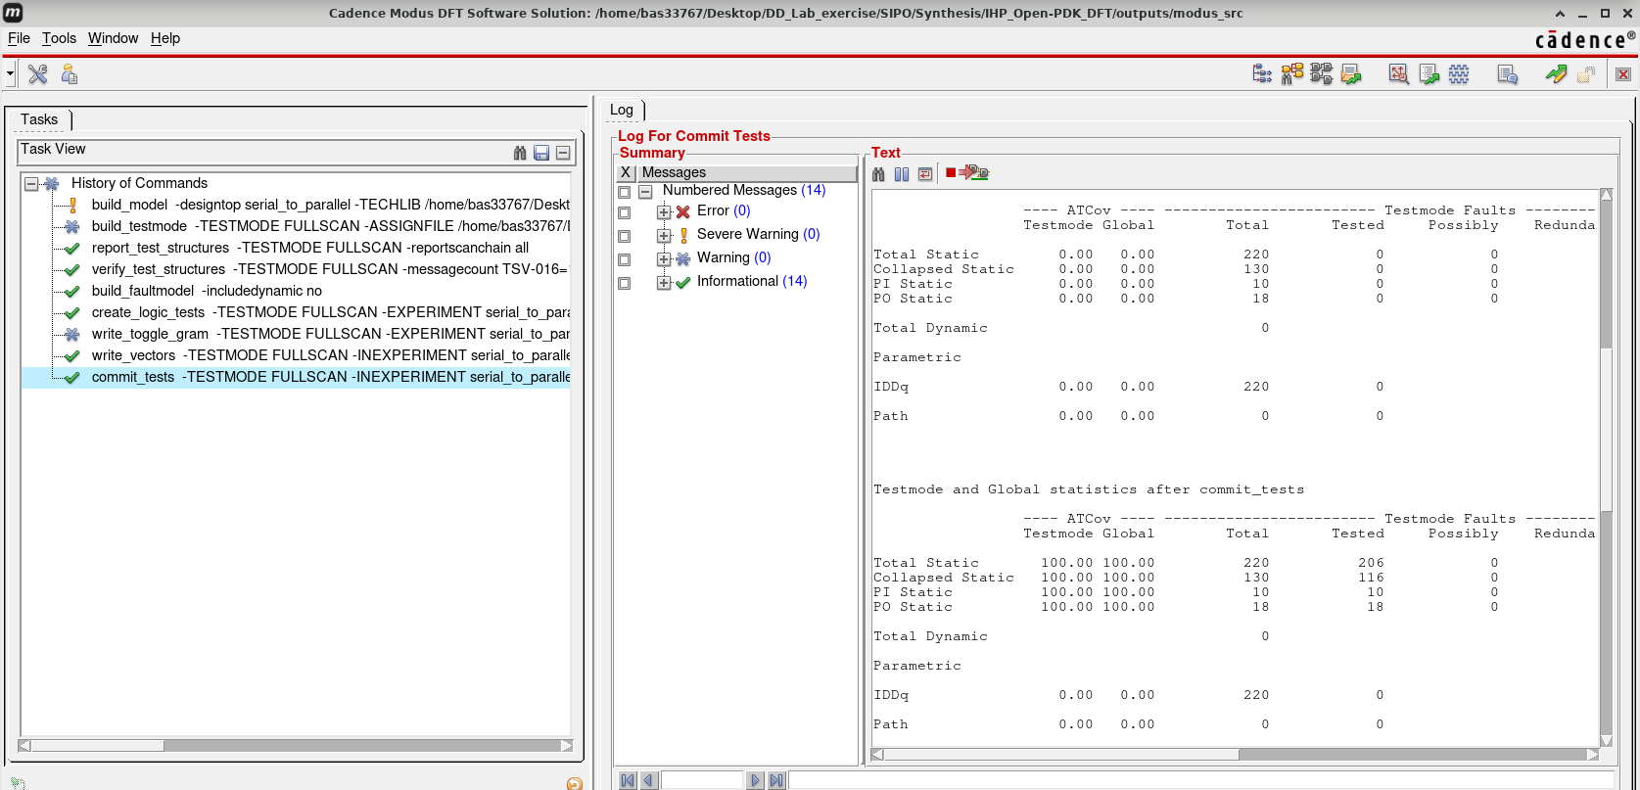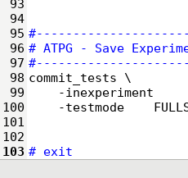
There are two additional script to run XCELIUM to test the DFTs. One is without SDF file another with SDF. That with SDF file, need to be modified (change the path of default SDF), otherwise it will be failed. These script can be sourced directly from genus consol.
>> source outputs/modus_src/run_fullscan_sim
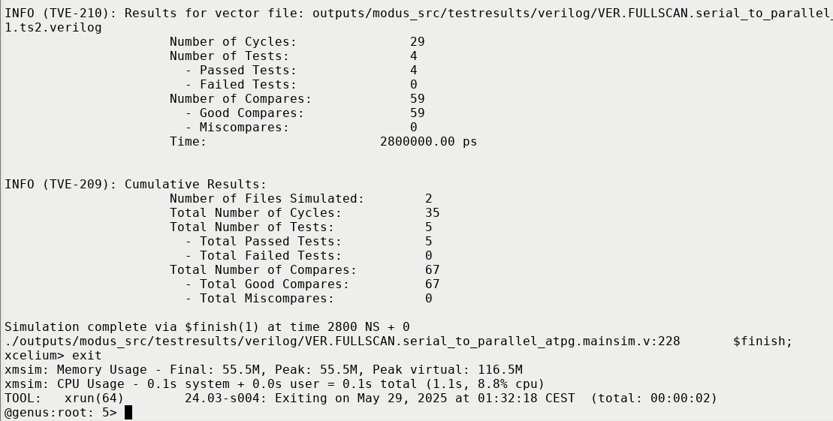

https://github.com/baruaeee/DD_Lab_exercise/blob/master/SIPO/Verification/Pre-Synthesis/SIPO1_tb.v
https://github.com/baruaeee/DD_Lab_exercise/blob/master/SIPO/Synthesis/IHP_Open-PDK/SDC/SIPO.sdc

