Transposed Direct Form 1
Hardware Accelerated DSP
- Create project named tdf1lp3
- Create IP Block name: zedblp3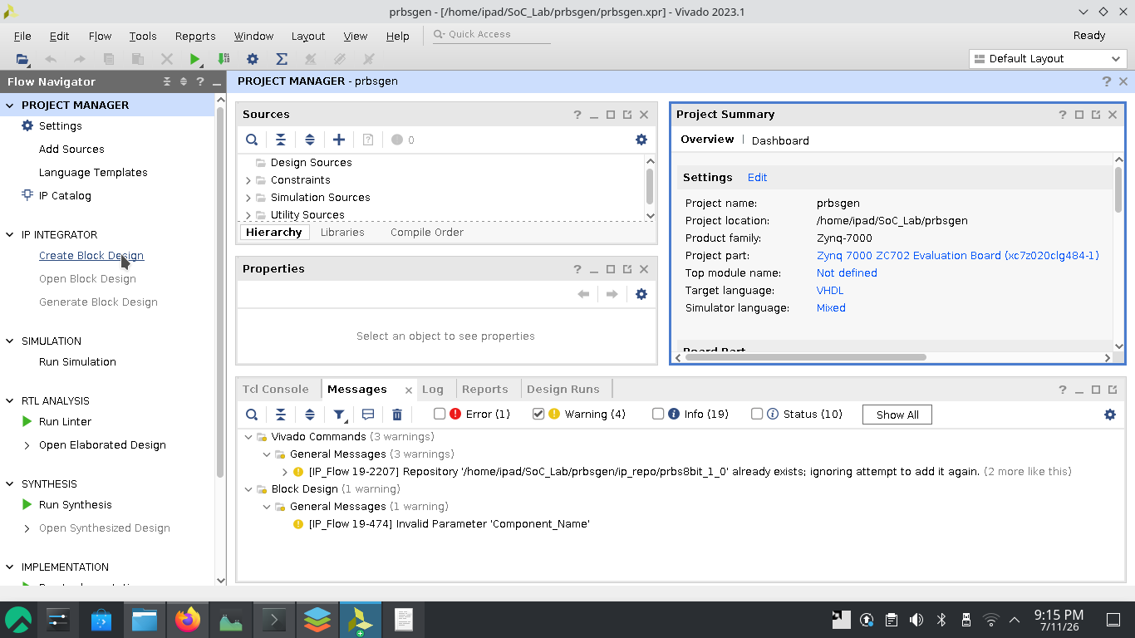
- Add IP (+) => search zynq
- Run Block Automation
- Peripheral I/O Pins: same as before, but keep “M AXI GPI interface” enabled.
- Create and Package New IP...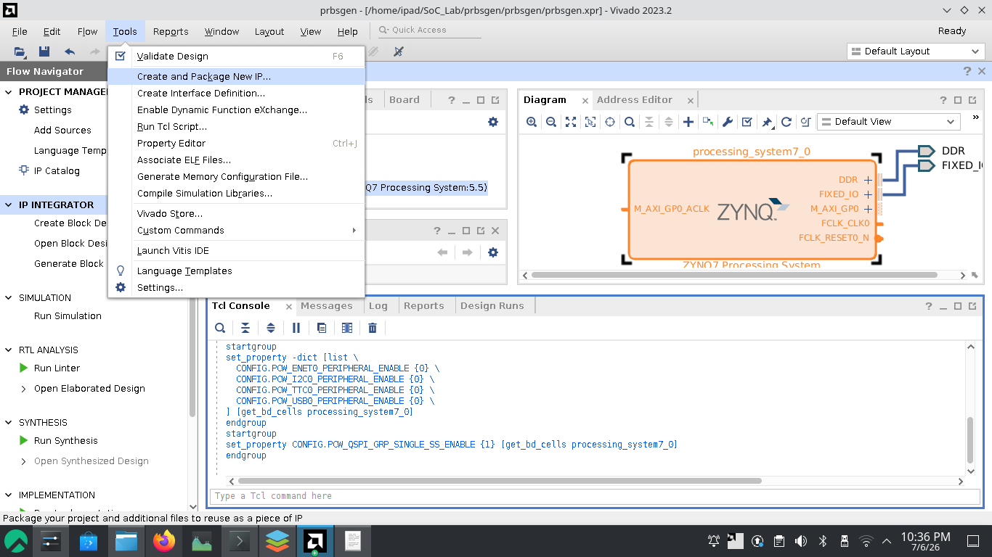
- Create AXI4 Peripheral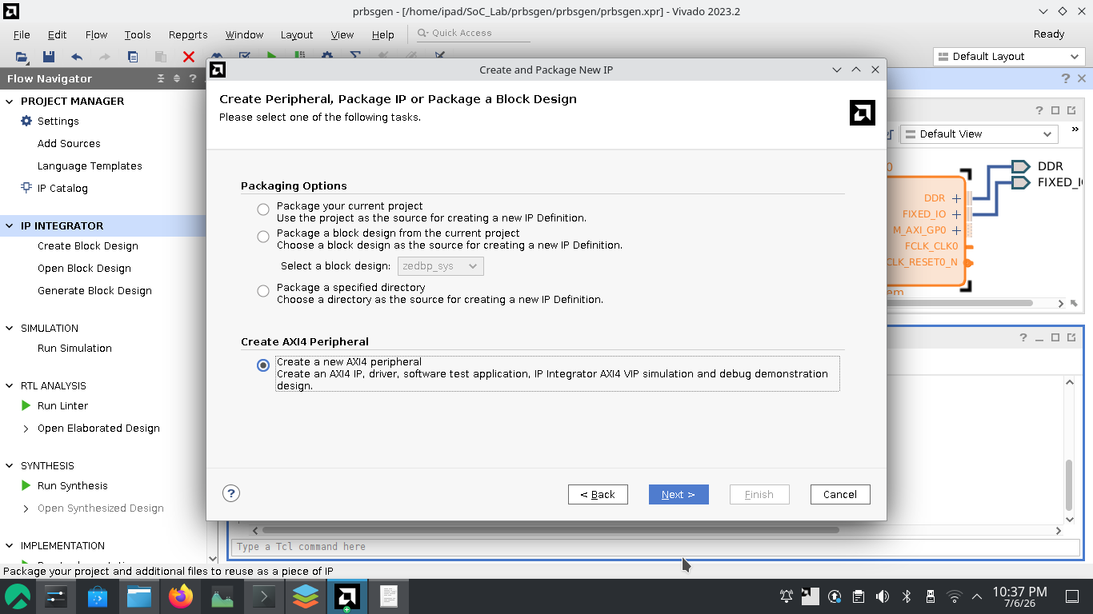
- Create IP Repo folder “ip_repo” on the project directory as well as “vitiswsp” for Vitis Workspace.
- Name : iir3lowpass, Descr.: IIR lowpass 3. order, TDF-I fromat

- Add interfaces (keep defaults)[4 slave register by default-32bit each]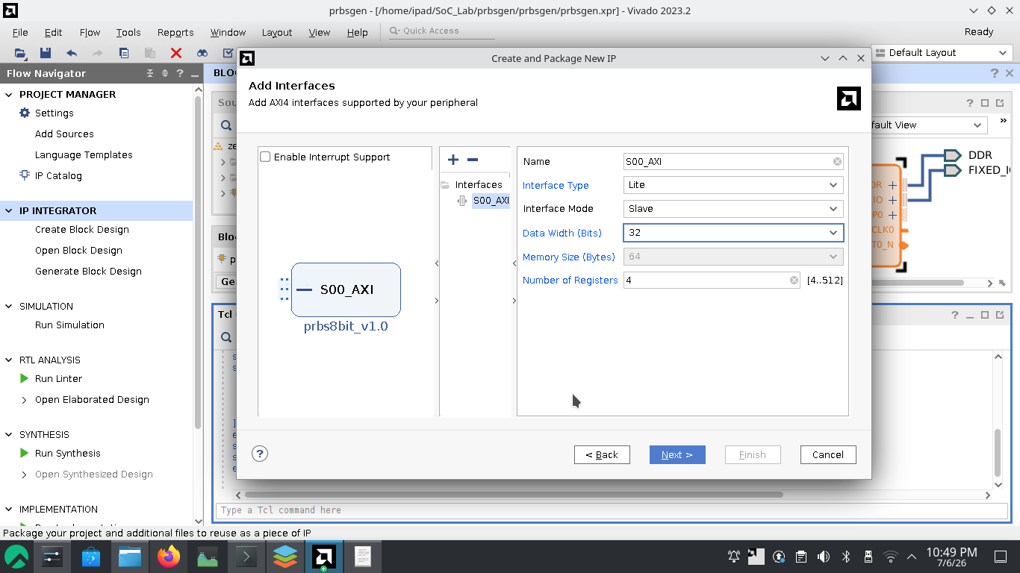
Each register is 32 bits (4 bytes), so addresses increment by 4. [Each register is 4 bytes wide, so the next register starts at current address + 4.]
Slave registers:
Bridge two world => Software (c/c++) and Hardware (VHDL/Verilog)
Enable Run-Time Control
Decouple Timing
The AXI bus runs at a different clock than your PRBS logic. Slave registers act as synchronization points.
- Select edit IP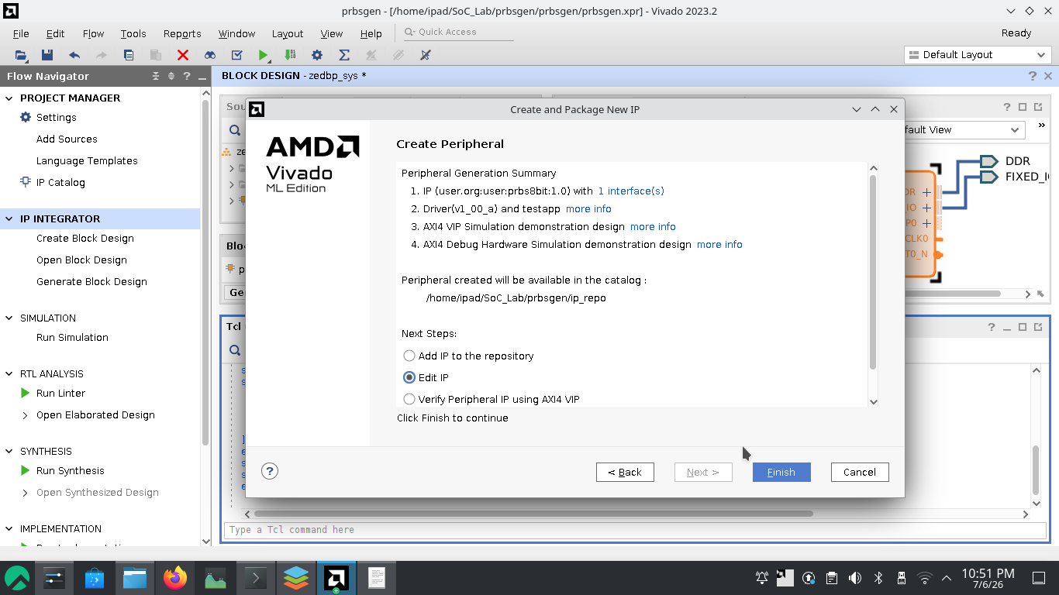
- It should open the “Package IP” tab.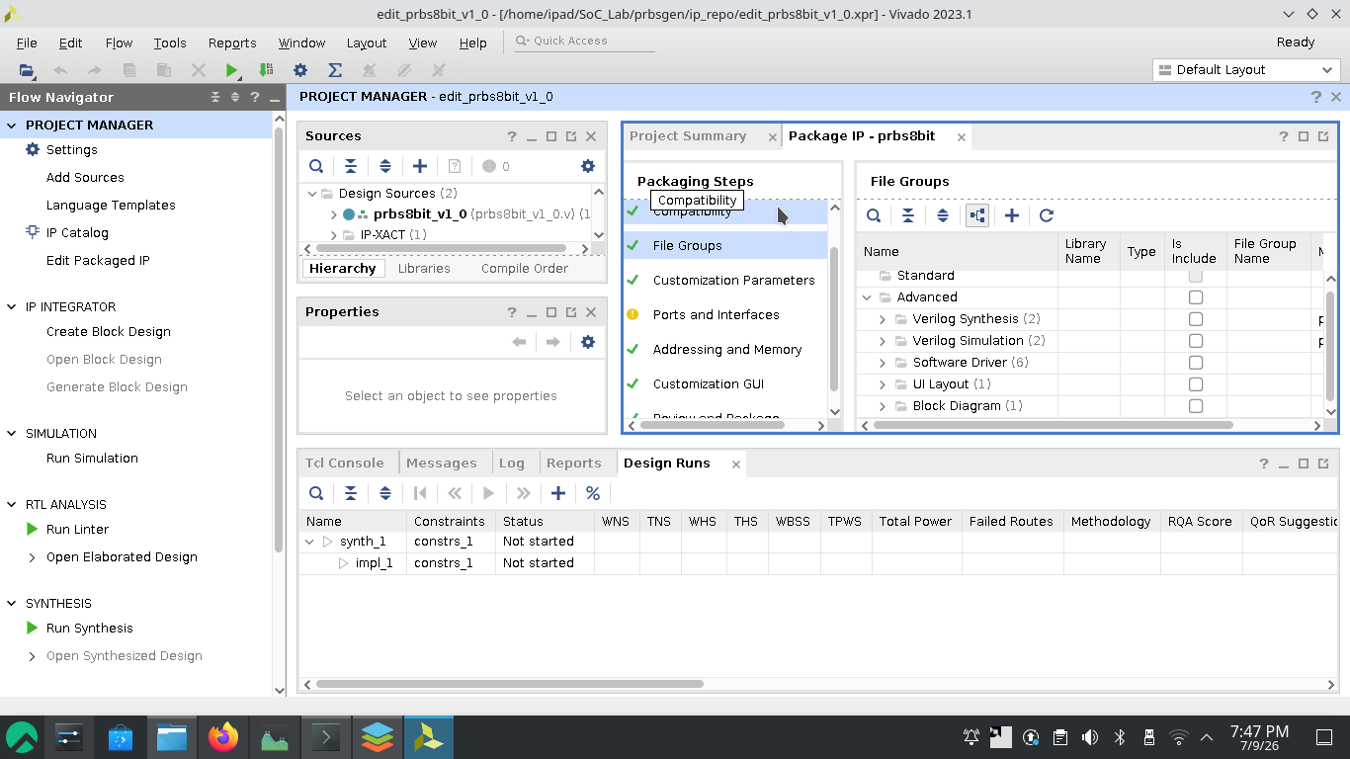
- Go to “File Groups” => “Software Drivers” and open the Makefile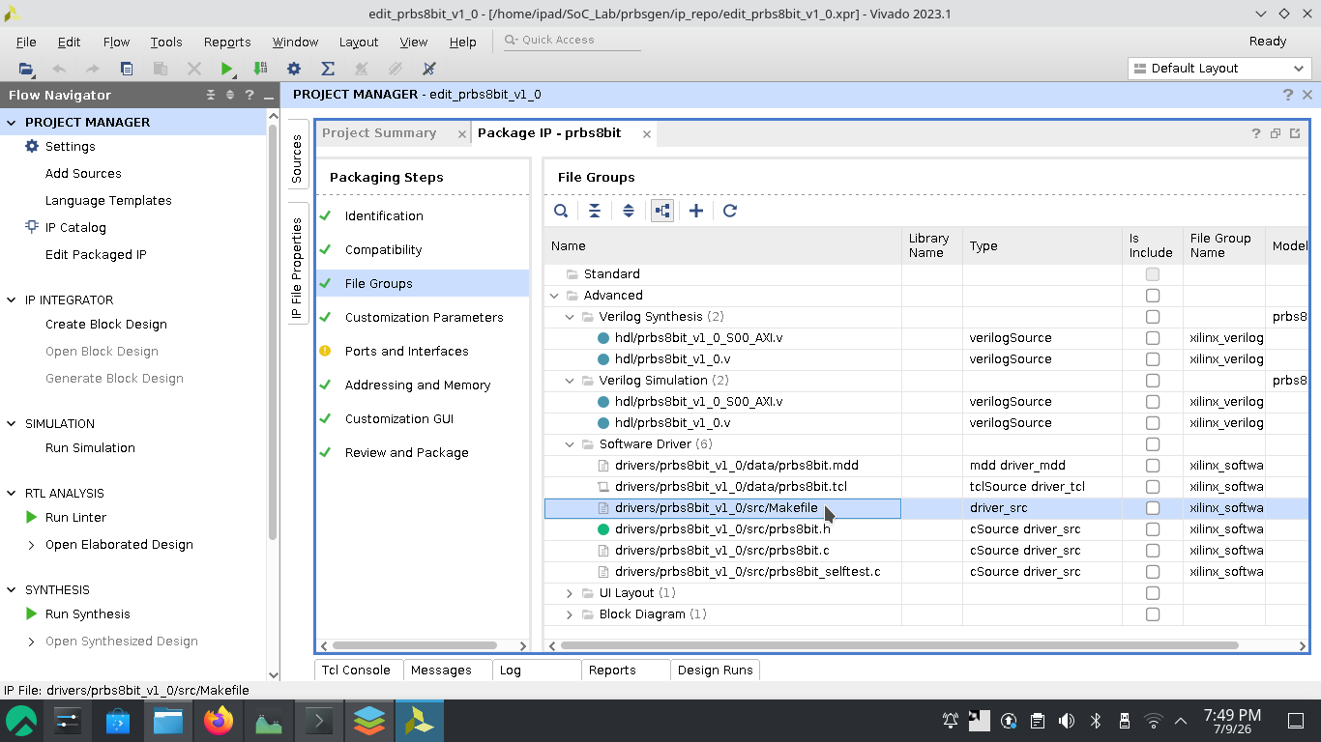 or from <project_dir>/ip_repo/prbs8bit_1_0/drivers/prbs8bit_v1_0/src/ and open the make file
- Change the wildcard 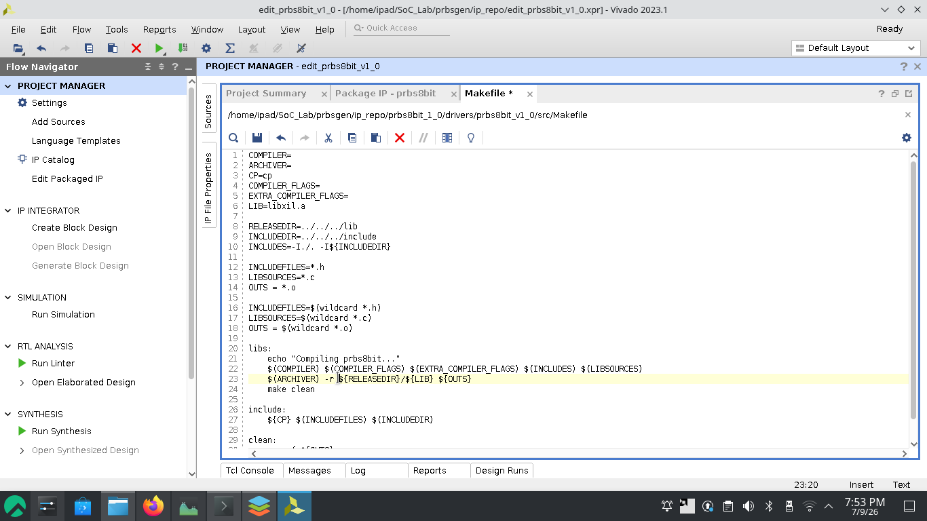 to 
the GNU Make engine treats the asterisk as a literal text string: "the text string *.c"
- If this tab is not opened or accidentally closed, can be opened from “Open IP-XACT File”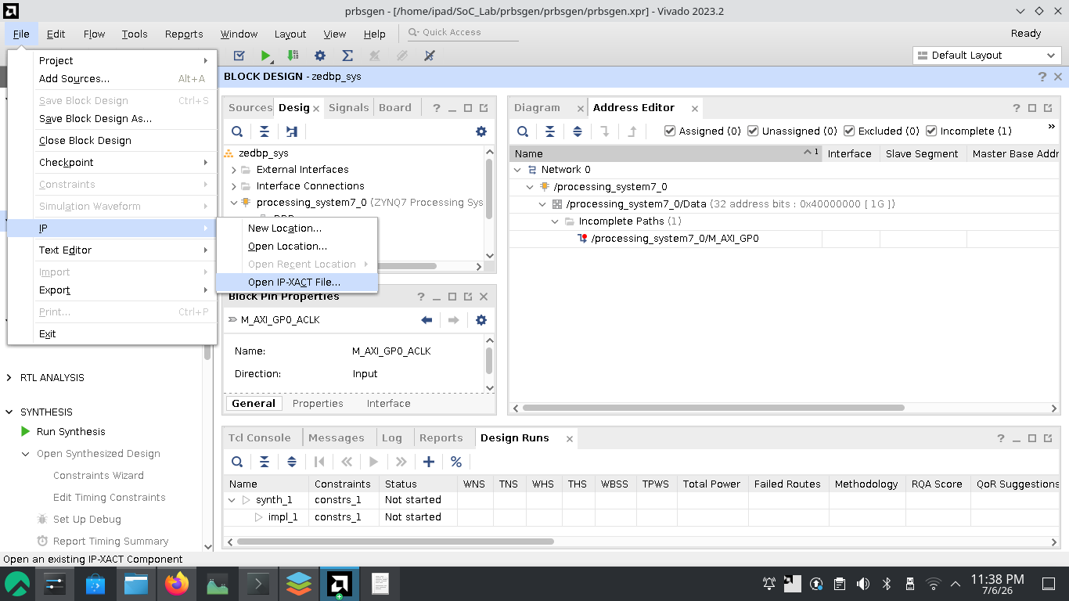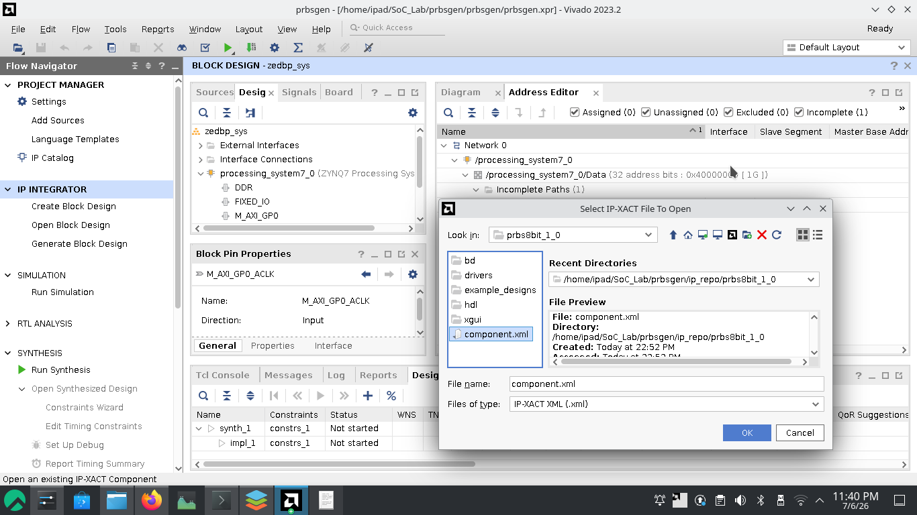
- Open both “prbs8bit_v1_0.vhd” and “prbs8bit_v1_0_S00_AXI”. (These are the two auto-generated files that make up the packaged AXI4-Lite IP core.)
prbs8bit_v1_0.vhd-The Top-Level Wrapper:
This is the main IP interface file. It acts as the "shell" that connects your custom logic to the AXI4 bus system.
it contains:
=> The AXI4-Lite slave interface signals (address, data, read/write strobes, etc.)
=> instantiates the second file (S00_AXI) as a sub-component
=> Wraps your actual PRBS algorithm (the logic can be implemented here)
prbs8bit_v1_0_S00_AXI.vhd — The AXI4-Lite Slave Interface:
This is the AXI bus protocol handler. It manages all the low-level AXI4-Lite signaling so it don't have to be written manually.
It does-
=> Decodes AXI read/write transactions
=> Manages the addressable register space (typically 4–32 registers by default)
=> Handles handshaking (AWVALID/AWREADY, WVALID/WREADY, etc.)
=> Provides a simple register interface that the top-level file can read from/write to
=> Here the PRBS Logic is implemented on it (prbs8bit_v1_0_S00_AXI.vhd).
=> reasons: ** Simplicity: One file to edit, one file to simulate. ** Teaching clarity: Students see bus interface + algorithm together. ** Quick iteration: No cross-file instantiation to manage. **
The Trade-Off
PRBS logic tied to AXI — can't easily reuse for non-AXI designs
Mixing bus protocol + algorithm gets messy as design grows
Hard to swap AXI for APB/AHB later
Must simulate full AXI stack to test PRBS
Functional, but not "clean" for IP repository
- Input/Output:
8 switches (zbSwitch 7 to 0) → PRBS seed value, enable, or polynomial select
5 buttons (zbPushB 4 to 0) → Reset, trigger, mode control
8 LEDs (zbLED 7 to 0) → Visualize 8-bit PRBS output in real-time
the names are defined in the xdc (constraint file), can be any meaningful name
- Edit prbs8bit_v1_0_S00_AXI.vhd. Define ports for the physical ports in the entity declaration uzbSwitch, uzbPushB, uzbLED.
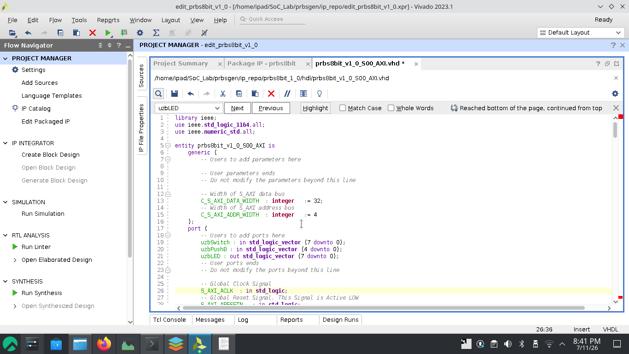
- Slave register map and constant, signal declaration .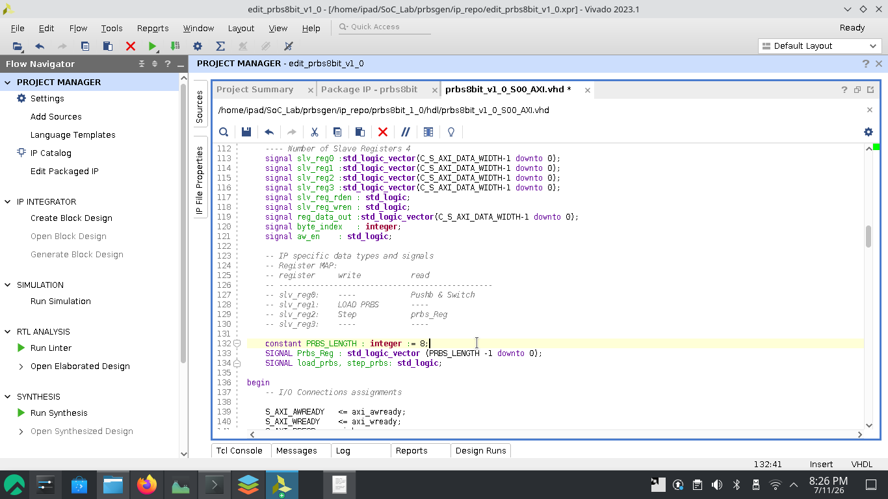
- Modify “Implement memory mapped register select and write logic generation...”
get the control signal for prbs process 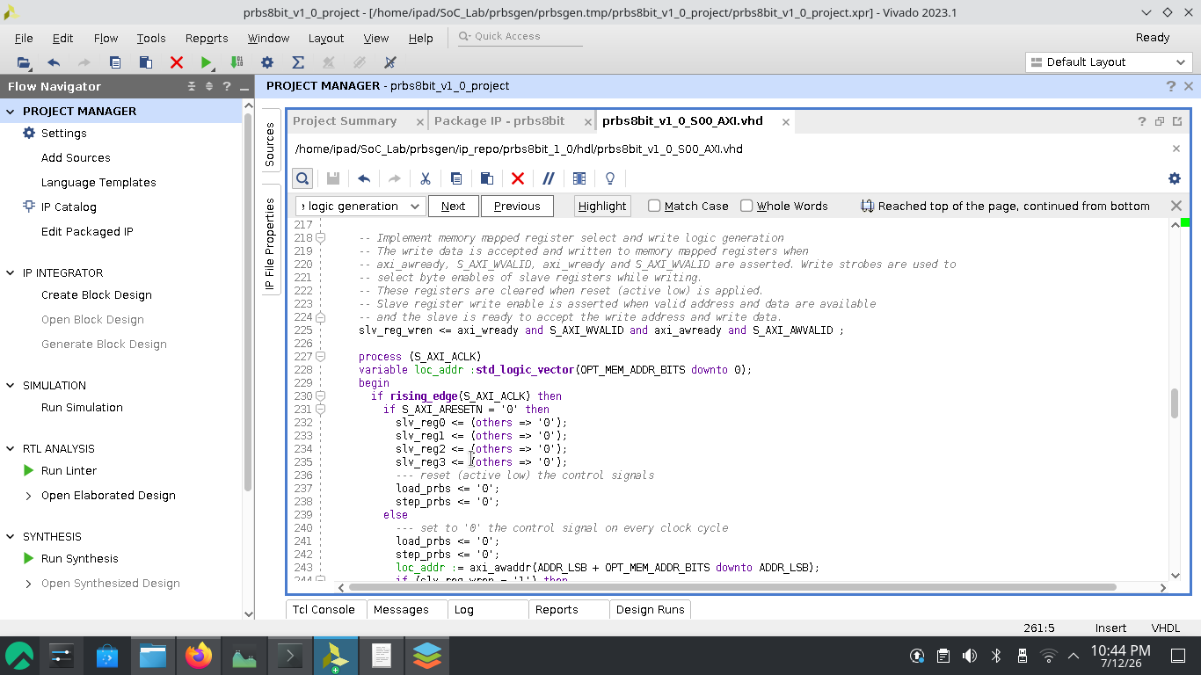 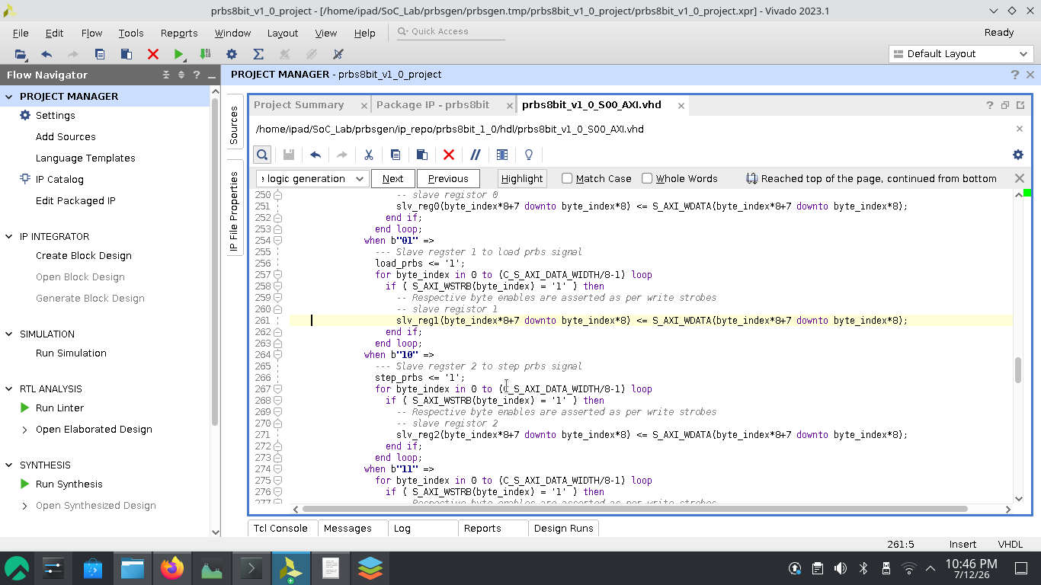 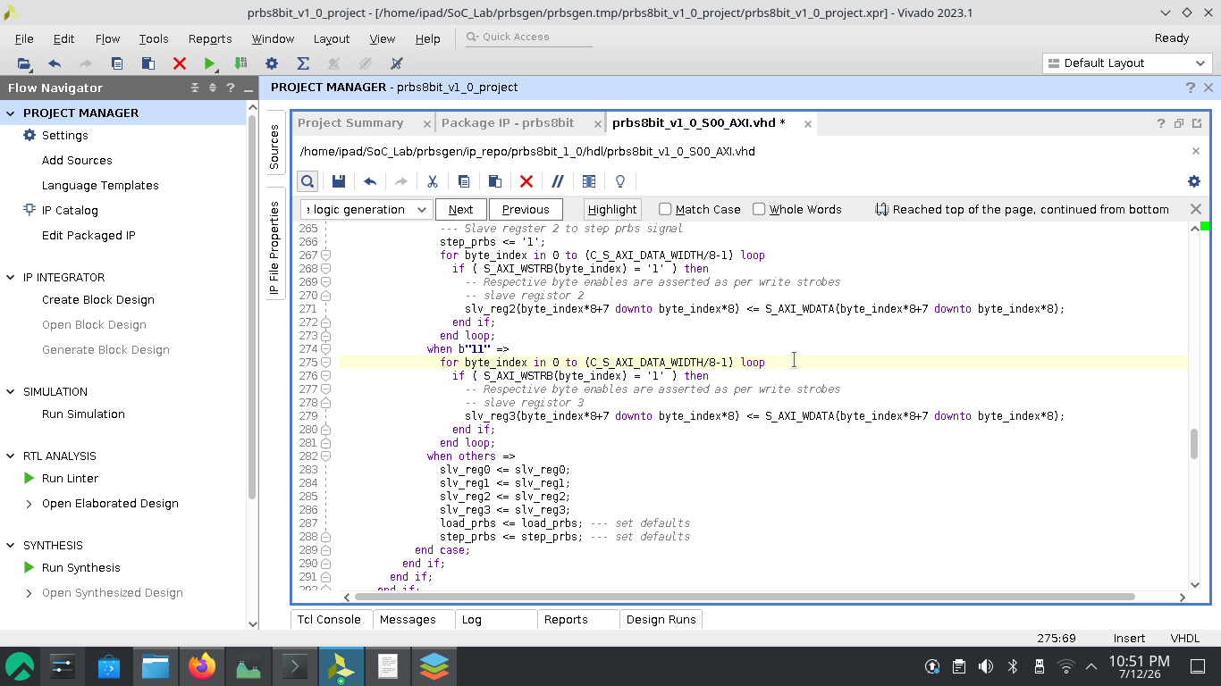
- Modify “Implement memory mapped register select and read logic generation...”
1. Map slave register 0 for reading the switches: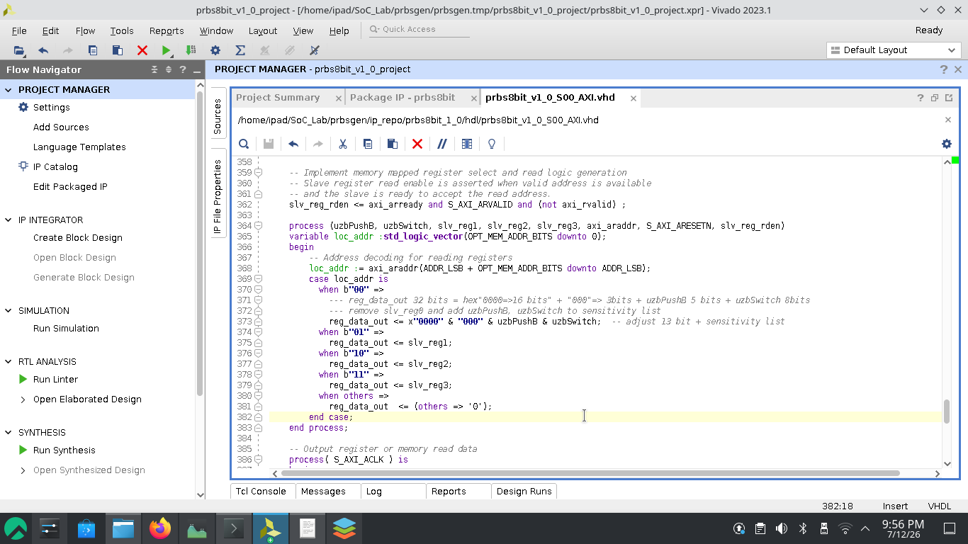
2. Slave register 1 read as it is. Map Slave register 2 to read prbd register.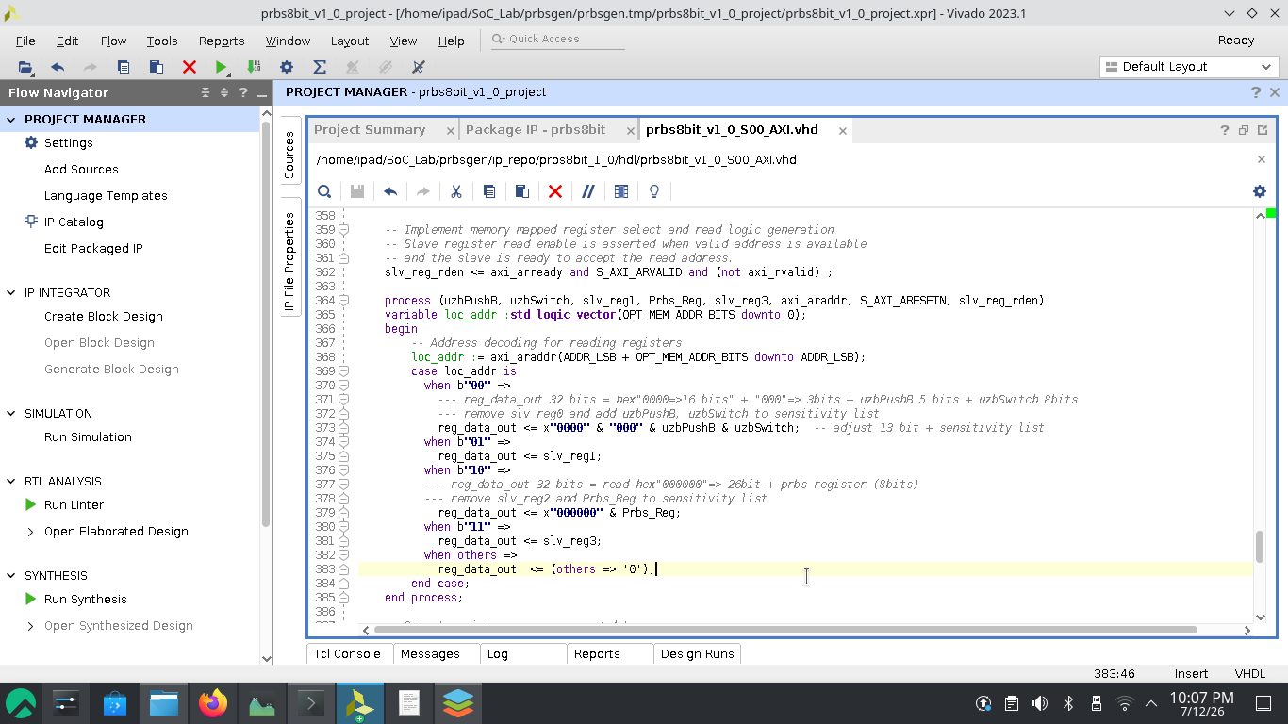
- User logic: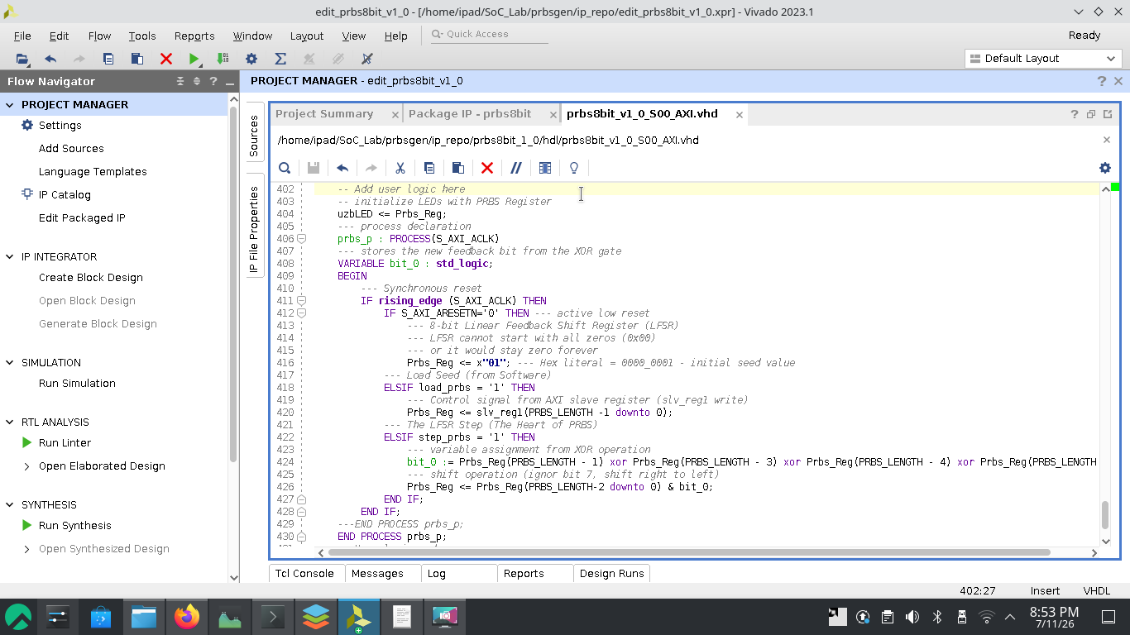
- Edit prbs8bit_v1_0.vhd: add ports according to the constraint file 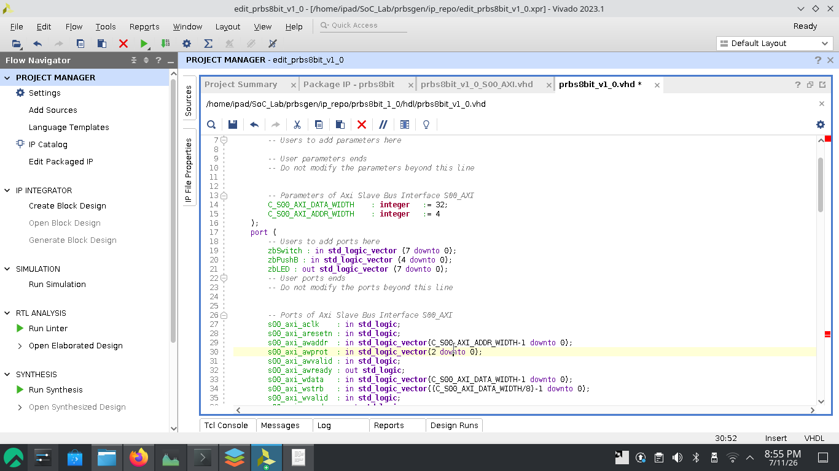 , add the same ports declared on the AXI bus protocol handler (prbs8bit_v1_0_S00_AXI.vhd) 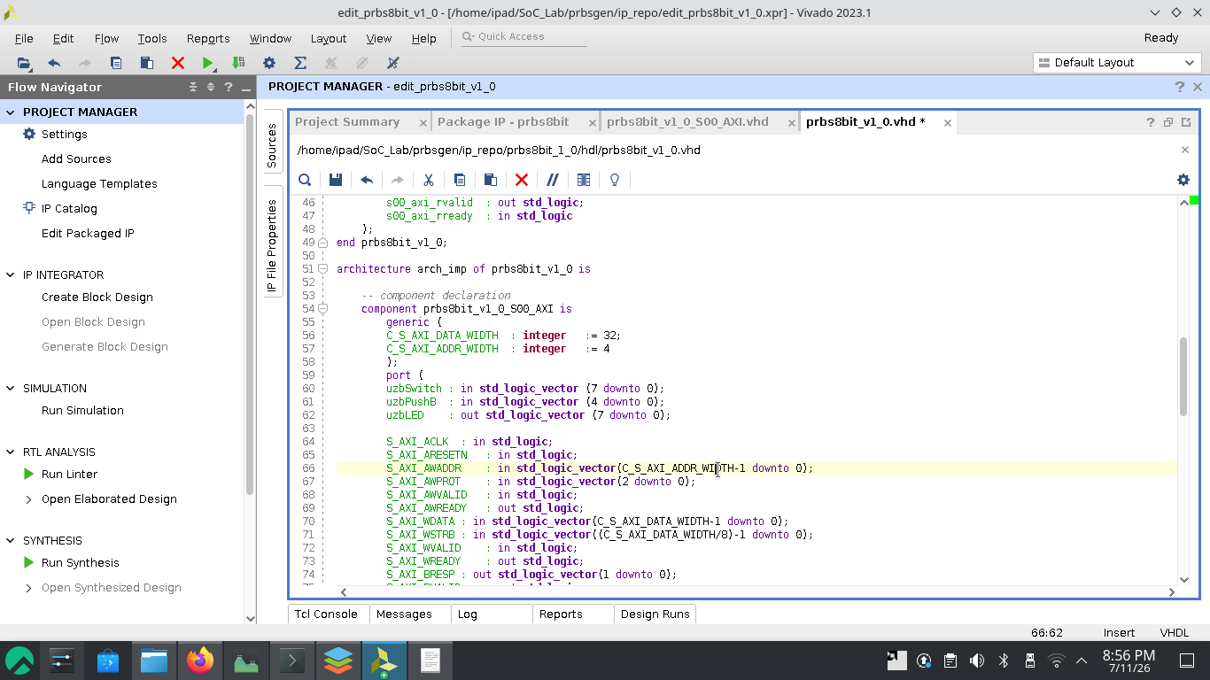 and map the with it’s instantiation 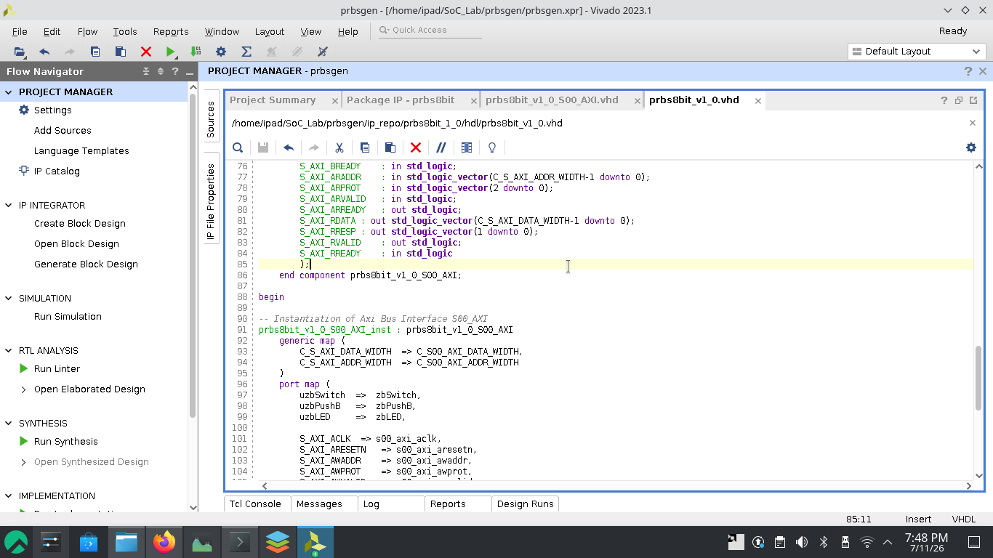
- Now in the “Package IP – prbs8bit” tab click “Merge changes from File Group Wizard” while File Groups selected-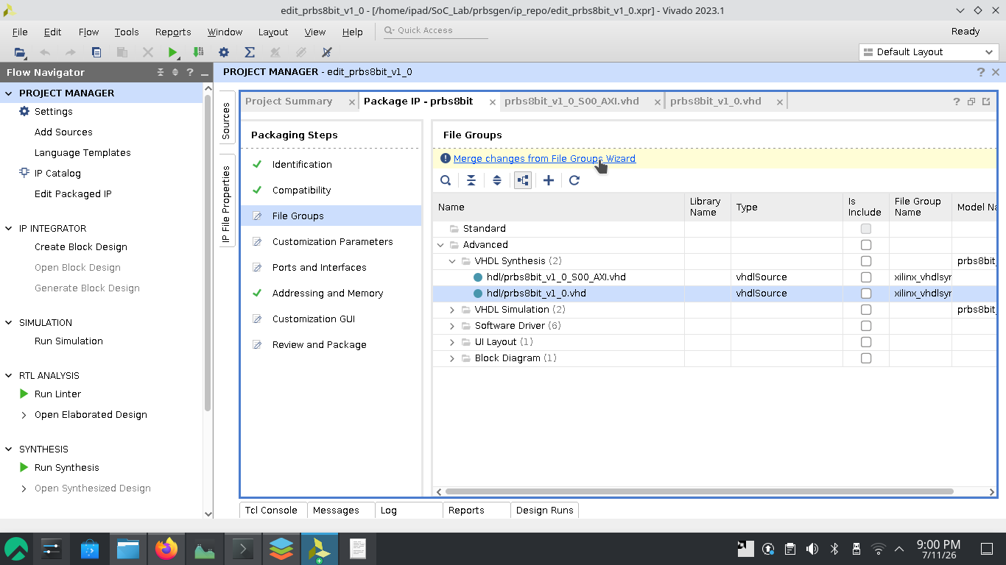
- Click “Merge changes from Customization Parameters Wizard” 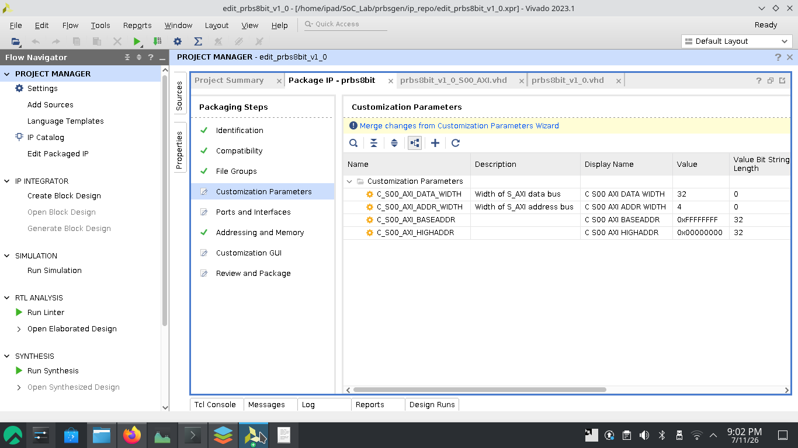
- Click “IP has been modified.” and “Re-package IP”.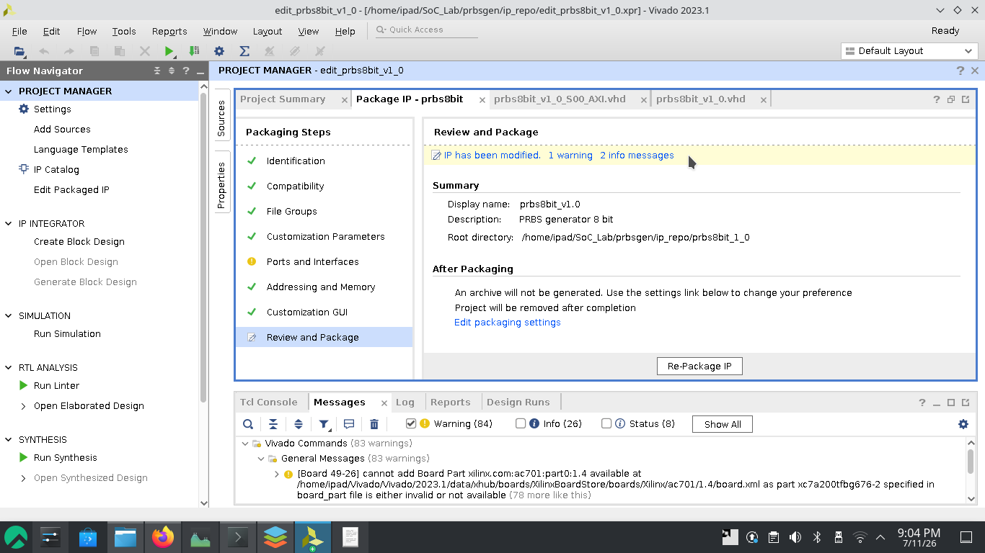
and close the project.
- Now we have a unique IP named “prbs8bit_v1.0”. Add it to the block design (see step [1]).
- Click “Run Connection Automation”.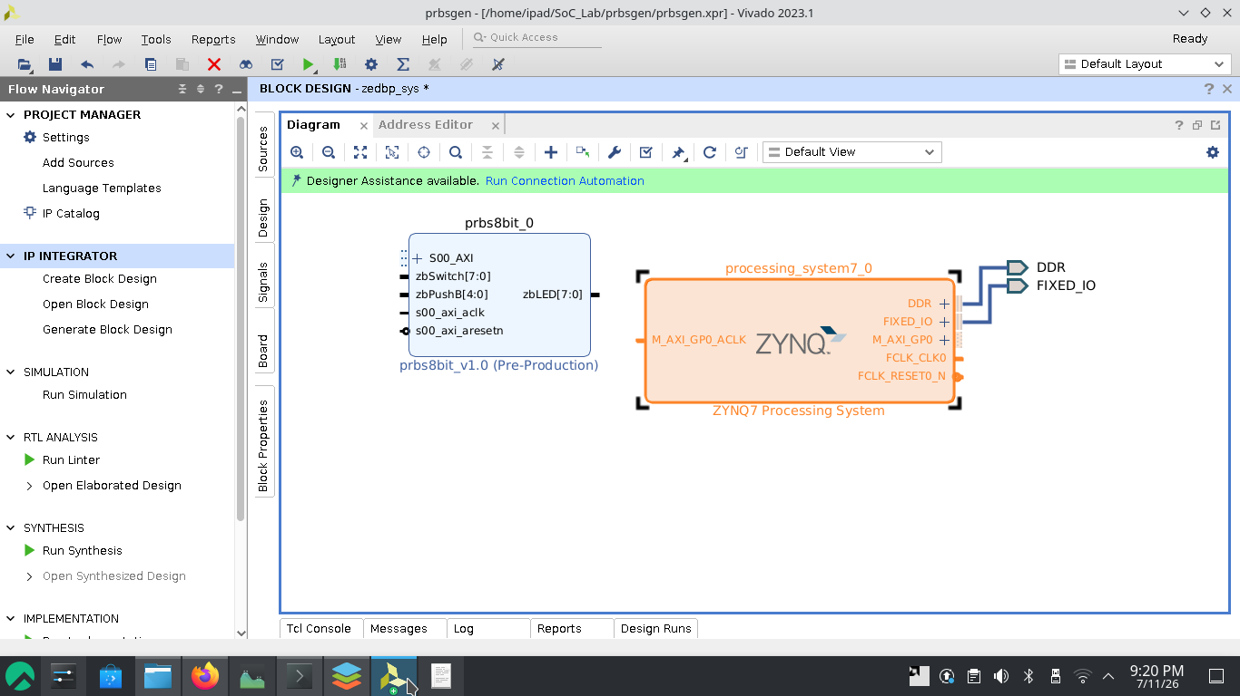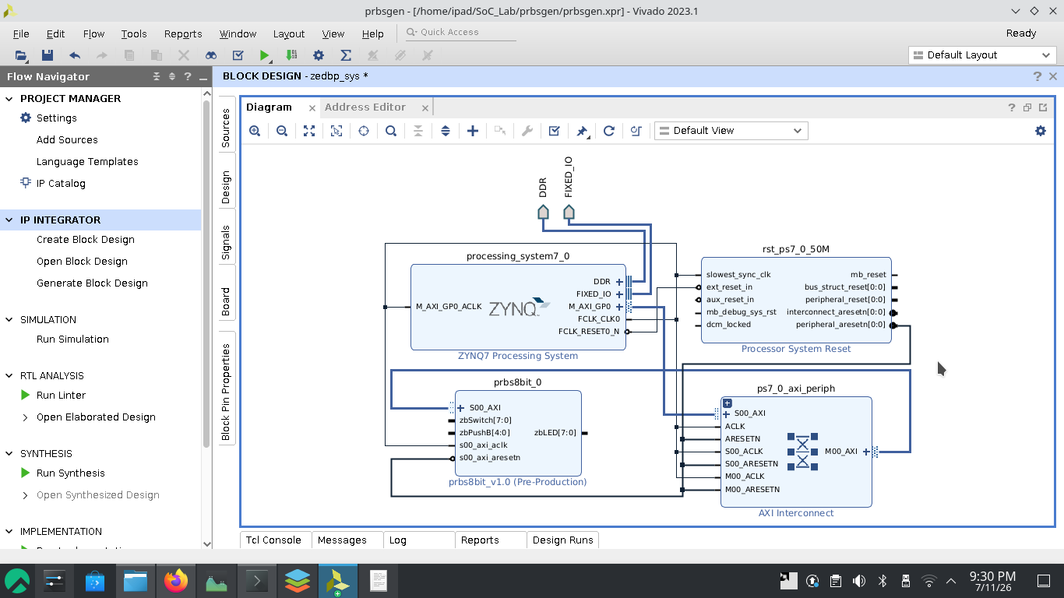
- Now we have some open ports in the “prbs8bit_0” IP which we need as peripheral. For that they need to be made external.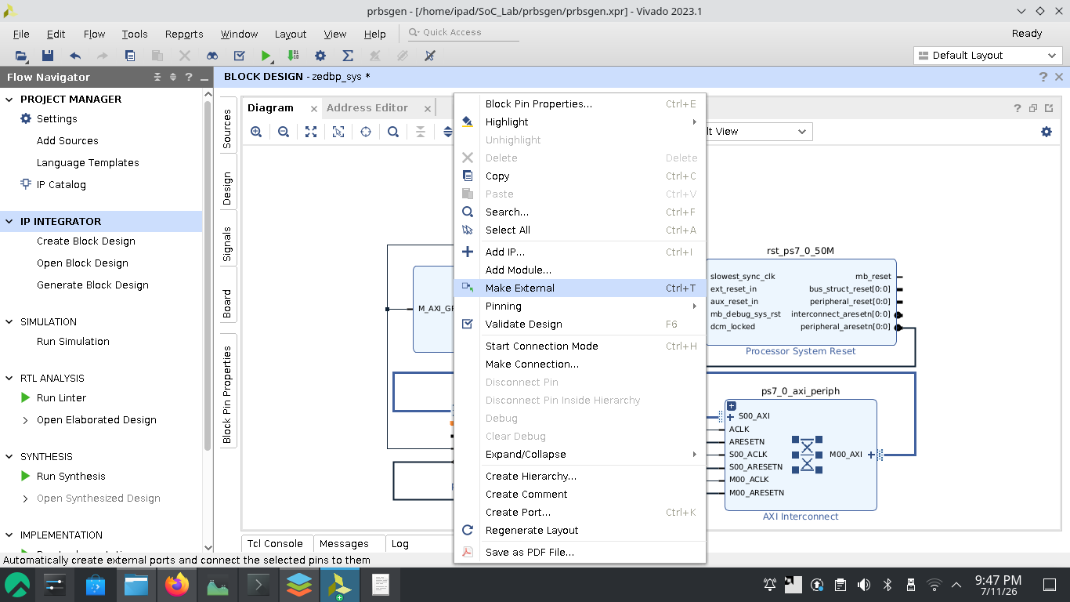
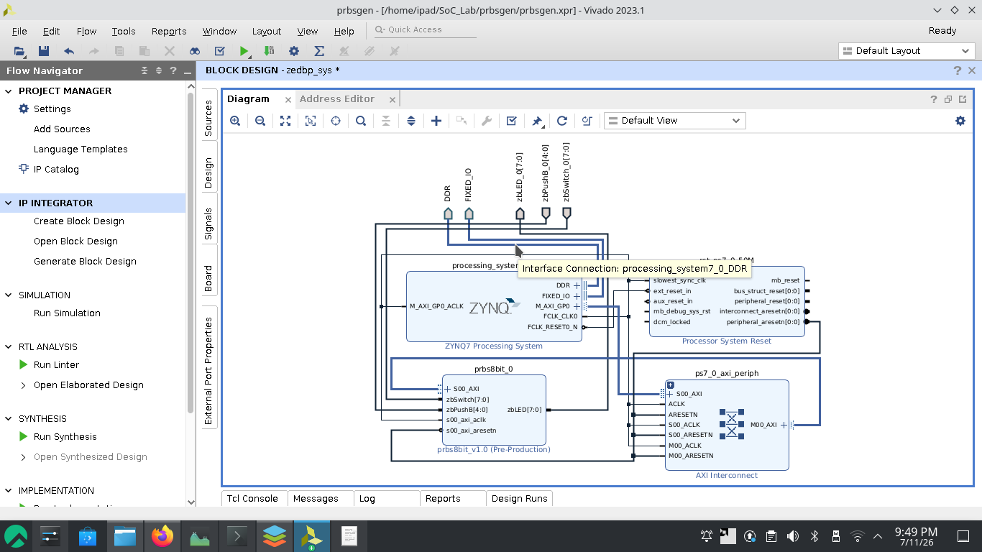
- The interface name are not as expected (based on the the .xdc constraints) and it will throw error if not changed (remove “_0”) 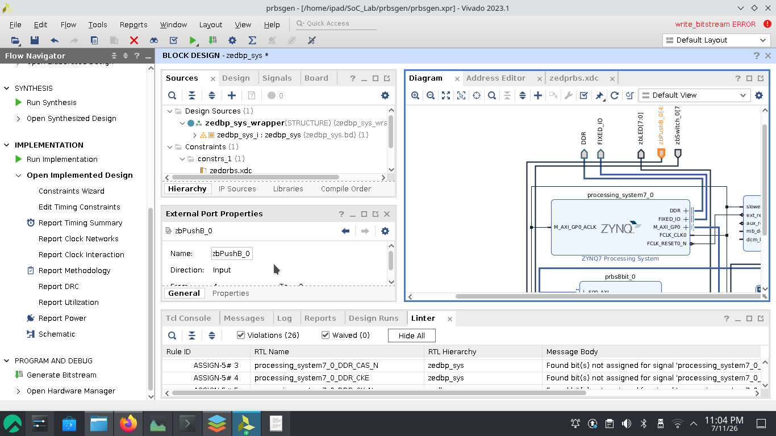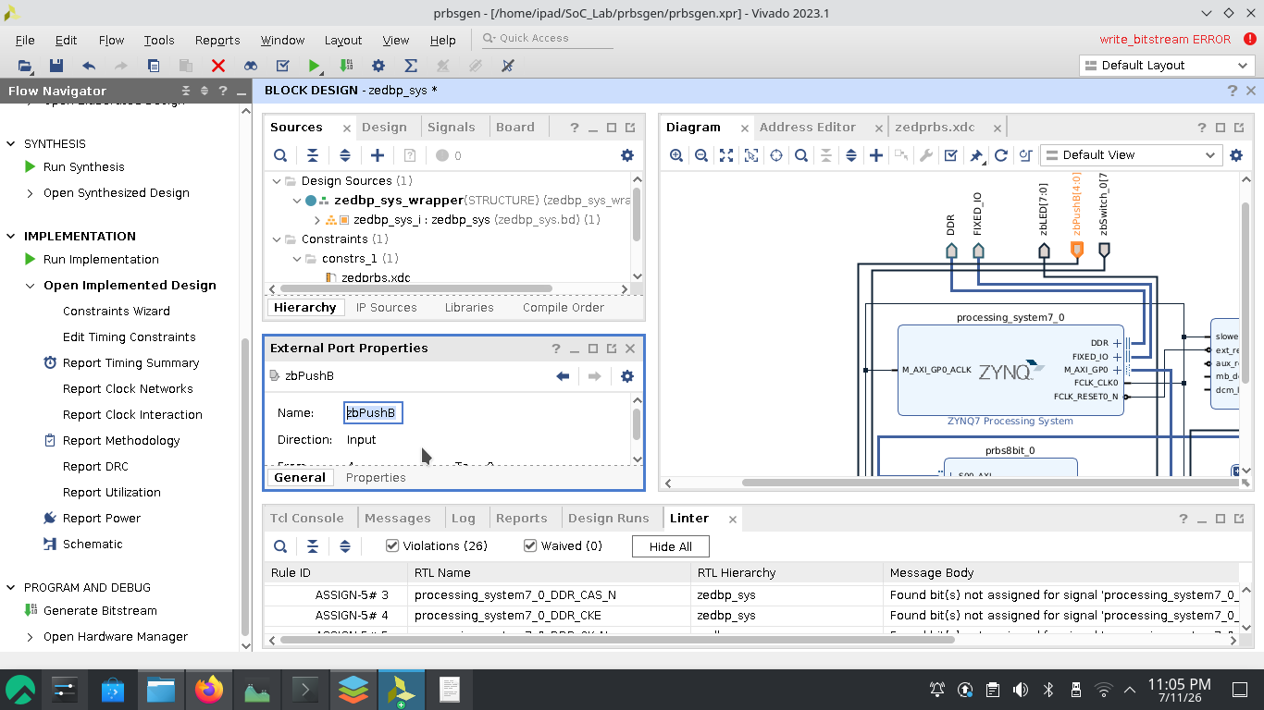after correction 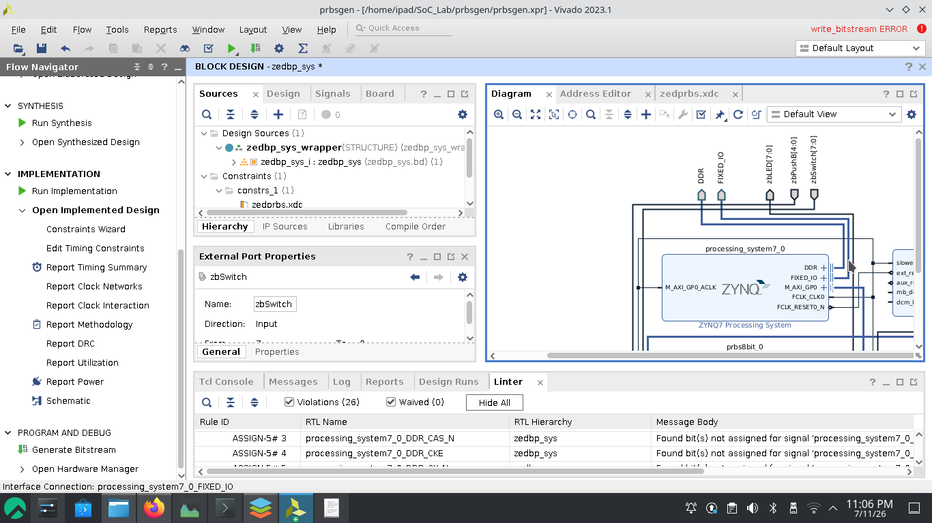
- Validate the design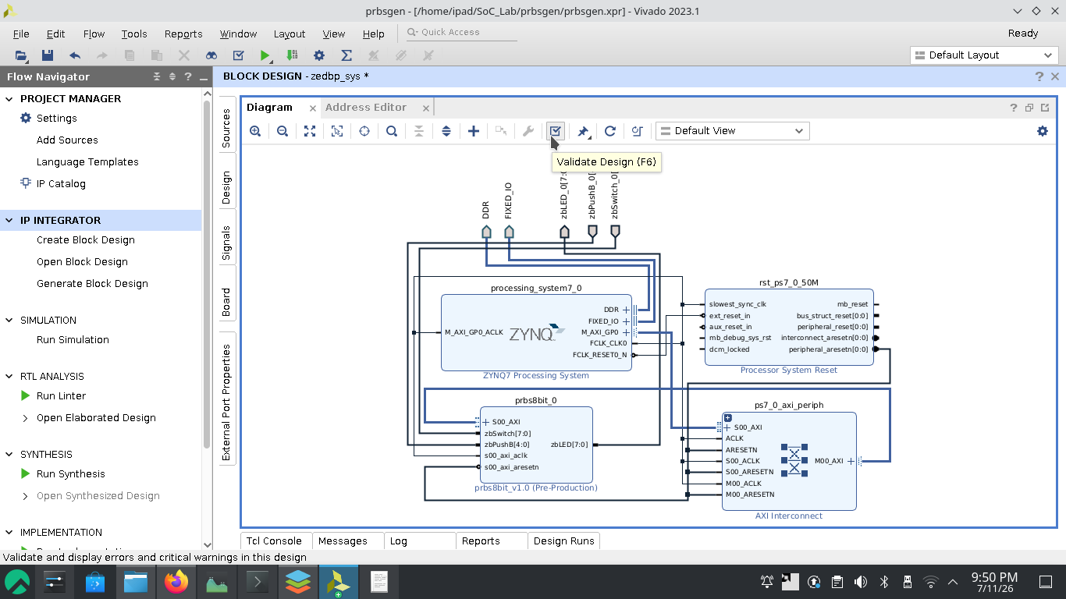
- To make the block design synthesizable, it must be in HDL Wrapper. Create HDL Wrapper 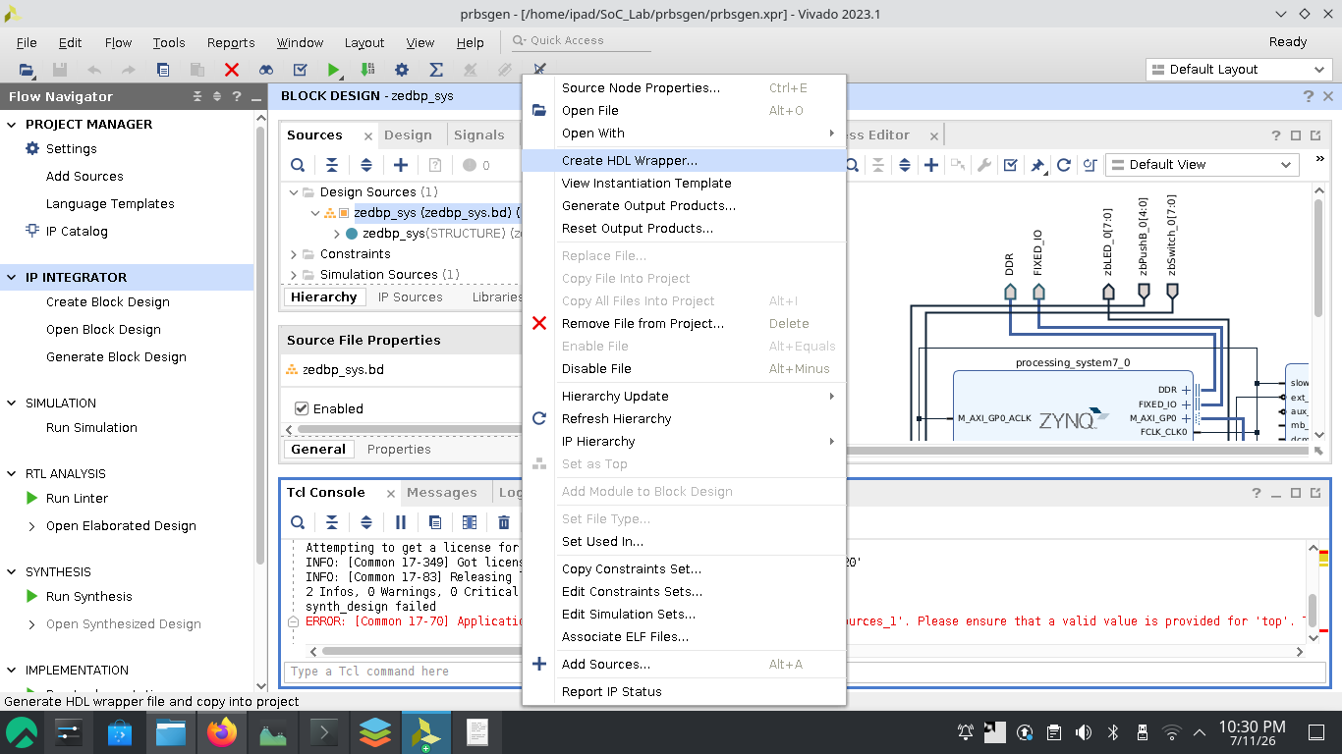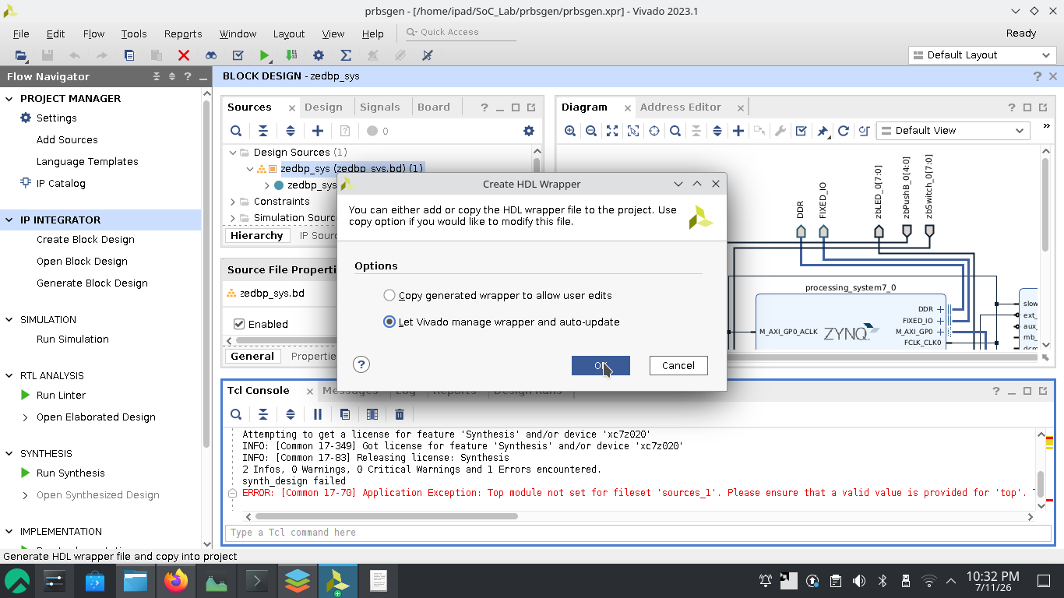
- Add constraint file (zedprbs.xdc)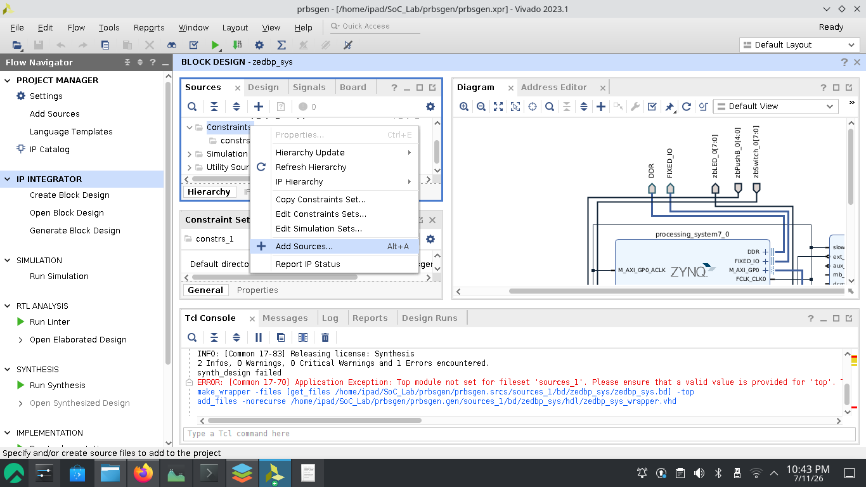or add simply the zedprbs.xdc file.
- Run Linter, Synthesis and implement 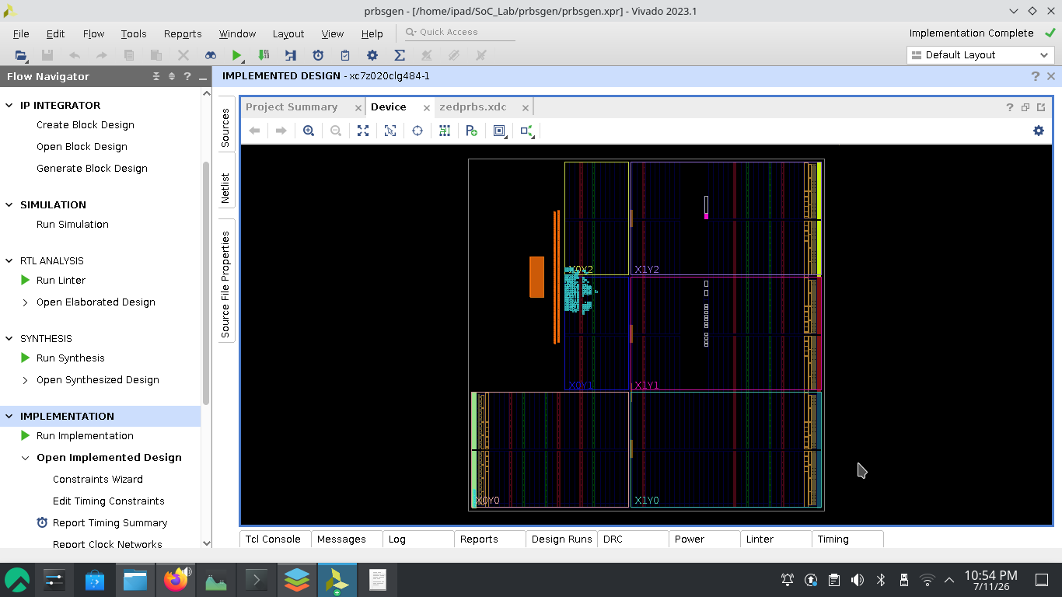 and generate bitstream.
- If everything done without error export Hardware including bitstream. 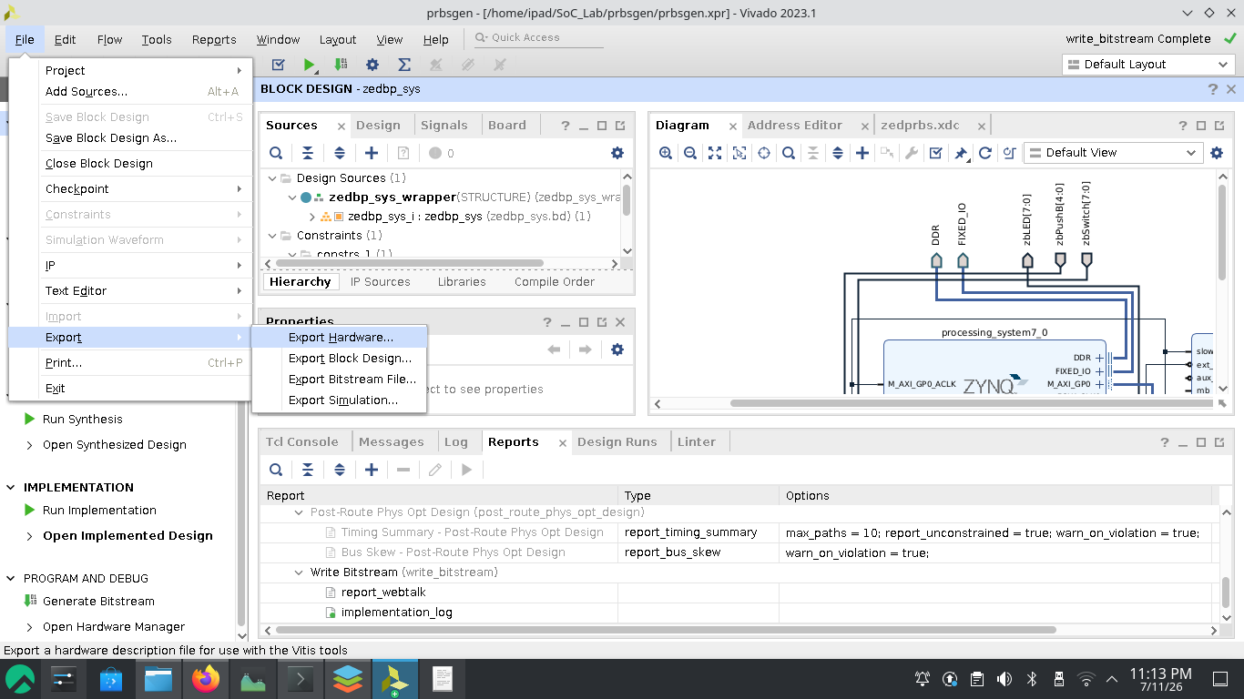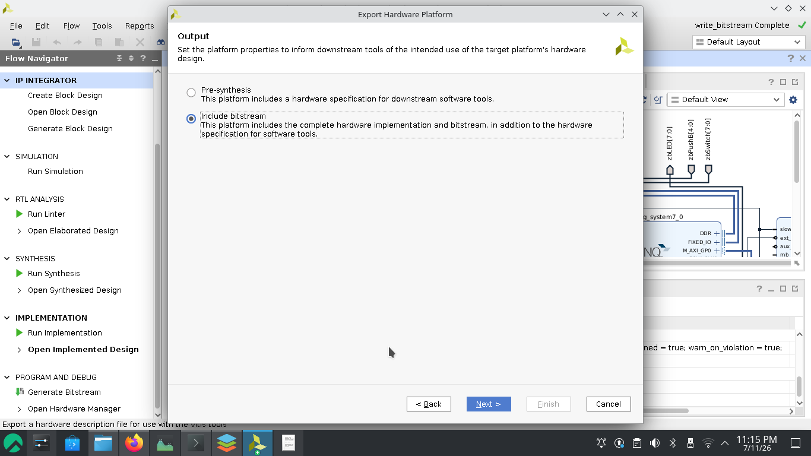
- After that open Launch Vitis IDE from tools menu.
- Create Platform Project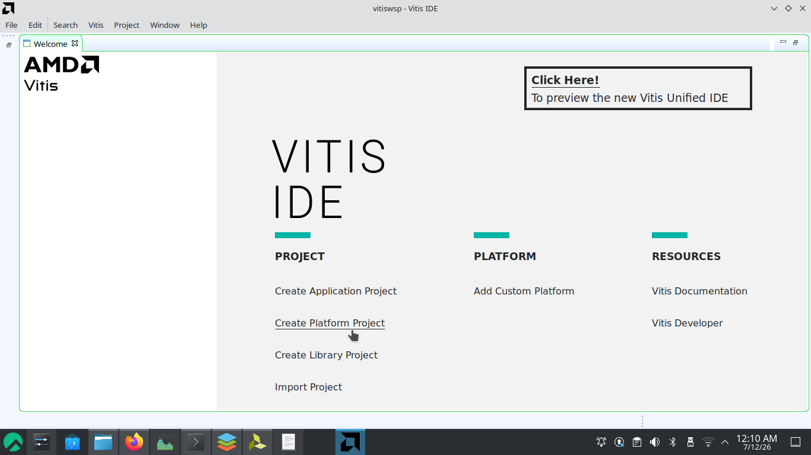 named “zedbp_hardware”, select the “.xsa” file generated by Vivado, uncheck “Generate boot component”.
- Create new application project from the File menu named “prbsivp_system”, select “Hello World” template.
- Add #include "xparameters.h"
it contains— Base Addresses of the IP Cores, Processor and System Info, Interrupt and DMA Configuration

