**Let’s assume frequency, $f \left[e.g 50Hz\right]$**

**Number of fractions considered (per half cycle), $n \left[n must be odd number, e.g. 5\right]$**

**Max amplitude to pulse-width ratio, $M=1.3$**

**Duration of half wave, $τ=\frac{1/f}{2}=\frac{1/50}{2}=10ms$**

**%Decrease of $M$ from Amplitude max. to Amplitude min., $X=\left(n+1\right)/2=\left(5+1\right)/2=3\%$**

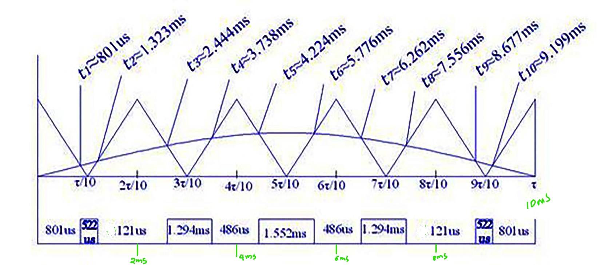**As sine wave is symmetrical wave, we can only calculate 1st quarter of the total cycle for the pulse width calculation.**

**The above diagram is a typical project from my bachelor project. At first my purpose is to create a suitable formula so that it would be easy to program with a typical microcontroller.**

**For max. Amplitude:**

$$t=\frac{\frac{1}{f}}{4}=\frac{\frac{1}{50}}{4}=5ms$$

$$M=1.3=\frac{R_{A}}{R_{dt}}=\frac{1}{R_{dt}} \left[for typical micocontroller V_{max}=5volts⟹R_{A}=100\%\right]$$

$$⟹R_{dt}=\frac{1}{1.3}=0.769=\frac{PW}{T_{n}}=\frac{PW}{τ/n}⟹PW=0.769∙τ/n=0.78∙10ms/5=1.538ms$$

**1st Left to the max:**

$$t=\left(n-2\right)\frac{τ}{2n}=\left(5-2\right)\frac{10ms}{2∙5}=3ms$$

$$M=1.3-1.3×\frac{3}{100}=1.26$$

$$R_{A}=\frac{V_{t}}{V_{max}}=\frac{V_{max}\sin{2∙π∙f∙t}}{V_{max}}=\sin\left(2∙π∙f∙t\right)=\sin\left(2∙50∙3ms∙180\right)=0.809$$

$$1.26=\frac{R_{A}}{R_{dt}}=\frac{0.809}{R_{dt}}$$

$$⟹R_{dt}=\frac{0.809}{1.26}=0.64=\frac{PW}{T_{n}}=\frac{PW}{τ/n}⟹PW=0.64∙τ/n=0.64∙10ms/5=1.28ms$$

**2nd Left to the max:**

**Mid: 1ms Delay: 618.035uS| Mid: 3ms | Mid: 5ms | Mid: 7ms | Mid: 9ms |**