Performance Of Perceptron Algorithm On Student Performance Data

Shubham Barudwale
School of Computing Sciences and Engineering, VIT Chennai, Tamilnadu, India 600127
Email: barudwaleshubham.dinesh2015@vit.ac.in

Abstract-
The perceptron is the simple algorithm which uses supervised learning to classify the dataset into two parts. It is a linear classifier which classifies the given weighted data points into two groups linearly. It assigns each of the datapoint a class which it belongs to. It can also be compared to a human neuron which takes input from other neurons and either asserts or do not assert based of information gained i.e gives binay output. We study the performance of perceptron algorithm on the Student Performance dataset is known to be linearly inseperable for given three classes. The developed system performs with 89% of accuracy while classifyting in two classes.

1. Introduction
Machine learning is the process in which the algorithm will take the data input and will try to find out the decision boundary to classify the given input into appropriate classes. In perceptron algorithm we try to seperate the data linearly by a line or a plane or hyperplane in higher dimensions. So that all points (maximum) in one class belong to that class. Then we try to take the test set of the data and check if the testing data is classfied correctly with maximum accuracy. We try to improve the accuracy by running the algorithm again and again till we get desired accuracy.

2. Methadology
The perceptron algorithm is used in neural networks. A perceptron is an artificial neuron which works on threshold logic. It accepts multiple inputs e.g. x1x2,x3,....xn with weights which are summed up. If sum is greater than the threshold then the neuron gets asserted and the point is labeled as one class, if neuron does not get asserted then the datapoint belongs to another class. Inputs and weights are generally real values, weights are the importance of the filed in the given dataset which can be negative.
According to threshold the algorithm will be dividing the data into two classes which are seperated by either line for 2D or plane for 3D or hyperplance in higher dimensions. The perceptron is majorly used to classify the linearly sepearble data.

3. Dataset – Student Performance Dataset
Student performance dataset is the dataset which has data about 650 students in two schools and their academic performance. It has thirty three attributes for each student e.g. School, sex, age, Family Size, study Time, health and the target academic marks. The school GP has 423 records and rest are of MS. I have distributed the performance in the three categories bad(0-7), medium(8-14), good(15-20) and tried to apply perceptron to classify them. I have used 70% of the data as training data and 30% data as testing data.

4. Algorithm
The perceptron algorithm is as follows:
for calculating the output ‘y’ of the input data ‘x’:

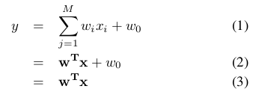

where w and x are the vectors in which wi is vector of weight of the each attribute in vector xi. W0 is the threshold value.
While training the weights are given randomly and are adjusted by varying values until the clasiffication is correct on training data. We can also declare the number of loops until which the weights are adjusted. The new weight is calculated by following formula:
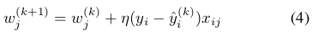

here, w^{(k)}_{j} is weight associated with ith input and k^{th} iteration. Ŋ is learning rate and w_{ij} is valur of j^{th} attribute in training parameter x_{i}.

5. Experiments
Initially we will take the three classes that is poor(0-7), medium(8-14) and good(15-20). We will see all the fields and will try to train the data to get the target classification. The algorithm was ran for 1000 epochs iterations. The training dataset was ran thurough algorithm till error reaches 0.001. Error was mean square error function. The performance was given in figure.
Due to data was mostly overlapping due to integer range linear graphs was not clearly seen in many two dimensional (by taking two fields).
The perceptron was performed on the same data using sklearn perceptron which gives us the perceptron using predefined perceptron algorithm in the sklearn.

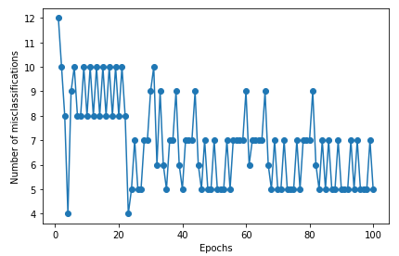
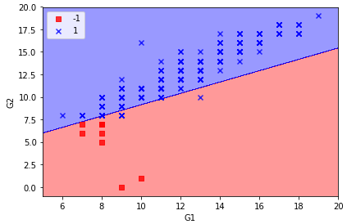

6. Conclusion
We used perceptron to seperate the Student performance data and classify them according to target function into two classes (here taken poor and good only). We have exerimented on two parts. When we applied the perceptron on the Marks G1 and G2. The data was linearly seperable while taking marks only that’s why the algorithm easily seperated the data points in 100 iterations perfectly and accuracy on test data was about 89-92%. When we applied the perceptron on the other fields we couldent see the linearly seperable classes because of non linearly seperable data.
Here we can conclude that the perceptron is able to give good performance on the data which is linearly seperable only. In our case it was Marks distribution and not other integer ranged data.

7. Referances

1)http://www.bogotobogo.com/python/scikit-learn/Perceptron_Model_with_Iris_DataSet.php

2) http://scikit- learn.org/stable/modules/generated/sklearn.linear_model.Perceptron.html

3) https://www.cs.cmu.edu/~avrim/ML10/ lect0125.pdf

