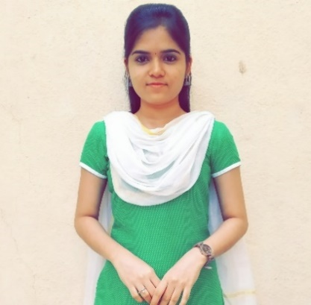**Baruni Priya T S**

1, c2 c2 road, balarengapuram, Madurai - 625009

(+91) 7598158062

[barunipriyats@gmail.com](mailto:barunipriyats@gmail.com)

***Objective:***

To work for an organization which provides me the opportunity to improve my skills and knowledge to grow along with the organization objective.

***Academic Qualification:***

* **B.E. Computer Science and Engineering**

Institution : Velammal College of Engineering and Technology, Madurai.

Mark : 9.6

Year of passing : 2023

* **HSC**

Institution : St. Joseph’s Matriculation Higher Secondary School, Madurai.

Mark : 93%

Year of passing : 2019

* **SSLC**

Institution : Fusco’s Matriculation School, Madurai.

Mark : 98.6%

Year of passing : 2017

***Area of Interest:***

* JAVA
* HTML
* CSS
* JavaScript
* C programming
* Data Structures and Algorithms
* MS Office(Word, Excel & PowerPoint)
* Content writing

***Achievements:***

* Ranked highest total in the subject-Computer Science, HSC
* Won “Leadership” and “Overall Excellence” awards in 2017
* Scored 91% in NPTEL examination
* Finalist of HackBit hackathon conducted by BIT campus

***Skill Set:***

* Responsibility
* Teamwork skills
* Self-learning
* Leadership skills
* Active Listening
* Communication skills

***Personal Information:***

* **D.O.B :** 18-11-2001
* **Sex :** Female
* **Marital Status :** Single
* **Languages Known :** English, Tamil
* **Nationality :** Indian
* **State :** Tamil Nadu

**Place:** Madurai