A proposal for

Predicting Energy Consumption using LSTM

**Abstract**

This research aims to forecast energy consumption utilizing data from Finland's transmission system operator. The project's goal is to determine whether a machine learning model can provide satisfactory results for a complex forecasting challenge, while also examining various machine learning techniques and creating a data-driven forecasting model for energy. The dataset includes six years of hourly electricity consumption in Finland, making it a seasonal univariate time series. We employed a long short-term memory (LSTM) model for training. The model's performance was assessed using root mean squared error (RMSE) to ensure comparability with the energy readings in the dataset. The findings indicate that machine learning algorithms can effectively predict electricity consumption, enabling us to optimize the use of renewable energy, plan for peak and off-peak load days, and minimize waste from polluting standby generation.

**Dataset**

The data is imported from Finland's transmission system operator as a CSV file. There is a total number of 52965 observations and 5 variables in this dataset and no missing values were found. The minimum load volume is 5341 MWh, and the maximum load volume is 15105 MWh along with an average volume of 9488.750519 MWh. The data is univariate time series, where there is a need for one column to present time and another one to present energy consumption.

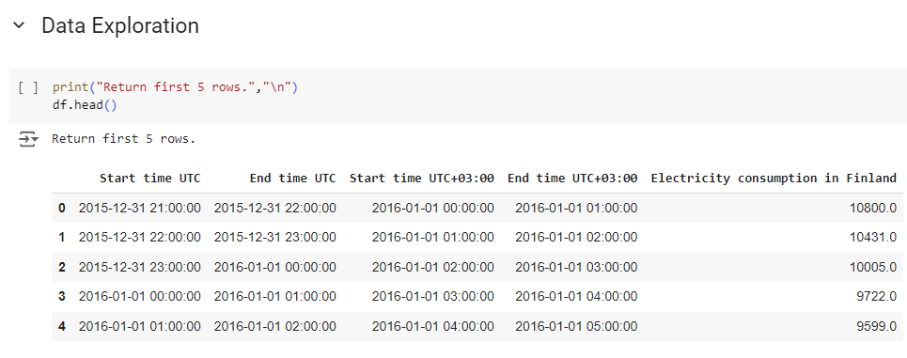

**Univariate Time Series**

A univariate time series is a sequence of data points for a single variable recorded at consistent time intervals. It captures how this variable changes over time, allowing for the analysis of trends, seasonality, and cyclic patterns. In univariate time series analysis, the goal is often to model the temporal dependencies within the data to make future predictions or detect anomalies. Common techniques used for analyzing univariate time series include autoregressive models (AR), moving averages (MA), and more advanced models like ARIMA and LSTM networks for forecasting. The focus is solely on the historical values of that one variable, without considering external influences.

**LSTM**

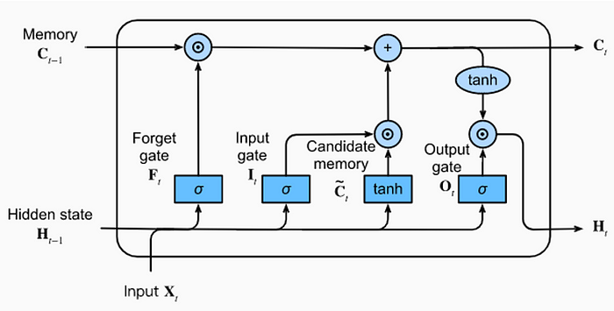

LSTM (Long Short-Term Memory) is a type of recurrent neural network (RNN) designed to handle the vanishing gradient problem that standard RNNs face, making it particularly effective for time series data and sequential tasks where long-term dependencies need to be captured. LSTMs use a series of memory cells that can retain information over long periods, selectively deciding what to keep or discard through mechanisms known as gates: the **input gate**, **forget gate**, and **output gate**. These gates control the flow of information into and out of the cell, allowing the network to maintain relevant information for longer periods and forget irrelevant data.

LSTMs are commonly used for tasks like **time series forecasting**, speech recognition, and natural language processing, where it's crucial to remember data from earlier time steps to make accurate predictions. The ability to store and process long-term dependencies in sequences makes LSTM a powerful tool for capturing patterns in data with complex temporal relationships.

More information: [https://medium.com/@ottaviocalzon](https://medium.com/@ottaviocalzone/an-intuitive-explanation-of-lstm-a035eb6ab42c)