Adding a new customer

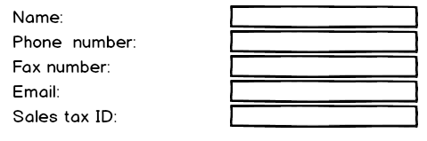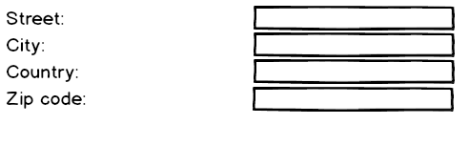

Changing a customer

