Annexure 1

Project Report
on

AI Linux Security Assistant

Submitted
In Partial Fulfillment of
MASTER OF COMPUTER APPLICATIONS (MCA)/BACHELOR OF COMPUTER APPLICATIONS (BCA)
Submitted by:

Basaaria Imroz
160625748011

Under the Supervision of:
(Name of Project Guide, Designation)


School of Computer Applications
Manav Rachna International Institute of Research and Studies
(DEEMED TO BE UNIVERSITY)
Sector-43, Aravalli Hills
Faridabad – 121001

July 2026

Annexure 2

Declaration

I do hereby declare that this project work entitled “AI Linux Security Assistant” submitted by me for the partial fulfillment of the requirement for the award of MASTER OF COMPUTER APPLICATIONS/BACHELOR OF COMPUTER APPLICATIONS is a record of my own work. The report embodies the finding based on my study and observation and has not been submitted earlier for the award of any degree or diploma to any Institute or University.

SIGNATURE
Name: Basaaria Imroz
Roll No:160625748011
Date: 23-07-2026

Annexure 3

Certificate from the Guide

This is to certify that the project report entitled ”AI Linux Security Assistant” submitted in partial fulfillment of the degree of MASTER OF COMPUTER APPLICATIONS/BACHELOR OF COMPUTER APPLICATIONS to Manav Rachna International Institute of Research and Studies, Faridabad is carried out by Mr./ Ms. Basaaria Imroz (160625748011), under my guidance.

Signature of the Guide
Name:
Date:

Head of Department
Name:
Date:

ACKNOWLEDGEMENT

I gratefully acknowledge for the assistance, cooperation, guidance and clarification provided by Ms./Mr. _____(guide name)_________ during the development of AI Linux Security Assistant.
I would like to extend my sincere gratitude to Prof. (Dr.) Suhail Javed Quraishi – HOD and Prof. (Dr.) Mamta Dahiya – Associate Dean for their valuable teachings and advice. I would like to thank Dr. Raj Kumar – TPO for his continued support during the internship. I want to thank all the department faculty members for their cooperation and support. I want to thank non-teaching staff of the department for their cooperation and support.
This opportunity is a big milestone in my career development. I will strive to use gained skills and knowledge in the best possible way, and I will continue to work on their improvement, to attain desired career objectives. I hope to continue cooperation with all of you in the future.

TABLE OF CONTENTS
Section | Title
I | Cover Page
II | Declaration
III | Certificate from the Guide
IV | Acknowledgement
V | Index / Table of Contents
VI | Introduction
VII | System Study
VIII | Feasibility Study
IX | Project Monitoring System
X | System Analysis
XI | System Design
XII | Input / Output Form Design
XIII | System Testing
XIV | System Implementation
XV | Documentation
XVI | Scope of the Project
XVII | Bibliography

VI. INTRODUCTION

This chapter provides an overview of the internship organization, the objectives of the project, and the team involved in its successful execution. It also introduces the Multi-Agent Cybersecurity Assistant project and highlights the collaborative efforts between academia and industry in promoting AI-driven cybersecurity solutions.

About the Organization
The internship was conducted under the ACM Student Chapter and ACM-W Student Chapter, School of Computer Applications, Manav Rachna International Institute of Research and Studies (MRIIRS), in collaboration with Ditto Security, under the mentorship of its Founder, Mr. Ajinkeya. This industry–academia collaboration provided students with practical exposure to Artificial Intelligence, Agentic AI, and Cybersecurity through hands-on training and real-world projects.

1.1.1 Overview
The Multi-Agent Cybersecurity Assistant project was developed as part of an AI and Cybersecurity Internship Program organized under the ACM Student Chapter and ACM-W Student Chapter, School of Computer Applications (SCA), Manav Rachna International Institute of Research and Studies (MRIIRS), Faridabad, in collaboration with Ditto Security, a cybersecurity organization specializing in modern cybersecurity practices, ethical hacking, cloud security, Artificial Intelligence (AI), and Agentic AI solutions.
The internship was designed to provide students with practical exposure to emerging technologies by combining theoretical concepts with hands-on implementation. The program emphasized the development of intelligent cybersecurity solutions using Large Language Models (LLMs), Agentic AI, ReAct reasoning, Function Calling, Multi-Agent Systems, and cybersecurity automation techniques. Students gained practical experience in designing AI-driven applications that address real-world cybersecurity challenges.
The internship was conducted under the academic guidance of the faculty members of the School of Computer Applications, MRIIRS, while the industry mentorship and technical training were provided by experts from Ditto Security. The sessions were led by the Founder of Ditto Security, Mr. Ajinkeya, who shared valuable industry insights, demonstrated practical cybersecurity tools, and guided students in developing advanced AI-powered cybersecurity projects.
This collaborative initiative bridged the gap between academia and industry by enabling students to apply classroom concepts to practical cybersecurity scenarios and preparing them for careers in Artificial Intelligence and Cybersecurity.

1.1.2 About ACM Student Chapter
The Association for Computing Machinery (ACM) is the world's largest educational and scientific computing society dedicated to advancing computing as a science and profession. ACM provides numerous opportunities for students, researchers, educators, and professionals to enhance their technical knowledge through conferences, workshops, research publications, coding competitions, and professional networking.
The ACM Student Chapter at the School of Computer Applications, MRIIRS, serves as a platform for promoting technical excellence among students by organizing:
- Technical workshops
- Coding competitions
- Hackathons
- Research seminars
- Expert talks
- Industry interactions
- Skill development programs
- Innovation and entrepreneurship activities
The chapter encourages students to explore emerging technologies such as Artificial Intelligence, Machine Learning, Data Science, Cybersecurity, Cloud Computing, Blockchain, and Software Engineering while fostering research and innovation.

1.1.3 About ACM-W Student Chapter
The ACM-W Student Chapter is an initiative of ACM dedicated to supporting, celebrating, and empowering women in computing and technology. It aims to increase the participation of women in Computer Science and Information Technology through leadership opportunities, technical events, mentoring programs, research activities, and community engagement.
At MRIIRS, the ACM-W Student Chapter actively organizes:
- AI and Cybersecurity workshops
- Technical boot camps
- Women leadership programs
- Innovation challenges
- Research paper writing workshops
- Industry expert sessions
- Career guidance seminars
- Collaborative projects with industry partners
The internship program provided an inclusive learning environment where students developed technical competencies while enhancing teamwork, leadership, communication, and problem-solving skills.

1.1.4 About School of Computer Applications (SCA), MRIIRS
The School of Computer Applications (SCA) is one of the premier schools of Manav Rachna International Institute of Research and Studies (MRIIRS), Faridabad, offering undergraduate, postgraduate, and doctoral programs in Computer Applications and Information Technology.
The school focuses on delivering quality education through an industry-oriented curriculum, practical learning, research, innovation, and strong industry collaborations.
Key focus areas include:
- Artificial Intelligence
- Machine Learning
- Data Science
- Cybersecurity
- Internet of Things (IoT)
- Cloud Computing
- Blockchain
- Full Stack Development
- Software Engineering
- Mobile Application Development
SCA regularly collaborates with industry leaders to conduct internships, certification programs, workshops, hackathons, and live projects that enhance students' employability and practical skills.

1.1.5 About Ditto Security
Ditto Security is an emerging cybersecurity organization dedicated to providing modern cybersecurity solutions, security awareness, penetration testing, vulnerability assessment, cloud security consulting, AI-enabled security solutions, and cybersecurity education.
The company actively promotes practical cybersecurity learning by conducting workshops, internships, and professional training programs covering topics such as:
- Ethical Hacking
- Network Security
- Cloud Security
- Digital Forensics
- Threat Hunting
- Security Operations Center (SOC)
- Incident Response
- AI Security
- Agentic AI
- Secure Software Development
- Cybersecurity Automation
The internship emphasized real-world cybersecurity problems and encouraged students to develop intelligent AI systems capable of assisting security analysts in detecting, analyzing, and responding to cyber threats.

1.1.6 Industry Mentor – Mr. Ajinkeya
The internship program was technically mentored by Mr. Ajinkeya, Founder of Ditto Security, who possesses extensive expertise in Cybersecurity, Artificial Intelligence, Security Operations, and Security Automation.
During the internship, Mr. Ajinkeya guided students through practical implementations of:
- Agentic AI
- Large Language Models (LLMs)
- Prompt Engineering
- Multi-Agent Systems
- Cybersecurity Automation
- Threat Detection
- Incident Response
- Vulnerability Assessment
- Secure AI Applications
- Real-world Security Workflows
His mentorship helped students understand current industry practices and apply advanced AI technologies to cybersecurity use cases.

1.1.7 Vision
The collaborative internship initiative aims to create a new generation of AI-enabled cybersecurity professionals capable of designing intelligent, secure, and scalable systems that address evolving cyber threats while contributing to technological innovation and digital security.

1.1.8 Mission
The mission of the internship program is to:
- Bridge the gap between academic learning and industry practices.
- Promote practical implementation of AI and cybersecurity concepts.
- Develop problem-solving skills through real-world projects.
- Encourage innovation using emerging AI technologies.
- Build industry-ready professionals equipped with modern cybersecurity knowledge.
- Foster collaborative learning through academia-industry partnerships.

1.1.9 Services Offered During the Internship
The internship program provided comprehensive training and practical exposure in various domains, including:

Artificial Intelligence
- Prompt Engineering
- Large Language Models (LLMs)
- Agentic AI
- AI Agents
- ReAct Framework
- Function Calling
- Multi-Agent Systems

Cybersecurity
- Linux Security
- Networking Fundamentals
- Ethical Hacking
- Threat Hunting
- Vulnerability Assessment
- Incident Response
- OWASP Top 10
- Security Operations Center (SOC)
- Secure AI Applications

Practical Learning
- Hands-on coding sessions
- Capstone project development
- Team collaboration
- GitHub usage
- Project documentation
- Industry mentorship
- Technical presentations

1.1.10 AI and Cybersecurity Initiatives
The internship focused on emerging AI-driven cybersecurity solutions by integrating Artificial Intelligence with security automation. Students worked on projects involving:
- AI-Powered SOC Analyst Assistant
- Threat Hunting Assistant
- Multi-Agent Cybersecurity Assistant
- Incident Response Copilot
- AI Phishing Detection System
- Secure AI Chatbot
- Linux Security Assistant
- OWASP Security Advisor
- Cyber Defense Copilot
These projects introduced students to the practical implementation of AI in cybersecurity operations using intelligent agents capable of autonomous reasoning and decision-making.

Aims and Objectives
This section outlines the primary purpose, objectives, and expected outcomes of the Multi-Agent Cybersecurity Assistant project. It defines the project's goals and highlights the knowledge and practical skills gained through the internship in Artificial Intelligence, Agentic AI, and Cybersecurity.

1.2.1 General Objective
The primary objective of this internship project is to design and develop a Multi-Agent Cybersecurity Assistant capable of automating cybersecurity investigations using Artificial Intelligence. The system employs multiple specialized AI agents that collaboratively analyze security logs, detect cyber threats, identify vulnerabilities, recommend mitigation strategies, and generate comprehensive security reports. The project demonstrates the integration of Agentic AI, Large Language Models (LLMs), Multi-Agent Systems, ReAct reasoning, and Function Calling to solve real-world cybersecurity challenges.

1.2.2 Specific Objectives
The specific objectives of the project are:
- To develop a modular Multi-Agent Cybersecurity Assistant using Python and Streamlit.
- To design an intelligent agent orchestration framework that enables collaboration among multiple AI agents.
- To implement a Log Analysis Agent for parsing and analyzing security logs.
- To develop a Threat Detection Agent for identifying malicious activities and classifying threat severity.
- To implement a Vulnerability Assessment Agent capable of analyzing scan reports and detecting security weaknesses.
- To design a Report Generator Agent for creating professional cybersecurity assessment reports.
- To implement a shared memory architecture that enables efficient communication among AI agents.
- To integrate Large Language Models (OpenAI GPT, Google Gemini, or Ollama) for intelligent reasoning and recommendations.
- To demonstrate the use of ReAct reasoning and function calling in solving cybersecurity tasks.
- To provide an intuitive Streamlit-based interface for uploading security artifacts, visualizing analysis results, and downloading reports.

1.2.3 Learning Outcomes
Upon successful completion of the internship and project, students will be able to:
- Understand the principles of Agentic AI and Multi-Agent Systems.
- Design and implement AI agents for cybersecurity applications.
- Apply ReAct reasoning for multi-step problem solving.
- Develop AI-powered security automation solutions.
- Analyze security logs and identify suspicious activities.
- Detect vulnerabilities using automated AI workflows.
- Generate professional cybersecurity assessment reports.
- Build interactive web applications using Streamlit.
- Integrate Large Language Models into practical software solutions.
- Understand industry-standard cybersecurity workflows and AI-assisted incident analysis.
- Gain experience in collaborative software development, GitHub version control, and technical documentation.

1.2.4 Project Goals
The key goals of the Multi-Agent Cybersecurity Assistant are:
- Automate cybersecurity investigations through specialized AI agents.
- Reduce the time required for security analysis.
- Improve the accuracy of threat detection.
- Facilitate collaborative decision-making using agent orchestration.
- Provide actionable recommendations for vulnerability mitigation.
- Generate comprehensive and professional security reports.
- Demonstrate the practical application of Agentic AI in cybersecurity.
- Develop a scalable framework that can be extended with additional AI agents and security modules.

1.3 Manpower
The successful completion of the internship project involved collaboration between academic mentors, industry experts, and the student development team. The organizational structure is illustrated below in Figure 1.

Organizational Structure
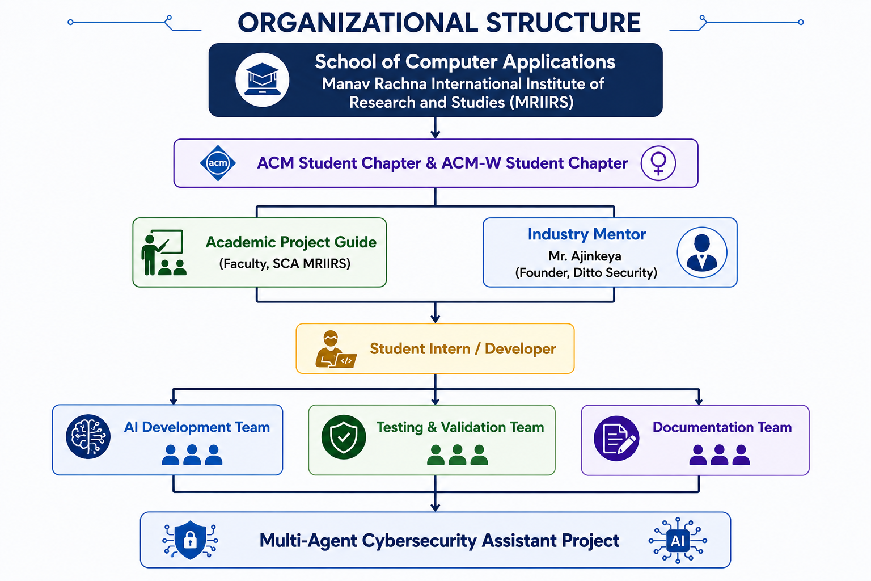
Figure 1. Organizational Structure

Roles and Responsibilities

Project Guide (Faculty Mentor (Name) – SCA, MRIIRS)
- Supervised project planning and execution.
- Reviewed technical documentation and implementation.
- Ensured academic quality and adherence to university guidelines.
- Provided guidance on software engineering practices and project evaluation.

Industry Mentor (Mr. Ajinkeya, Founder – Ditto Security)
- Delivered technical training on AI and Cybersecurity.
- Guided the implementation of Agentic AI concepts.
- Reviewed project architecture and cybersecurity workflows.
- Shared industry best practices and real-world use cases.

Student Intern (Basaaria Imroz) / Developer
- Designed and developed the Multi-Agent Cybersecurity Assistant.
- Implemented AI agents, orchestration logic, and user interface.
- Performed testing, debugging, and documentation.
- Prepared reports, presentations, and project deliverables.

VII. SYSTEM STUDY

2.0 Introduction
A system study is the stage of software development in which the problem environment is examined in detail before a solution is designed. It helps the developer understand the users, their current working method, the limitations of that method, the risks involved, and the capabilities that the proposed system must provide. For the AI Linux Security Assistant, the system study focuses on the difficulties faced by students and beginner administrators while learning Linux commands, interpreting permissions, and applying secure administration practices.
Linux is widely used in servers, cloud environments, cybersecurity laboratories, software development, and network administration. Although Linux offers powerful command-line tools, this strength can also create risk for an inexperienced user. A command that appears simple may modify file ownership, delete data, expose a service, or grant access to every local user. The purpose of the proposed project is not to execute commands on behalf of a user; instead, it supports safer learning by explaining what a command means before the user acts on a real system.
The study identified a recurring educational problem. Beginners often search for a quick command to solve an access issue, copy it from an online source, and run it without understanding the security consequence. A common example is chmod 777, which is frequently used to remove permission errors but gives read, write, and execute access to all users. The proposed assistant provides immediate context, identifies the associated risk, and recommends a least-privilege alternative appropriate to the type of file or directory.

2.1 Existing System
In the existing approach, students use a combination of search engines, tutorial websites, manual pages, classroom notes, and trial-and-error in a terminal. Linux manual pages are technically valuable but can be difficult for a beginner because they describe complete syntax and many options without always explaining the security impact of a specific command. A learner therefore has to combine information from several places before reaching a correct conclusion.
Permission analysis is also usually performed manually. The learner reads a string such as -rwxrwxrwx, remembers that the three permission triplets belong to owner, group, and others, converts each triplet into numeric form, and then decides whether the permissions are appropriate. This process is prone to error, especially when group-write access, world-write access, special setuid bits, directories, or service accounts are involved.
System hardening guidance is similarly fragmented. Recommendations about SSH configuration, firewall policy, automatic security updates, account control, log monitoring, and unused services are usually found in separate guides. A student may know individual commands but still not understand the principle of least privilege or why a security change should be tested carefully before it is applied to a remote server.

2.1.1 Working of the Existing System
The existing workflow usually begins when a user encounters a terminal error, permission-denied message, or configuration problem. The user searches for a solution, chooses a command, runs it, and only later notices its side effects. In many cases, there is no structured risk check before execution. This is especially problematic for commands involving sudo, rm, chmod, chown, systemctl, firewall configuration, or downloaded shell scripts.

Step | Existing activity | Issue
1 | User encounters a Linux problem. | The user may not understand the root cause.
2 | User searches a command online. | Advice may be generic, outdated, or unsuitable.
3 | User copies and runs the command. | The command may be unsafe for the environment.
4 | User checks the result after execution. | Damage or exposure may already have occurred.
5 | User documents findings manually. | Learning evidence and reporting are inconsistent.

2.1.2 Limitations of the Existing System
- Lack of unified explanation: command purpose, syntax, risk, and secure alternative are usually not shown together.
- Difficulty in interpreting permissions: beginners may not understand owner, group, others, numeric modes, or special bits.
- Unsafe copy-paste practice: downloaded commands may be executed without validation or source review.
- No immediate risk classification: students may not know whether a command is low, medium, high, or critical risk.
- Insufficient security context: a standard command explanation may not discuss least privilege or service-specific access needs.
- Manual report preparation: students need to collect observations and recommendations separately for assignments.
- Inconsistent hardening guidance: firewall, SSH, updates, logs, and service reduction are often learned independently.

2.2 Proposed System
The proposed system is an AI Linux Security Assistant developed as a local Streamlit application. It receives a Linux command, terminal output, or permission string and provides structured feedback. The feedback contains the purpose of the command, recognized options, likely security implications, risk severity, a safer alternative, permission findings, hardening recommendations, and an overall educational security score.
The system uses a modular design. The command parser reads input as text and identifies the executable, options, and arguments. The permission analyzer extracts a symbolic mode from a supplied permission string or an ls -l line. The hardening module provides a curated checklist of security practices. The Linux security agent combines these modules in a transparent ReAct-inspired sequence of thought, action, and observation. Finally, the report generator converts the assessment into a downloadable PDF report.
A major design decision is that the application never executes a user-provided command. The command is parsed only for educational and security-analysis purposes. This avoids the possibility that a learner accidentally uses the dashboard as a way to run destructive or privileged commands. The project therefore functions as an intelligent tutor and decision-support system rather than an automated system-administration tool.

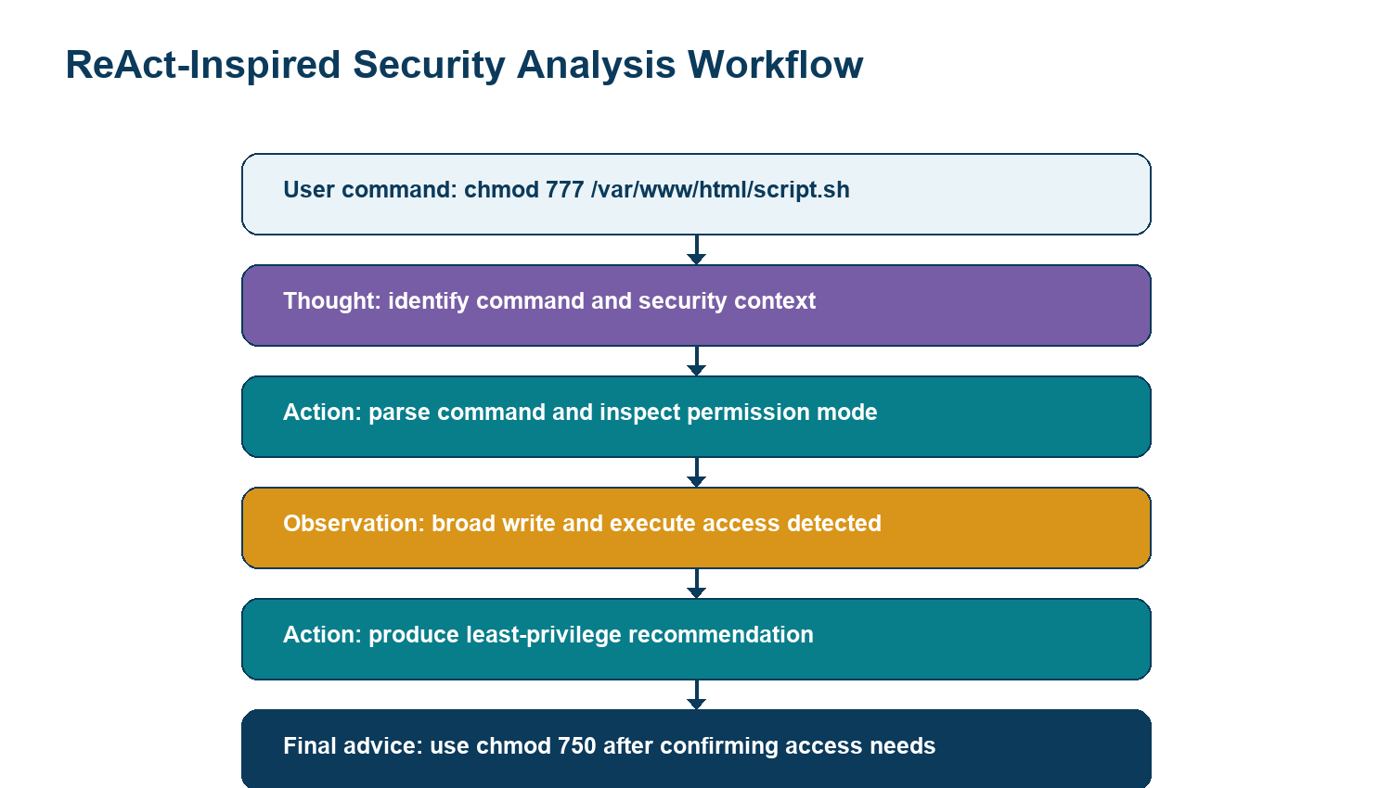

2.2.1 Proposed System Workflow
First, the user enters a command, terminal output, or symbolic permission string. Second, the system checks whether the command matches known Linux command patterns and extracts its options and arguments. Third, it evaluates risk rules such as broad chmod modes, recursive deletion, force options, privileged sudo execution, or remote scripts piped directly into a shell. Fourth, the permission analyzer determines whether the supplied item is world-writable, world-executable, group-writable, or uses special permission bits. Fifth, the hardening component adds preventive recommendations. Sixth, the dashboard displays the results and allows the user to download a report.
Module | Input | Output
Command Parser | Linux command text | Command name, options, arguments, purpose, risks, safer alternative
Permission Analyzer | Permission string or ls -l line | File type, owner/group/others access, numeric mode, findings
Hardening Module | Assessment context | Security practices and safe command examples
Linux Security Agent | Results from local tools | Workflow observations and security score
Report Generator | Complete assessment | Structured PDF security report

2.2.2 Advantages of the Proposed System
- Beginner-friendly explanations: the system uses clear language rather than only technical manual-page terminology.
- Safer learning environment: the project analyzes text and does not execute commands or change user files.
- Permission transparency: the user sees the effect of owner, group, and others permissions separately.
- Least-privilege guidance: risky broad modes are compared with more restrictive alternatives such as 640, 700, or 750.
- Structured hardening advice: common security areas are presented as a reusable checklist.
- Report generation: the student can save findings and recommendations as a PDF document.
- Extensible architecture: new command rules, LLM integration, ACL analysis, or distribution-specific guidance can be added later.

Area | Advantage
Safety | Commands are parsed; they are never executed by the application.
Learning | Findings use beginner-friendly language and explain why a pattern matters.
Consistency | Deterministic rules give repeatable results for common commands and modes.
Least privilege | Recommendations highlight secure modes such as 640 and 750 where appropriate.
Reporting | A PDF report preserves assessment findings and hardening guidance.
Extensibility | The tool facade and prompts can be connected to LLM or LangGraph workflows later.

2.3 Existing System and Proposed System Comparison
The proposed system improves the learning workflow by combining security explanation and assessment in one place. It does not replace official Linux documentation or expert review; instead, it provides an accessible first layer of explanation that encourages the learner to verify the command, understand the impact, and use secure defaults.
Parameter | Existing System | Proposed System
Command understanding | Manual reading of multiple references. | Command name, purpose, options, usage, and risk in one result.
Permission analysis | Manual decoding of symbolic permissions. | Automatic owner/group/others and numeric-mode analysis.
Risk awareness | Usually depends on learner experience. | Low, Medium, High, or Critical classification.
Security recommendations | Scattered across tutorials and notes. | Least-privilege alternatives and hardening checklist.
Safety | User may run copied commands immediately. | Input is analyzed locally and never executed.
Documentation | Manual notes or screenshots are required. | PDF report is generated from current assessment.
Target user | Assumes some Linux familiarity. | Designed specifically for students and beginners.

2.4 Problem Statement
Students learning Linux security often struggle to understand what a command does, when administrator privileges are required, how file permissions affect security, and how to secure a Linux system using basic hardening steps. These gaps can lead to insecure configuration, accidental exposure of files, misuse of privileged commands, and dependency on unverified copy-paste instructions. The problem is therefore to create a safe and beginner-oriented assistant that explains command behavior, analyzes permissions, identifies common insecure patterns, and recommends responsible alternatives without executing any user input.

2.5 Scope of the System Study
The study focuses on common Linux commands and standard Unix-style permissions. It includes chmod, chown, sudo, rm, curl, wget, ssh, systemctl, ufw, passwd, and find. The permission logic focuses on regular files, directories, symbolic links, owner/group/others triplets, world-write access, world-execute access, group-write access, and special bits. The study does not claim to inspect a live operating system, perform vulnerability scanning, or apply configuration changes automatically.

VIII. FEASIBILITY STUDY

3.0 Introduction
Feasibility study determines whether a proposed system can be developed, used, and maintained successfully within the available technical, behavioural, and economic constraints. For the AI Linux Security Assistant, feasibility is strong because the project is based on common Python libraries, an accessible web interface, local text analysis, and a carefully limited security scope.

3.1 Technical Feasibility
The system is technically feasible because all selected tools are widely available and compatible with normal student development environments. Python provides a readable and flexible language for parsing text, organizing modules, and generating reports. Streamlit provides a simple method for creating a local dashboard without the complexity of a separate frontend framework. Pandas and Plotly support structured display and visual score presentation, while ReportLab generates portable PDF output.
The core security analysis does not require root privileges or direct access to a Linux host. The project receives text as input, performs local pattern analysis, and returns explanations. This design reduces infrastructure requirements and removes the need to set up a vulnerable test server simply to demonstrate the application. Optional LLM integration may be added later, but it is not required for the reliable operation of the current rule-based version.
Resource | Minimum requirement | Role in the system
Processor | Intel Core i5 / AMD Ryzen 5 or equivalent | Runs Python and local dashboard
Memory | 8 GB RAM | Supports browser, Python packages, and report generation
Storage | 256 GB SSD or more | Stores source code, virtual environment, and reports
Operating system | Windows, Linux, or macOS | Supports Python and Streamlit
Python | Version 3.11 or above | Main development language
Internet | Optional after installation | Needed only for package setup or future LLM features

3.1.1 Technical Challenges and Mitigation
Challenge | Mitigation
Ambiguous commands | Use conservative parsing and recommend manual-page review for unknown commands.
Unsafe input | Never pass user input to a shell or subprocess.
Permission format variation | Accept symbolic mode alone or a complete ls -l line.
Overconfident recommendations | Use educational wording and advise users to confirm service requirements.
Report readability | Separate score, findings, recommendations, and hardening checklist.
Future AI variability | Keep deterministic rules as the stable baseline.

3.2 Behavioural Feasibility
Behavioural feasibility considers whether target users will accept the system and whether it improves their learning process. The proposed project is aimed at students, beginner Linux users, faculty members, and junior administrators. These users benefit from a single interface that begins with familiar inputs such as commands and ls -l output. The dashboard does not assume advanced security knowledge and explains findings with direct wording.
The system supports behavioural acceptance by avoiding intimidating terminology wherever possible. For example, instead of only saying that a mode is “unsafe,” it explains that a world-writable item can be modified by any local user. It then provides a safer direction such as using chmod 640 for a regular private file or chmod 750 for a directory or script where group traversal is genuinely required. This helps users understand the reason behind the recommendation.
- The dashboard has only three primary input fields and one analysis button.
- Results are divided into tabs, making the learning flow easier to follow.
- Risk labels help learners prioritize attention without reading every technical detail first.
- The PDF report supports classroom assessment, self-study, and project documentation.
- The local-analysis statement builds confidence because users know their commands are not executed.

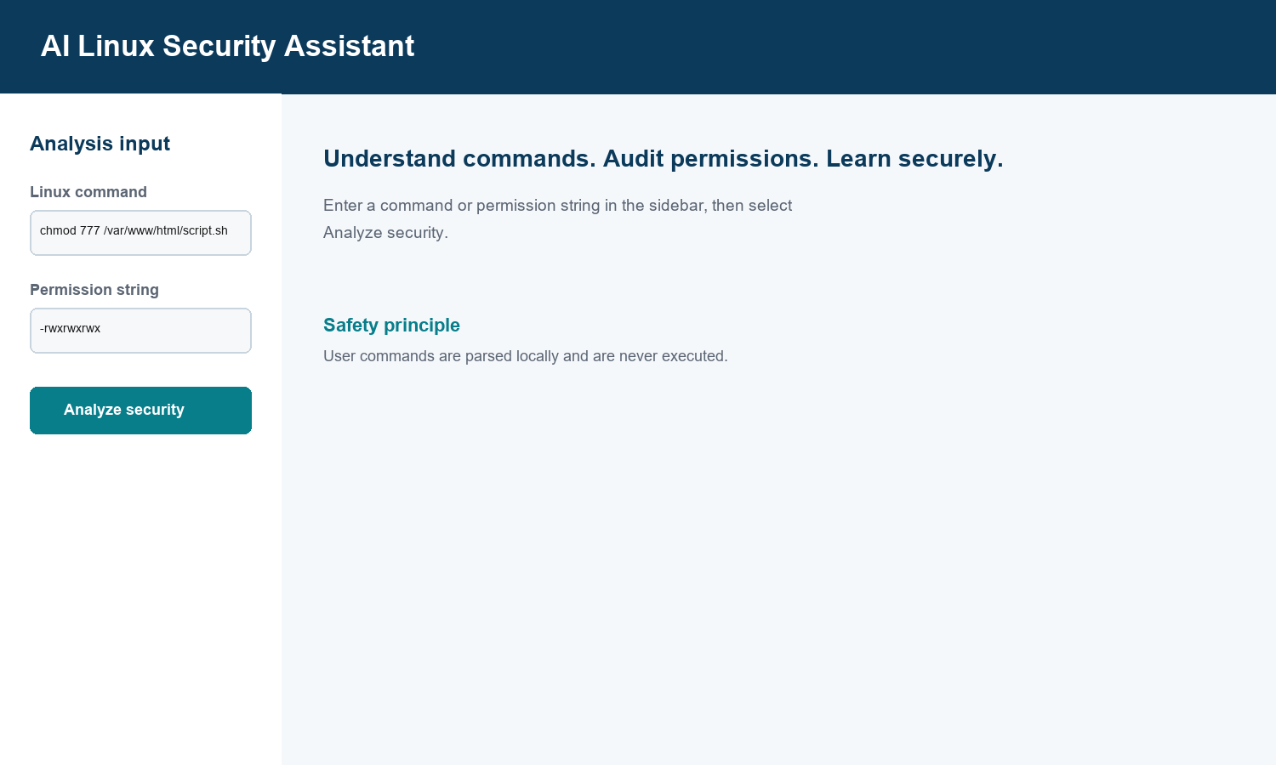

3.3 Economic Feasibility
The project is economically feasible because the required software stack is open source or freely available for educational use. A student can build, test, and run the application using an existing laptop. The core version does not need paid cloud infrastructure, a database server, commercial vulnerability scanner, or an external AI subscription. The cost of maintenance is also low because the source modules are small and independently organized.
Item | Cost implication
Python and packages | Free and open source
Streamlit dashboard | Free and open source
ReportLab PDF generation | Free and open source
VS Code and GitHub | Free for educational use
Existing laptop and internet | Existing infrastructure
Optional online LLM | Not required for the baseline project

The expected benefits are significant for an academic project: faster understanding of Linux security concepts, more consistent permission analysis, safer administration habits, reusable hardening guidance, and easier generation of project evidence. The project therefore offers good educational value at minimal financial cost.

IX. PROJECT MONITORING SYSTEM
Project monitoring is the process of tracking tasks, milestones, quality checks, and deliverables throughout development. The AI Linux Security Assistant was developed using an iterative approach. Each component was designed, implemented, checked with representative test input, and then integrated into the final Streamlit dashboard. This approach reduced the risk that a problem in one module would affect the entire project.

4.1 Development Phases
Phase | Activities | Output
Requirement analysis | Identify user needs, security use cases, and project constraints. | Problem statement and feature list.
System design | Define modules, data flow, inputs, outputs, and safety boundaries. | Architecture and file structure.
Implementation | Build parser, permission analyzer, hardening module, agent, dashboard, and report generator. | Working Python modules.
Testing | Use normal, unsafe, malformed, and privileged command examples. | Validated test-case results.
Documentation | Prepare README, security report, and academic project report. | Submission-ready documents.
Packaging | Prepare source archive and GitHub-ready configuration. | Project ZIP and .gitignore.

4.2 Gantt Chart And Monitoring
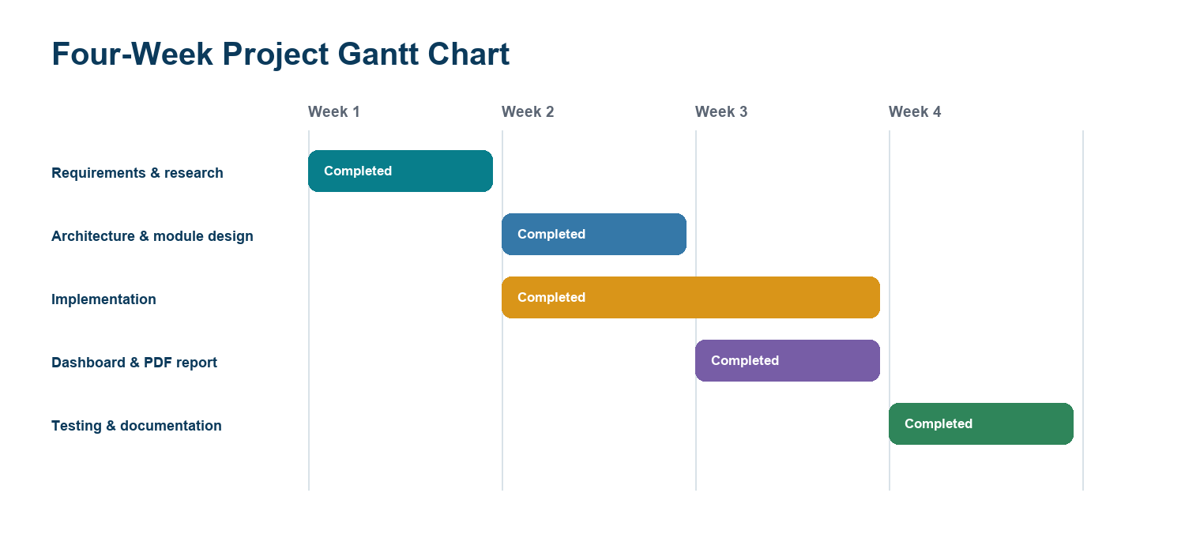
Figure 4. Four-week project development schedule.
Progress was monitored by checking the completion of each module against its planned output. The testing stage included both normal and insecure examples so that the rule-based risk classification could be verified. Documentation was developed alongside implementation to ensure that the report reflected the actual application behavior.
- Requirement changes were reviewed before altering risk rules.
- Each parser was validated with representative Linux commands and modes.
- Dashboard and PDF outputs were checked for clarity and readability.
- Final project files were packaged for GitHub submission.

X. SYSTEM ANALYSIS

5.1 Requirement Specification
Requirement specification defines what the system must do and the quality standards it must maintain. The functional requirements describe visible system features. The non-functional requirements describe qualities such as safety, usability, privacy, performance, reliability, and maintainability.

5.1.1 Functional Requirements
ID | Requirement
FR1 | The system shall accept a Linux command entered by the user.
FR2 | The system shall accept optional terminal output and symbolic permission strings.
FR3 | The command parser shall identify the command name, options, and arguments.
FR4 | The system shall explain command purpose, typical use, and security implications.
FR5 | The system shall identify common risky patterns such as chmod 777, recursive deletion, and remote shell piping.
FR6 | The permission analyzer shall show owner, group, others, numeric mode, and risk findings.
FR7 | The hardening module shall provide security recommendations and example commands.
FR8 | The agent shall create a transparent action-and-observation summary.
FR9 | The dashboard shall present score, risk levels, findings, and download option.
FR10 | The report generator shall create a PDF security report for the current assessment.

5.1.2 Non-Functional Requirements
- Safety: user-provided command text must never be executed by the application.
- Usability: the interface must be understandable to a beginner with basic Linux awareness.
- Reliability: repeated analysis of the same input should produce the same baseline result.
- Performance: common text inputs should be analyzed within a few seconds.
- Privacy: core analysis should remain local and should not require transmission of input to an external service.
- Maintainability: each major feature should be isolated in a separate Python module.
- Portability: the solution should run on common operating systems supporting Python and Streamlit.
- Extensibility: additional command rules, LLM integration, or security checks should be addable without redesigning the dashboard.

Category | Requirement
Safety | Never execute user-supplied commands or write to user paths.
Usability | Use clear labels, tabs, examples, and beginner-friendly explanations.
Reliability | Produce consistent rule-based findings for identical input.
Performance | Complete typical text analysis and report generation within seconds.
Maintainability | Keep parser, permissions, hardening, report, and UI modules separate.
Portability | Run on Windows, Linux, or macOS where Python dependencies are installed.
Privacy | Use local input parsing for core features; no input is sent externally by default.

5.2 System Flow Description
The system begins with user input. A user can enter a Linux command, a copied terminal line, a permission string, or a combination of these. The application creates an assessment session and sends the relevant text to the command parser and permission analyzer. The command parser uses safe tokenization to identify the executable and options. It applies known security rules and creates an explanation. The permission analyzer identifies the file type and access triplets, calculates the numeric mode, and adds findings when broad access patterns are detected.
The agent then combines the command and permission results with the hardening checklist. It calculates an educational security score by reducing the score when command or permission risk is high. This score is deliberately described as a learning indicator, not as an enterprise security rating. The dashboard displays the analysis in separate tabs, while the report generator uses the same structured data to create a downloadable report.
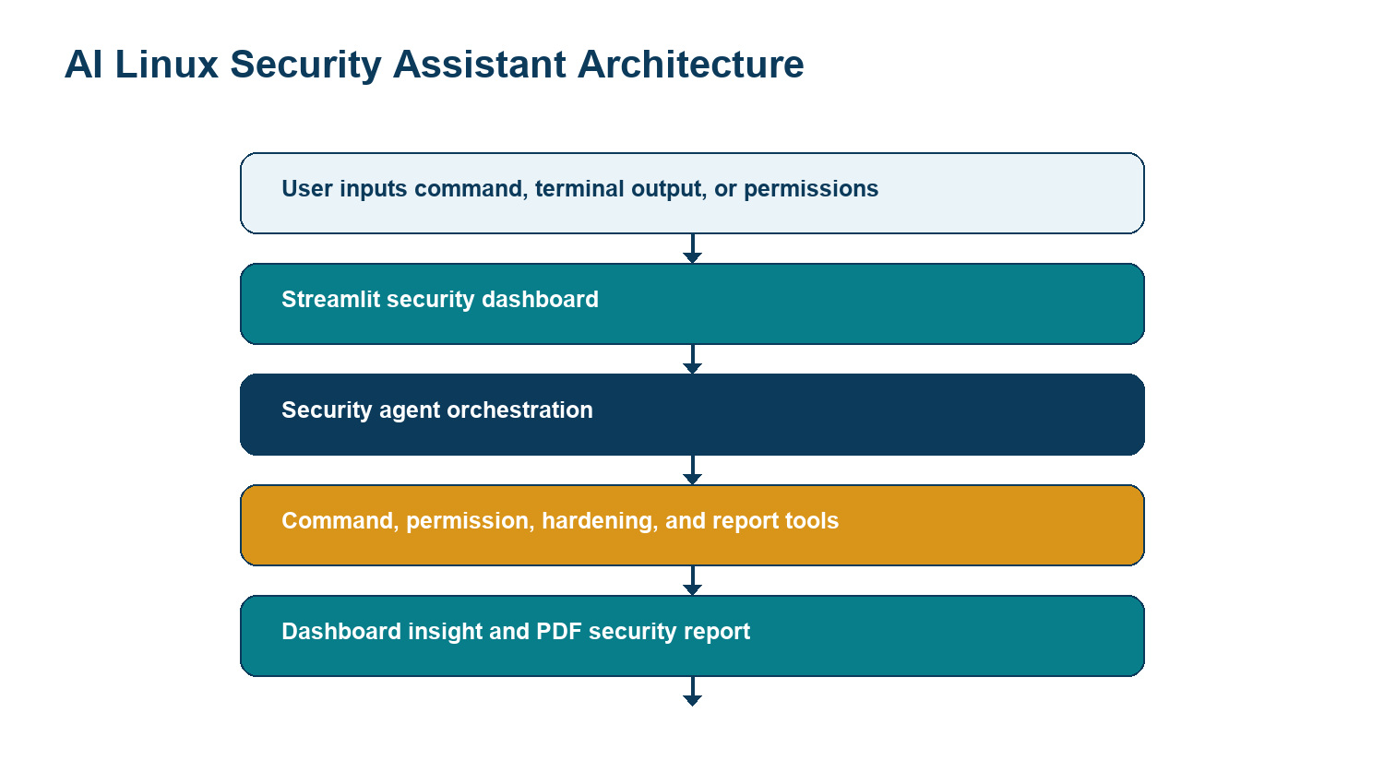

Detailed ReAct-inspired workflow for a risky permission example.

5.3 Data Flow Description
At the context level, the User is the external entity. The User provides text input and receives security guidance. At Level 1, the application contains four major processes: input validation, command explanation, permission analysis, and hardening/report generation. Each process receives only the data required for its role. The final result is returned to the user as dashboard content and an optional PDF report. No live system files, passwords, or administrator credentials are required by the baseline workflow.
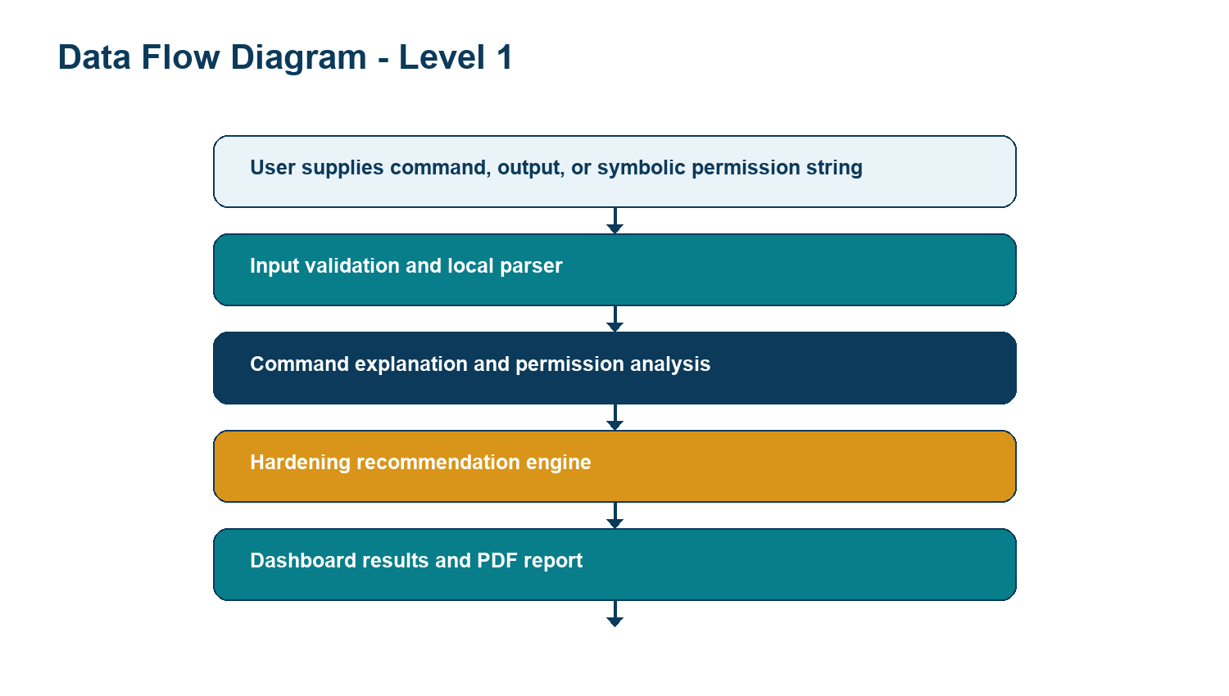
Figure 7. Level 1 data flow diagram.

Level 0 Context
At Level 0, the User provides command or permission data to the AI Linux Security Assistant and receives guidance, findings, a score, and a downloadable report. No external system is modified.

Level 2 Interpretation
At Level 2, input validation routes text into a command parser and a permission parser. The command parser checks known commands and patterns, while the permission parser evaluates the type and access triplets. The hardening component adds safe administration practices, and the report generator compiles the final response.

5.4 Logical Data Description
Entity | Important fields | Purpose
Command Assessment | command, options, arguments, purpose, risk, safer alternative | Stores interpreted command details.
Permission Assessment | raw value, file type, owner, group, others, numeric mode, findings | Stores permission analysis.
Hardening Step | area, rationale, command example | Stores security guidance.
Security Assessment | command result, permission result, hardening list, score, workflow | Represents one complete user session.
Security Report | summary, findings, recommendation, date | Represents downloadable documentation.
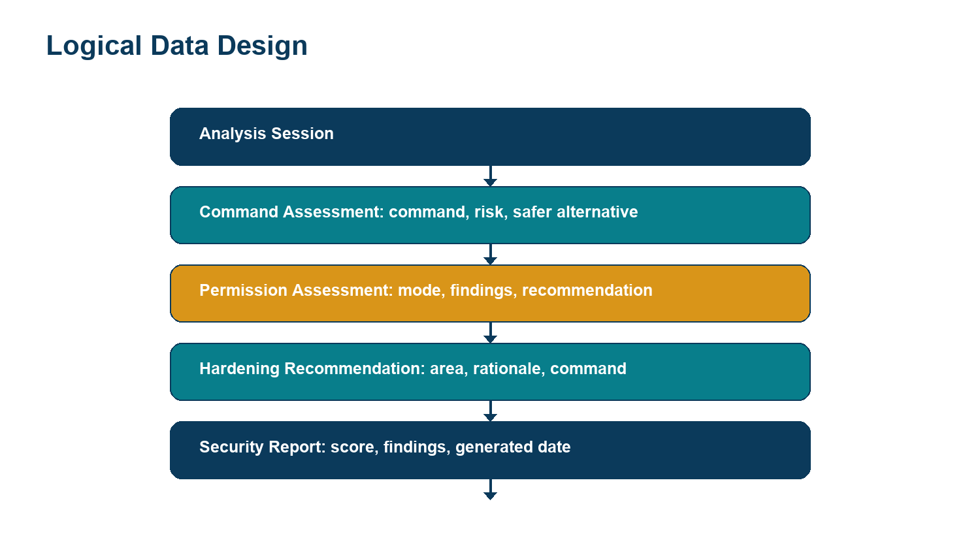
Figure 8. Logical entities used during an assessment.

The application does not require a database for its baseline educational use. Each analysis session is represented in memory as a structured assessment containing command results, permission results, hardening steps, a security score, and workflow observations. This lightweight design keeps the application simple and privacy-friendly while allowing future storage features to be added intentionally.

XI. SYSTEM DESIGN
The system design is based on modularity, clarity, and safe handling of user input. The design separates presentation from analysis logic. The Streamlit file contains visual widgets and result tabs. The Linux agent is responsible for orchestrating analysis modules. Individual modules perform focused tasks. This arrangement makes the source code easier to test and helps a beginner understand the role of each file.
File | Design role
app.py | Creates the dashboard, inputs, tabs, metrics, gauge, and report download button.
linux_agent.py | Coordinates the assessment workflow and calculates the security score.
command_parser.py | Defines supported commands, reads tokenized input, and flags risky patterns.
permission_checker.py | Converts symbolic mode into owner, group, others, numeric mode, and findings.
hardening.py | Contains secure administration topics and example commands.
report_generator.py | Formats assessment results as a PDF report.
tools.py | Provides a function-calling style interface for local tools.
prompts.py | Contains optional prompt templates for future LLM enhancement.

6.1 Input Design
Input fields are intentionally simple. The Linux Command field accepts a single command line. The Permission String field accepts a value such as -rw-r----- or a complete ls -l line. The Terminal Output field is optional and can contain copied output. Placeholder examples guide the user toward acceptable input. The primary button begins the analysis only after user interaction.

6.2 Output Design
The output is separated into four tabs. The Security Overview tab presents the combined score, command risk, permission risk, gauge, and high-level workflow. The Command Explainer tab provides purpose, typical usage, implications, and safer alternative. The Permission Analyzer tab provides file type, owner, group, others, numeric mode, findings, and recommendation. The Hardening Guide tab presents recommended practices and provides a PDF download button.

XII. INPUT / OUTPUT FORM DESIGN

7.1 Input Form Design
The input design follows the principle of minimal user effort. A beginner does not need to upload a file, configure a server, or understand a complex form. The user can paste a command directly from a terminal. The permission string can be copied from ls -l output. If a learner has only a symbolic mode, that mode is also accepted. These options make the project useful in practical classes where students work with different Linux examples.

Input Validation
- Blank command input returns an informational message rather than an error.
- Permission analysis accepts either a symbolic mode or a full ls -l line.
- Malformed permission input receives an instruction to provide a format such as -rw-r-----.
- Command text is tokenized only; it is never passed to a shell or subprocess.

7.2 Output Form Design
The output is written in a tutorial-like format. A command result begins with the recognized command and its purpose. It then shows a risk level and security implications. Instead of only warning the user, the system recommends a safer approach. Permission results identify the kind of item and clearly separate the access rights of owner, group, and others. Hardening output broadens the lesson by explaining related defensive practices such as SSH security, firewall configuration, software updates, and log monitoring.

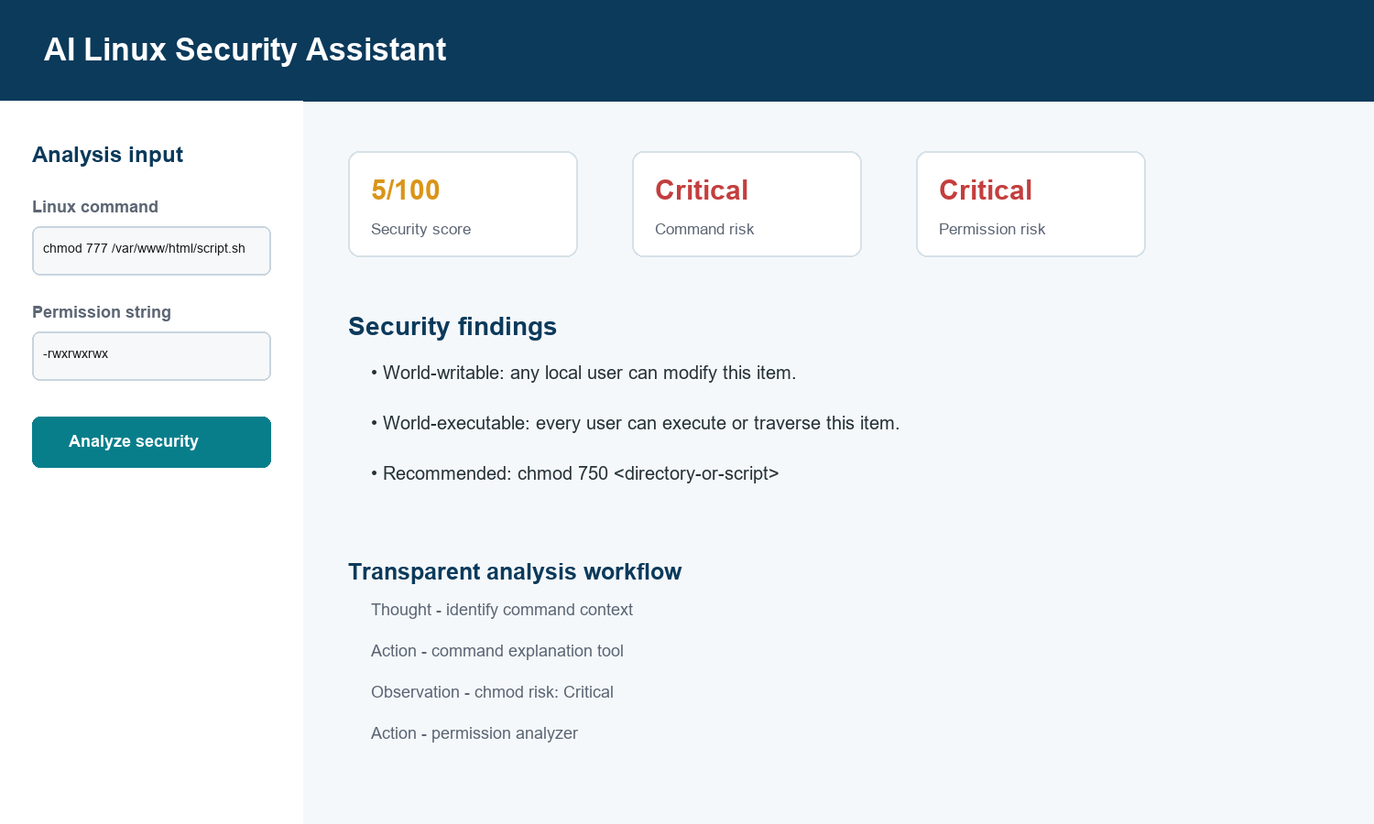

7.3 Report Design
The PDF report is designed as an academic and learning artifact. It includes a title, generation date, overall security score, command details, permission summary, findings, recommended commands, and a hardening checklist. The report uses short sections so that a user can understand the main risk quickly. It also reminds users that the recommendations should be checked against actual ownership, service requirements, backup procedures, and access policy before implementation.

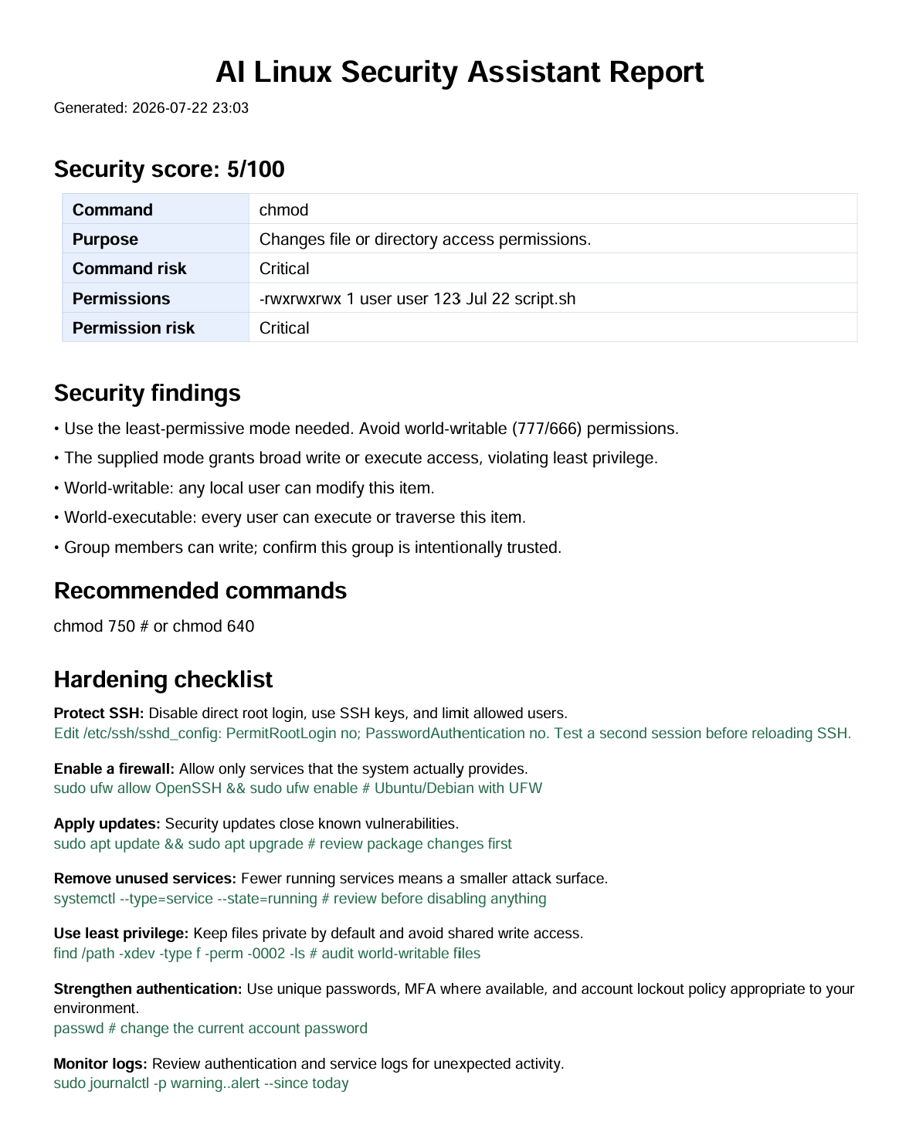

XIII. SYSTEM TESTING

8.1 Test Data Preparation
Test data was prepared to cover both normal and insecure cases. The test set includes command examples, valid permission strings, complete ls -l style lines, malformed input, privileged commands, deletion commands, and remote script execution patterns. The objective was not to run these commands; the objective was to confirm that the application explains them correctly and classifies important risks in a consistent manner.
Test ID | Input | Purpose
TC01 | chmod 777 file.txt | Checks broad permission warning.
TC02 | -rwxrwxrwx | Checks world-writable and world-executable findings.
TC03 | -rw-r----- | Checks low-risk private group-readable file mode.
TC04 | sudo rm -rf /tmp/test | Checks privileged recursive deletion warning.
TC05 | curl https://example.com/install.sh | bash | Checks remote script execution warning.
TC06 | ssh user@server.example.com | Checks safe SSH explanation.
TC07 | invalid permission input | Checks format guidance and error handling.

8.2 Test Cases and Results
ID | Expected result | Actual result | Status
TC01 | Critical chmod finding and safer mode suggestion. | Critical risk and chmod 750/640 guidance displayed. | Pass
TC02 | Critical permission risk with broad-access findings. | World-writable, world-executable, and group-write findings displayed. | Pass
TC03 | Low risk and numeric mode 640. | Low-risk explanation and numeric 640 displayed. | Pass
TC04 | High or critical warning about recursive deletion. | High-risk explanation and safer interactive alternative displayed. | Pass
TC05 | Critical warning about downloaded remote code. | Critical warning and checksum/inspection guidance displayed. | Pass
TC06 | Secure connection explanation and key guidance. | SSH purpose and secure-key recommendation displayed. | Pass
TC07 | Informational message about expected format. | Input format guidance displayed without application failure. | Pass

8.3 Testing with Live Input
A demonstration test was performed using chmod 777 /var/www/html/script.sh as the command and -rwxrwxrwx as the permission string. The command parser identified chmod as a permission-changing command and marked the risk as Critical because the supplied mode grants broad write and execute access. The permission analyzer identified the regular file type, calculated numeric mode 777, and reported that the item was world-writable and world-executable.
The assessment calculated a very low security score because both the command and the permission string indicated a serious least-privilege violation. The output recommended reviewing the actual access need and using a more restrictive mode, such as chmod 750 for an appropriate script or directory and chmod 640 for a private regular file. The hardening checklist also advised users to verify ownership, avoid broad shared write access, and apply changes only after confirming service requirements.

8.4 Testing Conclusion
The test cases demonstrate that the core project features work as intended for representative beginner Linux security scenarios. The application distinguishes safe and unsafe patterns, explains the result in plain language, and produces a structured report. The testing also confirms the main safety requirement: all command input remains text and is not executed by the application.

XIV. SYSTEM IMPLEMENTATION
Implementation began by defining a folder structure in which each feature was separated into an individual Python file. The Streamlit application imports the LinuxSecurityAgent and uses the assessment object to populate the dashboard. The command parser uses shlex-style tokenization so that command text can be separated without calling a shell. Known command definitions provide purpose, basic syntax, implications, and safer guidance. Additional rules identify chmod modes, remote shell pipes, recursive removal, privileged operations, and recursive ownership changes.
The permission checker uses a regular expression to identify the first file-type symbol and nine permission characters in either a direct permission string or complete terminal output. It groups the permission characters into owner, group, and others triplets. The checker calculates the numeric form and creates findings based on world-write, world-execute, group-write, and setuid/setgid patterns. The hardening module provides a stable set of educational recommendations. The report module formats the assessment using ReportLab.

9.1 Installation and Execution
Step | Command / action
1 | Create a Python virtual environment.
2 | Install dependencies using pip install -r requirements.txt.
3 | Start the application using streamlit run app.py.
4 | Open the local Streamlit URL in a browser.
5 | Enter a command or permission example and select Analyze Security.
6 | Review results and use Download PDF Security Report if needed.

9.2 Security Controls in Implementation
- No call to subprocess, os.system, shell execution, or remote administration is used for user input.
- The parser reads command strings only and provides educational output.
- The report contains guidance, not automated remediation actions.
- The baseline version works without an external API key or cloud-based AI service.
- The README warns users to test firewall and SSH changes carefully in real environments.

XV. DOCUMENTATION
Documentation is an important deliverable because it helps users, evaluators, and future developers understand the project. The project includes a README that explains installation, features, sample inputs, folder structure, and safety notes. The source modules contain responsibility-focused documentation so that each component can be understood independently. The PDF report generator provides user-facing documentation for a particular assessment.

10.1 User Manual Summary
To use the application, the user launches the Streamlit dashboard, enters a Linux command or permission string, and selects Analyze Security. The user first reviews the security overview, then opens the command and permission tabs for detailed explanation. The hardening tab provides general recommendations. If a record is required, the user downloads the generated PDF report. The project should be used for learning and first-pass review; it does not authorize users to change production systems.

10.2 Maintenance Documentation
A developer can extend the command dictionary in command_parser.py to support additional Linux commands. New permission checks can be added in permission_checker.py. Hardening steps can be maintained in hardening.py. The Streamlit dashboard can be extended with additional tabs, filters, or input methods. Future developers should preserve the non-execution guarantee and should validate every new rule with safe test cases before release.

Document | Audience | Purpose
README.md | User / evaluator | Setup, usage, examples, safety note.
Project report | Academic evaluator | Design, analysis, testing, implementation.
Source modules | Developer | Maintainable implementation and extension points.
PDF security report | Learner | Saved analysis result and recommendations.

10.3 Security And Ethical Use
The assistant is an educational decision-support tool. It must not be interpreted as authorization to alter production systems or as a replacement for an experienced administrator. Its implementation deliberately avoids shell execution of user input. This protects users from accidental execution of destructive commands and reinforces the security lesson that every command must be understood before it is run.
- Use test environments for experimenting with permission changes.
- Keep a recovery path when changing SSH, firewall, or ownership settings.
- Verify application and service requirements before restricting access.
- Treat downloaded scripts as untrusted until source and integrity are verified.
- Never paste passwords, API keys, private keys, or sensitive production logs into unapproved tools.

XVI. SCOPE OF THE PROJECT

11.1 Present Scope
The present scope includes explanation of common Linux commands, analysis of standard symbolic permissions, detection of selected insecure patterns, hardening recommendations, score visualization, and PDF report generation. The project is especially suitable for students who need to understand command risk before using a Linux terminal. It is also useful for demonstrations of least privilege, permissions, secure administration, and AI-assisted cybersecurity workflows.

11.2 Limitations
The application does not perform a live scan of a Linux host and does not validate the current owner, service account, access-control list, SELinux policy, or filesystem mount configuration. The risk score is educational and depends only on the text supplied by the user. Some Linux commands are unknown to the local command dictionary and therefore receive general safe-review advice. Recommendations must always be evaluated against the requirements of the specific environment.

Limitation | Reason / impact
No live host scan | The baseline does not inspect a real Linux machine; it avoids invasive access.
Rule coverage is selective | Uncommon commands and distribution-specific behavior need future expansion.
No ACL / SELinux policy parser | The current analyzer focuses on standard Unix permission triplets.
No automatic remediation | Recommendations are educational; users decide and execute changes themselves.
LLM integration optional | Core results are deterministic; richer conversational explanation is a future extension.
Score is educational | It summarizes supplied evidence and is not an enterprise security rating.

11.3 Future Enhancements
- Integrate a consent-based LLM for richer conversational explanations while retaining local safety rules.
- Support ACL, SELinux context, Linux capability, and sudoers configuration analysis.
- Provide distribution-aware advice for Ubuntu, Debian, Fedora, Red Hat, and Kali Linux.
- Add a guided hardening checklist that records user-selected actions locally.
- Support safe import of sanitized configuration snippets such as sshd_config and firewall rules.
- Create a Docker-based laboratory mode for demonstrations without touching the host system.
- Add multilingual output and teacher-defined exercises for classroom use.
- Maintain a user-controlled local history of assessments and reports.

11.4 Conclusion
The AI Linux Security Assistant provides a practical bridge between Linux command learning and cybersecurity awareness. Its greatest value lies in encouraging the learner to pause before acting: understand the command, inspect the permissions, evaluate the risk, choose the least-privilege alternative, and verify the environment-specific requirement. The project demonstrates that useful AI-ready security assistance can be designed safely by combining structured tools, transparent workflow, clear language, and responsible boundaries.

XVII. BIBLIOGRAPHY
- Linux Foundation. Linux Documentation Project and Linux manual pages. https://www.kernel.org/doc/man-pages/
- GNU Project. GNU Core Utilities Manual. https://www.gnu.org/software/coreutils/manual/
- OpenSSH. OpenSSH Manual Pages and Security Documentation. https://www.openssh.com/manual.html
- CIS. CIS Benchmarks for Linux. https://www.cisecurity.org/cis-benchmarks
- OWASP. OWASP Application Security Verification Standard and secure-development resources. https://owasp.org/
- Streamlit. Streamlit Documentation. https://docs.streamlit.io/
- Python Software Foundation. Python Documentation. https://docs.python.org/3/
- ReportLab. ReportLab User Guide. https://www.reportlab.com/docs/reportlab-userguide.pdf
All web references should be checked for the latest version and cited according to the institute’s required citation format before final academic submission.

