Title: Real-Time Anti-Money Laundering Using Temporal Graph Neural Networks (TGNNs)
Author: Basabraj Biswas
Goal:
The primary goal of this project is to detect suspicious banking accounts by analyzing how money flows between accounts over time, rather than checking transactions using fixed rules.
Instead of asking:
Is this single transaction abnormal?
the system asks:
Is this account behaving abnormally in the context of the entire transaction network and its history?
This is achieved by modeling transactions as a dynamic graph and learning patterns using a Temporal Graph Neural Network (TGNN).
Dataset
The dataset consists of banking transaction records with columns such as:
Column | Meaning | Why Important for AML
sender | Account sending money | Source node
receiver | Account receiving money | Target node
amount | Log-normal distribution | Mimics real-world transaction amounts (few very large transfers)
timestamp | Random time over years | Enables temporal modeling (TGNN)
transaction_type | IMPS / NEFT / RTGS / UPI | Behavioral pattern feature
country | Foreign country selection | Cross-border laundering indicator
is_cross_border | 15% probability | Simulates suspicious international flow
risk_flag | 10% probability | Ground truth label for suspicious behavior
velocity_score | Random score (0–10) | High-frequency activity indicator
network_score | Random score (0–5) | Connectivity/risk in transaction network

From this tabular data, a transaction graph is constructed:
- Each account → node
- Each transaction → time-stamped edge
Thus, the CSV is converted into a temporal graph dataset suitable for TGNN learning.
Statistical Analysis Component
Before applying the TGNN model, statistical analysis is performed to understand baseline behavior:
- Average money sent and received per account
- Transaction frequency per account
- Degree distribution (how many connections each account has)
- Identification of highly connected “hub” accounts
- Distribution of transaction amounts
These statistics are used to create node features such as:
Node Features = [ avg_sent,avg_received ]
This step helps the model start with meaningful behavioral summaries instead of raw IDs.

Model Variants
You experimented with multiple model ideas before settling on TGNN:
Variant | Description | Limitation
Rule-based AML | Fixed thresholds (amount, frequency) | Misses network patterns
Static GNN | Uses graph but ignores time | Cannot detect evolving fraud
RNN on transactions | Uses time but ignores relationships | No network awareness
TGNN (final model) | Uses graph + time + memory | Captures evolving money flow patterns
The TGNN combines:
- Message passing between connected accounts
- GRU-based temporal memory
- Graph aggregation of neighbors

Metric Evaluation
To evaluate model performance, you used:
- Accuracy – how many accounts classified correctly
- ROC Curve & AUC – model’s ability to separate normal vs suspicious
- Precision@K – how many of the top flagged accounts are truly suspicious
These metrics are more suitable for AML than plain accuracy because AML is a highly imbalanced problem.
What is Precision@K?
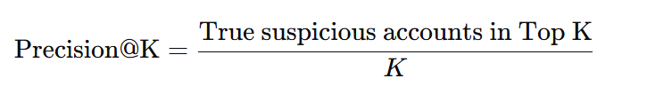
Precision@K is an AML-favorite metric. It measures how many of the Top K highest-risk accounts predicted by your model are actually suspicious.

It evaluates the quality of your model’s ranking, not all predictions.

Why Precision@K is critical in AML ?
In a real bank:
- Your TGNN may score 500 accounts with risk probabilities.
- Investigation team can manually check only Top 20 / 50 / 100 accounts.
So the bank asks:
“Are the accounts your model ranks at the top really suspicious?”
That is exactly what Precision@K answers.
Example from TGNN output
Suppose after running your model:
Account | Risk Score | Actual Label
ACC_101 | 0.97 | Suspicious
ACC_302 | 0.95 | Suspicious
ACC_011 | 0.92 | Normal
ACC_224 | 0.90 | Suspicious
ACC_078 | 0.88 | Suspicious
If K = 5
Out of top 5, 4 are truly suspicious
Precision@5= 4\5 = 0.80
This means:
80% of the accounts you told the bank to check are truly risky.That’s excellent in AML.
Difference from normal Precision
Normal precision checks all flagged accounts.
Precision@K checks only the most important alerts.
Your model may have:
- Precision = 0.62 (overall)
- Precision@20 = 0.90 (top alerts are very accurate)
This is very desirable.

Why TGNN helps Precision@K ?
Because TGNN understands:
- Money flow chains
- Temporal patterns
- Account behavior history
- Network structure
It ranks the most dangerous accounts at the top, improving Precision@K significantly compared to rule-based systems.
Short explanation
Precision@K measures how many truly suspicious accounts appear in the Top K highest-risk predictions. In AML, this is crucial because investigators only examine the top alerts, so ranking quality matters more than overall precision.

Model Overview:
Temporal Graph Neural Networks (TGNN)
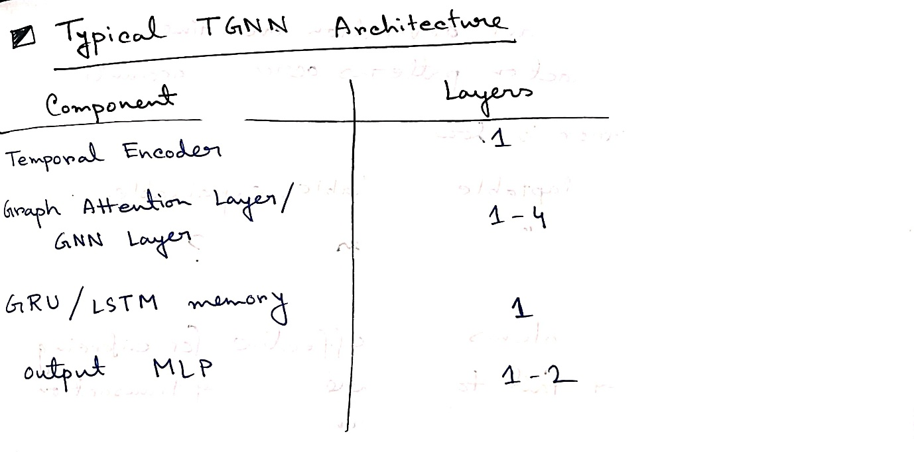
A Temporal Graph Neural Network (TGNN) is a class of neural architectures designed to operate on graphs whose structure and node/edge features vary over continuous time. TGNNs generalize Graph Neural Networks (GNNs) by introducing specialized modules for modelling dynamic, event-driven interactions in evolving networks. Their core innovation lies in maintaining per-node temporal memory and leveraging graph-based aggregation operators with time-aware mechanisms, enabling state-of-the-art performance for both transductive and inductive prediction tasks on dynamic graphs (Rossi et al., 2020).

Transductive Learning: This is a method where the model predicts outcomes based directly on specific data points, without creating any general rule (or a universal predictive function).

Thousands of bank accounts sending money to each other over time.
This is not a table problem.
This is a who-talks-to-whom, when, and how often problem.
That is exactly what a Temporal Graph Neural Network (TGNN) is built for.

What is the “Graph” here?
In your project:
- Each bank account = a node
- Each transaction = a connection (edge) between nodes
- Each edge has:
  - amount
  - time
  - type
  - country
So instead of rows in Excel, your data becomes a living network of money flow.

Why “Temporal”?
Because time matters a lot in money laundering.
Example from real life:
Time | Transaction
10:01 | A → B ₹5,00,000
10:03 | B → C ₹4,90,000
10:05 | C → D ₹4,80,000
Individually? Normal.
But in sequence? That’s layering → classic AML pattern.
A normal GNN cannot understand this sequence.
TGNN can.
That’s why it’s called Temporal.

The Most Important Idea: “Memory”
This is the important part. TGNN gives each account a memory.
Think like this:
Every account keeps a passbook of everything it has ever done. So when a new transaction happens, the model does not see it as a new event.
It asks: Based on this account’s past behavior, is this suspicious?
Example:
If an account usually sends ₹2,000 and suddenly sends ₹5,00,000 to a new account it’s an alert.
Rule-based system cannot see this.
TGNN remembers the history.

What happens when a transaction occurs?
When A sends money to B:
TGNN does 4 things:
- Looks at A’s memory
- Looks at B’s memory
- Looks at time gap since last transaction
- Looks at transaction features (amount, country, type)
Then it updates both A and B’s memory.
So the network is learning continuously.

How it detects money laundering
TGNN doesn’t just check amount.
It checks patterns like:
- Chains of transactions
- Fast movement of funds
- New accounts suddenly connected
- Repeated circular transfers
- Cross-border hops
- Accounts that act like “bridges”
These are impossible to code using rules.
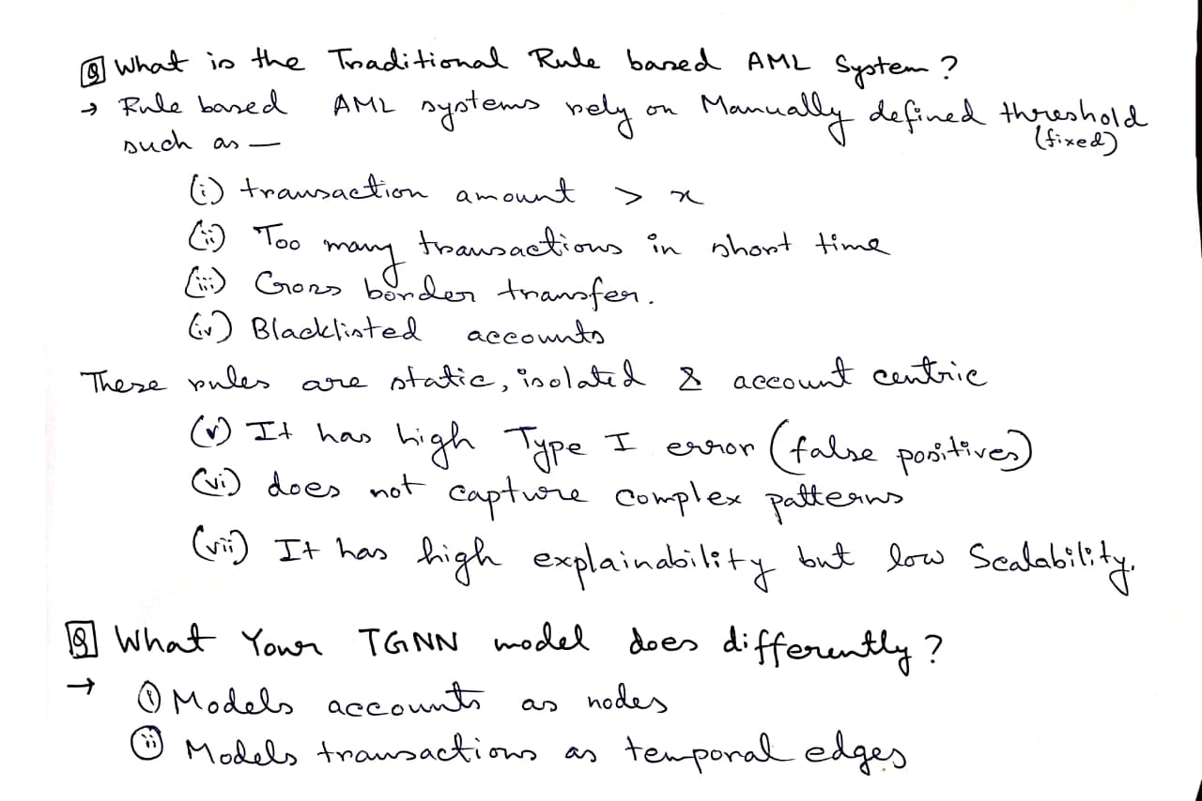
But TGNN learns them automatically from graph + time.
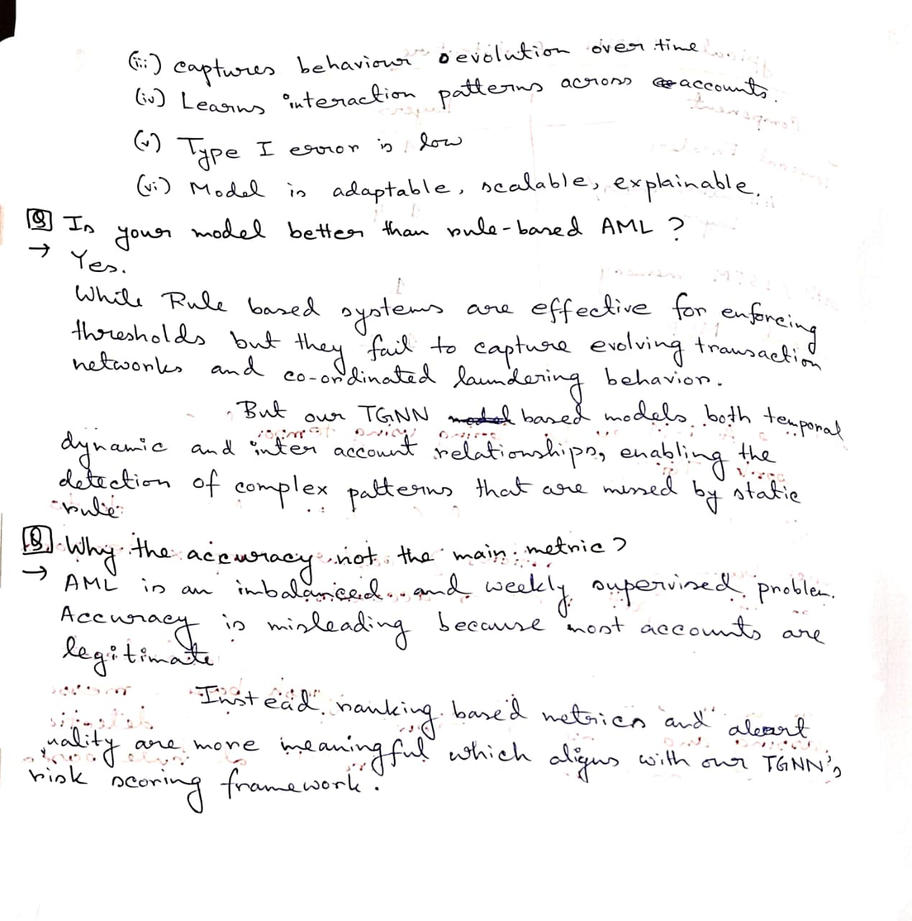
In simple understanding
TGNN treats bank transactions like a social network of money, remembers every account’s past, understands the order of events, and learns complex laundering patterns that rules can never capture.

TGNN Concept | AML project
Node memory | Account transaction history
Edge event | Bank transaction
Time encoding | Timestamp of transaction
Message passing | Money flow between accounts
Attention | Which neighbors are important
Embedding | Risk profile of each account
Output | Suspicious / Normal

Why this paper is important ?
This Rossi et al. paper is basically saying:
“If you want to model dynamic systems like transactions, this is the correct architecture.”
Which is exactly what you implemented.

Layman explanation
Traditional AML checks transactions row by row. My system converts transactions into a network of accounts and tracks how money flows over time. Each account has a memory of its past activity, and the model learns complex laundering patterns like chains, loops, and rapid transfers that rule-based systems miss.

Final intuition
If AML was a movie:
- Rule based system looks at one frame
- TGNN watches the entire movie and remembers the story
That’s the whole difference.
Outcomes
The project demonstrates that:
- Suspicious behavior is better identified from money flow patterns than individual transactions.
- The TGNN model detects accounts involved in hidden laundering chains that rule-based systems miss.
- Even with simple node features, the graph + time modeling significantly improves detection capability.
- The system works on any bank CSV dataset by automatically converting it into a graph.
Key takeaway:
Fraud is not visible in a single transaction — it is visible in the structure and evolution of the transaction network, which TGNN successfully learns.

