**CS405 WebGL Project Report**

**Task 1: Calculating ModelView Matrix**

In Task 1, ChatGPT calculated the matrix itself:

const transformationMatrix = new Float32Array([

0.3535533845424652, -0.6123723983764648, 0.7071067690849304, 0.3,

0.3535533845424652, 0.6123723983764648, 0.7071067690849304, -0.25,

-0.8660253882408142, -0.5, 0, 0,

0, 0, 0, 1

]);

## Task 2: Modification of getModelViewMatrix() Method

In Task 2, modified the getModelViewMatrix() function using function inside utils.js

function getModelViewMatrix() {

// Initialize identity matrix

let modelViewMatrix = createIdentityMatrix();

// Translation

const translationMatrix = createTranslationMatrix(0.3, -0.25, 0);

const scalingMatrix = createScaleMatrix(0.5, 0.5, 1);

const rotationXMatrix = createRotationMatrix_X(degreesToRadians(30));

const rotationYMatrix = createRotationMatrix_Y(degreesToRadians(45));

const rotationZMatrix = createRotationMatrix_Z(degreesToRadians(60));

modelViewMatrix = multiplyMatrices(modelViewMatrix, translationMatrix);

modelViewMatrix = multiplyMatrices(modelViewMatrix, scalingMatrix);

modelViewMatrix = multiplyMatrices(modelViewMatrix, rotationXMatrix);

modelViewMatrix = multiplyMatrices(modelViewMatrix, rotationYMatrix);

modelViewMatrix = multiplyMatrices(modelViewMatrix, rotationZMatrix);

// Convert to Float32Array

const finalModelViewMatrix = new Float32Array(modelViewMatrix);

console.log(finalModelViewMatrix);

return finalModelViewMatrix;

}

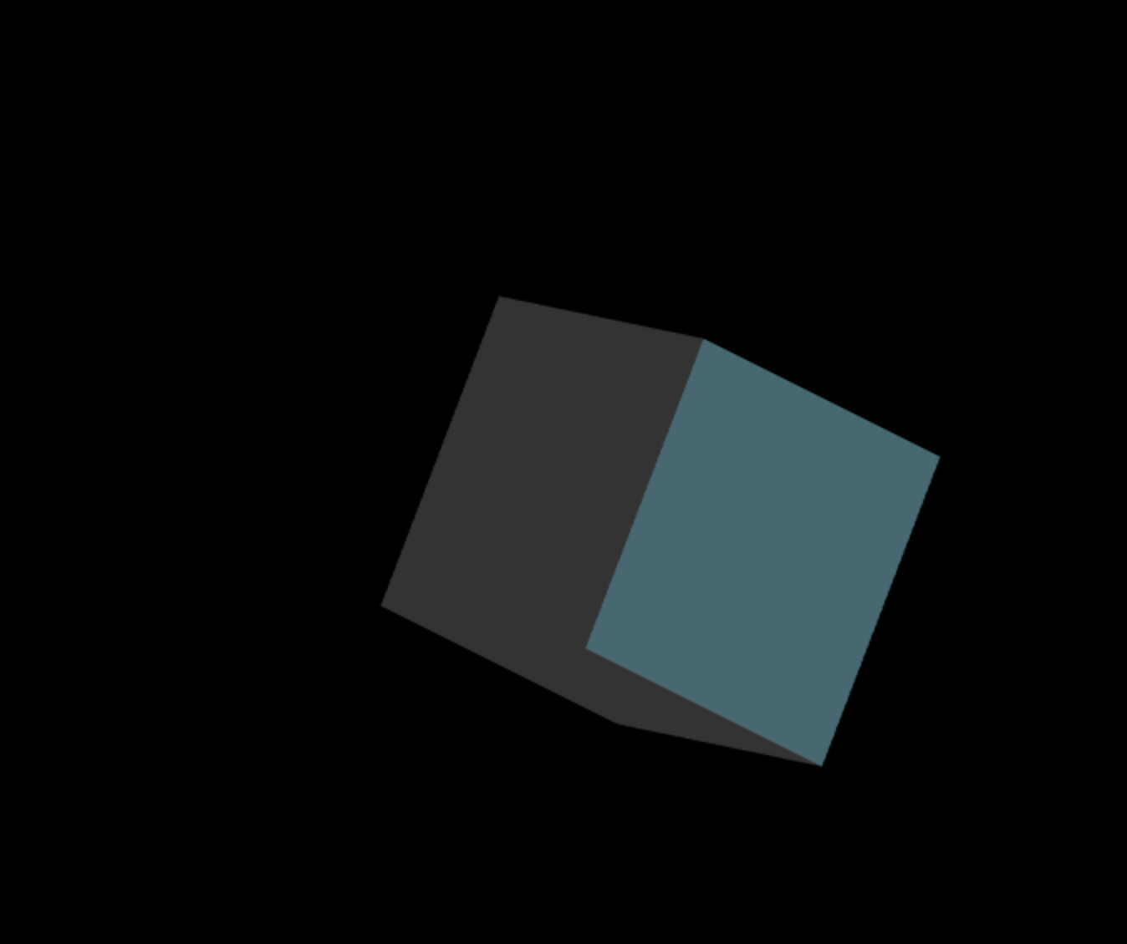

**Task 3: Animation Implementation with getPeriodicMovement() Method**

In Task 3, asked chat to implement **getPeriodicMovement()** method.

function getPeriodicMovement(startTime) {

const elapsedTime = (Date.now() - startTime) % 10000; // Elapsed time in milliseconds, repeating every 10 seconds

const halfTransitionTime = 5000; // 5 seconds for each transition

let progress = 0;

if (elapsedTime < halfTransitionTime) {

// First 5 seconds - transition to the calculated transformation

progress = elapsedTime / halfTransitionTime;

} else {

// Last 5 seconds - return to the initial position

progress = 1 - (elapsedTime - halfTransitionTime) / halfTransitionTime;

}

var modelViewMatrix = createIdentityMatrix();

const translation = [0.3 * progress, -0.25 * progress, 0];

glMatrix.mat4.translate(modelViewMatrix, modelViewMatrix, translation);

const scaling = [0.5 * progress + 0.5, 0.5 * progress + 0.5, 1];

glMatrix.mat4.scale(modelViewMatrix, modelViewMatrix, scaling);

const rotation = [30 * progress, 45 * progress, 60 * progress];

// Create identity matrix

// Apply transformations

glMatrix.mat4.rotateX(modelViewMatrix, modelViewMatrix, glMatrix.glMatrix.toRadian(rotation[0]));

glMatrix.mat4.rotateY(modelViewMatrix, modelViewMatrix, glMatrix.glMatrix.toRadian(rotation[1]));

glMatrix.mat4.rotateZ(modelViewMatrix, modelViewMatrix, glMatrix.glMatrix.toRadian(rotation[2]));

// Convert to Float32Array

const transformationMatrix = new Float32Array(modelViewMatrix);

return transformationMatrix;

}

## Conclusion

Task 1 done by ChatGPT however it wasn’t the same how I expected, then I implemented methods in utils.js for Task 2, then I asked chat to implement Task 3, in my opinion it wasn’t animating expectedly.