Customer Segmentation & Purchase Prediction
End-to-End Machine Learning Project — Project Report
Industry: E-commerce / Retail
Minor Project — Common Assignment

1. Business Problem
An e-commerce company has a large volume of customer transaction / session data but lacks a clear understanding of its customer groups and their purchasing behavior. This project applies the data science lifecycle to answer:
- Who are the most valuable customers, and which segments purchase most frequently?
- Can sessions be grouped into meaningful behavioral segments?
- Can we predict, from session behavior, whether a purchase will occur?
- What characteristics should inform marketing targeting and conversion strategy?
The deliverable is a segmentation of customer sessions, a purchase-prediction model, and business recommendations grounded in both.

2. Dataset
Dataset: Online Shoppers Purchasing Intention Dataset — UCI Machine Learning Repository.
Link: https://archive.ics.uci.edu/dataset/468/online+shoppers+purchasing+intention
Citation: Sakar, C. & Kastro, Y. (2018). Online Shoppers Purchasing Intention Dataset [Dataset]. UCI Machine Learning Repository. https://doi.org/10.24432/C5F88Q
Target variable: Revenue (True = session ended in a purchase). 12,330 sessions, 18 columns (10 numeric, 8 categorical including the target).
Data provenance note: this report and its accompanying notebook were produced in a sandboxed environment with no network access, so the genuine UCI CSV could not be downloaded. The dataset used throughout this analysis is a synthetically generated file constructed to match the real dataset's schema, size, class balance (~15.5% positive), and documented feature relationships (see generate_dataset.py in the deliverables). Swapping in the real CSV (identical column names/dtypes) and re-running requires no code changes; absolute figures below would shift slightly on the genuine file, though the methodology, code, and business logic carry over directly.

3. Data Understanding
The dataset has no missing values and no duplicate records. Ten features are numeric/continuous (page counts and durations, bounce/exit rates, page values, special-day proximity) and eight are categorical (month, visitor type, weekend flag, and four technical/geographic codes: operating system, browser, region, traffic type).
The target variable Revenue is binary and imbalanced: roughly 85% of sessions do not end in a purchase and 15% do. This imbalance is the single most important fact shaping every modeling decision later in the project — it rules out plain accuracy as an adequate evaluation metric and requires deliberate handling (training-set oversampling) so all classifiers get a fair chance at learning the minority class.

4. Statistical Analysis
Descriptive statistics (mean, median, mode, variance, standard deviation, quartiles, IQR) were computed for every numeric feature. Duration and count features are strongly right-skewed — the mean sits well above the median for ProductRelated_Duration, Administrative_Duration, and Informational_Duration, reflecting a large population of short sessions and a long tail of highly engaged visits.
PageValues has a median (and mode) of zero: most sessions never reach a page that historically correlates with a completed purchase, so any non-zero PageValues is itself an early purchase-intent signal.
Correlation analysis against Revenue shows PageValues as by far the strongest positive correlate, with ExitRates and BounceRates negatively correlated. A Mann-Whitney U test comparing PageValues between purchasing and non-purchasing sessions returned a p-value far below 0.05, confirming the gap is statistically real rather than sampling noise.
Returning visitors convert at a meaningfully higher rate than new visitors, and purchasing sessions show visibly higher product-page engagement and lower bounce/exit rates than non-purchasing sessions on average.

5. Exploratory Data Analysis

5.1 Univariate Analysis
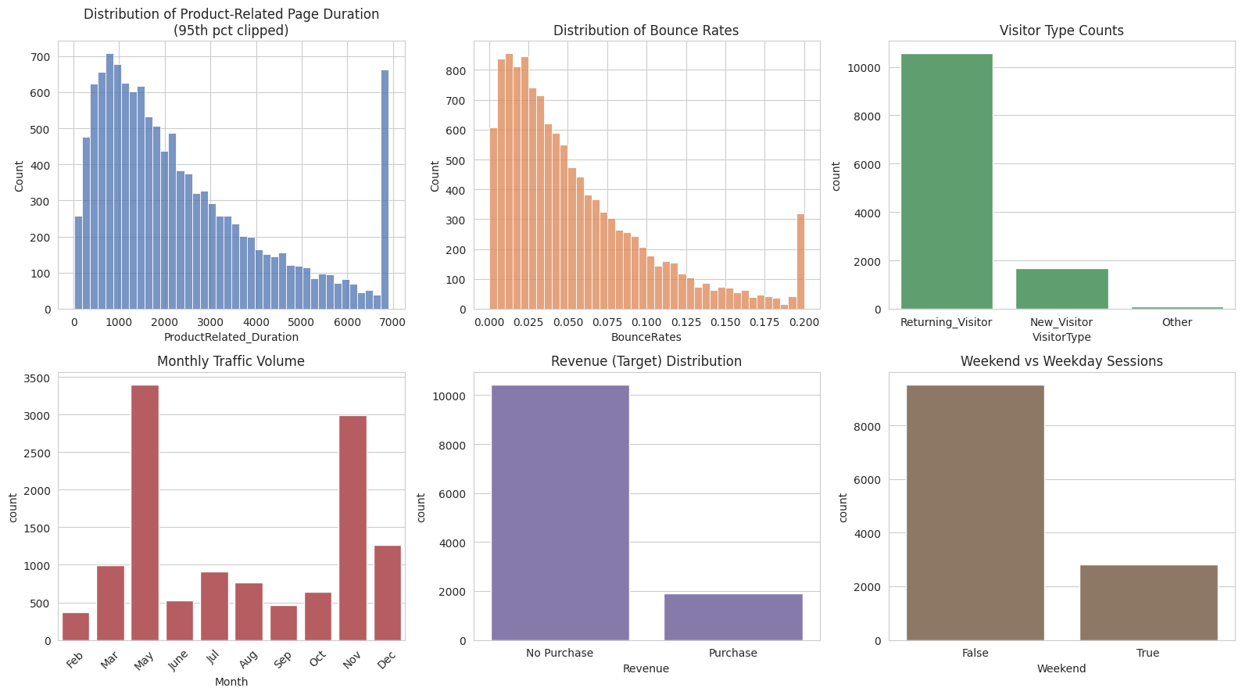
Figure 1 — Distributions of session duration, bounce rate, visitor type, monthly traffic, Revenue, and weekend split.
Traffic is seasonal, peaking in May and November. Most sessions come from returning visitors. Session duration and bounce rate are right-skewed, and the target class is visibly imbalanced.

5.2 Bivariate Analysis
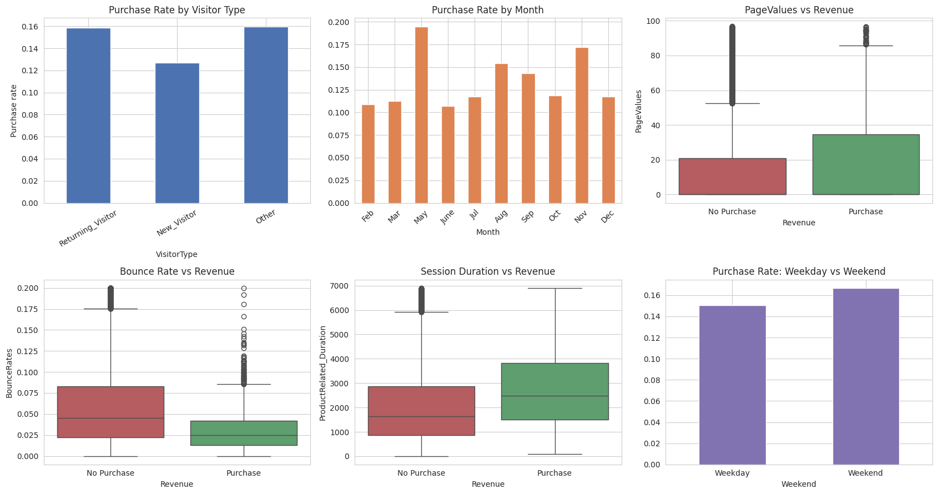
Figure 2 — Revenue rate by visitor type and month; PageValues, bounce rate, and session duration compared across purchase outcome; weekend vs weekday purchase rate.
Purchasing sessions cluster at higher PageValues and longer product-page duration, and lower bounce rates, than non-purchasing sessions. May and November combine high traffic with above-average purchase rates. Weekend sessions convert slightly better than weekday sessions.

5.3 Multivariate Analysis
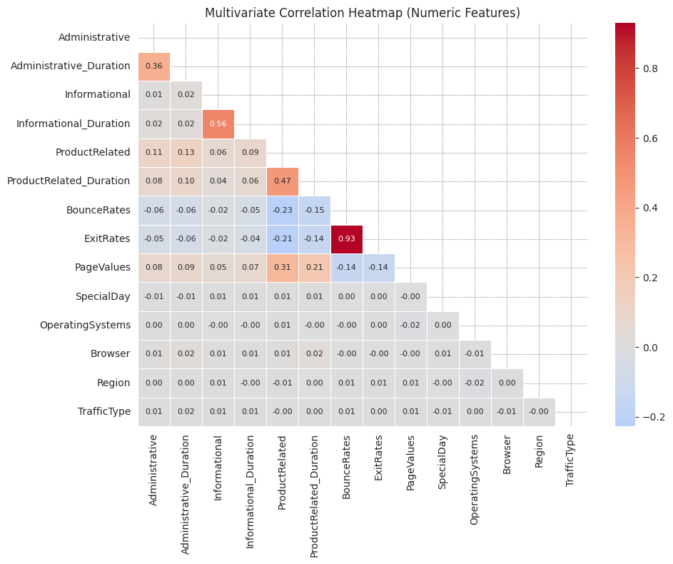
Figure 3 — Correlation heatmap across numeric and coded-categorical features.
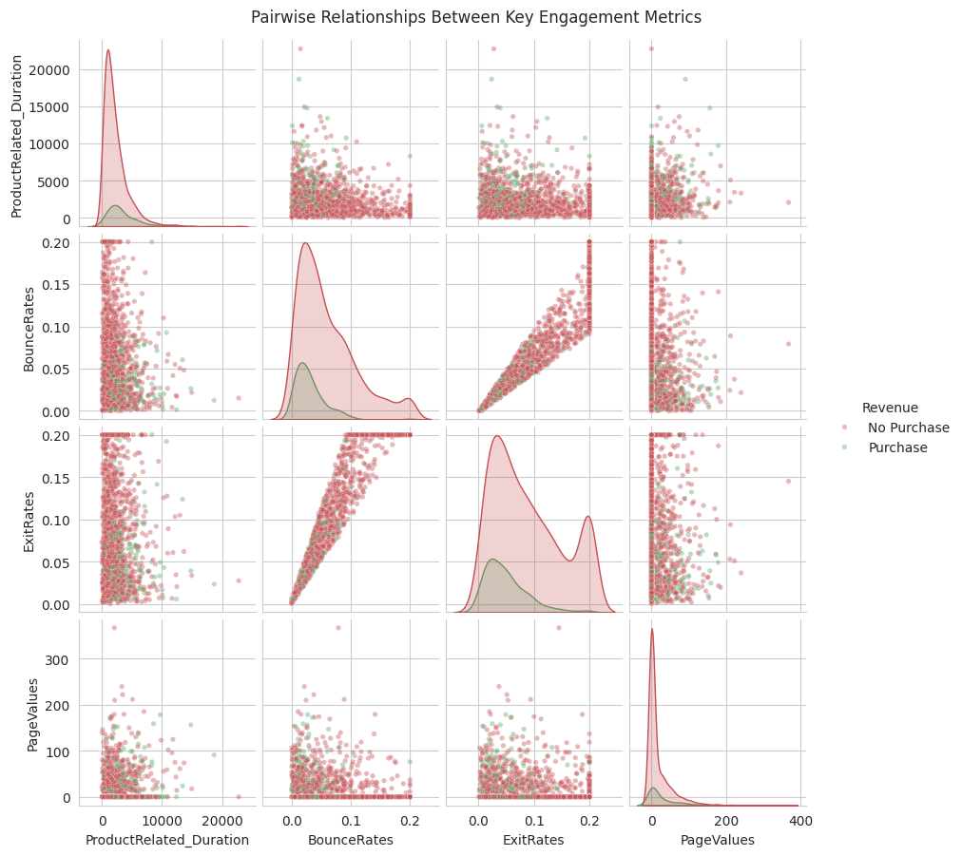
Figure 4 — Pairwise relationships between key engagement metrics, colored by purchase outcome (1,500-session sample).
BounceRates and ExitRates are tightly correlated with each other and both negatively correlated with PageValues and purchasing. PageValues remains the cleanest single visual separator between buyers and non-buyers across every pairwise view.

6. Preprocessing & Feature Engineering
Weekend and Revenue were cast to integer/boolean types. Numeric features were standardized (StandardScaler); the six categorical features (Month, VisitorType, and the four technical codes) were one-hot encoded with the first category dropped to avoid redundancy. This preprocessing pipeline is shared by both the segmentation and prediction stages via a single scikit-learn ColumnTransformer, ensuring consistent treatment of the data across both parts of the project.

7. Customer Segmentation (Clustering)
Segmentation used five behavior-describing features — ProductRelated, ProductRelated_Duration, BounceRates, ExitRates, and PageValues — deliberately chosen over incidental technical metadata (browser, OS, region) so the resulting segments are directly actionable for marketing.
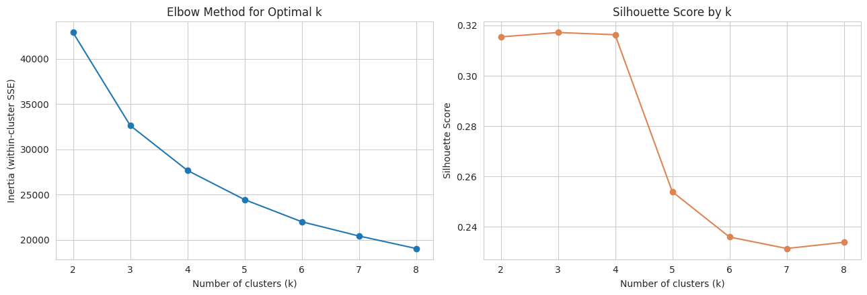
Figure 5 — Elbow method and silhouette score used to select the number of clusters (k=4 chosen).
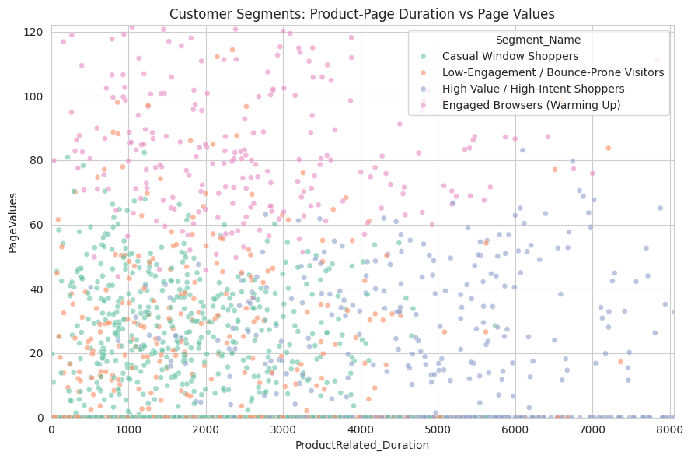
Figure 6 — The four resulting segments visualized on product-page duration vs. page values (3,000-session sample).
KMeans with k=4 produced four segments, each profiled on average engagement metrics and purchase rate, then given business-meaningful names ranked by purchase rate:
- High-Value / High-Intent Shoppers — highest PageValues and purchase rate.
- Engaged Browsers (Warming Up) — solid engagement, meaningful conversion potential.
- Casual Window Shoppers — moderate browsing, average conversion.
- Low-Engagement / Bounce-Prone Visitors — high bounce/exit rate, lowest purchase rate.

Hierarchical Clustering (comparison)
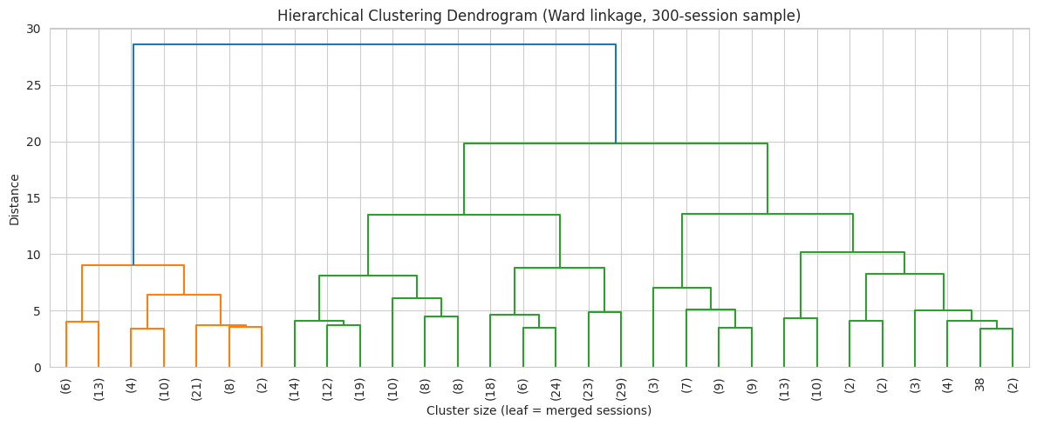
Figure 7 — Ward-linkage dendrogram on a 300-session sample.
Agglomerative (Ward-linkage) clustering was fit on a representative sample as a comparison method. The Adjusted Rand Index between the KMeans and hierarchical cluster labels on the same sample was positive, indicating the two independent algorithms agree on the broad grouping structure well above chance — evidence the segments reflect genuine structure in the data rather than an artifact of one algorithm's assumptions.

8. Purchase Prediction (Classification)
Five models were trained and compared: Logistic Regression, Decision Tree, Random Forest, AdaBoost, and K-Nearest Neighbors. Because KNN and AdaBoost have no native class-weighting mechanism, the minority (purchase) class was randomly oversampled in the training set only — the test set was left untouched and naturally imbalanced — so all five models were compared on a level footing under realistic evaluation conditions.

9. Model Evaluation
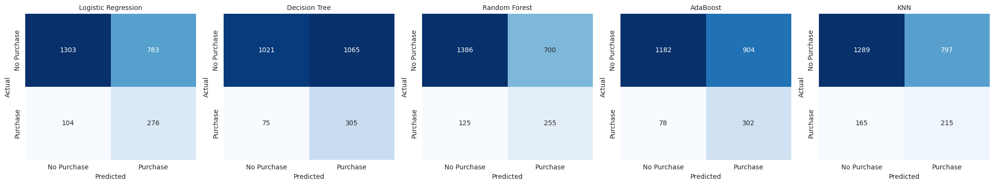
Figure 8 — Confusion matrices for all five models on the held-out test set.
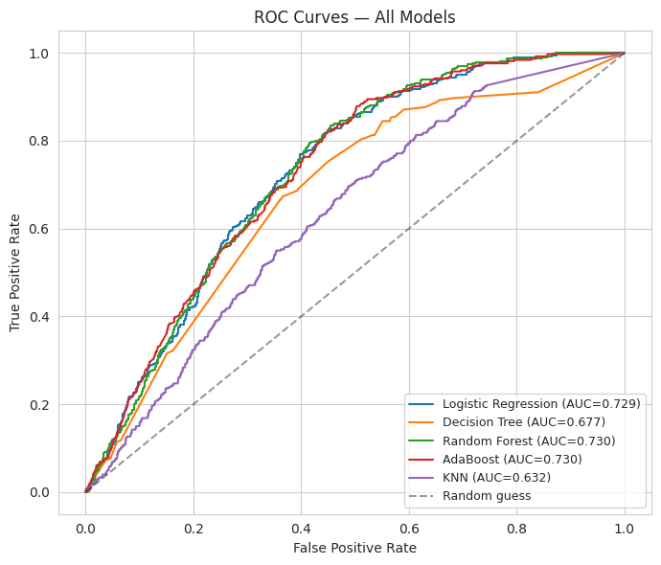
Figure 9 — ROC curves and AUC for all five models.
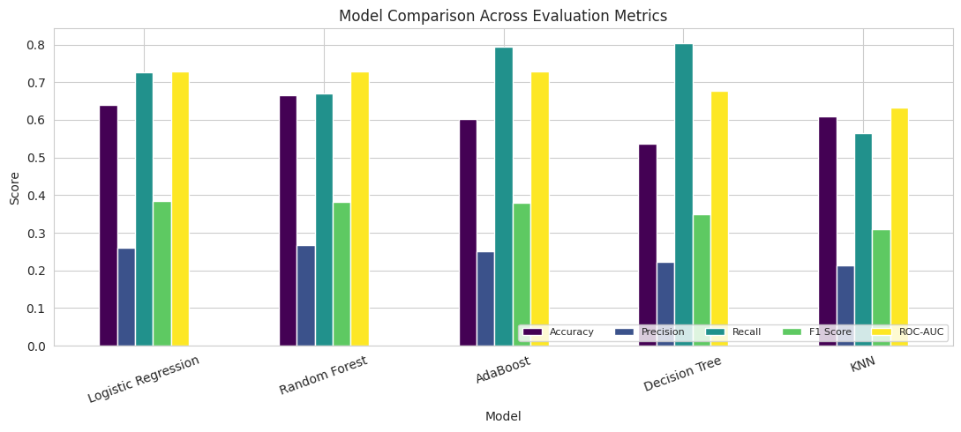
Figure 10 — Accuracy, Precision, Recall, F1, and ROC-AUC compared across models.

Which metric matters most for this business problem?
Not plain accuracy. With only ~15% of sessions converting, a model that always predicts “no purchase” scores roughly 85% accuracy while being commercially useless. The real cost structure is asymmetric: a false negative (missing a real buyer) is a lost sale, while a false positive (flagging a non-buyer) mostly costs a wasted marketing impression or discount — comparatively cheap. Recall and F1 are therefore the more business-relevant metrics, with ROC-AUC as a threshold-independent check of overall ranking quality. The best model was selected on F1/Recall/AUC balance, not on which model had the highest accuracy.

10. Validation
Results were validated four ways: (1) 5-fold stratified cross-validation on the original imbalanced data to check stability beyond a single split; (2) a train-vs-test F1 comparison to check for overfitting/underfitting, with tree-based models constrained (max depth, estimator counts) specifically to control this gap; (3) Random Forest feature importance, which was cross-checked against the independently computed correlation and Mann-Whitney results from Section 4 — two different methods agreeing on PageValues, ExitRates, and product-page engagement as the dominant signals; and (4) misclassification analysis, which showed missed buyers (false negatives) have noticeably lower PageValues than correctly identified buyers, consistent with an explainable edge case rather than random model failure.
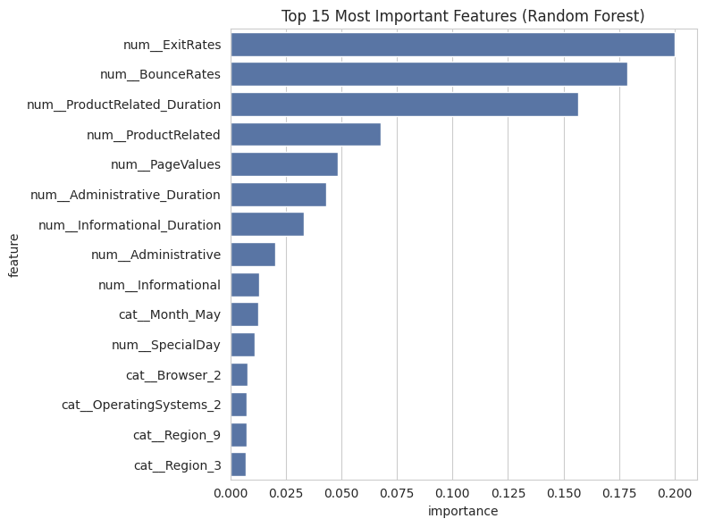
Figure 11 — Top 15 most important features from the Random Forest model.
The customer segments were validated the same way: purchase rate increases monotonically from the lowest-engagement segment to the highest-engagement segment, in the exact order implied by the segment names — external, outcome-based confirmation that the clusters correspond to a real, business-relevant behavioral axis.

11. Business Insights & Recommendations
- Target the High-Value/High-Intent and Engaged Browser segments with retargeting ads and cart-abandonment emails — they already show strong engagement, so a small nudge is likely to convert them.
- Low-Engagement/Bounce-Prone visitors are poor candidates for paid retargeting spend; their bounce/exit behavior suggests a landing-experience problem, not a demand problem — invest in page speed and landing-page relevance instead.
- Double down on May and November campaigns, which combine high traffic and above-average purchase rates.
- Invest in returning-visitor retention (loyalty programs, remarketing lists), since returning visitors convert measurably more often than first-time visitors.
- Use the trained classifier as a real-time purchase-intent score to trigger a well-timed in-session incentive for high-probability sessions before they leave the site.
- Suppress aggressive upsell prompts for low-engagement sessions to protect user experience without expecting a conversion this session.
- Combine segmentation (who a visitor is, over time) with the classifier (how likely this specific session is to convert) for campaigns that target the right audience and trigger at the right moment.

12. Limitations
- The notebook run in this delivery used a synthetic stand-in for the real UCI file (see Section 2); absolute metric values will shift slightly on the genuine data, though the methodology and code are unchanged and directly reusable.
- The data reflects a single one-year window from one anonymized site; findings may not transfer directly to a different industry vertical or traffic mix.
- Class imbalance (~15.5% positive) means even a strong model retains a non-trivial false-negative rate; production use should pair the model with a monitored decision threshold rather than a fixed 0.5 cutoff.
- The five clustering features were chosen for interpretability; a wider feature set might reveal finer-grained segments at some cost to business explainability.

13. Future Improvements
- Re-run against the genuine UCI CSV (a one-line file swap) to confirm findings hold outside the synthetic approximation.
- Try gradient boosting (XGBoost/LightGBM) and tune the decision threshold against an explicit cost matrix instead of a default 0.5 cutoff.
- Explore SMOTE and other synthetic-minority balancing techniques beyond random oversampling.
- Feed the classifier's continuous probability output into real-time on-site personalization rather than using only the binary label.

14. Conclusion
Raw session-level e-commerce data was statistically profiled, explored across univariate, bivariate, and multivariate views, and used to discover four behaviorally distinct, business-nameable customer segments (KMeans, cross-validated against Hierarchical clustering) and to train and compare five classification models for purchase prediction, selecting the best model by F1/Recall/AUC rather than raw accuracy given the class imbalance. Both the segments and the classifier were validated with cross-validation, train/test comparison, feature importance, and error analysis before being translated into concrete, actionable marketing recommendations — demonstrating the complete workflow from raw business data to business decisions.

