Program5: Develop a program to implement a sliding window protocol in the data link layer.
The Sliding Window Protocol is a key computer networking technique for controlling the flow of data between two devices. It guarantees that data is sent consistently and effectively, allowing many packets to be sent before requiring an acknowledgment for the first, maximizing the use of available bandwidth.
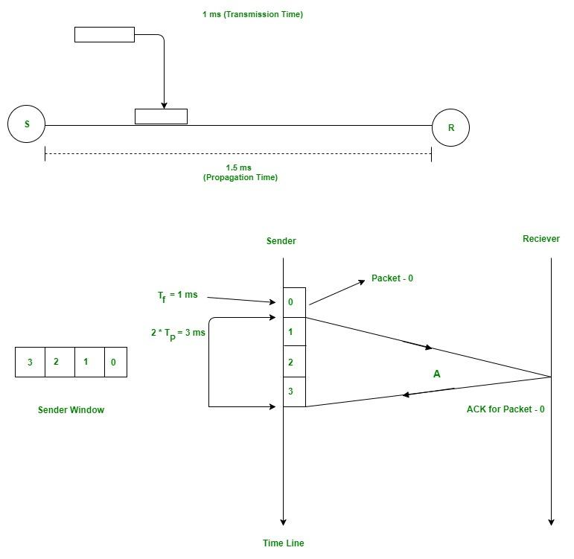

import java.util.Scanner;

public class program5 {
public static void main(String[] args) {
Scanner sc = new Scanner(System.in);

// User input
System.out.print("Enter the number of frames to be transmitted: ");
int totalFrames = sc.nextInt();

System.out.print("Enter the window size: ");
int windowSize = sc.nextInt();

int sent = 0; // frames sent so far

System.out.println("\n--- Sliding Window Protocol Simulation ---");

while (sent < totalFrames) {
// Send window of frames
int end = Math.min(sent + windowSize, totalFrames);

System.out.print("\nSender: Frames sent -> ");
for (int i = sent; i < end; i++) {
System.out.print(i + " ");
}

System.out.println("\nReceiver: Frames received -> ");
for (int i = sent; i < end; i++) {
System.out.println("Frame " + i + " received and acknowledged.");
}

// Move the window
sent = end;
}

System.out.println("\nAll frames have been transmitted successfully!");
sc.close();
}
}

OUTPUT:

Enter the number of frames to be transmitted: 10
Enter the window size: 4

--- Sliding Window Protocol Simulation ---

Sender: Frames sent -> 0 1 2 3
Receiver: Frames received ->
Frame 0 received and acknowledged.
Frame 1 received and acknowledged.
Frame 2 received and acknowledged.
Frame 3 received and acknowledged.

Sender: Frames sent -> 4 5 6 7
Receiver: Frames received ->
Frame 4 received and acknowledged.
Frame 5 received and acknowledged.
Frame 6 received and acknowledged.
Frame 7 received and acknowledged.

Sender: Frames sent -> 8 9
Receiver: Frames received ->
Frame 8 received and acknowledged.
Frame 9 received and acknowledged.

All frames have been transmitted successfully

