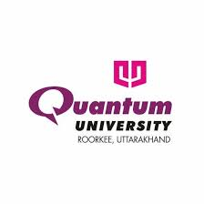
RESUME
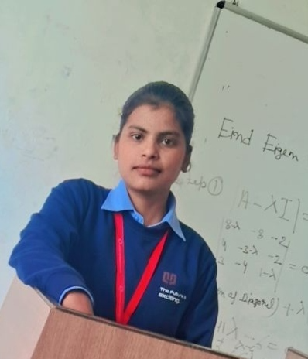

ANJALI SAINI
kanjali1722@gmail.com | 9528074309 | www.linkedin.com/in/anjali-saini-335a49372 | github.com/anjali1722

EDUCATION
Bachelor of Technology (B.Tech) in Computer Science & Engineering
Quantum University, Roorkee
July 2023 – Present
CGPA: 7.2 / 10
Class XII – State Board
LLRK Inter College, Thanabhawan - UP
2023 | Percentage: 64%
Class X – State Board
NHSS, Muzaffarnagar
2021 | Percentage: 82%

TECHNICAL SKILLS
- Programming Languages: Java, C, C++
- Web Technologies: HTML, CSS, JavaScript, Spring Boot, Node.js
- Databases: MySQL, MongoDB
- Developer Tools: Git, GitHub, VS Code, IntelliJ IDEA
- Operating Systems: Windows, Linux
- Other Skills: Data Structures & Algorithms, OOP, DBMS, REST APIs

PROJECTS
Customer Relationship Management – Java, Node, MySQL
Engineered a full-stack CRM system using Java, Node.js, and MySQL, developing robust REST APIs and CRUD functionalities for efficient customer data management. Designed an intuitive user interface to enhance user experience and streamline business processes.
Heart Disease Prediction Model Using AI-ML
Developed a machine learning model using the Random Forest algorithm with Python and Scikit-learn, achieving high prediction accuracy on healthcare datasets, and integrated it with a MERN stack application to enable real-time predictions.

INTERNSHIPS / WORK EXPERIENCE
InternPe – Web Developer
Sep, 2024 – Oct, 2024
- Developed responsive web pages using HTML, CSS, and JavaScript
- Completed a 4-week internship focused on web development
- Delivered assigned tasks efficiently with strong adaptability and quick learning

ACHIEVEMENTS & EXTRACURRICULAR ACTIVITIES
- Successfully executed multiple academic projects with practical implementation.
- Demonstrated strong problem-solving skills with strong learning and adaptability.

INTERESTS
- Coding and Problem Solving
- Backend Development
- Learning New Technologies

PERSONAL INFORMATION
- Address: Thanabhawan Shamli- UP
- DOB:16-09-2004
- Languages Known: Hindi, English
Date: 15/04/2026 Signature: Anjali Saini

