Installation of *WAMP SERVER 3* :{ latest one}

Many people contact various problems on the installation of Wamp server. It is actually very easy process indeed. Follow my below steps to install the wamp server on your pcs or laptops.

STEP 1:

Go to Google from your favorite web browser. And search for wamp server.

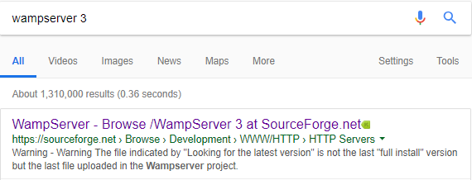

STEP 2:

Click on the link and press on Download button.

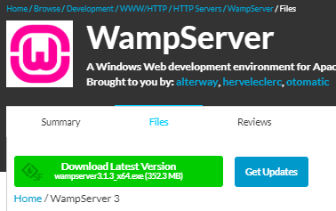

STEP 3:

When the Download is complete. Go to the download file and open the file.

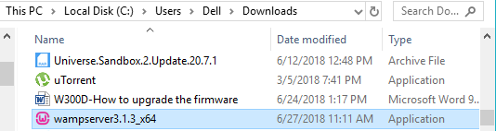

STEP 4:

The following box will appear press on Yes.

