1. **Virtual Machine:** Microsoft case study found that the virtual machines deployed in Azure had a carbon footprint 70 percent smaller than the modeled on-premises equivalent.

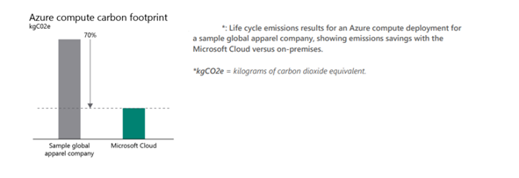

1. **Azure Storage:** Microsoft conducted a study with industry experts to determine the energy use and carbon emissions associated with Azure Storage compared with storage equivalents deployed in traditional enterprise datacenters. Our methodology considered the impact of the IT equipment and operations, datacenter infrastructure, and information flows over the internet required to provide a cloud service and its traditional on-premises equivalent.

The results show that Azure Storage is 71–79 percent more energy efficient than storage equivalents deployed in traditional enterprise datacenters (right), depending on the type of enterprise deployment. In addition to providing greater energy efficiency through the Microsoft Cloud, we purchase renewable electricity for more than 95 percent of our consumption, which includes the datacenters that power Azure Storage. When renewable energy is taken into account, carbon emissions from Azure Storage are 79–83 percent lower than traditional enterprise datacenter deployments of storage equivalents

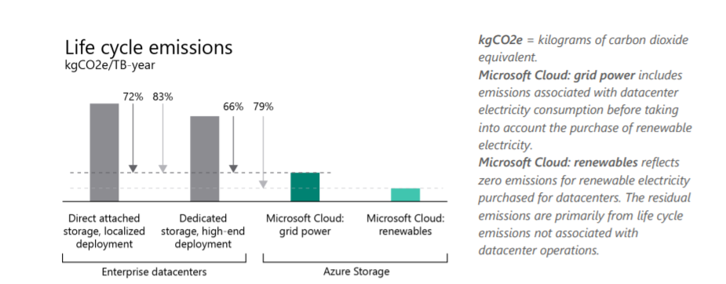

1. **Azure Compute**: Microsoft conducted a study with industry experts to determine the energy use and carbon emissions associated with Azure Compute compared with compute equivalents deployed in traditional enterprise datacenters. Our methodology considered the impact of the IT equipment and operations, datacenter infrastructure, and information flows over the internet required to provide a cloud service and its traditional on-premises equivalent.

The results show that Azure Compute is 52–79 percent more energy efficient than compute equivalents deployed in traditional enterprise datacenters (right), depending on the type of enterprise deployment.

In addition to providing greater energy efficiency through the Microsoft Cloud, we purchase renewable electricity for more than 95 percent of our consumption, which includes the datacenters that power Azure Compute. When renewable energy is taken into account, carbon emissions from Azure Compute are 92–98 percent lower than traditional enterprise datacenter deployments of compute equivalents (below).

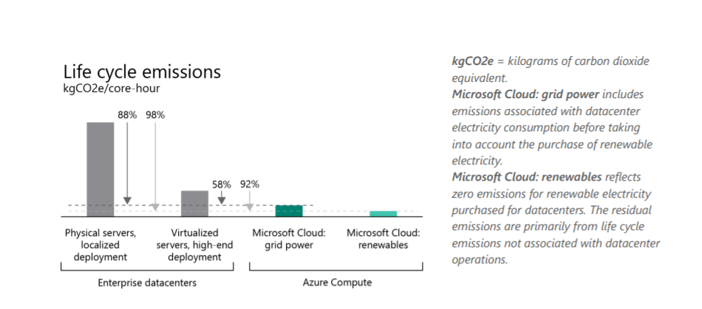

**Key parameters:** The analysis considered the following key parameters:

• **Equipment counts**: the number of devices (servers, networking equipment, and storage devices) required to provision a given deployment. This includes excess capacity in both the cloud and on-premises scenarios to account for equipment required to meet peak loads or planned future growth.

• **Equipment specifications**: the specifications of servers, storage equipment, and networking devices used for the analysis. This includes number of cores, processor power, storage capacity, and power draw at different utilizations. Actual equipment specifications were used to model the Microsoft Cloud scenarios. Specifications for representative equipment, as determined by industry experts, were used to model on-premises deployment scenarios.

• **Device utilization**: the load that a device (server, networking switch, or storage device) handles relative to the peak load the device can handle. This number is expressed as a percentage.

• **Device power consumption**: the power consumed by a device, either measured directly, or extrapolated based on manufacturer specifications and device utilization.

• **Networking equipment power consumption:** the power consumed by networking equipment in the datacenter that is not directly measured or included explicitly in the deployment (for example, aggregation and core switches).

•**Datacenter PUE:** an efficiency metric that is the ratio of the total amount of electricity consumed by a datacenter to the amount of electricity delivered to the IT equipment. By definition, PUE is equal to 1 or greater, and the closer PUE is to 1, the more efficient the datacenter. PUE accounts for electricity used in the datacenter for lighting, cooling, power conditioning, and other support services.

• **Electricity from data flows over the internet**: the additional electricity use incurred in cloud computing and large on-premises deployments from sending data over the internet that would not occur in smaller deployments where IT resources are co-located with the users. This electricity use was considered for the Microsoft Cloud and for large-scale deployments based on assumed typical usage patterns of each service.

• **Electricity carbon intensity:** the average emission rate for the regionally specific mix of primary energy (such as hydro, natural gas, coal, and wind) used to generate electricity provided to the electric grid. In order to convert electricity into carbon emissions, the electricity consumption data is multiplied by the carbon intensity of the electric grid where the electricity is consumed. As discussed in the Renewable electricity section earlier, we purchase renewable electricity for more than 95 percent of our consumption.