# **Application**

1. Click the application menu button

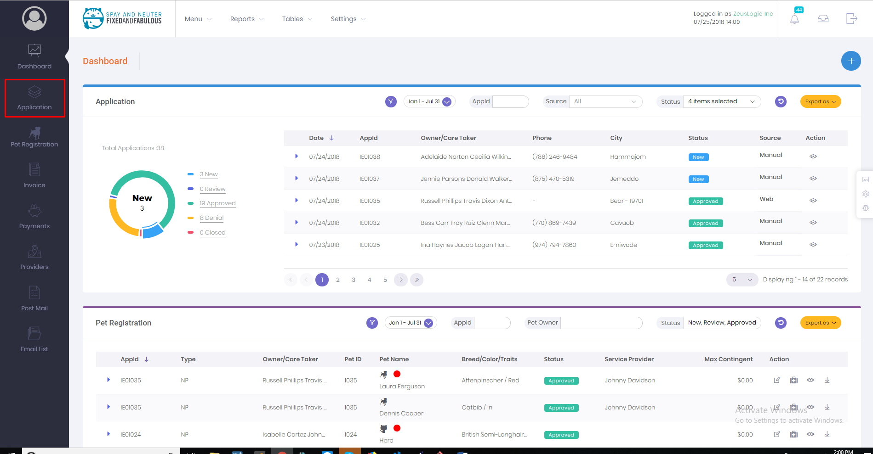

1. Following screen will be shown

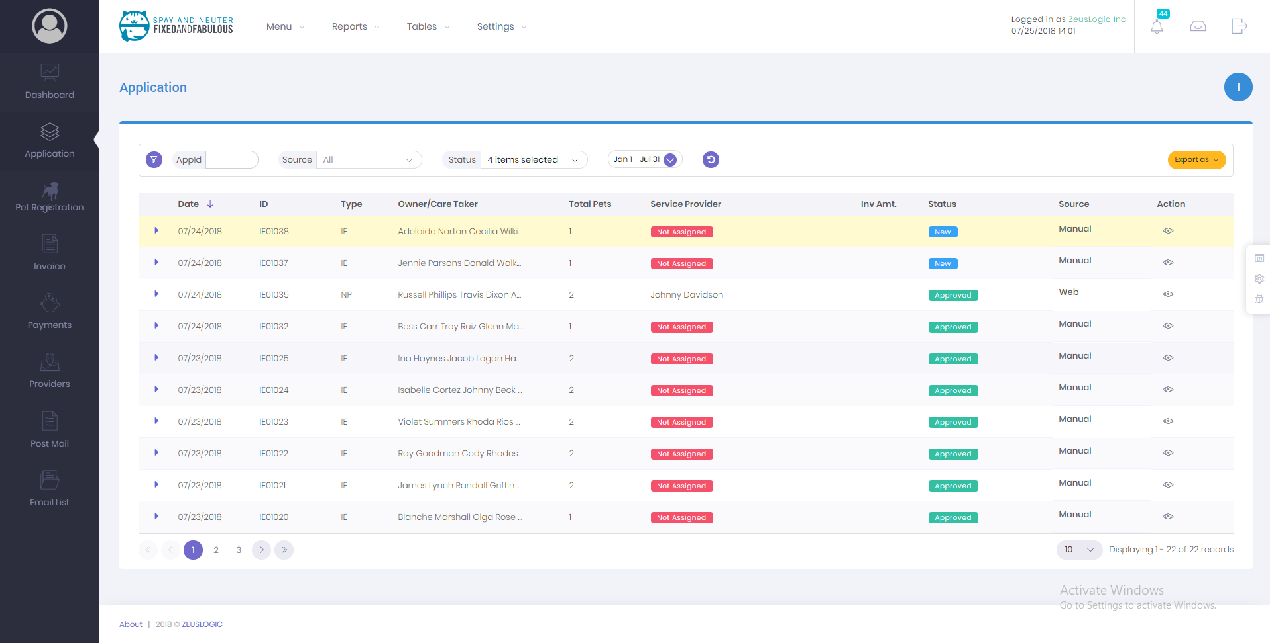

# **How to add citizen application?**

1. To create new citizen application, click on plus sign located at the right side of application page
2. Click on the add citizen application button

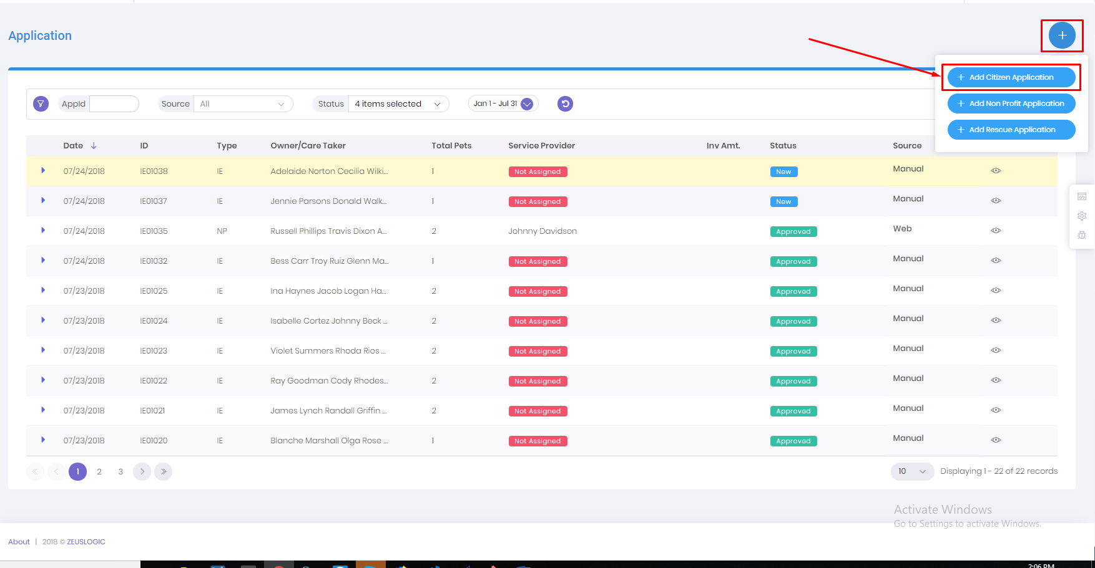

1. A popup form will show

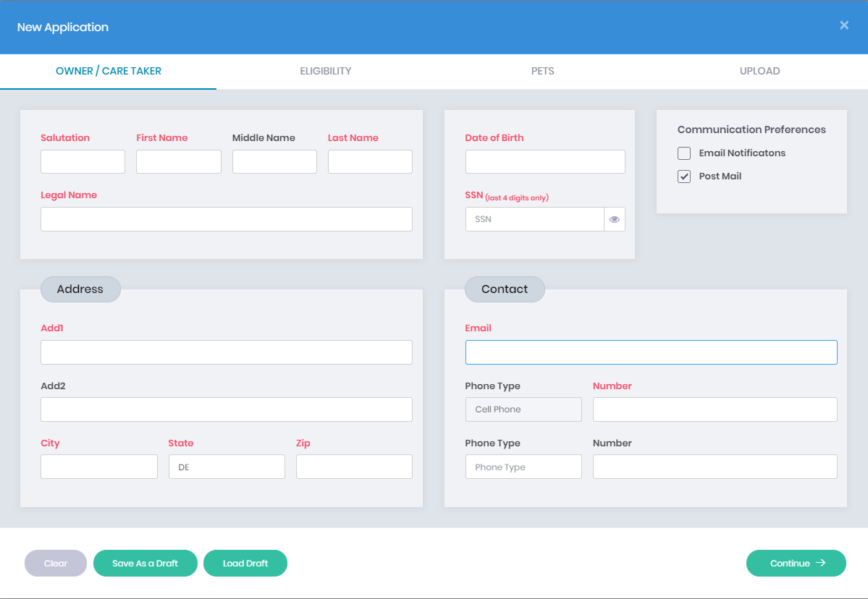

1. Form is divided into 4 sections: owner/ care taker, eligibility, pets and uploads

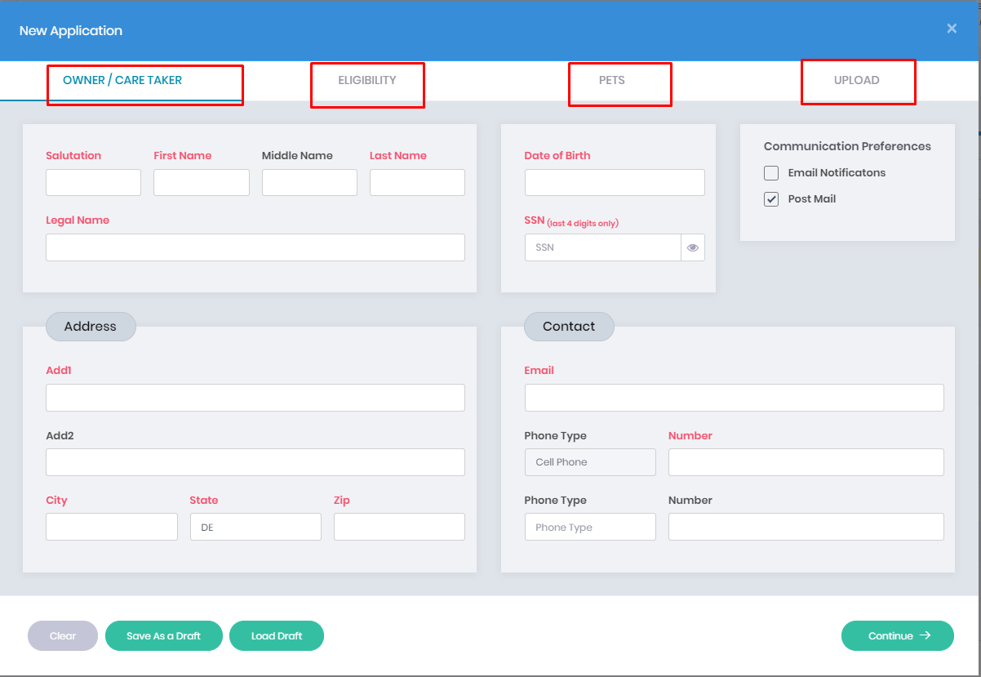

1. Fill the form correctly. The red label indicates that the field is mandatory.
2. At the bottom of form there are 4 buttons which they have own purpose: clear, save as a draft, load draft and continue.

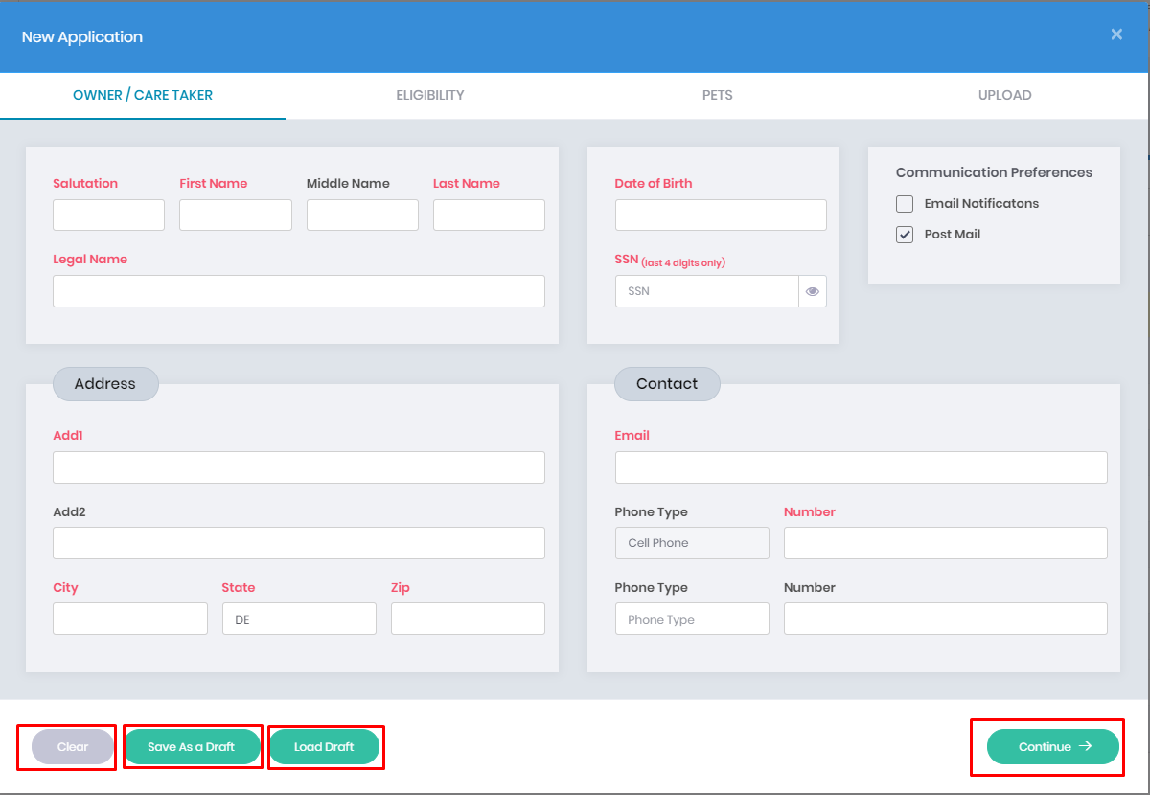

1. The clear button will clear all the input fields.
2. Save as Draft button will save all the values of input fields as draft for future use.



1. Load Draft button will load all the saved values from the draft. By clicking load it will populate all the saved values in the input fields

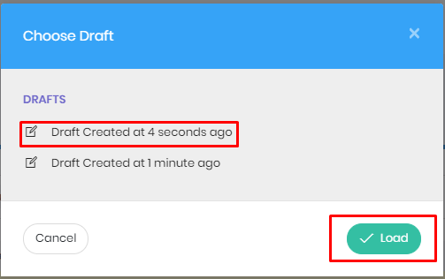

1. After filling all the input fileds of owner/care taker. Click the continue button, to go to the next section of the form.

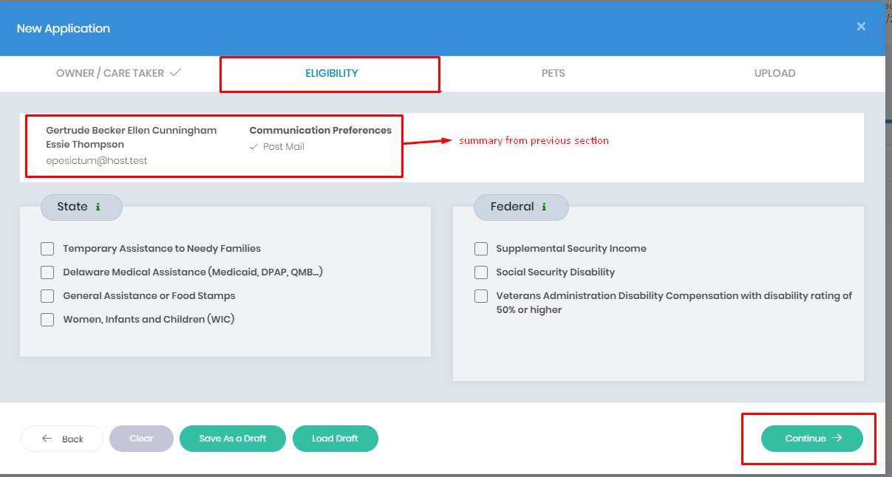

1. By clicking continue, it will go to the pets section.

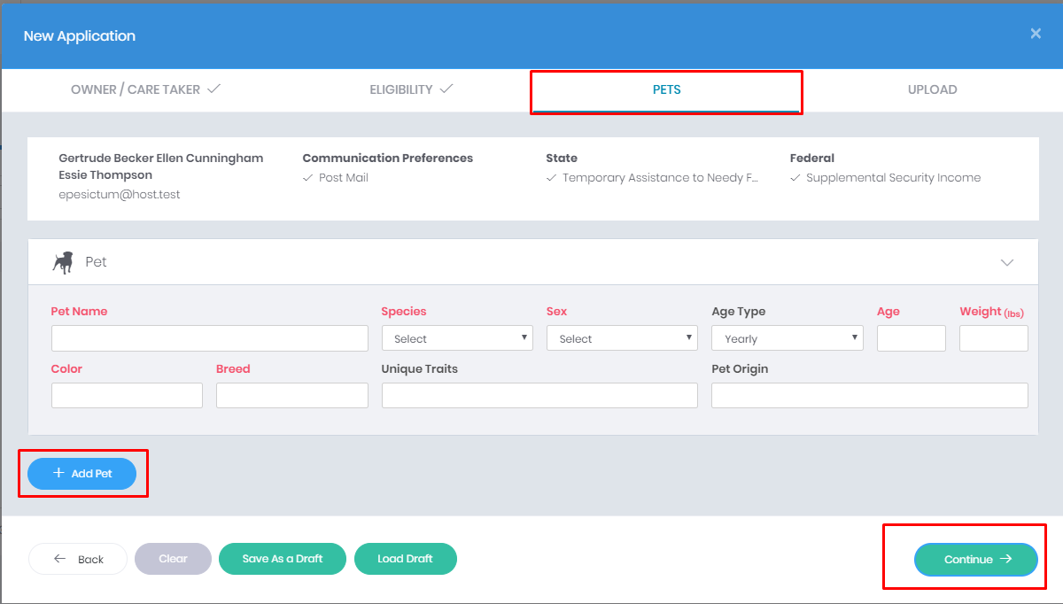

1. If you have more than 1 pet you can click the add pet button to add more pet fields.
2. After finishing this pets section you can continue again.
3. Next section is uploads where you can upload your application related documents.

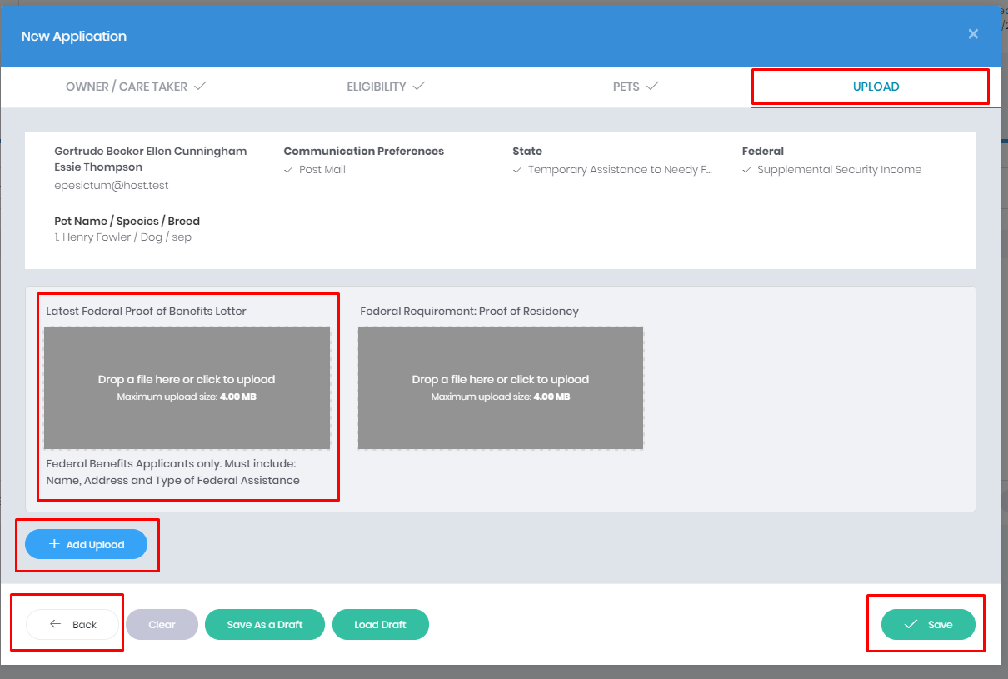

1. You can drop a file in the drop a file section to upload.
2. There is also add upload button which can give you to upload more files
3. Back button will bring you back to the previous section if you have forgotten anything.
4. After clicking save button, your application will be saved. And redirect into that newly created application.

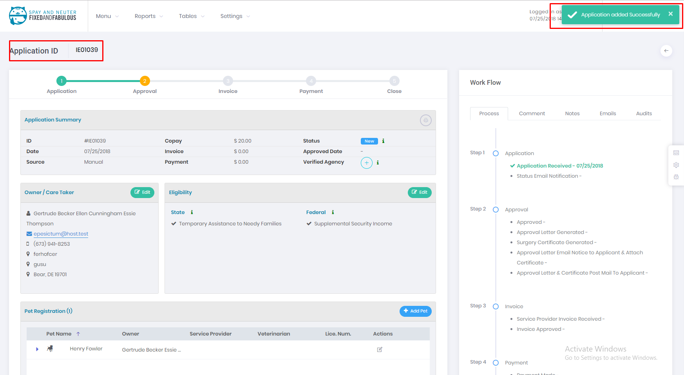

# **Description of application page**

1. In this single application page there are lots of section like progress bar, application summary, information about owner/care taker. Eligibility, pets section, invoice section, payment section and the work flow in the right side of the page.
2. At the top of the page there is progress bar which will show the state of the application at the time. Green will indicate finish, and yellow will indicate current state which you have to do and gray line will indicate your future states of the application.



1. Next section is about itself application. It includes id, copay, status, application date, etc. It contains print button to print the application page. You can verify this application by clicking plus(+) sign.

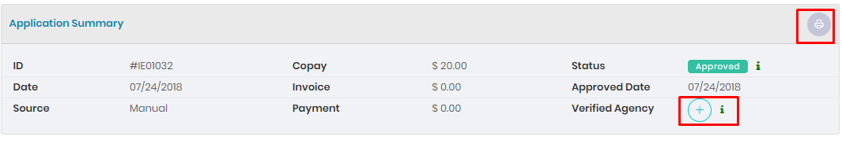

1. Next section, information about owner/care taker and information about eligibility where you can edit owner/care taker and eligibility.

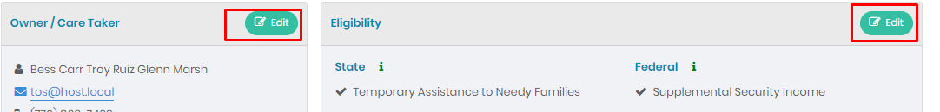

1. Next section, Pets section where we can find this application pets detail. You can have three options for each pet where you can edit the pet, add treatments to the pet and download the certificate generated of that pet. But these two options are only available after the application is approved.

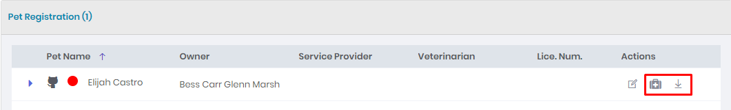

1. Next Section is File section. You have two section on it, one for file that are uploaded at the time of application created or you can upload from clicking upload button. And another section is for generated files where files are generated when you approve or disapprove application or you can regenerate the files.

You can view file or download.

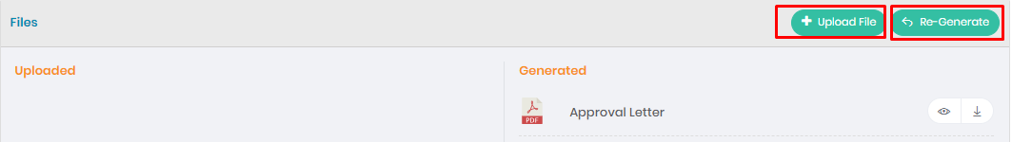

1. Next sections are Invoice and payment section which cannot be available until the application is approved.
2. At the bottom of this page you will see two buttons: Denial and Approve.
3. At the right side of the application, there are five tabs: application process, comment section, notes, email and audits.

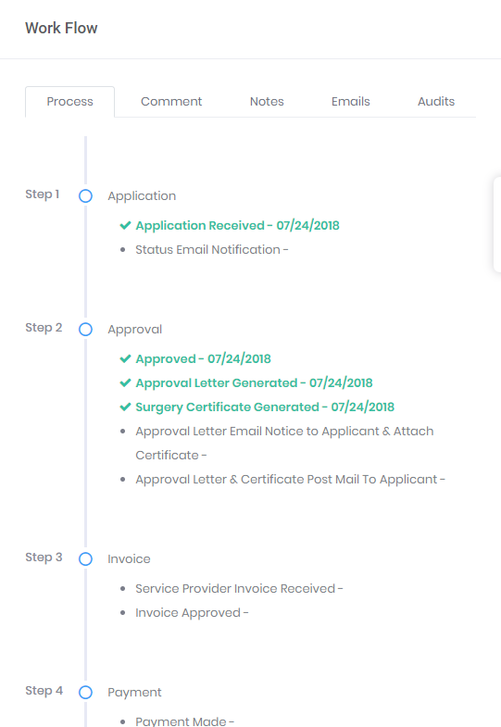

# **How to Approve Or Disapprove Application?**

1. If the application has all the requirements than it you click the Approve button otherwise hit the Denial button.



1. If you click denial button, popup form will appear on your screen

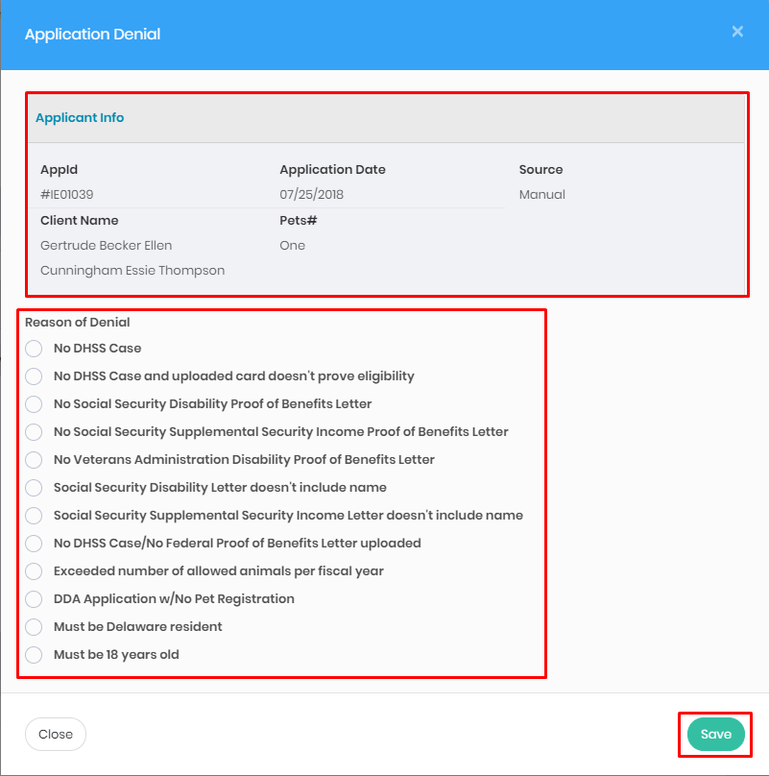

1. In this popup there will be details of application and the reason of denial. Choosing appropriate denial reason, click the save button.
2. After clicking save button, denial letter will generate and the process of application will be closed as denied.



1. But if you approve the application, than three letter will generate : approval letter, surgery certificate and copay reminder.

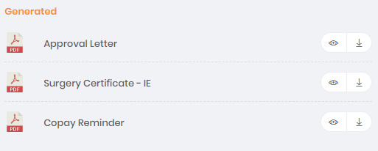

# **How to add Pet?**

1. Click on add pet button located at the right top corner of pet section.

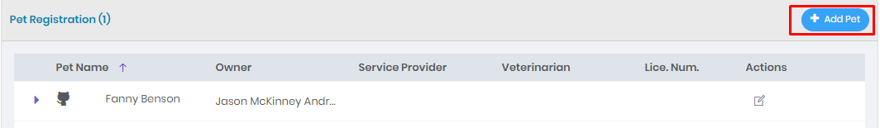

1. Add pet form popup will be shown on the screen.

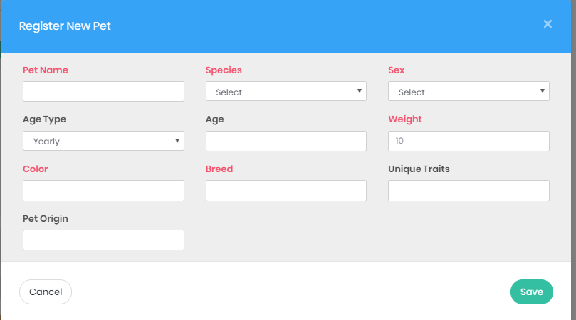

1. Fill the form correctly. The red label indicates that the field is mandatory.
2. Click the Save Button.

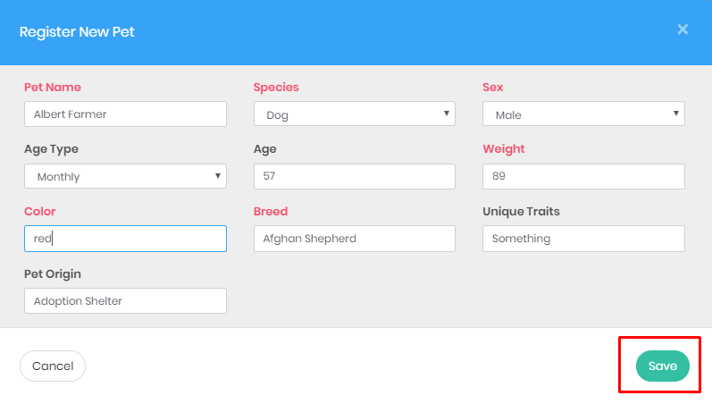

1. Newly added pet will be shown in the pet table like below.

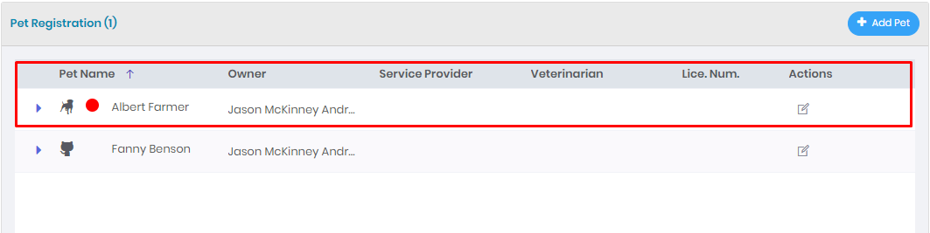

# **How to edit Owner/Care Taker?**

1. Click on edit button located at the right top corner of the owner/care taker section.

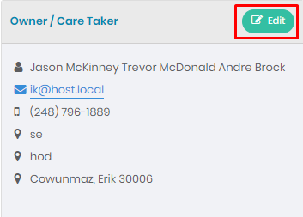

1. Popup form will be shown on the screen with its value in the input fields.

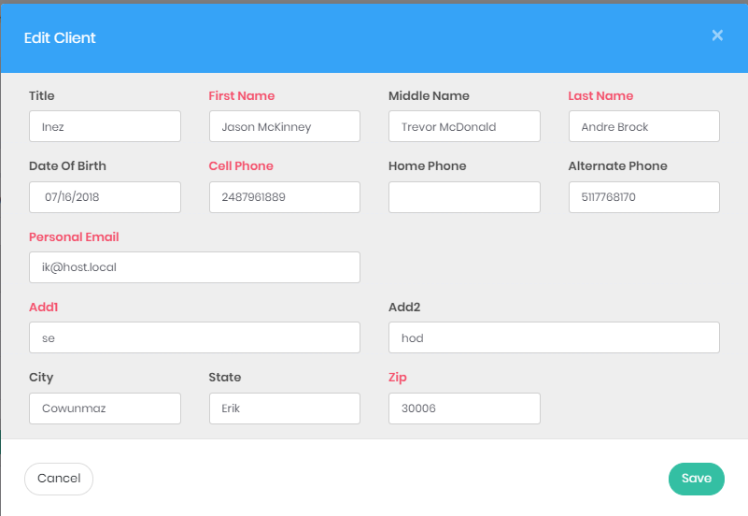

1. Edit the field properly. Red label field is mandatory.
2. Click the Save Button.

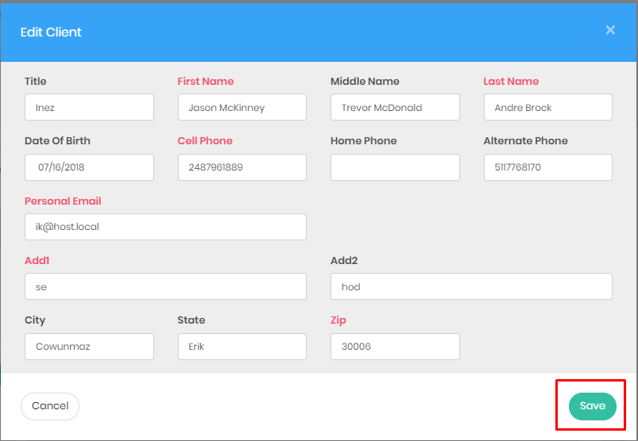

1. The updated value will be shown in the owner/care taker section after that.

# **How to edit eligibility?**

1. Click on edit button located at right top corner of eligibility section.

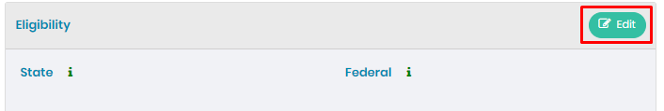

1. Popup form will be shown on the screen with its value in the input fields.

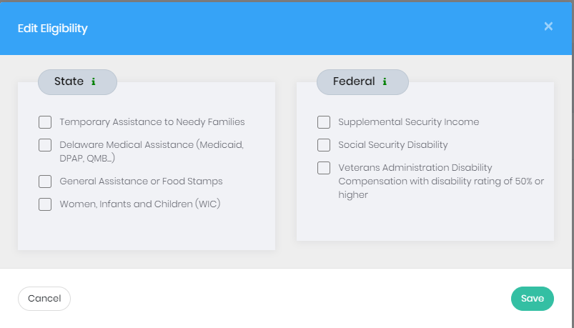

1. Fill the form properly.
2. Click the Save Button.

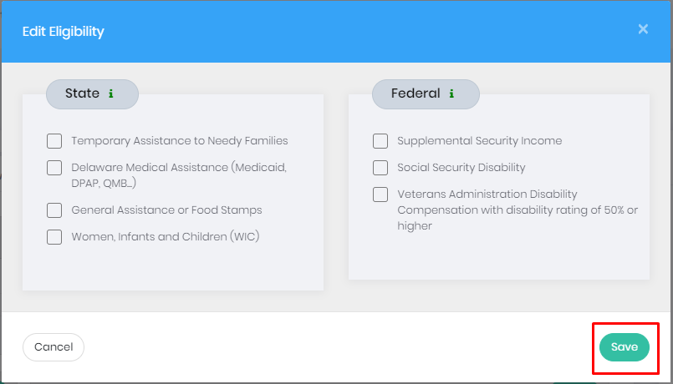

1. The updated value will be shown in the eligibility section.

# **How to Upload File?**

1. Click on upload file button located at right top corner of files section.



1. Popup form will be shown on the screen to upload file.

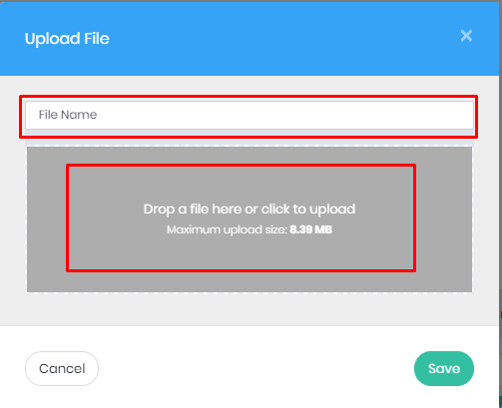

1. Drop a file inside the upload area and give its name.
2. Click the Save Button.

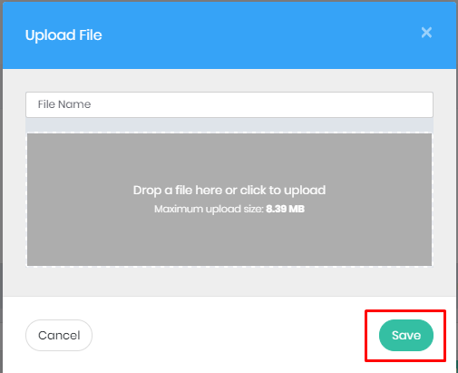

1. Uploaded file show in the uploaded section.

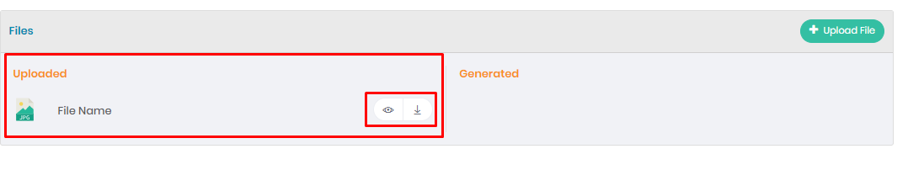

1. The generated file will be shown in the generated section.
2. Files can be view and download as well.

# **How to add Procedure to the pets?**

1. Click the medical sign button located at the right side of the pets table between edit and download button.

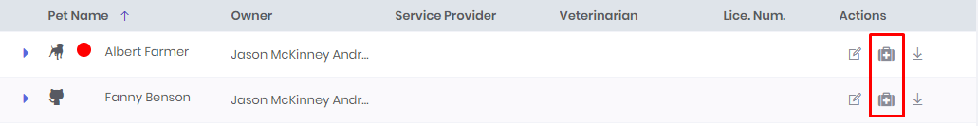

1. Popup form will appear on the screen with its application id and pets information.

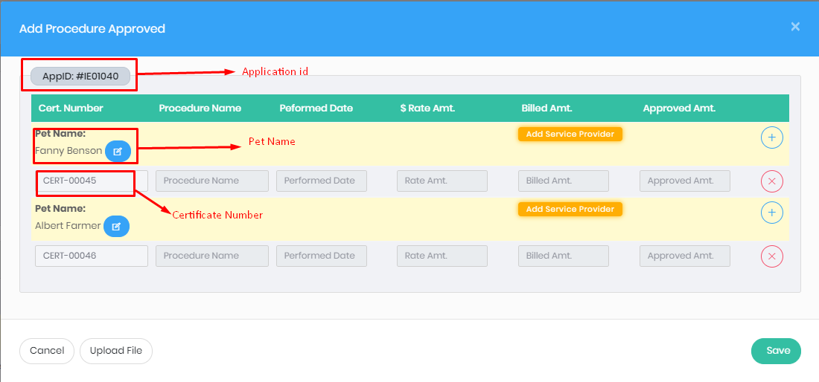

1. Click the add service provider to add provider and veterinarian for the pet.

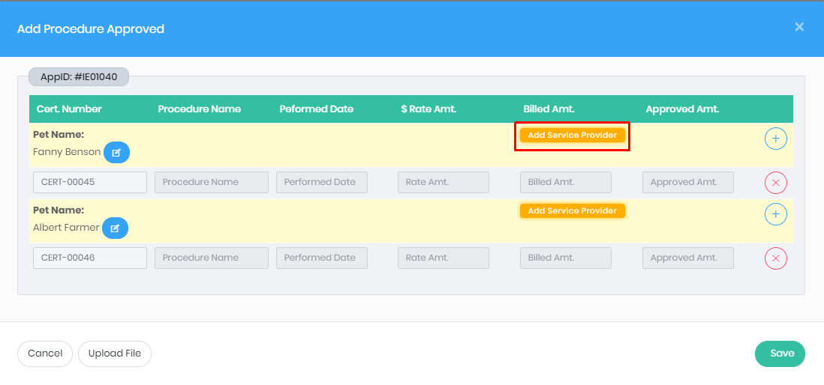

1. Another popup will be shown with available providers and its veterinarian.

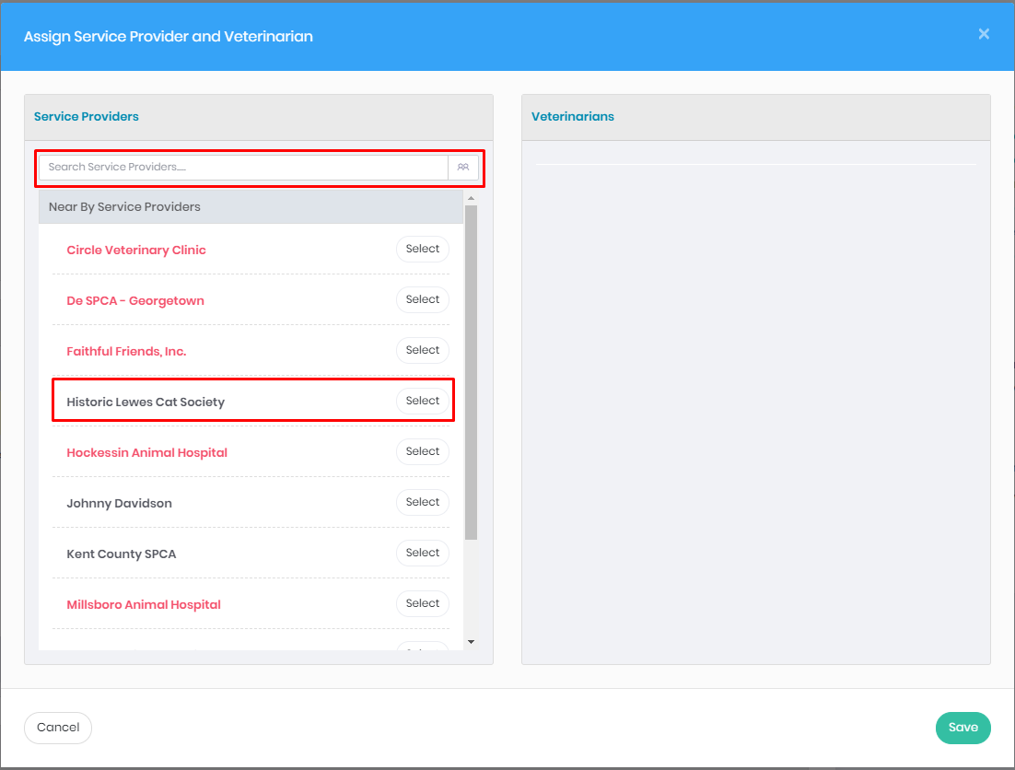

1. There is search bar at the top of the providers section which will search required providers.
2. The red text color indicates that it doesn’t contain any of their veterinarian. So, select which is not red color.
3. After selecting the providers, its veterinarian will be shown in the right side. Select the appropriate veterinarian.

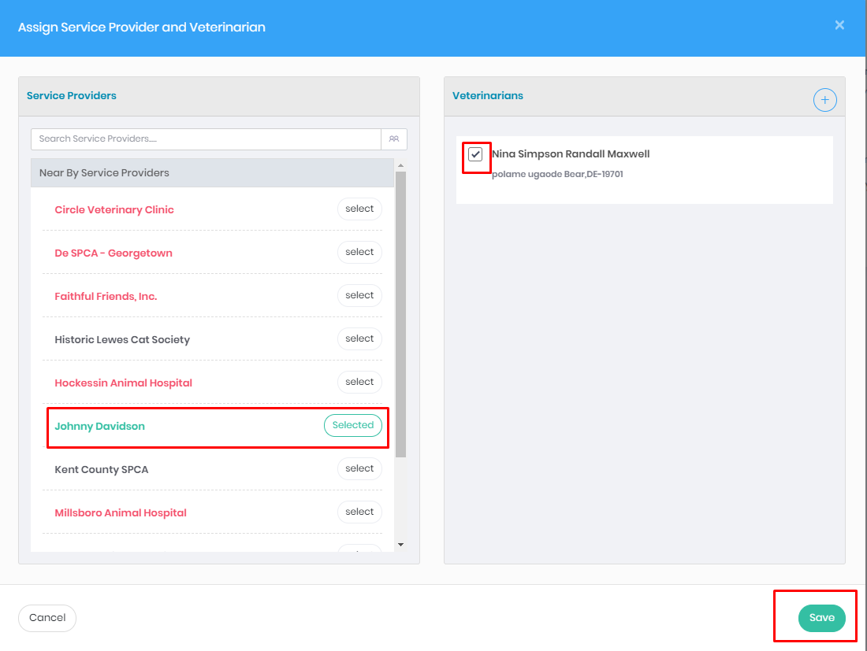

1. After selecting service provider and veterinarian, click on the Save Button.
2. After saving, its information will appear on the procedure screen. We can change it as we wish.

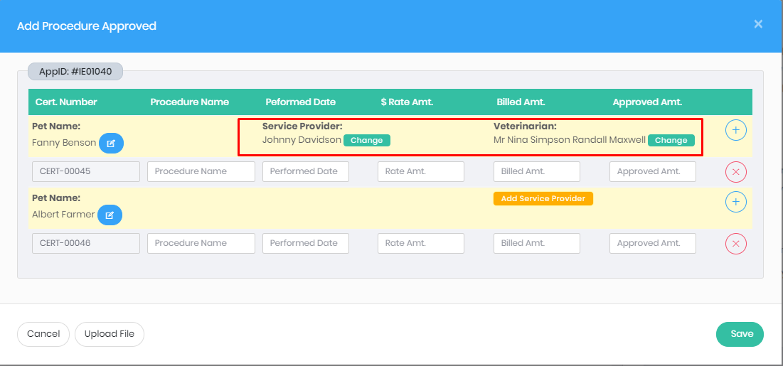

1. Repeat steps from 3 if it consist more than 1 pet.
2. After adding provider and veterinarian for all pets, it should look like this.

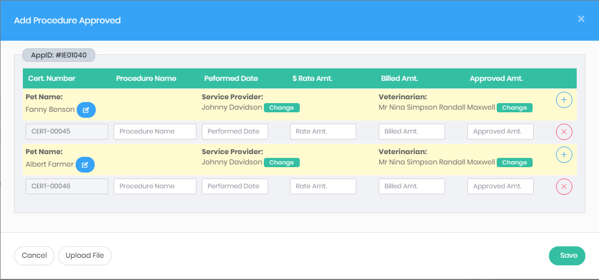

1. We can have different providers for each pet.
2. We can add more procedure by clicking add button and remove procedure by clicking the remove button.

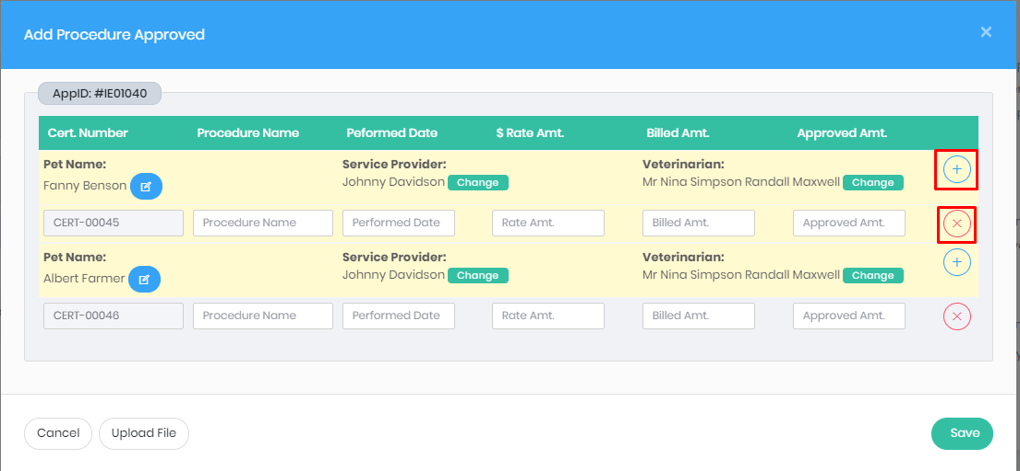

1. Fill the form properly.
2. Click the Save Button.

