# Analysis

## Definition

Analysis includes those tasks that go into picking the necessities or conditions to meet for another or modified project or product, assessing the possibly clashing prerequisites of the different stakeholders, analyzing, documenting, validating and managing system or software requirements.

Analysis is the process of identifying and defining the needs of the customers for an application that will be developed or changed. Analysis incorporates all of the tasks that are coordinated to recognize the prerequisites of different stakeholders. Thus analysis expects to analyze, report, validate and manage system or software necessities. Business requirements are accounted, actionable, measurable, testable, and traceable, help to recognizes business opportunities, and are defined to a support system design.

## Analysis Methodology – combined (hard and soft) approach of analysis

Analysis of human activity   
While creating the futsal management system. Firstly, most important factor is to interact with people. The accountant must speak polite with new group who are willing to be a member of the futsal. They should co-operate effectively with member of the group, if they need any suggestion and technical help from the system.

So, proper analysis of the people is needed while creating project. If they person is mentally fit or not to lead the management team.

Analysis of information and information modeling   
It is the plan of practices that choose the structure, lifecycle and accessibility necessities of the information in about a business. It is required in the present associations to enable information stream all through the affiliation.

The information must flow on the basis of the design of the information model. The E.g. For the futsal management are listed below:

Analysis of design and socio technical aspectSociotechnical systems in various leveled progression is an approach to manage complex legitimate work structure that sees the relationship among people and advancement in workplaces. The term in like manner implies the correspondence between society's confusing establishments and human direct.

It depend how system flow in the project, how to create good software etc. And motive is to develop and design project structure on the basis of socio technical aspect. Database used while creating project etc.

### Design and human Computer Interface

Feasibility Study

An analysis and evaluation of a proposed project to determine if it is technically feasible, is feasible within the estimated cost, and will be profitable. Feasibility studies are almost always conducted where large sums are at stake.

a feasibility study is performed, which determines whether the solution considered to accomplish the requirements is practical and workable in the software.

### Technical feasibility

It deals with technical resource of the project? What type of technology is used while developed project what process or technique used while creating project?

### Economic feasibility

It deals with the budget require for the development of the project. What are the types of resource is required for the project?

### Operational feasibility

It is used to identify the importance of certain problem and how to solve. It takes action accordingly to track that problem.

Legal Feasibility

It helps to know the country constitution provide permission to create such website or not. By the help of that software, it tracks personal detail or not.

Time

When client provides software to build, the time is firstly fixed. It’s our major concern to finish the development of the software in time. If due to some difficulties, project won’t be able to finish in time, the developer team has to pay fine to client on the basis of agreement.

So, the company major concern is to make proper plan and develop the software in time.

Social

Social factor is also matter to concern while creating software. Does it affect people directly/indirectly or not? While creating the project it also focuses that how does it affect a particular community, races, and castes.

So, proper analysis is done when the developer is creating project and client also must focus on that parts.

## Information Gather

### Questionnaires

For the development of project, I have focus on the different method of collection of the information. I have observed different society. Finally, I reach that futsal is the game people book courts and plays frequently, where lot of youth come to play. For more knowledge, I have taken questioner to the people of my local area and also to school and college. Finally, I got my result of my questioner and I perform other analysis parts.

These are the question I asked to general peoples.

1. How often do you play Futsal?
2. What kind of problem do you have to face booking a futsal court?
3. How many futsal court lies nearby you?
4. What kind of booking process should be implemented?
5. Would you prefer web application to book futsal court?

## Interview

It is also a method to collect information while creating project. It helps to save time and also economic to collect information. The person can ask anything about project while he is taking interview. In interview the interview get detail information about the body language of the interviewer.

These are the questions asked by interviewer to futsal mangers.

1. How do you schedule your bookings?
2. Do you have computerized system for that?
3. What kind of problems do you have to face to manage bookings?
4. How many different ways do you provide for booking the court?
5. Would you prefer web application to manage you schedule and bookings?

## Use Case Diagram

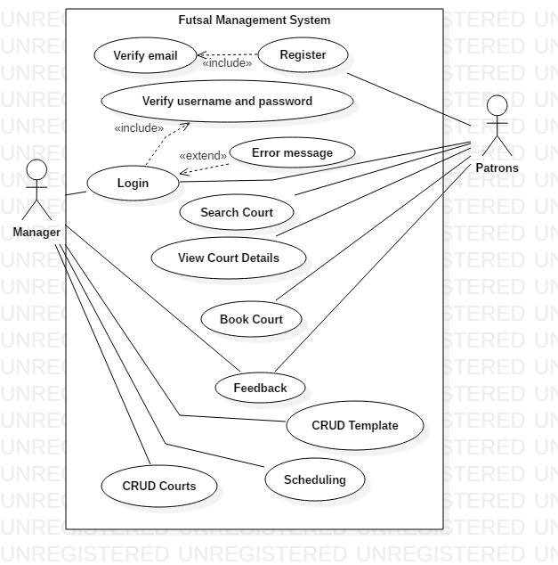

## System Architecture and Database Architecture

### Software Development Architecture

For the creation of project based on futsal application, I have used Window platform to develop web application apps for desktop users. NodeJS and react is used while creating the software. It is supported in every desktop application for this system software. It uses mongo dB database server to store data for the project. And also support all libraries, express, mongoose, body-parser, multer to store image.

It is a sensible model that depicts the direct, structure and the point of view on the system. It is generally called vision and depiction of the structure. It shows the lead and the structure of the system. It depicts the stream the structure. It shows association between each other and condition. It chooses decision with accomplice lead and character. It gives nuances plans and standards of the system. It shows what the structure includes? Like gear and programming.

For the design and development of my endeavor, I have pick MVC (Model View Controller) structure guide to develop my item and related with mongo DB database for android and site page. I have use people organized mythology, to list the condition while developing project.

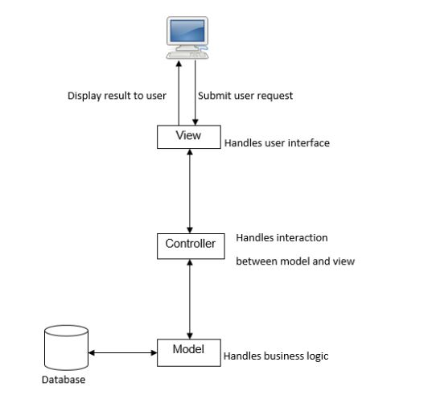

Figure 1system Architecture

### Database Architecture

#### 3-tier DBMS Architecture

3-tier DBMS architecture is the most consistently used architecture for web applications.

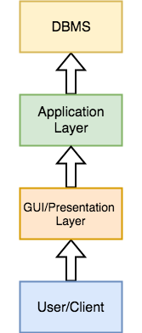

Figure : 3-Tier Architecture

It is an extension of the 2-tier architecture. In the 2-tier architecture, we have an application layer which can be accessed programmatically to execute various operations on the DBMS. The language that is supported by the application is generally Database Access Language and it processes end user requests to the DBMS.

## 3-tier architecture comes with an extra layer which is called Presentation or GUI Layer, which provides graphical user interface so that the end user can interact with the DBMS.

For actual end users, the GUI layer is the Database System, and they don't any idea about the application layer and the DBMS system.

## SRS Document

Specification is collection of the software and devices used to operate that. It may be available or may not available during developing the software. It is the requirement to meet for the proper development of the project. E.g.: if you are developing IOS apps for that you must have mac for the development of the software.

Some of the device and software are listed below:

|  |  |  |  |  |  |
| --- | --- | --- | --- | --- | --- |
| PRO_ID | Software | Device | model | performance | quality |
| PRO-1 | VS Code | laptop | I5 | Very fast | Support android studio |
| PRO-1 | Visual paradigm | laptop | I3 | fast |  |
| PRO-1 | PowerPoint | laptop | I3 | Very fast |  |
| PRO-1 | MS Word | laptop | general | fast |  |
| PRO-1 | Google Chrome | laptop | I5 | Very fast |  |

For the development of the project, I must focus on the device which I am using for the project. Technical manpower is the basic requirement for the development of the project. E.g.: if I am developing website for futsal, for that I have I3 laptop for the creation of the software are then it may or may not support the software, may be slow, may not be flexible, may not support all the feature in the I3 laptop.

Proper analysis should be done while creating the project. So, if proper analysis is not done it may reduce the function of the software. So, we are unable to create a good software.

Proper security should be maintaining while creating the project. So, the data can be easily secure.

### Non-functional requirements

|  |  |  |
| --- | --- | --- |
| Id | Requirements | MOSCOW |
| FR1 | performance | Must have |
| FR2 | security | Must have |
| FR3 | safety | Must Have |
| FR4 | Availability | Must have |
| FR5 | reliability | Must have |
| FR6 | Scalability | Must have |
| FR7 | User interface | Should Have |
| FR8 | Software interface | Should have |
| FR9 | Hardware interface | Should have |
| FR10 | Maintainability | Must have |

**Types of Moscow are listed below:**

Must Have: Is the requirement which developer must be include compulsory.

Should Have: is the requirement that are not necessary to include in the system.

Could Have: Is the requirement that are not necessary to include.

Would Like: is the requirement which not consider importance in current time but can provide importance in latter time.

## Class Diagram

Abc organization wants to make a futsal management system which basically creates platform between patrons and futsal courts for easy online booking. System stores information of all futsal courts and their location around the valley. Information is shown to patrons for booking. Patrons must create account to book online. System provides user-friendly interface for the patrons as well as for the futsal managers.

Following features should be implemented:

1. Managers can create template of their scheduling
2. Managers can create/update their schedule
3. Based on the schedule available futsal courts should appear to patrons
4. Patrons should be able to book/cancel
5. Patron and manager both can write feedbacks

### NLA

Natural Language Analysis(NLA) is the process where we analyze the scenario then identify the nouns, verbs, adjectives and then transform into classes, methods, and attributes respectively.

Step 1: List out all nouns.

|  |  |  |  |
| --- | --- | --- | --- |
| Nouns | | | |
| Abc organization | Futsal management system | Platform | Patrons |
| Futsal courts | System | Information | Courts |
| Location | Information | Patrons | Booking |
| Patrons | Account | System | Patrons |
| Futsal managers | Managers | Template | Schedule |
| Schedule | Futsal courts | Patrons | Patrons |
| Manager | feedback |  |  |

Step 2: Remove duplicate nouns.

|  |  |  |  |
| --- | --- | --- | --- |
| Unique nouns | | | |
| Abc organization | Futsal management system | Platform | Patrons |
| Futsal courts | System | Information | Courts |
| Location | Booking | Account | Futsal managers |
| Managers | Template | Schedule | feedback |

Step 3: Remove synonyms.

|  |  |  |  |
| --- | --- | --- | --- |
| Nouns | | | |
| System | Platform | Patrons | Courts |
| Location | Information | Booking | Account |
| Managers | Template | Schedule | Feedback |

Step 4: Removing irrelevant nouns.

|  |  |  |  |
| --- | --- | --- | --- |
| Irrelevant Nouns | | | |
| System | Platform | Information | Account |

Step 5: Listing candidate classes.

|  |  |  |  |
| --- | --- | --- | --- |
| Candidate Classes | | | |
| Patrons | Courts | Location | Booking |
| Manager | Template | Schedule | Feedback |

### Class diagram

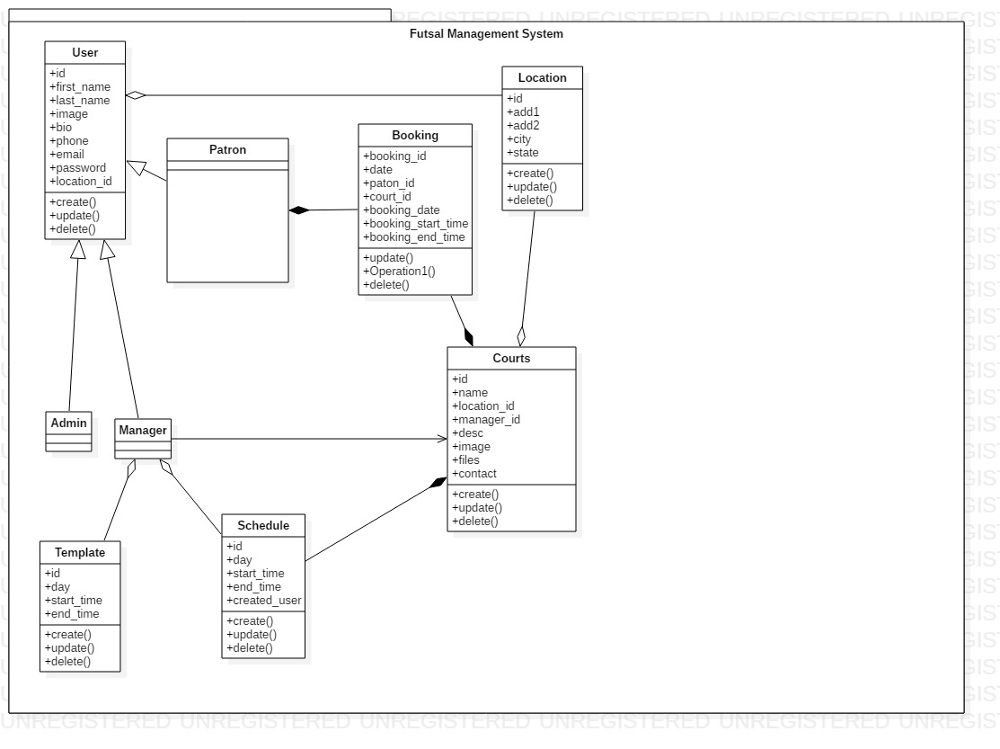

Figure 3 Class diagram

# Design

The solution of the making of new application is application design. This period of development manages the detail execution of the feasible system. It depends on explicit clients need. It comprises of three periods of development which are structural design, behavioral design and database design.

## Structural Design

It is the architectural map for an application that accentuates the structure of the entities, class, attributes, operations and relationships.

### Class Diagram

Class Diagram shows a static perspective on an application. Class diagram includes collections of classes, relationships, interfaces, constraints and collaborations. It is a diagram that can be mapped legitimately with object-oriented language.

*Figure 4: Class Diagram*



The above class diagram includes different types of relationships, for example, composition, dependency, association. Each model includes of controller which is dependent to their classes. Schedules are dependent on courts and the managing team members of the court. Bookings are dependent on users (managing team members) as well as courts’ available timesheet schedule. Managers create schedules for courts according to their regular timing and court availability. Bookings depends on courts and their availability. User cannot create bookings until court has it schedule on that particular time period.

## Behavioral Diagram

It is a functional activities of an application that changes over a time. It shows the interconnection of the entities to produce particular application behavior in use case, sequence and activity diagram.

### Activity Diagram

It is a graphical representation of series of activities of a application. It clarifies about how activity coordination to give features at various levels of abstraction.

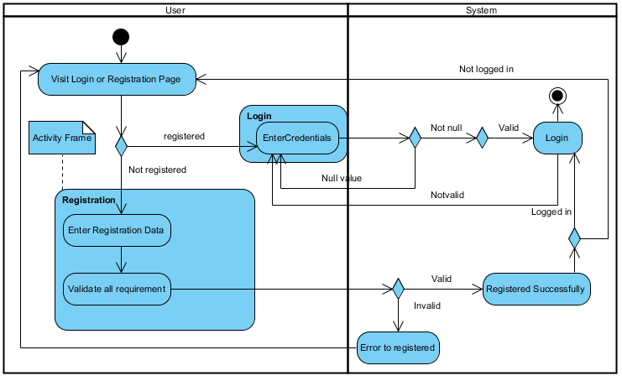

Figure : authentication activity diagram

In the diagram, the activities during the registration and login action are shown. User can visit login page as they need. On the off chance that the user is as of now registered, they can visit login, for un registered user they must be registered by either admin or organization’s legal contact person.

For the login procedure, the username and secret key must be made accessible. On the off chance that the username and secret word is invalid, at that point the login page is not reloaded and on the off chance that client enter invalid accreditations, at that point blunder message will be stacked in login page. Generally, user can without much of a stretch login to the application through a verification procedure.

For the registration procedure, user must give the personal detail in the structure inside a legitimate approval of information. In the event that the information is substantial, at that point user will be register effectively, error message will be shown in the registration page otherwise. After registration user can login to the application and on the off chance that login error message will showed, at that point the login page will be shown.

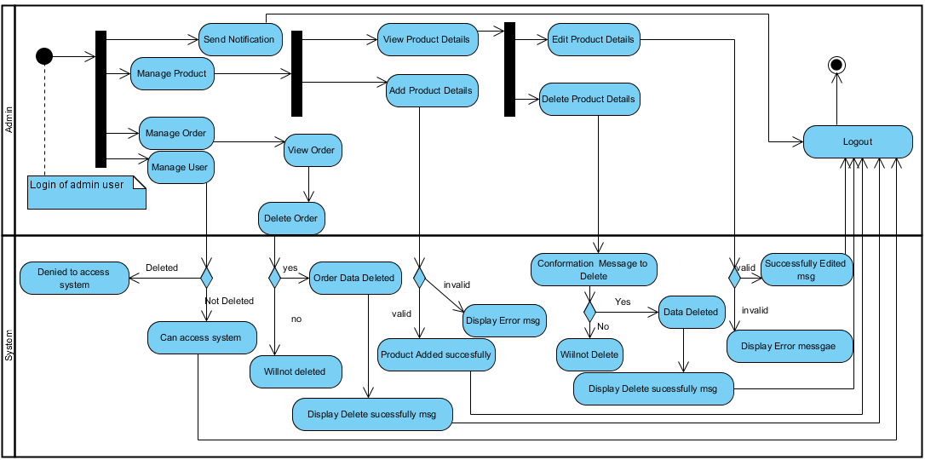

The above diagram illustrates the various actions of an admin user. As an admin user, s/he is able to carry out the management of court, schedules, users, and sending notifications to users in the case of essence. To carry out these administrative tasks, however, admin user must have logged in as an admin user with his/her login credentials.

Under **court management**, only authorized users or an admin user has the authority to add the court details, view existing and newly added court details, edit and delete court details. While adding a new court details, a pre-defined valid set of data must be entered or else an error message will be popped out. In order to make any changes in the existing or newly added court details, the view page of details can be accessed and be modified as required. Only in the case when a valid set of data is entered while editing the court details, a success message will pop out or else, an error message will pop out. A confirmation message will also pop out each time the authorized user tries to delete the court details and the data will be deleted only after the option “Yes” is selected. The action will be cancelled if the option “No” is selected or if the confirmation message is discarded.

Under **user management**, only an admin user will have the authority to block the users from accessing the system.

Under **schedule management**, an authorized user or an admin will have the authority to add a new schedule details and view, edit and delete an existing schedule details. The knowledge of present state of schedule to the user who is going to change/modify the schedule is of high importance and thus, the view page of schedule details must be displayed without any hassle. A confirmation message will also pop out each time the authorized user tries to delete the schedule details and the data will be deleted only after the option “Yes” is selected. The action will be cancelled if the option “No” is selected or if the confirmation message is discarded.

Under **notification management**, only an admin user will have the authority to create a new notification and send it to other users. In order to send a notification to one or many users, a list all users will be displayed and the admin user can select one or more recipients of the notification.

Below is a diagram that illustrates the various actions that can be carried out by a normal user.

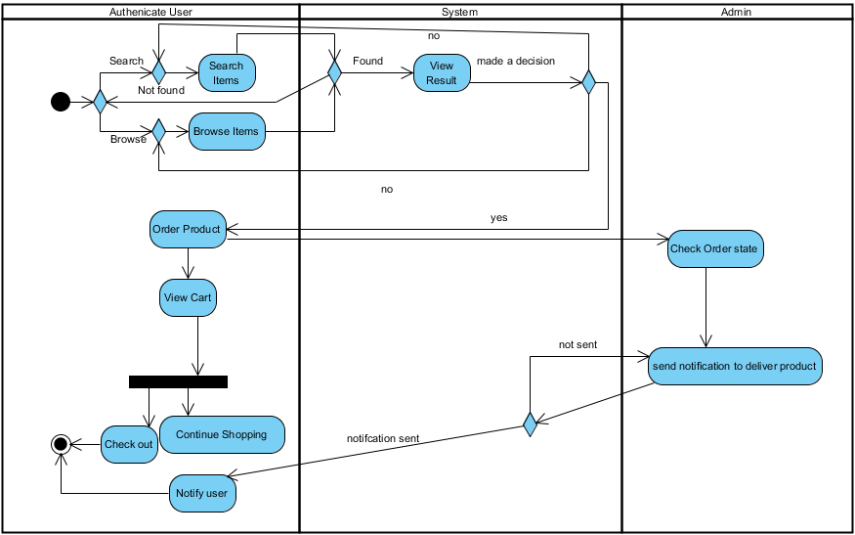

### Sequence Diagram

It is a sequential graphical representation of the interactions between objects. Which means, interaction between objects are shown in sequential order. The legit use of sequence diagram is to transform initial requirements in a use case to the next and more formal refinement level.

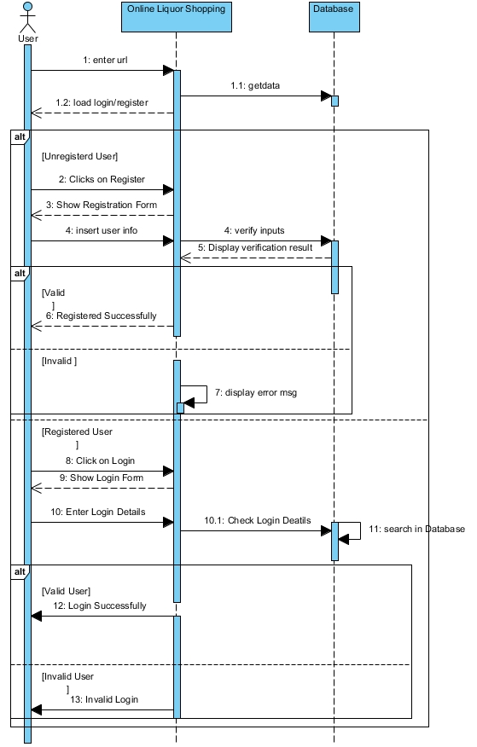

The sequence diagram mentioned above deals about the authorization and registration process and flow of objects. In the application admin clicks on add user if they are not register earlier otherwise they directly browse on login page and can sign in. When unregistered user enter their data and the data will be validated, verified and displayed in an application. Registered user enters username and password which will be validated and checked in database and the valid or invalid login message in shown to user.

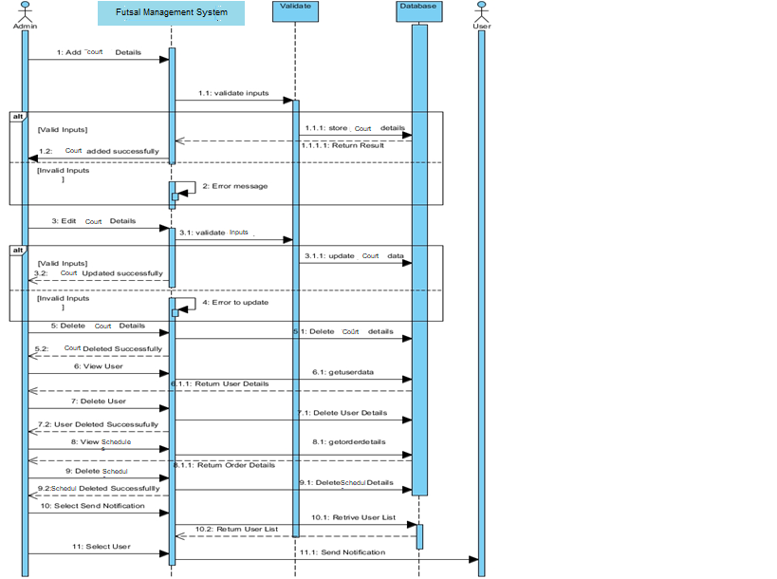

The above diagram outlines about the administrator user sequence diagram. After the login procedure, they can add courts and their schedules with in the approval of the information. In the event that administrator users enter substantial information, at that point application will return item included success message and in the event that data sources are invalid, at that point error message is popped out in the application.

For the adjustment of item courts, administrator user can alter and remove information. The court details can be altered with in the approve information in the application and it tends to be erased from the application.

They can see the user subtleties by getting information through database and retrieving data. The other user can be removed from the application if the administrator users don't need them to get to application.

Likewise, they can view court schedules, state and subtleties from database and modify the schedules accordingly.

For sending notification to the user, a particular user is selected by their email address and retrieved from the database. The application also checks for communication preferences for user for example if a user chose post mail they won’t get any email but post mail.

## Database Design

It is a graphical view of the meta data and interaction which shows the relationship between entities and exchange of data in a application.

### Entity Relationship Diagram

Entity-relationship model describes data involves in real world in terms of object and their relationships. It is widely used for initial database design. It describes overall structure of database. E-R model is in fact, semantic data model which describes the meaning of data. It has a capability to map the meanings and interactions of real world objects on to the conceptual schema.

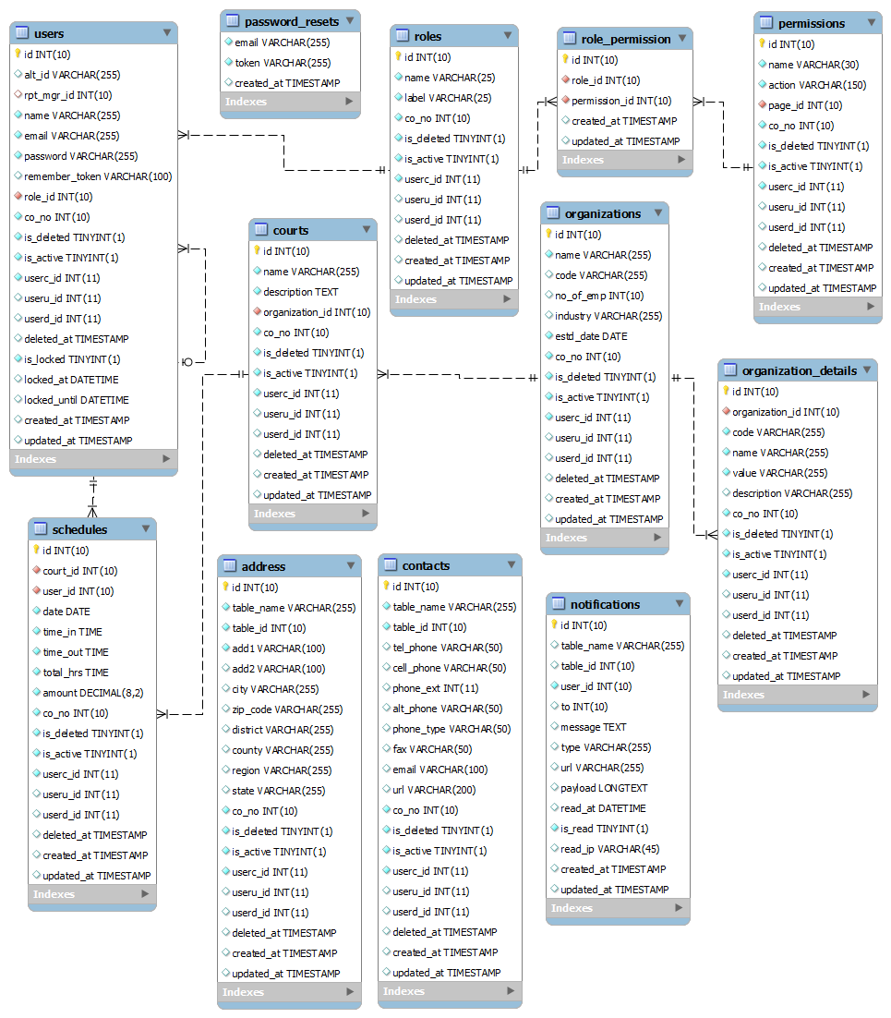

Figure 6: ER diagram

### Metadata

It is a blueprint of entities and attributes shown in the above ER diagram. There are twelve tables within different length, type and keys

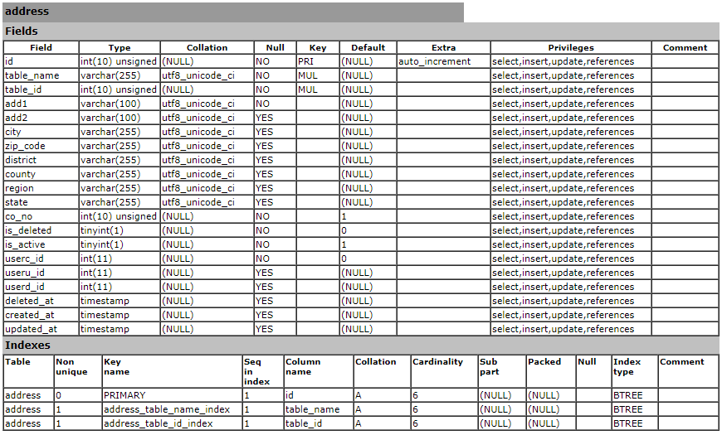

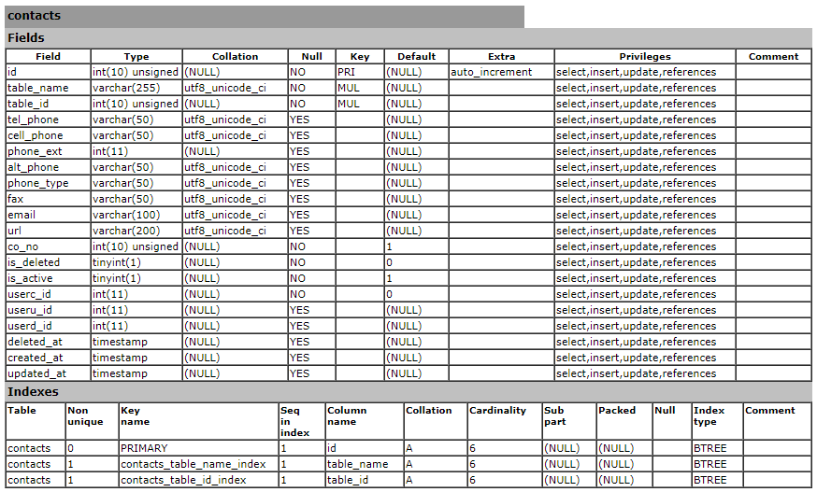

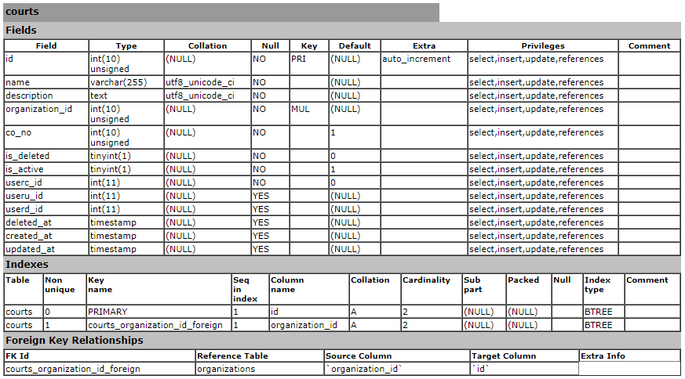

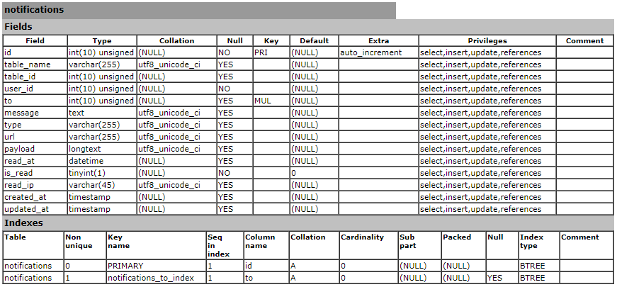

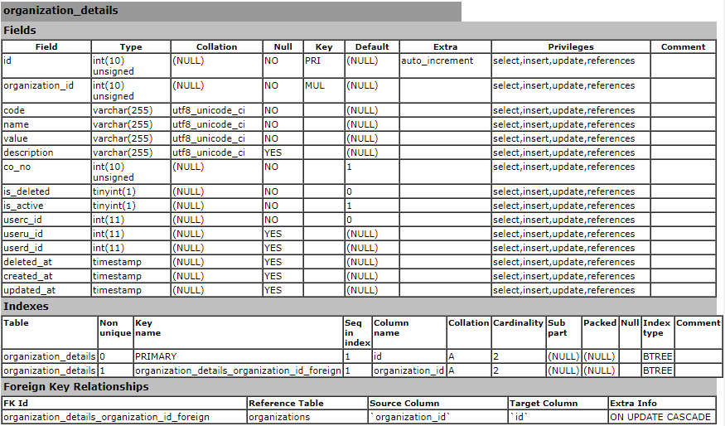

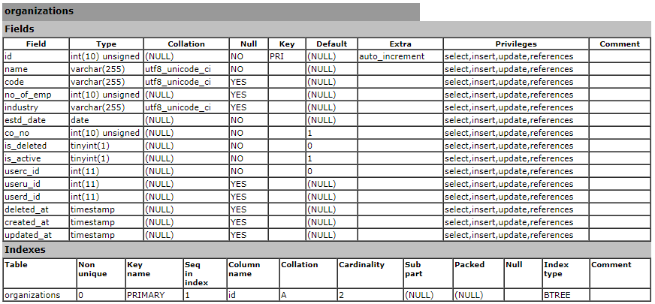

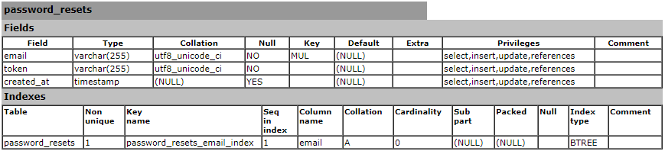

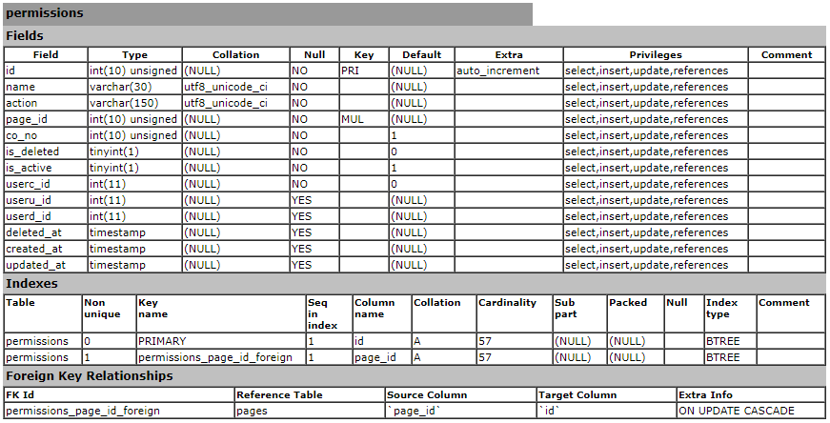

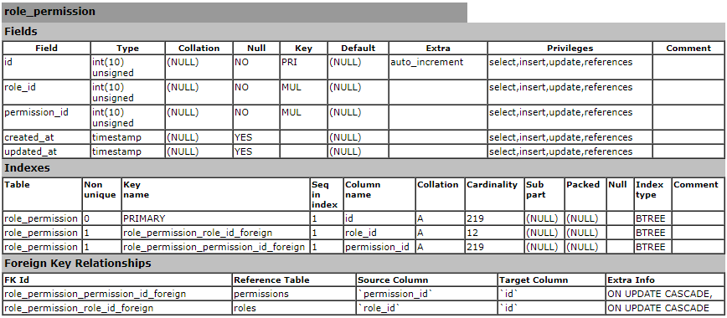

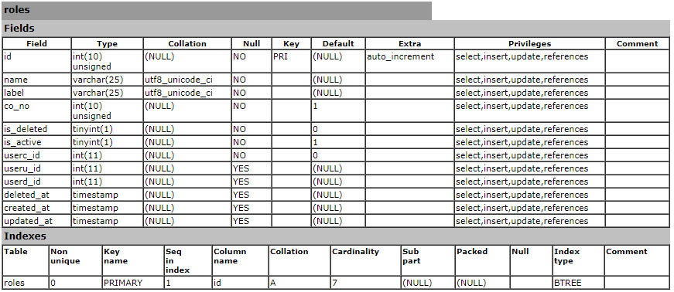

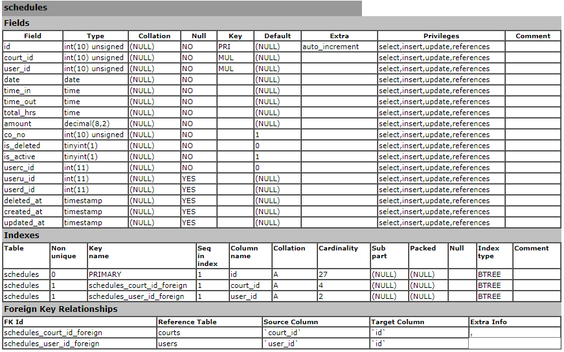

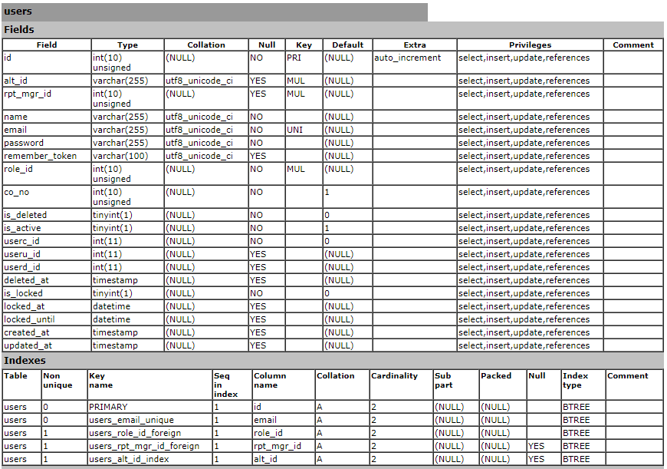

# Implementation

implementation is a method to convert design into real time application for working environment which is coded using different programming languages. The procedure is completed when a design model properly meets client’s requirements.

### Choice of Language

A website is implemented in PHP language. PHP is open source server side scripting language usually used for a web development or website development which is embedded into HTML. It was developed with a combination of various programs such as CGI (Common Gate Interface) for interaction between interface and database. Further, more concept and login were added and various version were developed and development is ongoing. Thus, PHP is flexible and easier to use for web development.

### Development Environment

##### Framework:

The project is developed in Laravel Framework which is open-source framework for web development. It was extended from Symphony framework and follows up MVC design pattern for coding. There are built-in set of features as routing, validations, authentication, testing and many more.

##### Standard Libraries

A package of small program codes that helps programmer to code system within a small effort is a library. For current application development, CSS and JS are included to support UI.

**JQuery**: A small but special library highlighted for JavaScript which simplifies HTML documentation traversing, event handling, animation and interaction with Ajax request.

**Bootstrap**: It is collection of predefined CSS and JS that will be used in system design and user interactions.

### Development Platform

The applications is developed and designed in Windows.

### IDE

IDE stands for Integrated Development Environment. It is tools that provides platform for efficient coding with integration of different feature.

PHPStorm is a perfect IDE for developing website using PHP. The general features of PHPStorm are language support, code completion, code quality analysis, debugging, testing, etc. It is an IDE which support the Laravel Framework without any problems.

### Development Strategy

It’s a way to deliver actual application from development phase to client workplace. It consists of various steps which are listed below:

**Release**: When an application passes by development process, it is ready to release in real time environment.

**Activation and Installation**: Activation is way to execute applications components. Installation is process to use the application in end user computer.

**Deactivate**: It is opposite process of activation.

**Adapt**: It is modification of application which had been already installed.

**Update**: The process to replace older version with new working one is update.

### System Migration

System Migration is specific method of moving application from one computer environment to another. It varies upon situation. Migration includes physical or logical dependencies which must be checked and handle fulfil at initial stage.

Some of dependencies of applications are listed below:

**Server**: It is a computer device with high specifications which can handle a large user traffic at a time.

**Apache Server**: Serve which runs in PHP scripts.

**MySQL**: It is database server.

**Composer**: It is dependency manager of PHP.

And all the required coding screenshots and images are in Appendix.

# Testing

Testing is investigation and evaluation of software quality of the application. The goal of software testing is to measure and evaluate software core functional requirement. Each functions in the core application are tested by various user perspectives and expected outputs were gained. Testing is done for the further precautions so that in future user would not face problem while using and accessing it.

There are different types of testing for example unit testing, black box testing, white box testing, acceptance testing, etc. Each of testing consist of own unique features and have different goals and procedures.

Black box testing and white box testing should be performed with test case and test plans.

**Test case**: It is a set of actions performed in software which is well documented.

Advantages of Test Case:

* It can be used anytime in a testing team for understanding of features and functionalities.
* Time Management
* Improved Software Quality

**Test Script**: It is written description of actions which is performed as a test.

## White Box Testing

White box testing is completely code based testing for the application. It focuses on feature of the application for testing. Test cases are required before going on testing. Integrated testing and unit testing are the example of white box testing.

## Black Box Testing

Black box testing focuses on the client side perspective of testing. In other words, application is expected to give some output as assert checks for the result and compare between expected and actual output. Test cases are required before going on testing. It requires well documentation regarding test cares and their results.

# Risk Management

The uncertain and unfortunate events in life time that might impact the aims and objectives of the application development is known as risk. There are two types of risks that is positive impact risk and negative impact risk. Whenever those type of risks are encounter it must be mitigating to be safe and secure from the counter attacks. Risk management can also be used to prevent various type of risk arising in the application development.

Risk management is extremely important part of the application development which increases the level of success on real time environment. The benefits of implementing risk management are listed below:

* Helps preventing damage from natural disasters
* Expenses saving for intensify revenue
* Mental satisfaction on project progression
* Make competitive edges over competitors
* Growth of accountabilities and responsibilities

The impact of risk is calculated with the identification of the likelihood and consequences in the project of application development. **Likelihood** is estimation of to happen something where **consequence** is result of the action or processes.

**Risk = Likelihood x Consequence**

## Likelihood

|  |  |
| --- | --- |
| **Likelihood** | **Value** |
| Low | 1 |
| Medium | 2 |
| High | 3 |

## Consequence

|  |  |
| --- | --- |
| **Consequence** | **Value** |
| Very low | 1 |
| Low | 2 |
| Medium | 3 |
| High | 4 |
| Very High | 5 |

## Risk Identification

The risks for my project of application development are described below in tabular form:

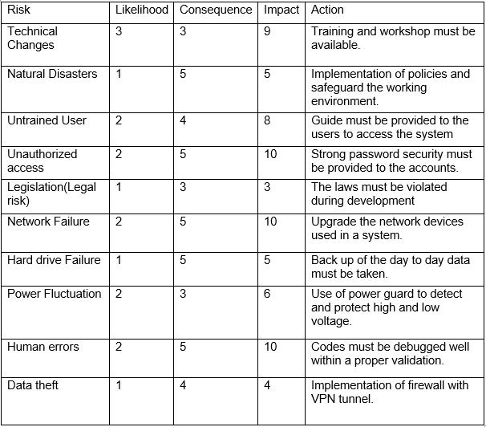

Figure : Risk management table

# Conclusion

For this application development assignment, I had divided project into different phases as analysis, designing, implementation, testing. After completing the project, I had mentioned background to be analyzed in initial part. I had completed analysis in Multi-view methodology where I had designed diagrams such as ER diagram, initial class diagram and use case diagrams. DFD diagram describes about the flow of data and information in a system. Rich picture is simply rough sketch of the system. ER diagram is simply relationship between tables. Class diagram shows the interrelation between class, entities and attributes. Use case diagram describes about how user interacts in an application. The requirements were acknowledged and they were divided into functional and non-functional requirements where it was prioritized into must have, should have, could have and won’t have. MVC pattern were followed.

The aims and the objectives of the application development project is to deliver an application that will help users in day to day work in real time environment. Various tools were used to finish the application project like JQuery, JavaScript, CSS, HTML5, PHP, MYSQL etc. An authorized admin can access the application for the access of functions included in a system. Unregistered or unauthorized user cannot access to the application to secure the database. Working in this application development project made my mind wide by giving the knowledge of different available IT tools and technologies. It gave me experience of working on real time application’s projects.